3D Printing Guide

This guide goes into everything related to 3D printing which ranges from setting up the 3D printer to specific settings to print each part out. The printer requires regular maintenance and can come up with issues which need to be diagnosed from time to time.

# Initial Printer Setup

## Initial Levelling

When the printer is first setup, the print bed would not be completely flat. A levelling process needs to be conducted so the printer can start functioning. The printer comes with two tools that help us level the bed. A 0.2mm thick level guide and a levelling block

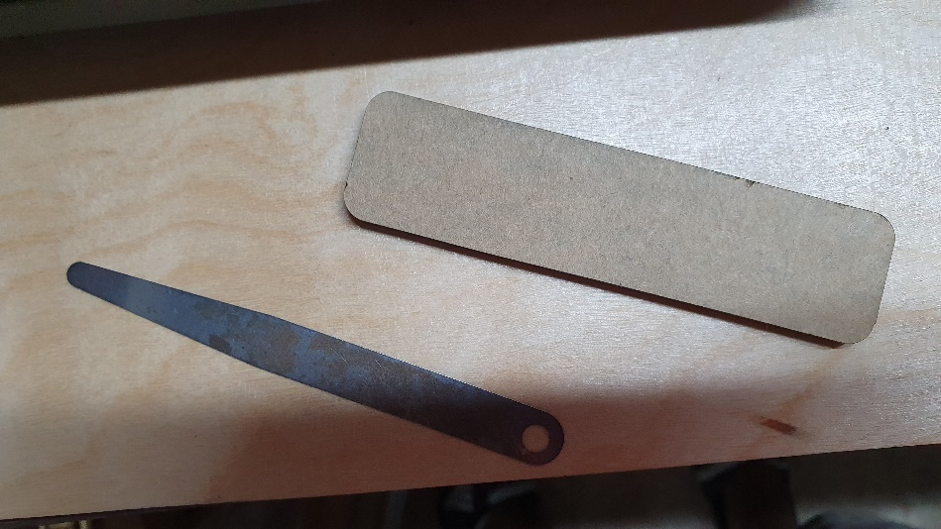

Levelling block

0.2mm guide

We are going to start by synchronizing the two z axis motors.

1. Place the levelling block on the right side of the base of the printer as seen below. Note, the bottom of the block is on the base of the printer and not the print bed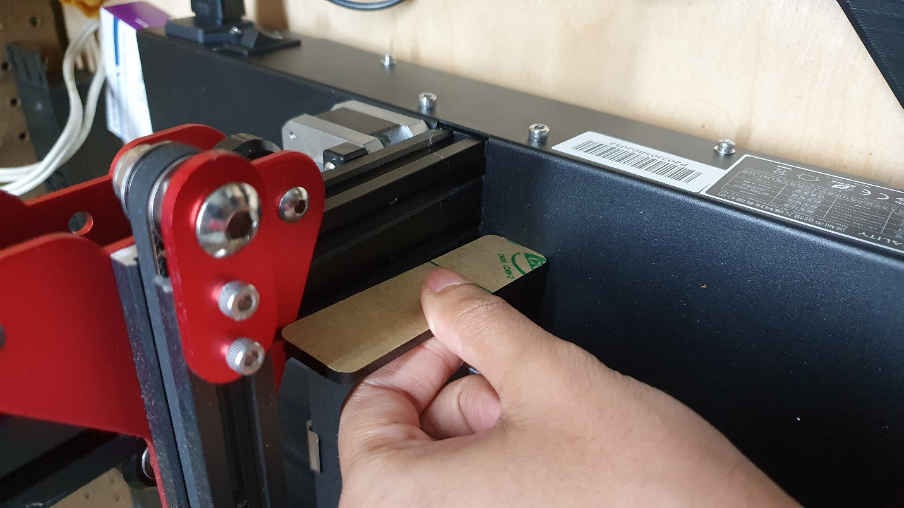
2. Then bring the Z axis down so that it’s touching the top of the levelling block and there is some force required to pull the block out.
3. Place the block on the left side of the printer. It should either be too loose or too tight to push the block between the z axis bar and the base since the motors aren’t level.
4. To level the motors, hold one of the z axis couplings and rotate the other one until the left and the right side require a similar amount of force to pull the levelling block. 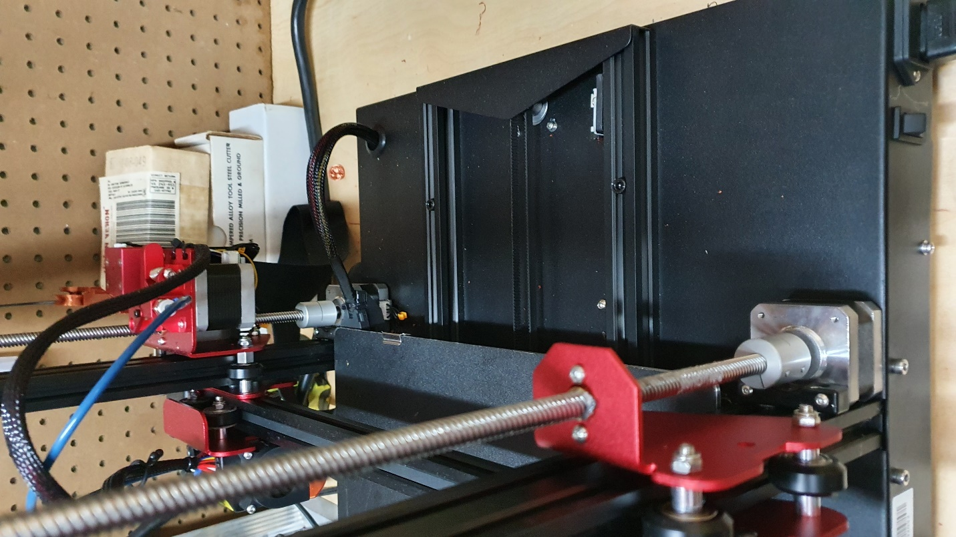

Z axis Couplings

After the motors are level, we need to level the bed. This procedure will be outlined in the “regular maintenance” section since the bed would need to be leveled one or two times a month.

The following video gives more detail on this levelling process

<https://www.youtube.com/watch?v=S-K-PdPngp8>

# Regular maintenance

## Bed Levelling

The print bed rides on four adjustable knobs which changes the height of each of the four corners. As time goes on these knobs can move around and cause the print bed to go out of level.

The printer has an auto levelling feature which can account for height variations less than 0.5mm but we need to manually level the bed if the variation is greater than that. A good rule of thumb is to relevel the bed every month or if you notice that it’s hard to get the prints off the bed.

The following steps can be followed in more detail in this video (same video linked at end of initial levelling section) <https://www.youtube.com/watch?v=S-K-PdPngp8>

1. On the printer, go to Temp🡪Manual and change the bed temperature to 60 degrees and nozzle temperature to 200. This is done because the bed and nozzle expand as it is being heated so we want to do our levelling with respect to the heated bed and nozzle.
2. On the printer go to Settings🡪Levelling🡪Aux levelling. There will be 5 sections of the bed that can be clicked on to move the nozzle to that point
3. Press the section 2 button and the printer nozzle should move to the bottom left of the print bed. Place the 0.2mm level beneath the nozzle and adjust the knob so that the nozzle is barely touching the level and there is a bit of resistance when moving the level around. **(Warning: Be very careful to not touch the nozzle and burn yourself)**
4. Repeat step 3 for section 3, 4 and 5 until all the four corners have equal resistance to the 0.2mm level
5. Go back to the levelling screen and press the down arrow on the left side twice to offset the nozzle down by 0.2mm
6. Start a test print and monitor the first layer carefully. While the print is running, go to the adjust screen
   1. If the filament seems to not be sticking to the bed well enough, lower the z offset until it does
   2. If the filament seems to smudge onto the bed or the nozzle is colliding with the bed, increase the z offset until the filament comes out as a fine line

## Cleaning

The printer has small parts that can clog up if not cleaned regularly. This section dives into the different types of cleaning that should be done to maintain print quality. These procedures should be repeated every month or whenever there is visible dirt on the printer.

1. Use isopropyl or acetone to clean the print bed.
2. Clean pieces of filament that have fallen onto the printer. When the filament enters into the printer on the left side, there can be some grinding which cause tiny flakes of filament to fall off. This could get into the belts and pulleys and clog up the motors.

# Software

When a 3D model is made, it needs to sliced and converted to gcode so that the printer can read it. This process is done by a slicing software.

This process begins by making a model which should be saved as an STL file. The STL file can then be imported into a slicer software and can be saved as a gcode file. This gcode file would have to be saved onto an SD card which would be inserted into the printer to begin printing.

My software of choice is Cura which is free to download and use. On initial setup you need to select your printer (Creality CR-10S PRO V2) so that the printers’ dimensions can be set. Then you can tweak the temperature and print settings to get the right print.

If the lab uses the printer a lot, Simplify3D is a $99 slicer that allows for greater control of print settings.

# Per Part Print Settings

This section assumes we are using the Hatchbox Black PLA filament which can be found on amazon. The following settings should be set for all prints using this filament unless otherwise specified

* Printing Temperature – 200C
* Printing Temperature Initial Layer – 205C
* Build Plate Temperature – 60C
* Print Speed – 50mm/s
* Infill Density – 30%
* Wall line Count - 4
* Enable Retraction - Ticked
* Retraction Distance – 5mm
* Retraction Speed – 45mm/s
* Enable Print Cooling – Ticked
* Build Plate Adhesion Type – Skirt
* Skirt Line Count – 2

## X/Y Stage Holder

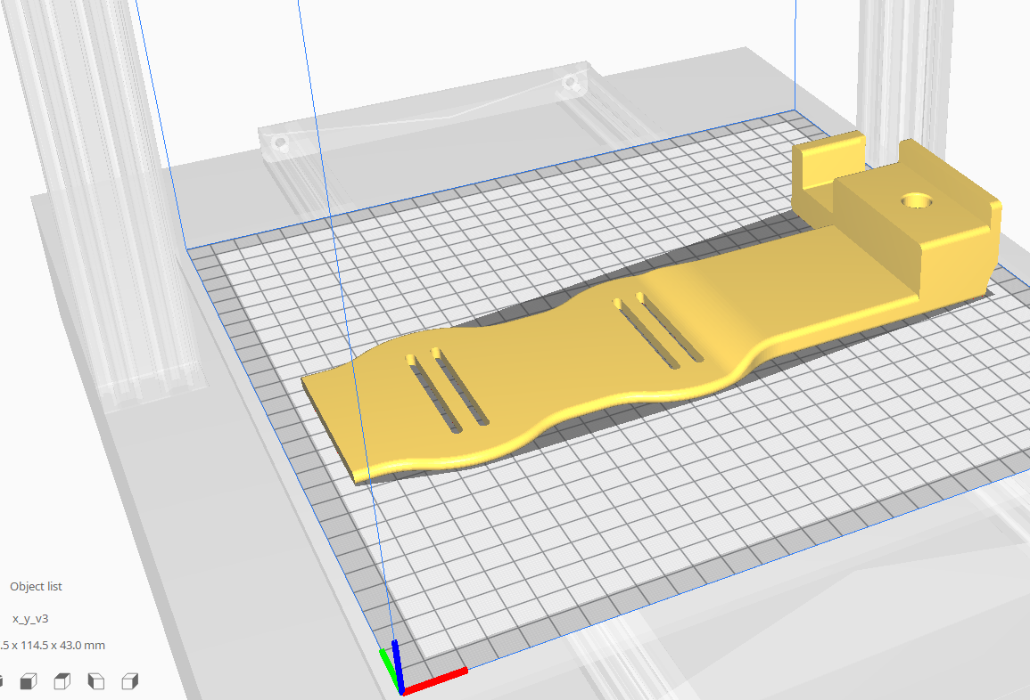

* Oriented flat onto the bed
* No Supports

To remove print, insert putty knife under thin end on the left side and break seal with the bed. Slowly unstick rest of print by moving putty knife to the right side. Put most of removing force on the right most side where the part is thickest. If a lot of force is applied to the thin end, part can snap.

## Motor Attachment

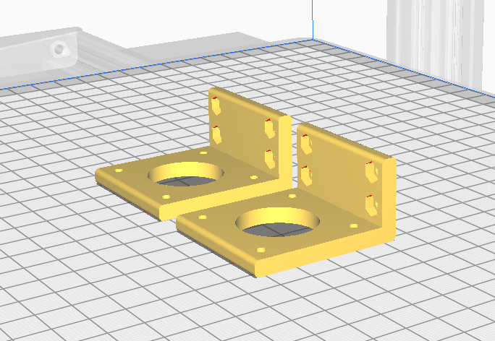

* Orient such that big hole is facing the build plate
* Print with supports
* Print two pieces for x and y motor

## Z Axis Holder

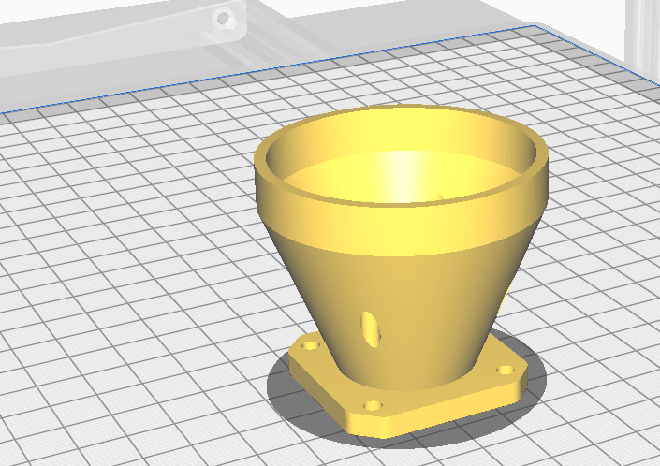

* Print without supports

## Z Axis Motor Couple

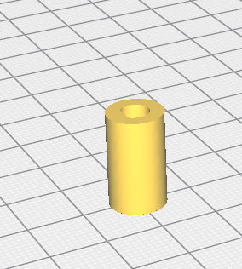

* Print without supports
* Print Speed: 40%
* Infill Density: 100%
* Orient with bigger hole facing upwards

## X/Y Stage Balancer

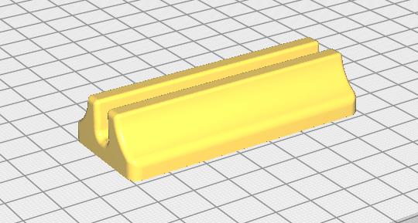

* Print without supports

## Nut Side/Screw Side syringe holder

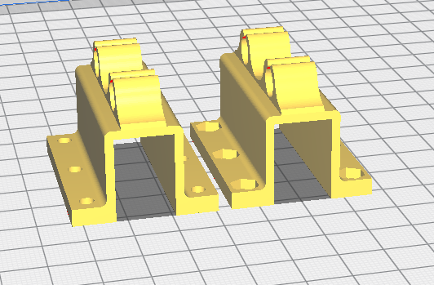

* Print with supports
* Print Speed: 40mm/s

## Breadboard Base/Lid

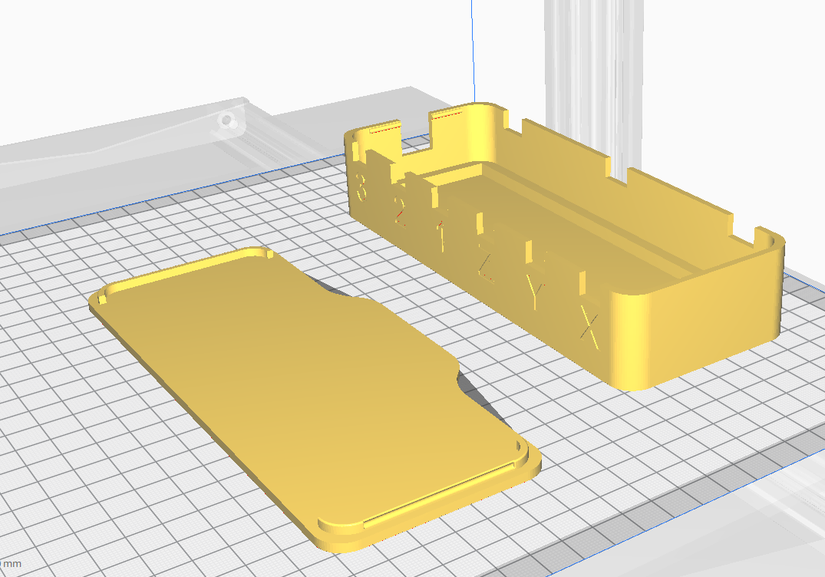

* Orient lid with notches facing up
* Layer Height: 0.1mm

## Pressure Regulator Motor Base

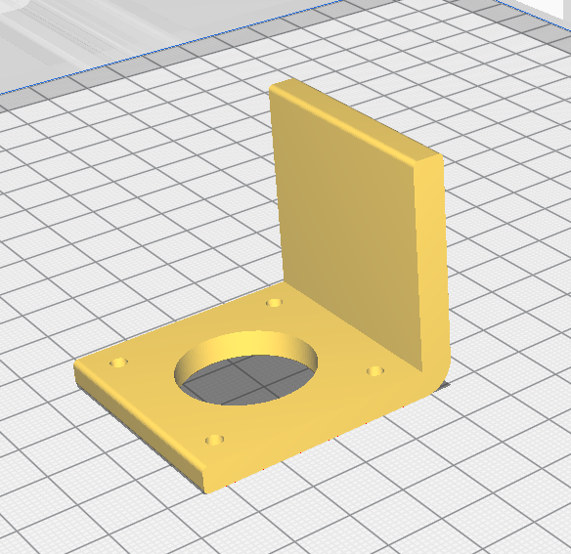

* Print with supports

## Pressure Regulator Shaft Couple

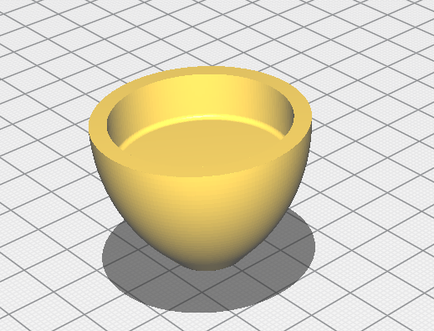

* Print without supports

# Diagnosing Issues

There are several issues that can arise with the printer. It could range from a simple software bug to a broken part. I have listed the issues that I have run into so far with remedies for them. If there comes an issue that is not listed here, it could most probably be found with a simple google search. If not, feel free to reach out to me and I will try find a solution to it.

## GCODE file not showing on printer

This is the most common and repeatable error that happens. This happens because the GCODE file name is too long. Renaming the file to 15 characters or less would fix the problem.

## Printer does not move but progress bar goes up

To remedy this, restart the printer. If that does not solve the issue, reformatting the SD card fixes it

## Filament grinds when entering extruder

This is a drawback of the base design. The filament spool is directly above where the filament enters the extruder. This means that the filament needs to bend sharply to enter the extruder and can cause some grinding. I’ve installed a filament guide with a bearing to minimize this issue. The print files and assembly guide can be found here <https://www.thingiverse.com/thing:3421841>

Thingiverse.com has a lot of other upgrades that can be installed such as tool holders and fan ducts which can improve performance.

## Fan Duct broke during print

Sometimes a print can come loose during the printing process which can hit the fan duct and break it. There are printable solutions for this that can be found on thingiverse. <https://www.thingiverse.com/thing:3709649/comments> this is a direct replica of the existing fan but designs with different cooling properties can be found.

After installing the printed fan duct, make sure to check if the fan is at the same height as the nozzle. If its below the nozzle it can hit the bed/part when printing.