Assembly Guide

This guide goes through all the processing and assembly steps required to get the remote-controlled microscope set up and running.

# Initial Assembly

## Inserting Nuts

There are quite a few 3D printed pieces that have hexagonal holes in them. These holes are to insert M3 Nuts into. The pieces that require this are

* The two Motor Attachments. They require 4 nuts each
* The nut side of the Syringe Holder. This requires 6 nuts

The holes are designed so that the nuts require some force to be pushed in, but once in they will stay locked in place.

## Inserting Screws

Every single motor would need to be screwed into their respective motor attachment. Each motor has four mounting holes and all four of them are used.

* Z Axis Holder
  + Slide the part over the motor shaft and insert screws into the four mounting holes. The angled holes on the printed part are access holes so that a screwdriver can fit through it to tighten the screws below

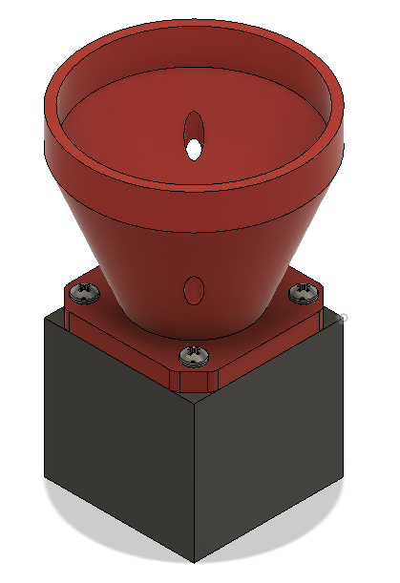

* X/Y Motor Attachment (Note: Insert the nuts onto the motor attachment before starting this step)
  + Attach the screws on one motor so that the cable pins are to one side of the vertical tab
  + On the second motor, attach the screws so that the cable pins are on the other side of the vertical tabs as seen in the pictures below

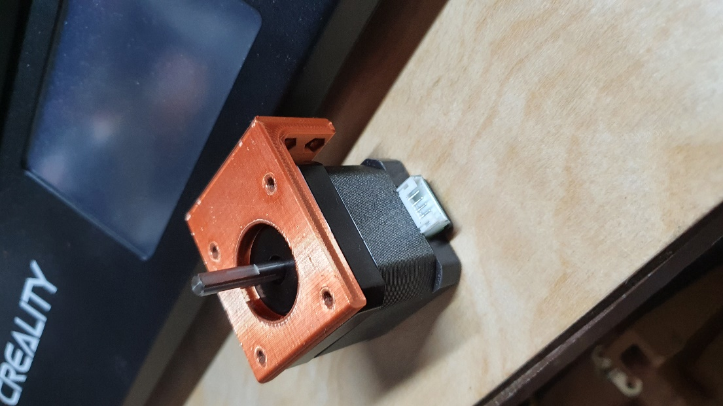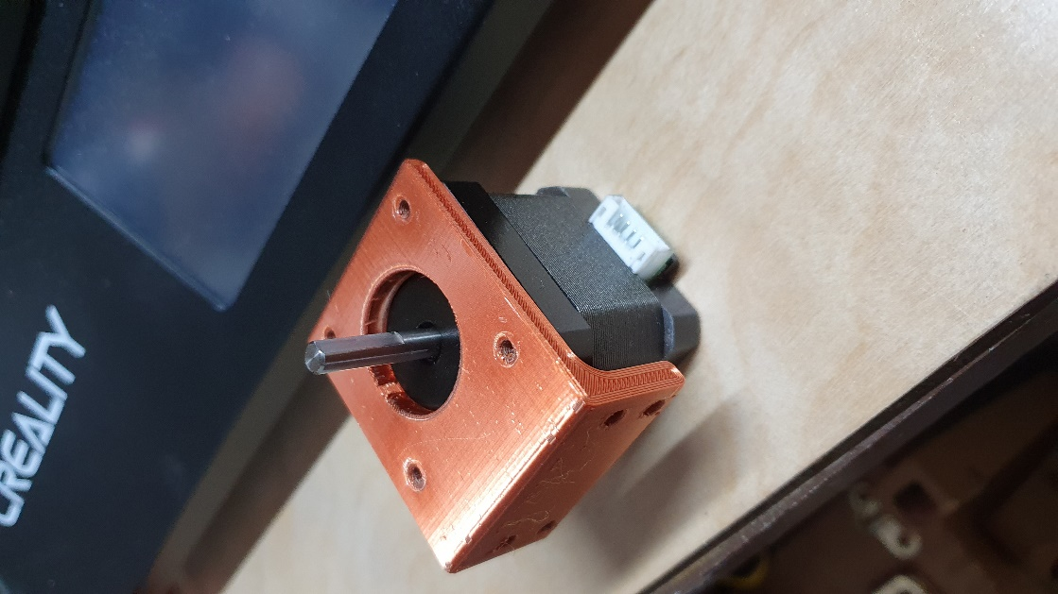

* + Insert the pulley so that the top of motor shaft lines up with the top of the pulley and tighten the set screw so that the set screw makes contact with the flat surface on the motor shaft

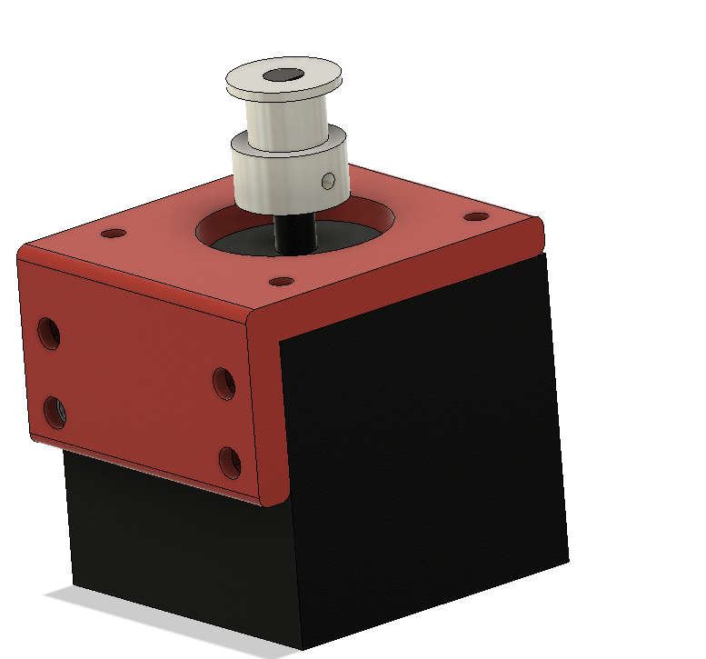

* Pressure Regulator Motor Attachment
  + Attach the screws onto the motor in a similar fashion as the X/Y motor mounts. The flat tab without any screw holes are going to be facing down so place the motor whichever direction makes wiring easier

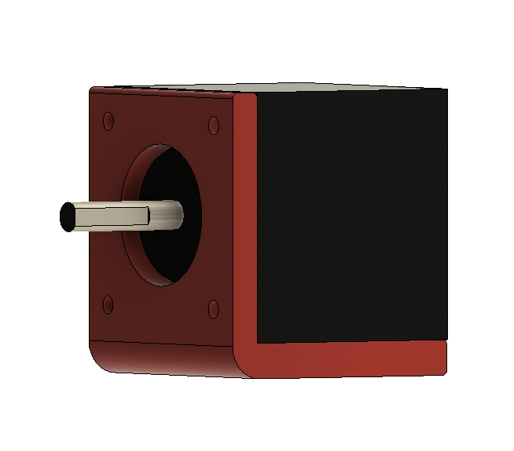

# Main Assembly

## Mounting Z Axis Motor

This process requires some disassembly of the microscope.

1. With all focus lenses inserted, rotate the lens turret so that the biggest lens is selected
2. Rotate the Z travel knob so that it is facing you, this unlocks the z travel and allows you to set the max height the lens can go up to
3. Move the coarse focus knob so that the lens is just below the x/y stage (**Warning: This step is important to prevent the lens from colliding with the stage when in use)**
4. Move the travel lock knob back up so that the max height is set
5. Undo the set screw seen on the left side of the focus knob and pull the fine focus knob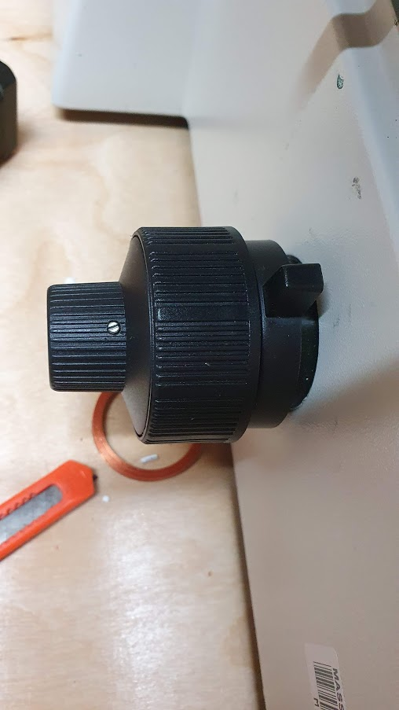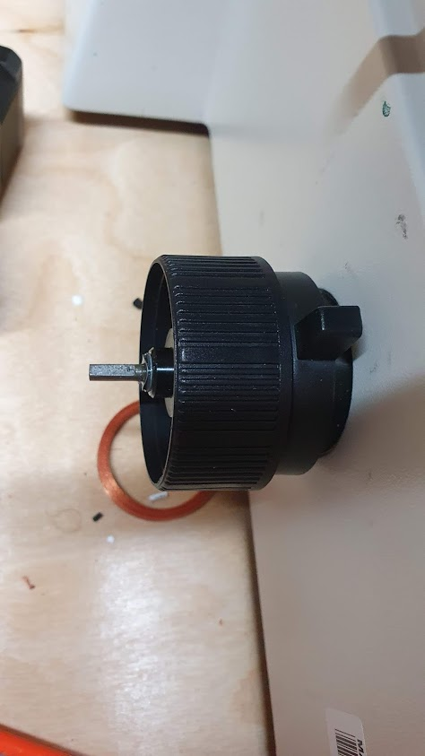

Z Travel Lock

1. Through the next steps we are inserting parts onto the shaft that’s been exposed. The shaft can easily be pushed causing the gears to slip. **Using your right hand hold the fine focus knob on the right side of the microscope in place**
2. Align and insert the Z axis motor couple onto the exposed shaft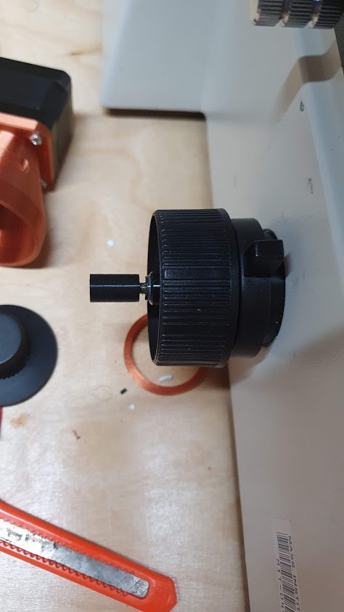
3. Align and insert the assembled Z axis motor. The motor might not go in on the first try but rotating the fine focus knob on the right side will make it easier for the motor to connect. You will get tactile feedback once the motor has connected when the fine focus knob movements start to feel granular.

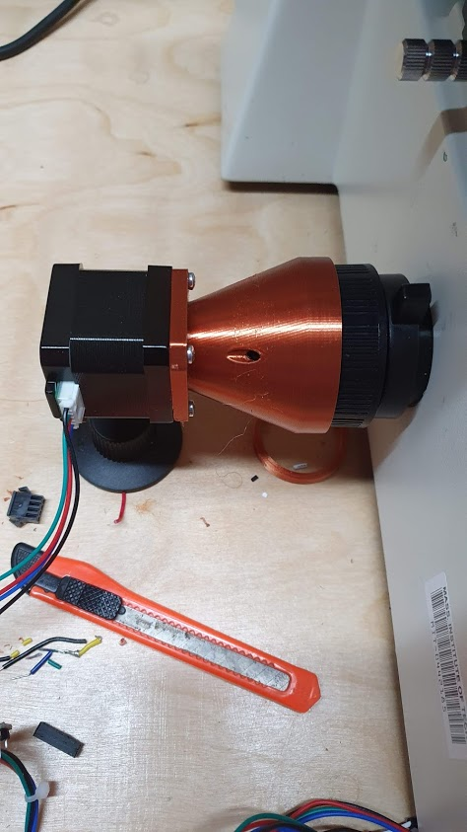

## Mounting X/Y Stage Holder

This is the largest component that will be inserted onto the microscope. It has fine tuned dimensions so pushing it too hard will cause it to break.

The part grabs onto the stage at the place marked with the red circle.

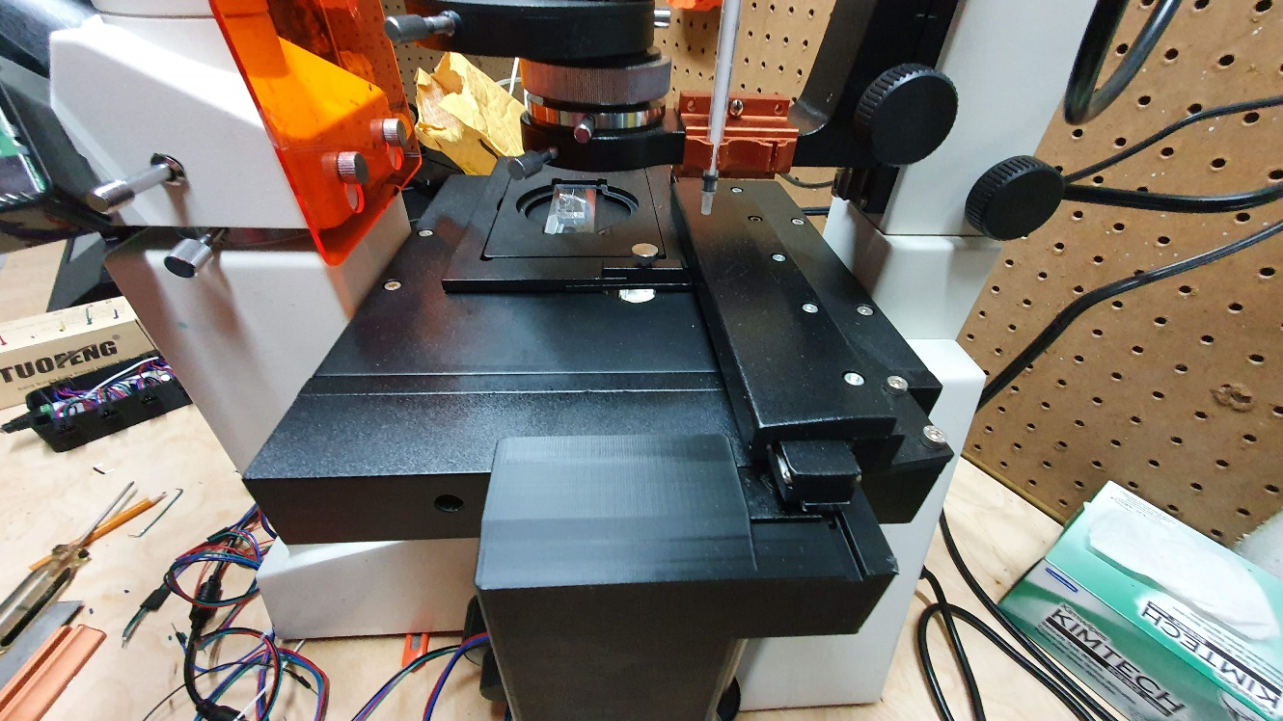

Push the part in until you feel that the part cannot move anymore. There may be a gap but that is okay. It has been designed so that the part will flex a bit and clamp onto the area sticking out.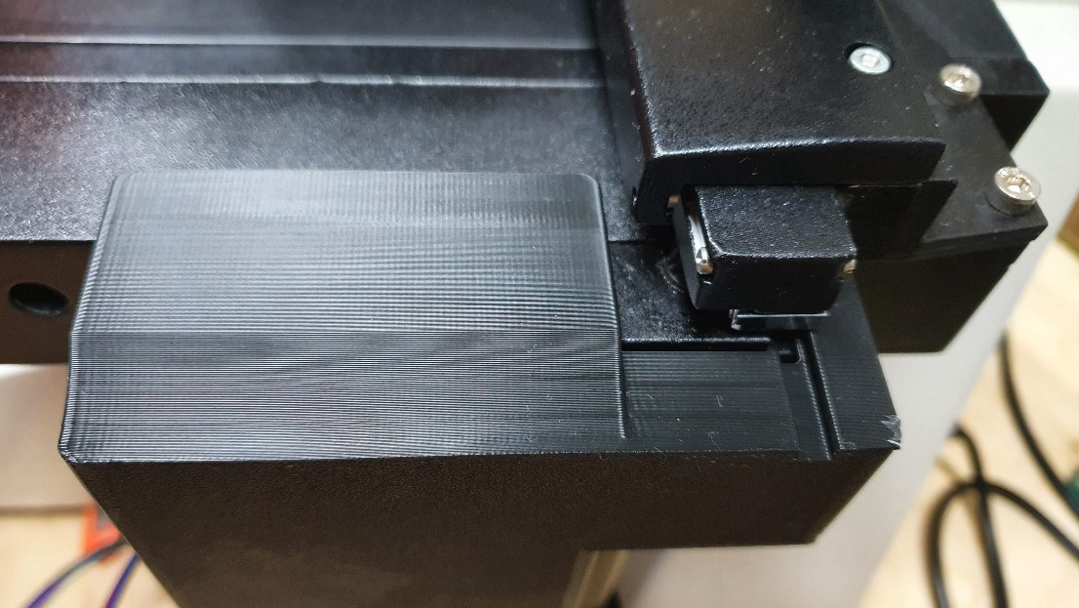

## Mounting X/Y Stage Motors

When mounting the motor attachment, we mounted the motors with different orientations. This is because one of the motors will be mounted upside down, but both the motors will have the wires coming out of the left side.

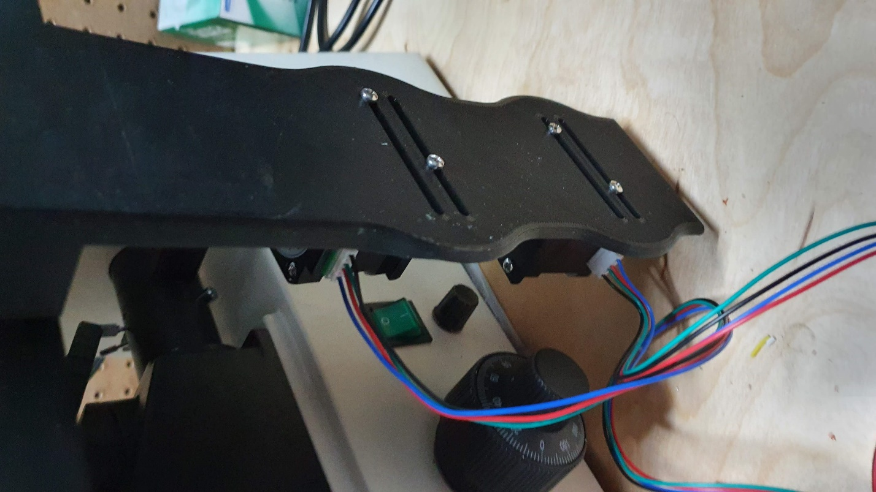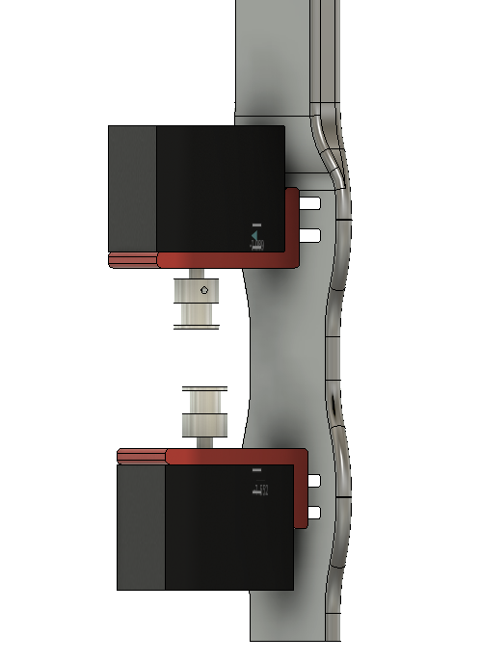

1. Align the motor attachment with the slots on the stage holder. Insert the top right and bottom left screw as seen in the picture above. Tighten it so that the screw will not come off, but the motor can freely slide horizontally
2. Repeat step one for the remaining motor and mount
3. Insert a timing belt onto the microscope’s x/y control knobs and pull it onto the topmost motors pulley
4. Pull the motor away from the knobs so that the slack on the belt is gone and tighten the two screws while pulling (**Warning: Using the stage holder as leverage when pulling the motors can cause the stage holder to crack)**
5. Move the motor pulley. If the control knob is not turning, there is still too much slack in the belt so redo step 4
6. Repeat step 3, 4 and 5 for the bottom motor. Once done correctly, the assembly should look like the below pictures

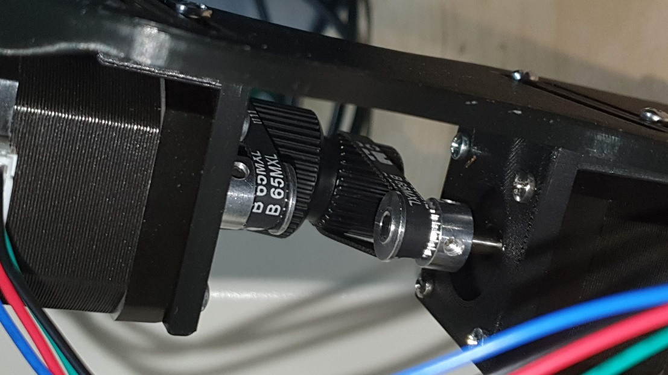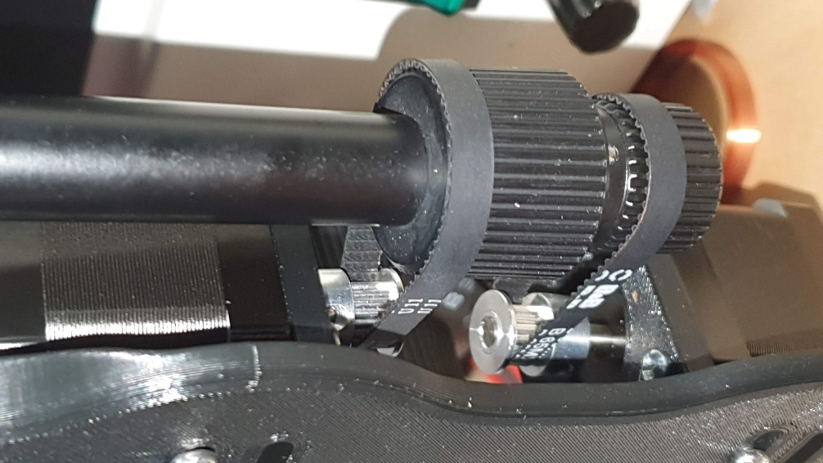

## Attaching X/Y Stage Balancer

The x/y stage holder deflects a bit when moving on the Y axis. This causes inaccuracies in the coordinate system saved by the computer after usage. To minimize this, we mount a stage balancer that goes on the bottom of the x/y stage holder.

1. Place the stage balancer on the table the microscope is on and slide it through the bottom of the stage holder
2. Move the y axis and check if it can move freely
3. Using double sided tape, stick the stage balancer to the table

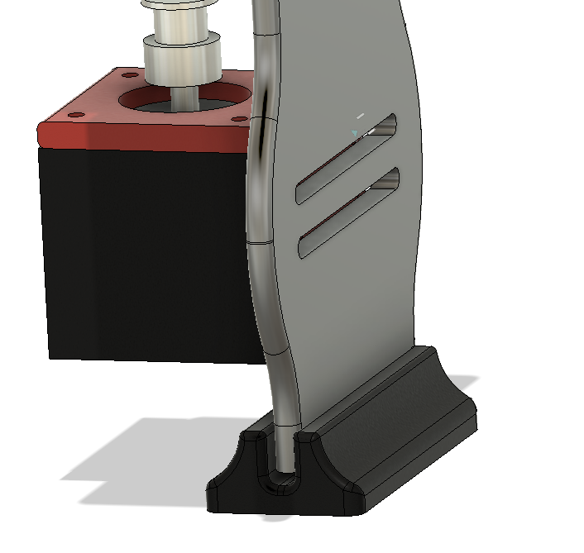

## Attaching Pressure Controller

1. Attach the pressure controller motor couple to the motor as seen in the image below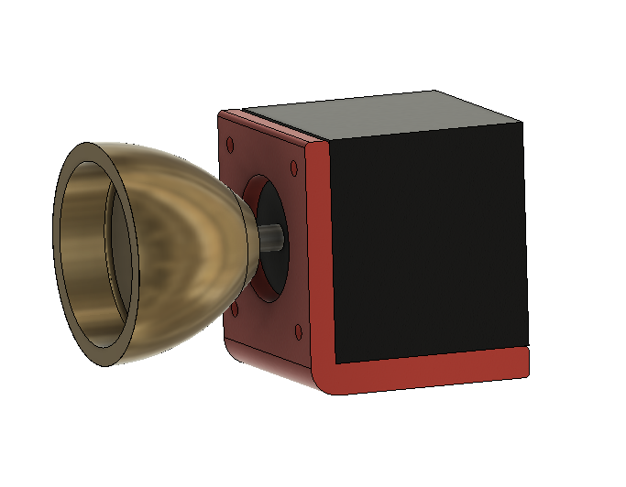
2. Slip the exposed end of the motor couple to the pressure regulators knob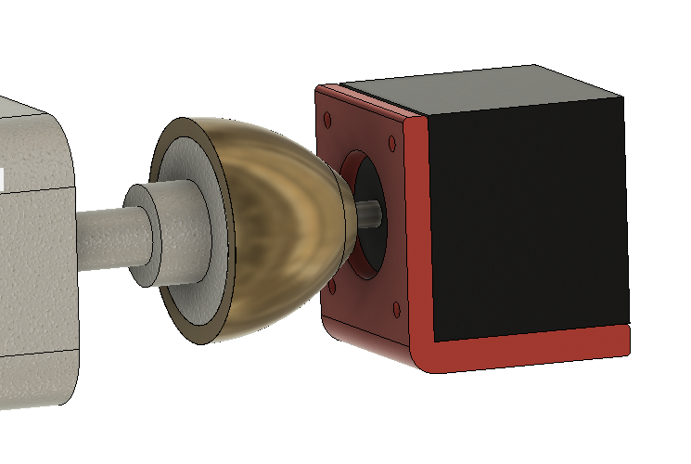

## Attaching Syringe Holder

Take the two parts of syringe holder and place it on the beam that connects to the light diffuser and screw the two pieces together.

