Electronics and Connection Guide

This guide will go through all the connections that will need to be made and how the electronics work together to allow the microscope to function. The brain behind this whole project is the Raspberry Pi 4 and the muscle is the A4988 stepper driver.

# Electronics

## A4988 Stepper Motor Controller

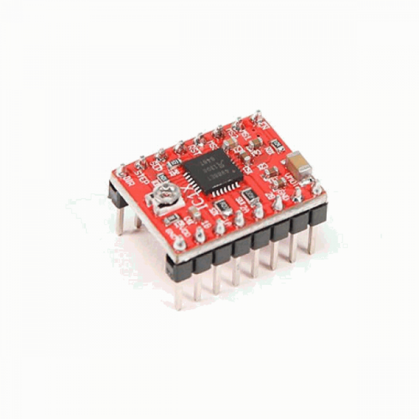

This motor controller has a lot of built in features that made it ideal for use in this project. It allows for a hardware controlled current limit that prevents the motors from burning up and it has step a microstepping feature that allows the motor to turn from 1.8 degrees per step down to 0.1125 degrees per step.

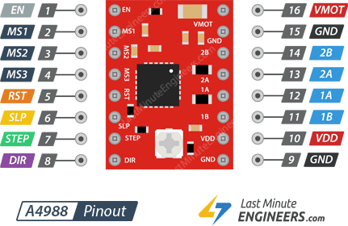

<https://lastminuteengineers.com/a4988-stepper-motor-driver-arduino-tutorial/> This article has all the in-depth information about the motor controller. For immediate knowledge, the following pins are whats important to us.

* MS1, MS2, MS3 – The X axis motor, Y axis motor and the pressure regulator motors have these three pins set to 5V to get the best resolution. The Focus stage motor has these set to low since we do not want a lot of resolution out of it.
* STEP – This is the pin we send pulses to. Each pulse tells the motor one step
* DIR – This pin determines the direction in which the motor will turn
* VMOT and GND – These are the pins we plug our 12V power supply to. **A 470 microfarad capacitor needs to go in between these pins so we don’t burn our circuitry if these is a voltage spike**
* VDD and GND – These are the pins we plug 5V to power the logic in the controller

## Circuit

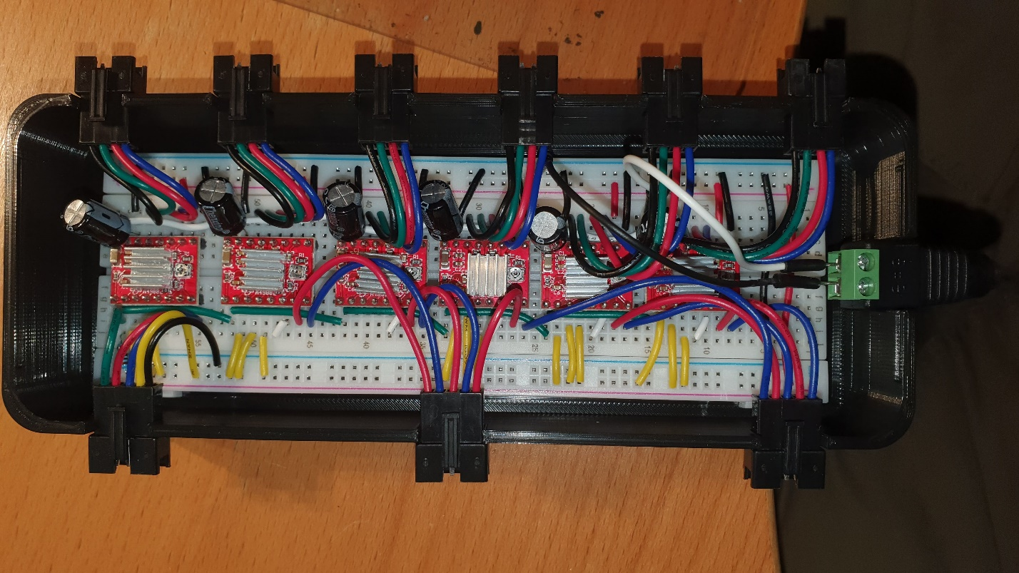

To explain this circuit, we first divide it into two sections. The left side and the right side which can be seen from the green divider line.

### Left Side

* Green Wires – These green wires connect to the enable pins of all the stepper motor controllers. When we send a low signal from the raspberry pi through the green connecting pin, we enable all the motors
* Yellow Wires – These wires represent 5V coming from the raspberry pi to the MS1, MS2 and MS3 pins
* Black Wire – This wire is the ground that completes the circuit. The 12V power supply ground also connects to the raspberry pi ground to make a common ground
* White Wires – These wires connect the SLP and RSP pins together
* Red Wires – These wires connect from the raspberry pi to the STEP pins
* Blue Wires – These wires connect from the raspberry pi to the DIR pins

### Right Side

* White Wires – These wires connect to the positive end of the 12V power supply. As mentioned before, there is a capacitor running between the white and black wires to prevent voltage spikes
* Black Wires – These wires connect to the common ground. The 12V negative is also connected to the common ground
* Red Wires – These connect to the 5V power rails to power the motor logic circuit
* 4 Wire Connectors – These connect to the motor and are color coded with the motor wires

## Camera

The Raspberry Pi HQ camera sensor is what we use to get the microscopes image to the computer.

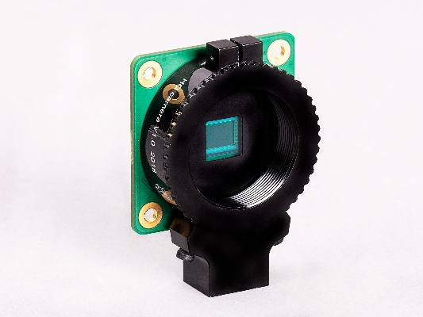

We unscrew the existing microscopes camera lens and screw it onto the HQ cameras sensor. (Warning: Do not leave sensors uncapped for a long time, this can cause dust to accumulate inside of them.)

## Raspberry Pi 4

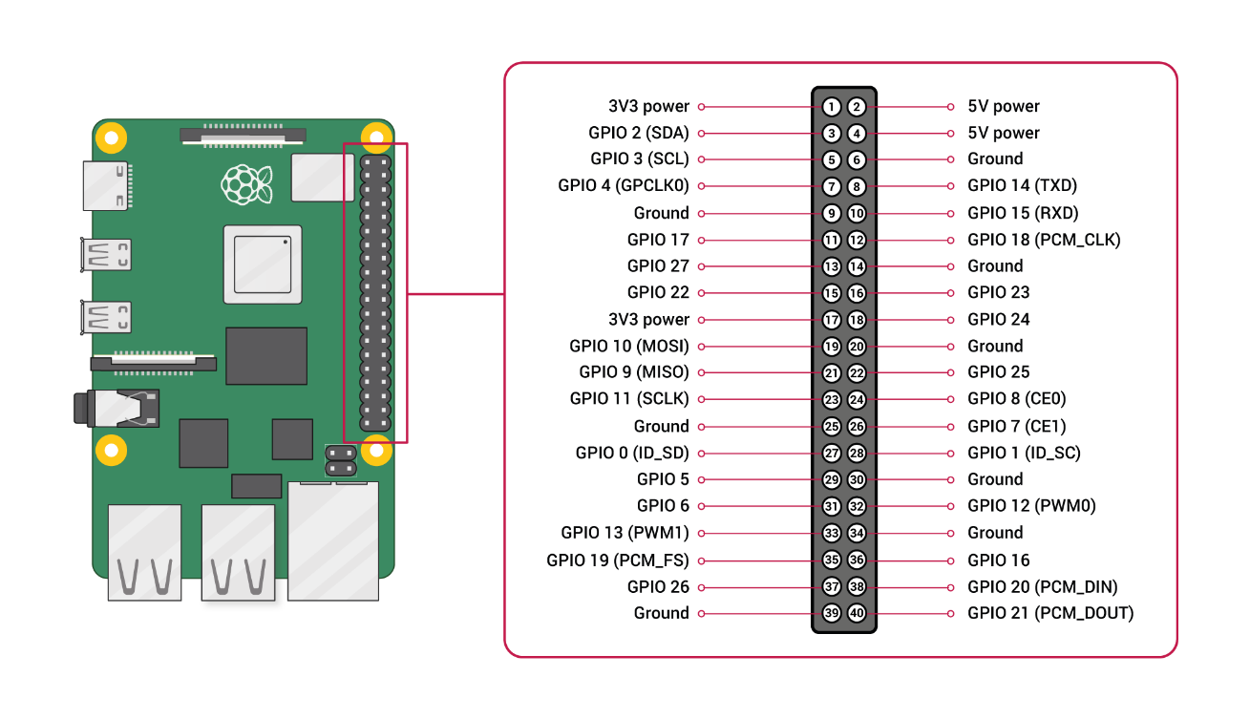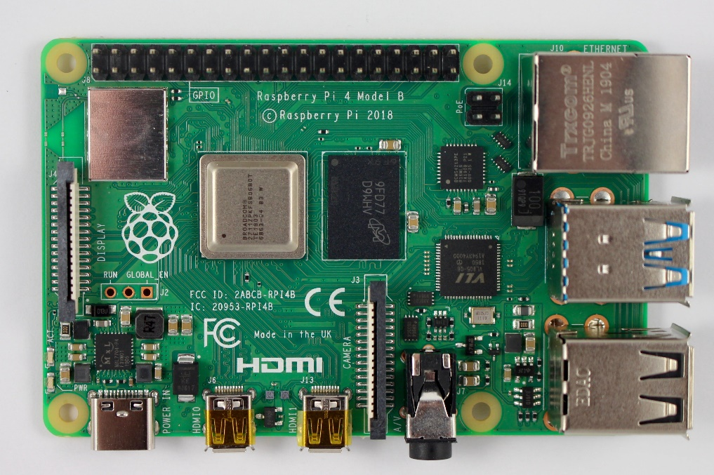

Camera Connector

Power Connector

This computer connects everything together. The pins on the right are what we are going to use to connect the Raspberry Pi to the motors and provide 5V power.

# Connections

## Motors

The circuit and its case have been designed to be user friendly so making connections can be as easy as possible. Each motor connection has a label for its corresponding position where X, Y and Z are for the X axis motor, Y axis motor and focus stage motor of the microscope. And 1,2 and 3 are for the 3 pressure regulators.

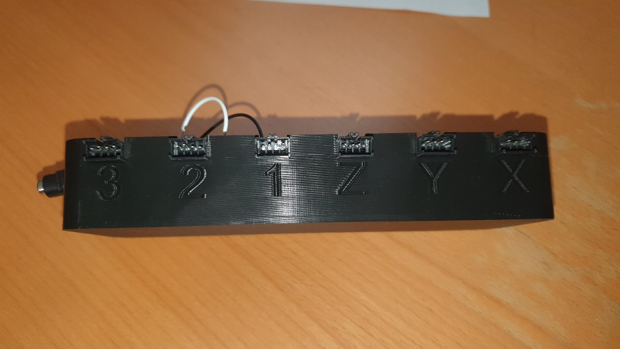

The motor cables should be inserted so that the color of the motor wires match the color of the connecting wire (Black on the right and blue on the left)

## Power

There is a DC power connector on the bottom of the circuit. This should be connected to the 12V power supply. (Note: plug in the power supply before booting the Raspberry Pi)

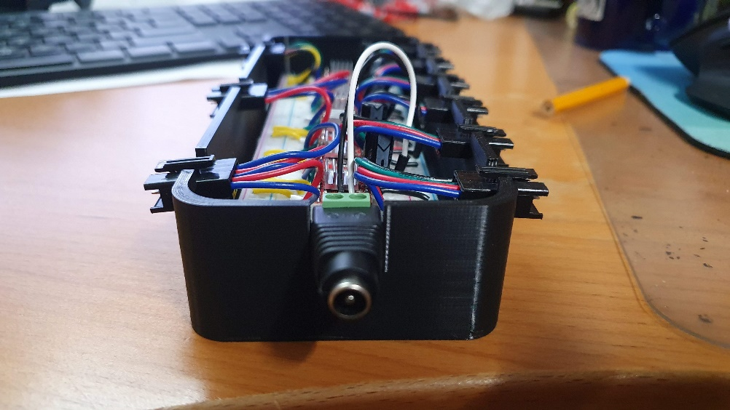

## Data Connections

There are three 5-pin connectors on the left side of the circuit case which connect to the Raspberry Pi for communication.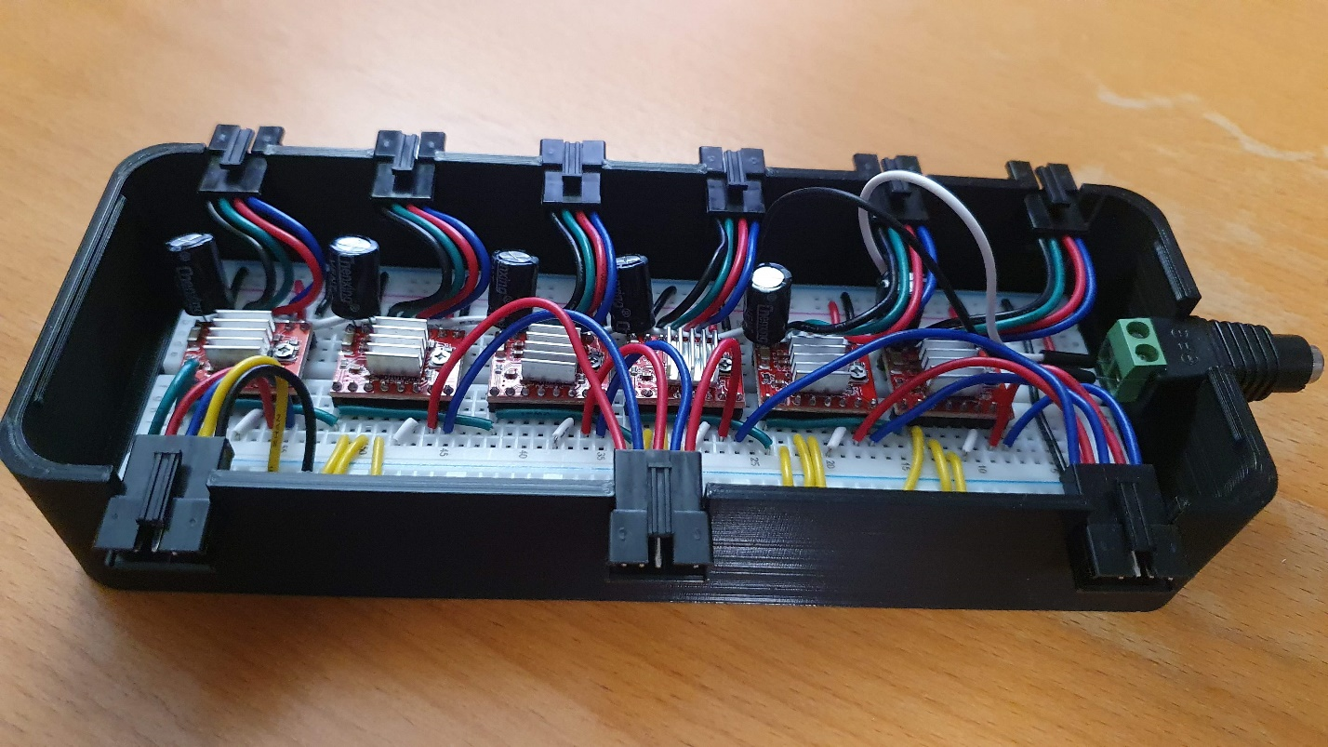

### Left Connector

* Green Wire – Connects the enable pin to pin 4 on the Raspberry Pi
* Red Wire – Connects the X axis step pin to pin 19 on the Raspberry Pi
* Blue Wire – Connects the X axis direction pin to pin 26 on the Raspberry Pi
* Yellow Wire – Connects the 5V power rail to the 5V pin on the Raspberry Pi
* Black Wire – Connects the common ground power rail to the GND pin on the Raspberry Pi

### Middle Connector

* Red Wire – Connects the Y axis step pin to pin 20 on the Raspberry Pi
* Blue Wire – Connects the Y axis direction pin to pin 21 on the Raspberry Pi
* Red Wire – Connects the Z axis step pin to pin 5 on the Raspberry Pi
* Blue Wire – Connects the Z axis direction pin to pin 6 on the Raspberry Pi
* Red Wire – Connects the 1st pressure regulator step pin to pin 7 on the Raspberry Pi

### Right Connector

* Blue Wire – Connects the 1st pressure regulator direction pin to pin 1 on the Raspberry Pi
* Red Wire – Connects the 2nd pressure regulator step pin to pin 25 on the Raspberry Pi
* Blue Wire – Connects the 2nd pressure regulator direction pin to pin 8 on the Raspberry Pi
* Red Wire – Connects the 3rd pressure regulator step pin to pin 23 on the Raspberry Pi
* Blue Wire – Connects the 3rd pressure regulator direction pin to pin 24 on the Raspberry Pi

The pin numbering on the Raspberry Pi are not intuitively laid out. A picture of the pins and its numbering are shown in the previous section for an easy lookup.

## Camera

After mounting the camera onto the microscope, the ribbon cable needs to be connected to the Raspberry Pi’s camera port. A picture of this port can be found in the previous section.

## Raspberry Pi

The last thing that should be connected is the Raspberry Pi USB-C power cable. The cable included in the Canakit bundle has a button which can act as a power switch, so that we do not need to pull cables.

**Warning: Never unplug a Raspberry Pi when it is turned on. Never plug or unplug the camera, motors, or power cables from the circuit when the Raspberry Pi is connected through the three 5-pin data connectors. This can corrupt the memory on the Raspberry Pi and make it useless.**