Interface Usage and Software Guide

This guide goes through how to use the interface and how the software works.

# Connecting to the Raspberry Pi

**This section is subject to change depending on channels IST allows for connections with the Raspberry Pi**

There are two ways that users can connect to the Raspberry Pi. Each of the two methods need to be tested since we are not sure which method is smoother on MIT WiFi

## VNC Viewer

The Raspberry Pi has VNC preinstalled on it which allows users to connect to it directly. Users can install Real VNC on their desktop and log in with predefined credentials. They can then share their screen which allows other students to see the control interface.

## Zoom

The lab can use Real VNC to login to the Raspberry Pi and give students remote control of the screen. This method would be more streamlined since it does not require students to download 3rd party software and login/logout to change users. In practice, it would be like using the SEM interface virtually.

# Before Startup

Before starting the program, make sure that the microscope lens is on the top left corner of the slide and the focus stage is as close as possible to the slide. This will allow the software to give the most accurate positional readout.

# Software Functionality

Once the program has been started, there should be around a five second delay before anything happens. During those five seconds, the stage is moving to the center of the slide. After that, you should see two windows pop up as seen in the picture below.

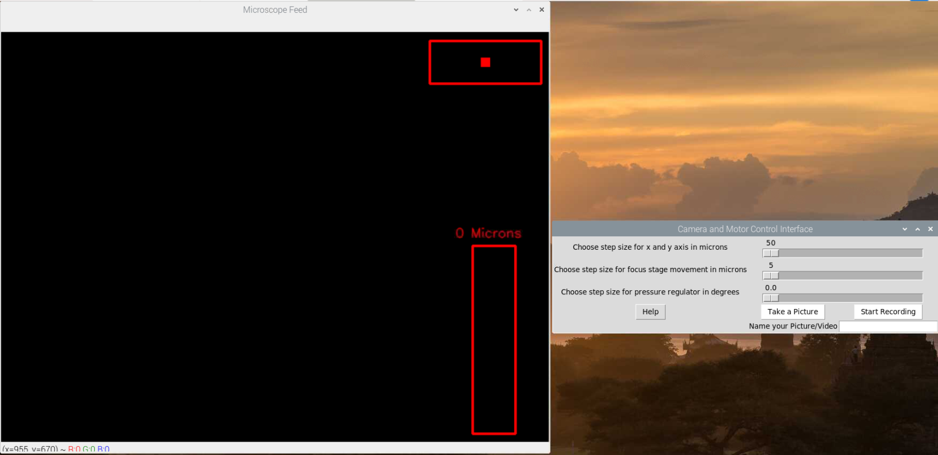

The window on the left will show the feed from the microscope along with the position readout. The top rectangle shows a visual representation of the X and Y position of the camera on the slide. The bottom bar shows a visual representation of how much Z distance has been covered when moving the focus stage. There is also a readout of the Z distance covered in microns. **This distance is as accurate as I can calculate it with given tools at home. I will include a section on how to modify the code if more accurate values can be found.**

The window on the right gives us control of the microscope motors and capturing pictures/videos

The 3 sliders allow us to vary the movement observed with a single click of the keyboard button. Before taking a picture or a video, name the file otherwise it will not save. The help button has all the keyboard inputs written in it for easy reference. Pictures are taken at an exposure of 66.67ms.

The keyboard inputs are:

* Up Arrow – Moves the Y axis down by selected step size
* Down Arrow – Moves the Y axis up by selected step size
* Left Arrow – Moves the X axis right by selected step size
* Right Arrow – Moves the X axis left by selected step size
* W Key – Moves the focus stage up by the selected step size
* S Key – Moves the focus stage down by the selected step size
* Q Key – Moves the focus stage up by one micron
* A Key – Moves the focus stage down by one micron
* R Key – Moves the 1st pressure regulator to the right by selected step size
* F Key – Moves the 1st pressure regulator to the left by selected step size
* T Key – Moves the 2nd pressure regulator to the right by selected step size
* G Key – Moves the 2nd pressure regulator to the left by selected step size
* Y Key – Moves the 3rd pressure regulator to the right by selected step size
* H Key – Moves the 3rd pressure regulator to the left by selected step size
* ESC Key – Initiates the shutdown procedure

Note: When naming your picture/video files, the motors can move if any of the above keyboard buttons are pressed. You can move the motors/pressure regulators back to the original position after naming the file.

Once you are done using the microscope, pressing the escape key will begin the shutdown procedure. This is where the X, Y and Z axis moves back to their initial position which can take between 5 – 10 seconds. After that, you can press the close button on the interface to end the program.

The Python console will give a readout of the action made so users can see if their keyboard presses are registered.

# Bugs

There are a couple of bugs that have been noted in the software. Below is a list of them which could be seen with regular usage.

* Duplicate file names – When saving a picture, there could be an empty video file that automatically saves with the same name.
* Drifting Coordinates – After using the X, Y and Z tracker for a while without restarting the program, it may seem like there is an error accumulating in the coordinates. This would be because stage and the focus travel distances were calculated by hand and could be off by a couple of micrometers.
* Y Axis lacks movement sometimes – The Y axis can seem like it is not responding correctly when changing direction, this is due to the stage holder flexing. This artifact has been minimized with the inclusion of the stage balancer, but this is one of the limitations of using low stiffness 3D printer filament.
* Errors popping up in the console – The python console may show various errors. This is due to the way the program has been written. These errors can be ignored if the program is working as intended.