IT5092 – Neuroscience and Neurocomputing
Lab Sheet 7 – Neuronal Decoding and Encoding
Student ID: MS26910222
Code files submitted: week1_bayesian_decoder.py, week1_tuning_curve.py, week2_population_vector.py (all TODOs completed), plus experiments_for_questions.py, which runs the extra experiments (noise and neuron-count sweeps, uniform priors) used to answer the questions. All results use SEED = 42 from config.py.

Exercise 1 – Bayesian Decoder

Results table (even spike counts)
R | P(Left|R) | P(Fwd|R) | P(Right|R) | MAP
0 | 0.963 | 0.037 | 0.000 | Left
2 | 0.894 | 0.105 | 0.000 | Left
4 | 0.736 | 0.263 | 0.001 | Left
6 | 0.475 | 0.516 | 0.008 | Forward
8 | 0.224 | 0.740 | 0.036 | Forward
10 | 0.080 | 0.800 | 0.120 | Forward
12 | 0.022 | 0.672 | 0.306 | Forward
14 | 0.005 | 0.418 | 0.577 | Right
16 | 0.001 | 0.192 | 0.807 | Right
18 | 0.000 | 0.073 | 0.927 | Right
20 | 0.000 | 0.025 | 0.975 | Right

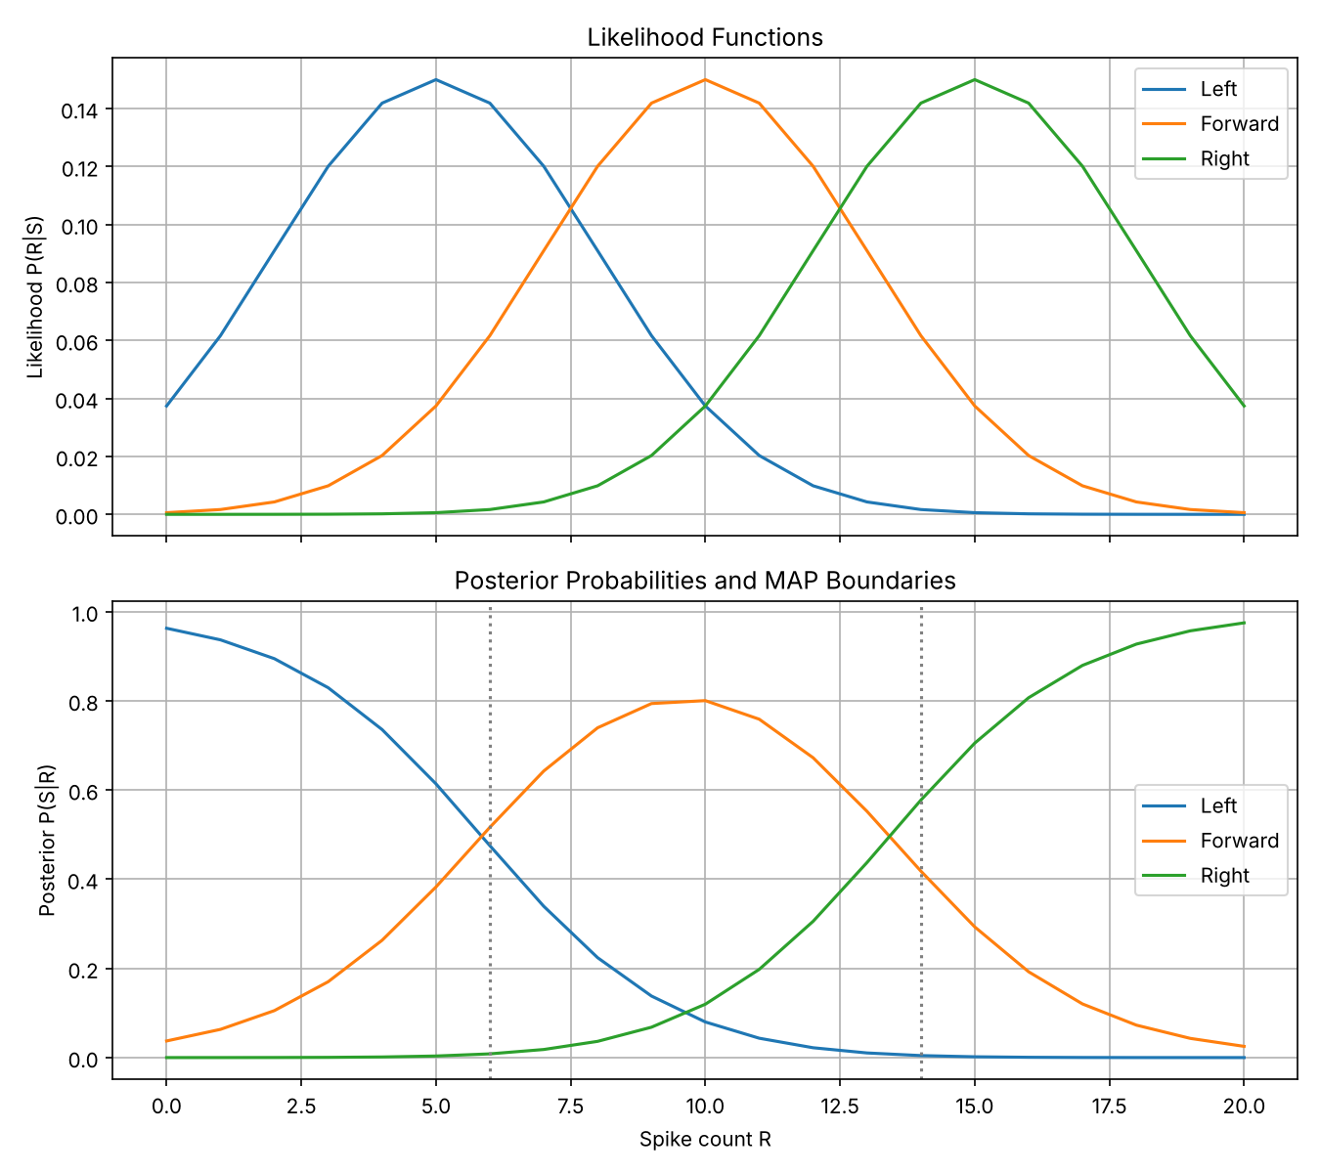
Figure 1 – Likelihood functions (top) and posterior probabilities with MAP decision boundaries (bottom)
Q1 Where do decision boundaries occur?
Decision boundaries are where the MAP decision switches from one stimulus to another, i.e. where two posteriors are equal. On the integer spike-count grid the decision changes from Left → Forward at R = 6 and from Forward → Right at R = 14 (the dotted lines in Figure 1).
Solving P(R|S₁)P(S₁) = P(R|S₂)P(S₂) for the Gaussian likelihoods gives the exact crossing points R ≈ 5.85 (Left/Forward) and R ≈ 13.42 (Forward/Right). If the priors were equal, the boundaries would sit exactly halfway between the likelihood peaks (7.5 and 12.5). Here they are not, which shows the priors are moving them.
Q2 How do priors affect results?
The posterior is likelihood × prior, so the prior adds weight to each stimulus. Forward has the largest prior (0.50), so its decision region is widened: it wins for R = 6 to 13 instead of 8 to 12 under uniform priors. Left has the smallest prior (0.20), so its region shrinks: its boundary moves from 7.5 down to 5.85. Right (0.30) is in between, so the Forward/Right boundary moves from 12.5 to 13.42. The priors also change how confident the decoder is. With the actual priors P(Forward|R=10) = 0.80, while with uniform priors it would be only 0.67.
Priors matter most where the likelihoods overlap and the evidence is ambiguous (around R ≈ 6–8 and 12–14). At the extremes (R = 0 or 20) the likelihood dominates and the prior barely changes the answer.
Q3 Is the decoder confident at spike count = 10?
Fairly confident, but not certain. At R = 10 the posteriors are P(Left) = 0.080, P(Forward) = 0.800 and P(Right) = 0.120, so the decoder picks Forward with 80% probability. R = 10 is exactly the peak of the Forward likelihood and Forward also has the largest prior, so this is the most confident Forward decision across all spike counts. Still, about 20% of the probability is on the other two stimuli because the likelihood curves (σ = 3) overlap heavily, so there is roughly a 1-in-5 chance of being wrong. That is much less confident than at the extremes (0.963 at R = 0, 0.975 at R = 20).

Exercise 2 – Gaussian Tuning Curve Fitting
Program output (noise_std = 6 Hz): A = 49.72, μ = 88.80, σ = 24.62, b = 5.18, R² = 0.9965
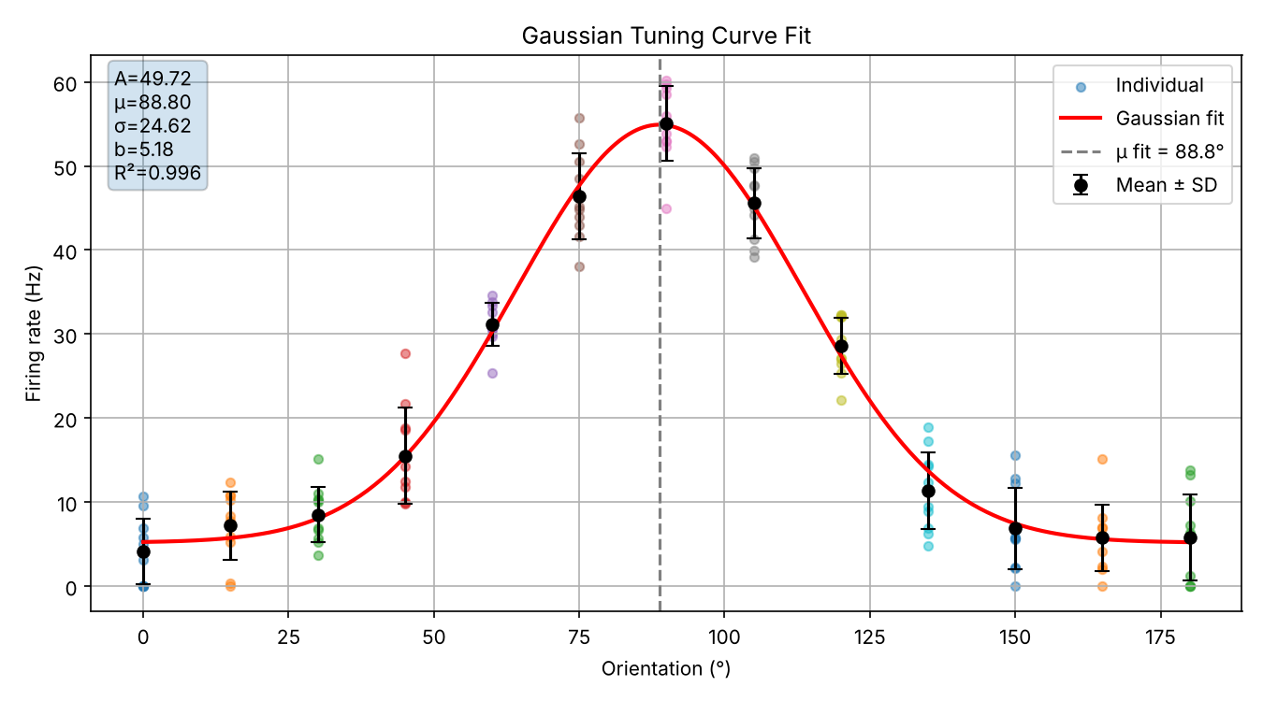
Figure 2 – Individual trials, mean ± SD and fitted Gaussian tuning curve (noise_std = 6 Hz)
Q1 Record your fitted parameters and compare them to the true values.
Parameter | True value | Fitted value | Absolute error
A (amplitude, Hz) | 50.0 | 49.72 | 0.28
μ (preferred orient., °) | 90.0 | 88.80 | 1.20
σ (width, °) | 25.0 | 24.62 | 0.38
b (baseline, Hz) | 5.0 | 5.18 | 0.18

All four fitted parameters are within about 1–5% of the true values. The largest absolute error is in μ (1.2°), which is small next to the 15° sampling step of the orientations. The small errors come from the random trial-to-trial noise, from averaging only 10 repetitions per orientation, and from clipping negative rates to zero.
Q2 What is your R² value? What does it mean in the context of tuning curve fitting?
R² = 0.9965. R² is the fraction of the variance in the mean firing rates (across orientations) that the fitted Gaussian explains: R² = 1 − SS_res / SS_tot. A value of 0.9965 means the Gaussian accounts for about 99.6% of the variation in the neuron's mean response, and only about 0.4% is left as residual error. In tuning-curve terms, the neuron's orientation selectivity is very well described by a single Gaussian with a preferred orientation near 90° and a width of about 25°. Note that R² is computed on the trial-averaged means. It does not mean single trials are this predictable, because individual trials still vary by about ±6 Hz.
Q3 Increase noise_std to 20 Hz and re-run. How do the fitted parameters and R² change?
Parameter | True | Fit (6 Hz) | Fit (20 Hz) | |Error| (20 Hz)
A (Hz) | 50.0 | 49.72 | 45.61 | 4.39
μ (°) | 90.0 | 88.80 | 86.67 | 3.33
σ (°) | 25.0 | 24.62 | 23.09 | 1.91
b (Hz) | 5.0 | 5.18 | 8.92 | 3.92
R² | – | 0.9965 | 0.9725 | –

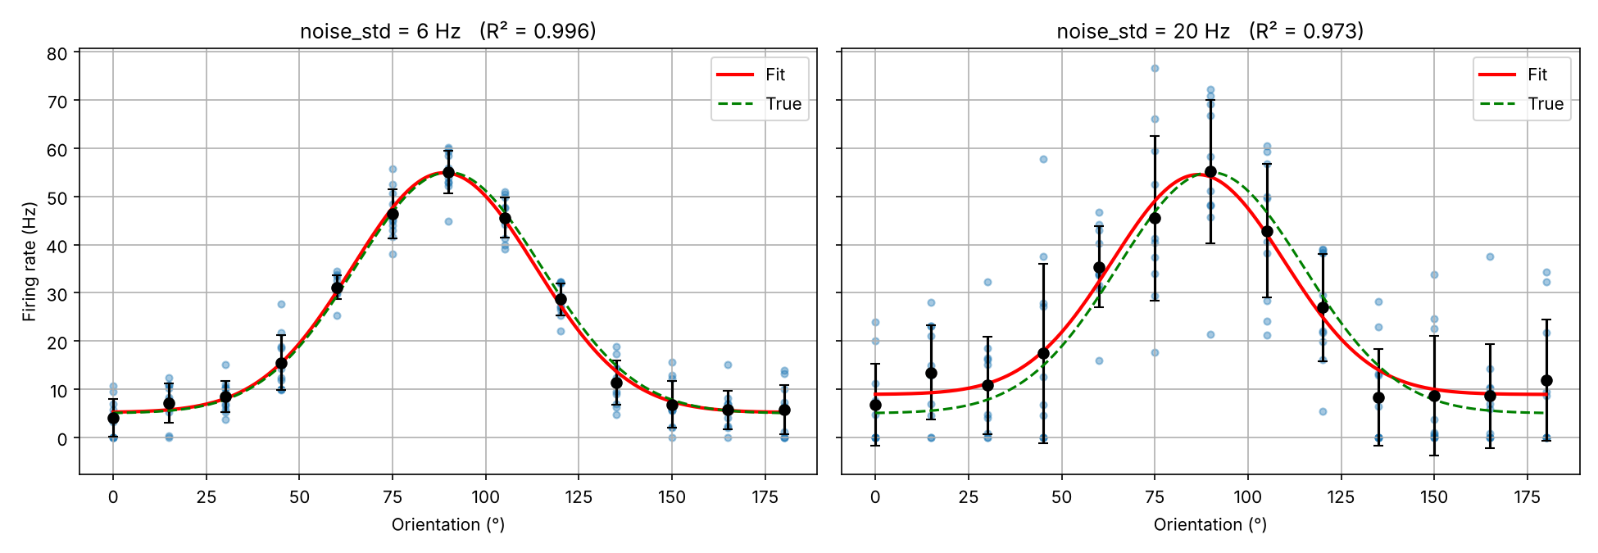
Figure 3 – Fit at noise_std = 6 Hz vs 20 Hz (green dashed = true curve, red = fit)
With 20 Hz noise the scatter of the individual trials and the error bars are much larger, and the fit becomes less accurate. Every parameter moves further from its true value: amplitude is underestimated (45.6 vs 50), the preferred orientation shifts by about 3°, the width narrows slightly, and the baseline is clearly overestimated (8.9 vs 5 Hz). R² falls from 0.9965 to 0.9725, so the model now leaves about 2.8% of the variance in the means unexplained instead of 0.4%.
The baseline bias is systematic, not just random. Near the tails the true rate is only about 5 Hz, so with SD = 20 Hz many noisy samples are negative and get clipped to 0. This pushes the mean rates upward at low-firing orientations, which inflates b and, in turn, reduces the fitted amplitude A. To check this was not a one-off result, I averaged over 200 random seeds. The mean absolute errors grew from (A 1.3, μ 0.6, σ 0.8, b 0.8) at 6 Hz to (A 5.9, μ 2.0, σ 2.8, b 5.5) at 20 Hz, and the mean R² dropped from 0.993 to 0.931.

Exercise 3 – Population Vector Decoding
Program output (N = 8 neurons, noise SD = 0.05): mean absolute error = 1.71°, max absolute error = 6.08° (at 285°).
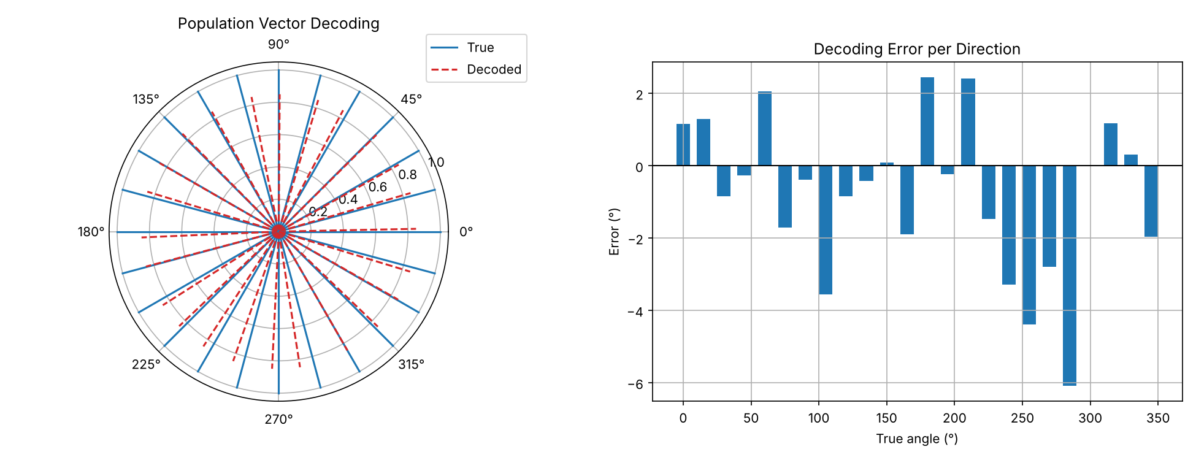
Figure 4 – True (blue) vs decoded (red dashed) directions, and signed decoding error per direction
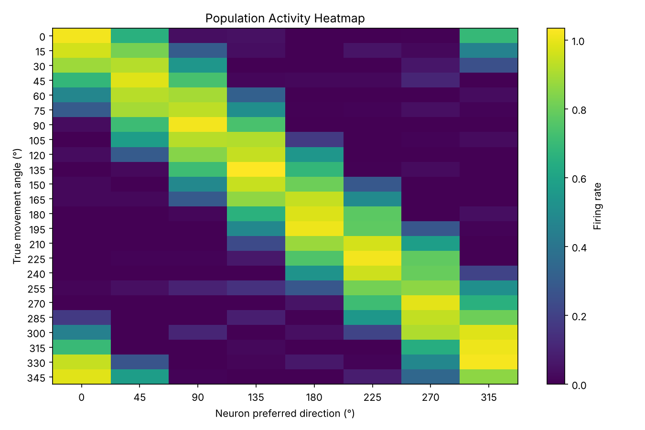
Figure 5 – Population activity heatmap (rows = movement direction, columns = neurons)
Q1 What is your mean average decoding error?
The mean absolute decoding error is 1.71° (maximum 6.08°) for 24 test directions with 8 neurons and noise SD = 0.05. The errors are small and have no consistent sign (Figure 4), so they come from the random noise and not from a bias in the decoder. Without noise the error is 0°: with 8 uniformly spaced, rectified-cosine neurons the population vector points exactly in the movement direction. Averaged over 200 repeated noise trials, the mean error is about 1.87°.
Q2 How does neuron count affect accuracy?
Neurons (N) | 4 | 6 | 8 | 16 | 32 | 64 | 128
MAE (°) | 2.57 | 2.12 | 1.87 | 1.34 | 0.95 | 0.66 | 0.47
Noise SD = 0.05, averaged over 200 trials × 24 directions
More neurons give more accurate decoding. The error falls roughly as 1/√N: doubling the population cuts the error by about 30%, and going from 8 to 128 neurons reduces it about 4×, from 1.87° to 0.47°. Each neuron's noise is independent, so when many neurons' contributions are summed into the population vector the noise partly cancels, while the signal adds up coherently. A denser set of preferred directions also covers the circle more evenly. With too few neurons the method breaks down even without noise. With only 3 rectified-cosine neurons the noiseless error is about 17°, because rectification leaves gaps in coverage. With 4 or more evenly spaced neurons the noiseless decoder is exact.
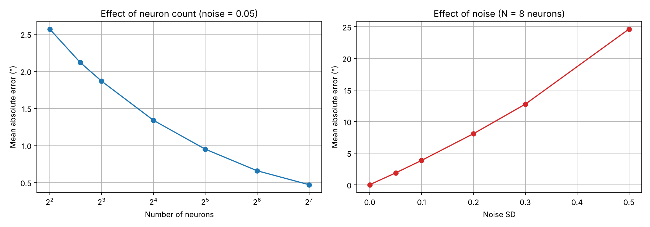
Figure 6 – Mean absolute decoding error vs number of neurons (left) and vs noise level (right)
Q3 How does noise affect decoding?
Noise SD | 0.00 | 0.05 | 0.10 | 0.20 | 0.30 | 0.50
MAE (°) | 0.00 | 1.87 | 3.84 | 8.07 | 12.74 | 24.63
N = 8 neurons, averaged over 200 trials × 24 directions
Decoding error grows roughly in proportion to the noise level: doubling the noise SD roughly doubles the mean error. With no noise the decoder is perfect. At SD = 0.05 (5% of the peak rate) it is accurate to about 2°. At SD = 0.5 (half the peak rate) the error reaches about 25°, and individual trials can be off by much more. Noise adds a random vector to the population vector and rotates its direction, and it also makes "silent" neurons fire spuriously so they pull the vector toward the wrong directions. Clipping rates at zero means this spurious activity is always positive, which adds a further distortion at high noise. Larger populations (Q2) are the main way to counteract this.

Reflection Questions
Q1 Which of the three approaches is most biologically plausible? Justify your answer.
Population vector decoding is the most biologically plausible. It needs only operations neurons can actually do: each cell's firing rate is multiplied by a fixed weight (its preferred-direction vector, which can be stored in synaptic weights) and the results are summed. A downstream neuron or layer can implement this weighted sum directly. It works on a single trial, uses many noisy neurons together, and degrades gracefully when some cells are lost. It is also based on real data. Georgopoulos et al. (1982, 1986) showed that the population vector from motor cortex neurons with cosine tuning predicts arm-movement direction, and the same idea is used in brain–computer interfaces.
The Gaussian tuning curve is an encoding model. It describes how a neuron responds, which is biologically realistic as a description of V1 orientation cells, but fitting it with curve_fit over many repeated trials is something the experimenter does, not the brain. Bayesian decoding is the statistically optimal reference point, and behavioural experiments suggest the brain often combines prior and evidence in a Bayes-like way (the "Bayesian brain" idea). However, an explicit Bayesian decoder needs full likelihood functions, normalization over all stimuli and stored priors, which is hard to implement exactly in neurons. It is better seen as a normative model of what the brain should compute, while the population vector is a plausible mechanism for how it could compute it.
Q2 How would population vector decoding behave if the number of neurons increased significantly, or if neurons had non-uniform preferred directions? What challenges arise in real neural populations?
Many more neurons: Accuracy improves because independent noise averages out (error ∝ ~1/√N; 128 neurons gave 0.47° vs 1.87° for 8). The gains shrink as N grows, and in real brains noise is often correlated between neurons, which cannot be averaged away, so accuracy levels off instead of approaching zero.
Non-uniform preferred directions: The basic population vector assumes preferred directions are spread evenly around the circle. If they cluster, the decoded vector is pulled toward the over-represented directions, creating a systematic bias, and directions with few neurons are decoded poorly. In a test with 8 neurons clustered between 0° and 90° and no noise, the mean error rose to about 40°, and 7 of the 24 directions could not be decoded at all because every neuron was silent. Solutions include weighting each neuron by the inverse of its local density, or using an optimal linear estimator or a maximum-likelihood/Bayesian decoder, which corrects for uneven sampling.
Challenges in real neural populations:
- Spike counts are Poisson-like, so the noise grows with the firing rate and is not simple Gaussian noise of fixed size.
- Noise is correlated across neurons, which limits how much averaging helps.
- Real tuning curves are not perfect cosines. They have different widths, amplitudes and baselines, and some neurons are tuned to several variables (speed, force, position) or are untuned.
- Preferred directions can drift over days (representational drift), so decoders need recalibrating.
- Electrodes record only a small, biased sample of neurons, and recordings include spike-sorting errors and lost units.
- Activity is dynamic: tuning changes over the course of a movement, so a static decoder misses time-varying information.
Q3 The Gaussian tuning curve was fitted using simulated data. How might the model need to change when applied to real neural recordings?
- Circular stimulus space: Orientation repeats every 180° (and direction every 360°), so a plain Gaussian is wrong at the edges. A wrapped Gaussian or a von Mises function, f(θ) = A·exp(κ·(cos(2(θ−μ)) − 1)) + b, handles this correctly.
- Realistic noise model: Real spike counts are non-negative integers whose variance grows with the mean (Poisson or over-dispersed). Instead of least squares with constant Gaussian noise, the fit should use Poisson or negative-binomial maximum likelihood, or at least weight each point by its variance.
- More flexible shape: Real tuning curves can be asymmetric, have a second peak 180° away (direction-selective cells), or saturate at high firing rates. A sum of two Gaussians, an asymmetric Gaussian, or a nonlinear output function may be needed.
- Other variables: Responses also depend on contrast, spatial frequency, attention, adaptation and time. Gain terms (e.g. contrast-dependent amplitude) or time-resolved models (e.g. a GLM with spike history) may be needed.
- Fitting robustness and validation: Real data are limited and noisier, so the model needs sensible starting values and parameter bounds (σ > 0, A ≥ 0, b ≥ 0), cross-validation instead of R² on the same data, confidence intervals for the parameters (e.g. via bootstrapping), and comparison against simpler or more complex models (AIC/BIC). Trial-to-trial variability, drift in the recording and spike-sorting quality also need to be checked.

