IT5092 – Neuroscience and Neurocomputing
Lab Sheet 9 – Information-Theoretic Analysis of Neural Responses
Student ID: MS26910222
Code files submitted: entropy_utils.py, mutual_information.py, spike_train_analysis.py, coding_efficiency.py (all TODOs completed) and lab08_information.ipynb (every task cell completed and run, with outputs saved). Entropy and mutual information are measured in bits (log base 2).

Exercise 1 – Entropy of Neural Responses
Spike distribution | Entropy H(R)
Original [0.5, 0.25, 0.25] | 1.5000 bits
Modified [0.95, 0.05] | 0.2864 bits

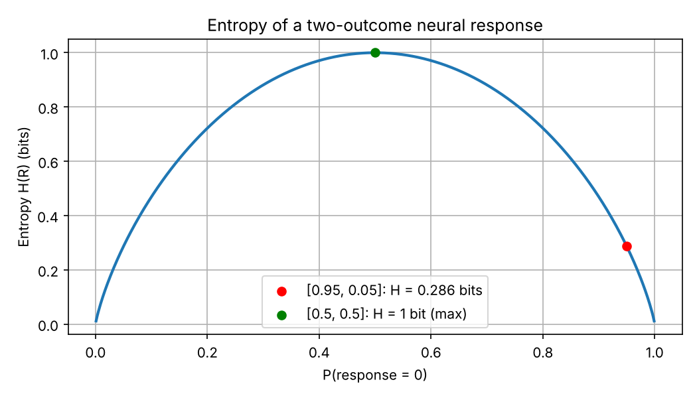
Figure 1 – Entropy of a two-outcome response as a function of P(response = 0)
Q1 How does the entropy value change compared to the original distribution? Does a skewed distribution carry more or less uncertainty?
The entropy falls from 1.5 bits to 0.286 bits, about 81% less. The skewed distribution carries less uncertainty. With P = 0.95 the neuron almost always gives the same response, so its output is highly predictable and each response tells us very little that is new. Entropy H = −Σ p·log₂p is largest when outcomes are equally likely (1 bit for two outcomes, Figure 1) and falls towards 0 as one outcome dominates. The skewed neuron reaches only 28.6% of the maximum possible 1 bit.

Exercise 2 – Mutual Information
Noise SD | I(S;R) | Response = stimulus
0.5 (original) | 0.4264 bits | 86.4%
2.0 (modified) | 0.0517 bits | 63.3%
Seed 0, 1000 trials, H(S) = 1 bit
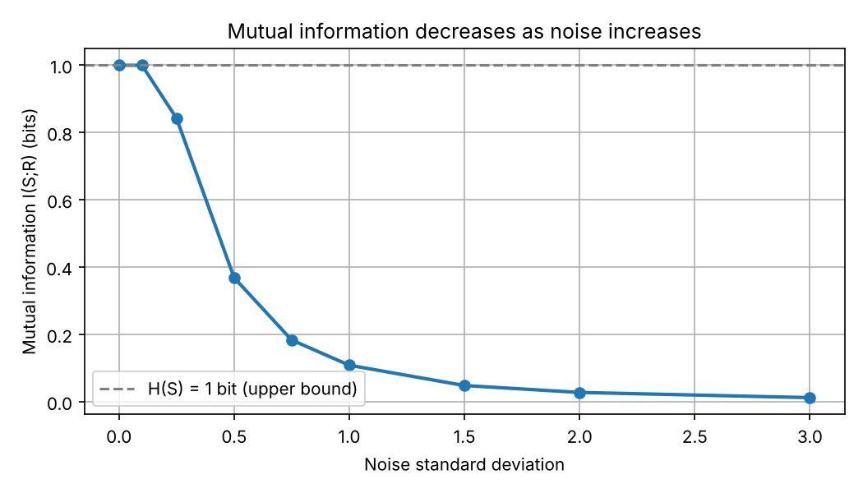
Figure 2 – Mutual information vs noise SD (mean of 20 random seeds)
Q2 Describe the effect on Mutual Information. Why does adding noise to the system decrease the information shared between stimulus and response?
Raising the noise SD from 0.5 to 2.0 cuts the mutual information from 0.43 bits to 0.05 bits, a drop of about 88%. At SD 2.0 the response is almost unrelated to the stimulus: it matches the stimulus only 63% of the time, against 50% for pure guessing. Figure 2 shows MI falling steadily from its maximum of 1 bit (= H(S)) towards 0 as noise grows.
MI can be written as I(S;R) = H(R) − H(R|S). Noise adds variability to the response that has nothing to do with the stimulus, so the noise entropy H(R|S) grows. The response distributions for stimulus 0 and stimulus 1 spread out and overlap more, so the same response can come from either stimulus. Seeing R then reduces our uncertainty about S much less, and the information shared by stimulus and response falls.

Exercise 3 – Spike Timing vs. Spike Count
Bin size | train_A binned | train_B binned | Entropy
100 ms | [3] | [3] | 0 bits
10 ms | [0 1 1 1 0 0 0 0 0 0] | [0 0 0 0 0 0 0 1 1 1] | 1 bit

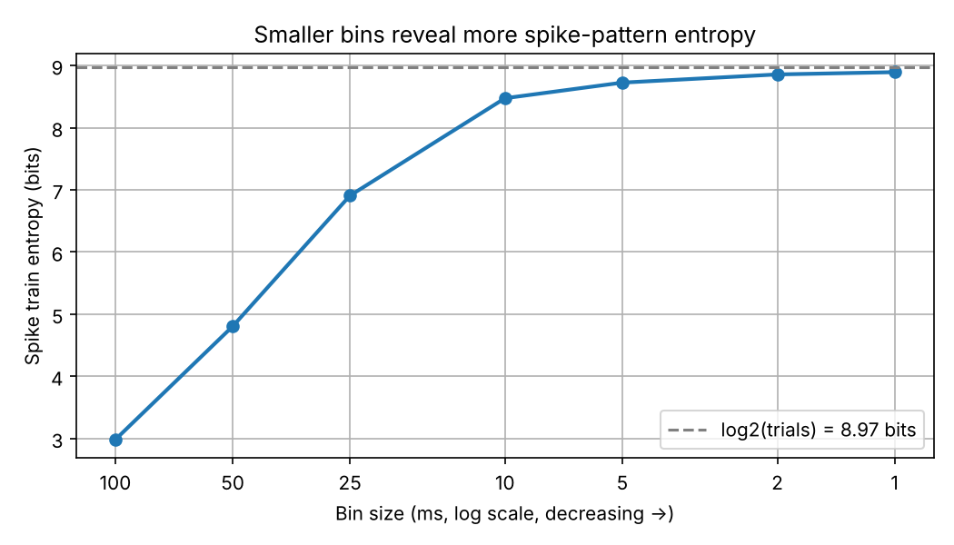
Figure 3 – Entropy vs bin size for 500 random 40 Hz spike trains of 100 ms
Q3 Explain how bin size affects spike train entropy. What happens to the 'information' when you use very large bins?
Smaller bins give higher spike train entropy. With 100 ms bins, train A (spikes at 10, 20 and 30 ms) and train B (70, 80 and 90 ms) both become the same pattern [3], so there is only one symbol and the entropy is 0 bits. With 10 ms bins the timing is kept, the two patterns differ, and the entropy is 1 bit. With 500 random spike trains (Figure 3), entropy rises from 2.98 bits at 100 ms to 8.47 bits at 10 ms and 8.89 bits at 1 ms. It levels off near log₂(500) = 8.97 bits, because with 500 trials no more than 500 distinct patterns can be seen.
With very large bins, all timing information is thrown away and the code becomes a pure spike count. Trains that differ only in when they spike become identical, so whatever a neuron encodes in spike timing (early vs late firing, here) is lost. Very small bins are not free either. They need much more data to estimate entropy reliably, and below the real precision of spike timing they mostly add noise entropy, not useful information.

Exercise 4 – Coding Efficiency
Distribution | Probabilities | Entropy | Efficiency (H / Hmax)
Uniform | [0.25, 0.25, 0.25, 0.25] | 2.0000 bits | 100.0%
Skewed | [0.7, 0.1, 0.1, 0.1] | 1.3568 bits | 67.8%
Hmax = log₂(4) = 2 bits
Q4 Which distribution is more efficient? Why would a neural system benefit from having a uniform distribution of firing rates?
The uniform distribution is more efficient. It reaches the maximum possible entropy of 2 bits for four response levels, while the skewed one reaches only 1.357 bits (67.8%), about 0.64 bits less per response. In the skewed case one response level is used 70% of the time, so most responses are predictable and the other levels go almost unused.
A neuron has a limited range of firing rates, and every spike costs energy. If it uses all its response levels equally often, every response is equally surprising and the neuron transmits the most information possible with that range. This is the idea of efficient coding (Barlow; Laughlin, 1981). The neuron's input–output curve is matched to the statistics of its inputs, so common stimulus values are spread across many firing levels and output levels are not wasted. A skewed distribution wastes capacity on responses that are almost always the same.

Critical Thinking Questions
1 Can a neuron have high entropy but low mutual information? Explain your reasoning.
Yes. Entropy measures how variable a response is. Mutual information measures how much of that variability is about the stimulus. Because I(S;R) = H(R) − H(R|S), a neuron whose variability is mostly noise has a high H(R), but its H(R|S) is almost as high, so the MI is close to zero. In my notebook demo, a neuron firing 0–3 spikes at random had H(R) = 2.0 bits but I(S;R) = 0.0002 bits. A neuron that followed the stimulus had a lower entropy (1.46 bits) but an MI of about 1 bit. High entropy is the capacity to carry information. It does not mean information is actually being carried.
2 Why does noise reduce mutual information?
Noise adds variability to the response that is independent of the stimulus. This raises the noise entropy H(R|S) and makes the response distributions for different stimuli overlap, so the response no longer identifies the stimulus reliably. Since I(S;R) = H(R) − H(R|S), a larger H(R|S) means a smaller MI. MI is also bounded by H(S), so as the noise grows the reduction in uncertainty about S shrinks towards zero. In Exercise 2, MI fell from 0.43 to 0.05 bits as the noise SD went from 0.5 to 2.0.
3 How does bin size affect spike train entropy?
Smaller bins give a finer time resolution and so more distinct spike patterns, which means higher entropy. Larger bins merge spikes into counts, so different timing patterns become the same symbol and entropy falls (from 1 bit at 10 ms to 0 bits at 100 ms for trains A and B). The right bin size is a trade-off. Bins should be small enough to capture the real precision of spike timing, but large enough that the patterns can be estimated from the limited data available. With very small bins the number of possible patterns grows very quickly, and the entropy estimate becomes limited by sample size (log₂ of the number of trials) and biased.
4 Does a higher firing rate always imply higher information transmission?
No. Information depends on how reliably the response changes with the stimulus, not on how many spikes are fired. A neuron firing at a constant high rate, or at a high rate unrelated to the stimulus, transmits almost nothing. In my demo, a random neuron averaging 50 spikes had I(S;R) = 0.006 bits. Higher rates can carry more information only when they vary with the stimulus. Even then the gains are limited:
- Spike-count noise (Poisson-like variance) grows with the rate, so neighbouring rates become hard to tell apart.
- Neurons saturate near their maximum rate, which reduces the variability of their responses.
- Spikes are metabolically expensive, so information per spike often falls as the rate rises.
This is why sparse, low-rate codes can be very informative and energy-efficient, and why the brain seems to optimise information per unit of energy, not raw firing rate.

