**Java Programming Test - Part2**

Before attempting part2 of this test you should have completed the part1 of the test [**here**](https://docs.google.com/document/d/1AjeG5poDrlv5qoUrjM3Pjd-4zusFd1f8XgsH5ycOdeI/edit)**.**

**In part2 of the test:**

1. We will build a strategy based on the local cached database built in part1
2. We will execute a buy order if buy requirement is met for an alt-coin (ex: ETH)
3. We will place a sell order if requirement met and set stop loss for the same alt-coin (ex: ETH).

**General steps in your application as a pseudo code:**

while(read-stream(from local database, XYZ/BTC)) {

If (buy-conditions(in 10s window, XYZ/BTC) == TRUE)

{

1. Place buy order 0.5% above the current average price;
2. Set a sell price to 5% above the buy price and Set stop loss to -7% below buy price
3. After 20 seconds drop the sell price to 1% above the buy price;
4. Check the executed trades (buy and sell difference) and deduce if it was a profitable or loss trade.

}

**What to code?**

1. Create a module in the application, that will be able to load the data from the database and will be able to stream the data to a handler (class that will handle the strategy) as if it was handling data from live orderbook.
2. Create a class for the following strategy for buying and selling an alt-coin.
   1. Load data of Bitcoin pairs from the database and code the following example strategy for buying based on that data
   2. Buy only when **ALL** the following requirements under are met:
      1. Bitcoin (BTC/USDT - <https://www.binance.com/en/trade/pro/BTC_USDT>) delta for last 24 hours is less than 3%
      2. Specific altcoin (Ex: ETH/BTC - https://www.binance.com/en/trade/pro/ETH_BTC) delta is less than 1.5% in the last 10 mins
      3. For a 10s window, condition#1 is met (see below for condition#1)
      4. For the same 10s window, condition#2 is also met (see below for condition#2)
   3. Set buy order for average price +0.5% [ Avg Price = (Highest Bid + Lowest Ask)/2. So, from Figure#1 and Figure#2 for ETH it is avg of 0.025949 and 0.025921 BTC ]
   4. After buying set sell price to 5% below buy price, after 20 seconds lower the sell price to 1%
   5. After buying set stop loss to -7%
3. Connect the strategy and test it with the saved data in the Database. You should be able to maintain a list of all executed orders for each alt-coin pair to see if we have made a profit or loss over a period of time.
4. Make the code as fast as possible and as readable as possible.

**Condition#1**

1. This condition focuses on live BIDs from the orderbook (though we refer to Binance screenshot here, the data has to come from local DB cache).
2. Please look at Figure#1 below, it shows live bids from an order book for ETH/BTC from Binance at a specific timestamp. The first line indicates that a buyer of ETH is willing to pay 0.025949 BTC for each ETH. So, for 0.467 ETH (that he wants to buy) a total value of 0.01211818 BTC. In this live order book this is the highest/top bid value.
3. Lets calculate top 3% bids (top 3% of buy values) and their volume in BTC.
   1. The top buy (bid) value is 0.025949 BTC.
   2. The 97% value of top bid price i.e., 97% of 0.025949 is 0.02517053 BTC.
   3. Add up all the BTC volume [column 3 below - “Total (BTC)”] of the top 3% Bids i.e., Add up all the BTC volume between bids 0.025949 (100%) and 0.02517053 (97%). If the BTC volume is at least 3BTC, then start the 10s window.
4. For a continuous 10s window if BTC volume is 3BTC then the condition#1 is met.

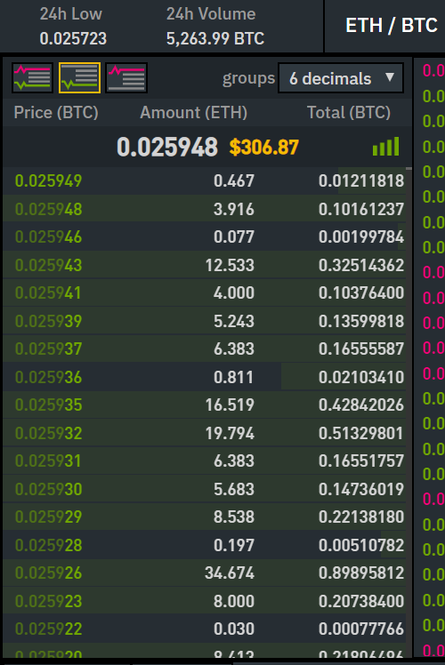

***Figure#1:*** *Live bids for ETH/BTC from Orderbook*

**Condition#2**

1. This condition focuses on the live asks from the orderbook. (though we refer to Binance screenshot here, the data has to come from local DB cache).
2. Please look at Figure#2 below, it shows live asks from an order book for ETH/BTC from Binance at a specific timestamp. The last line indicates that a seller of ETH is willing to accept 0.025921 BTC for each ETH. In this live order book this is the lowest/top ask value. So, for 4.016 ETH (that he wants to sell) a total value of 0.10409874 BTC.
3. Lets calculate top 3% asks (top 3% of ask values constitute the last 3% of the asking prices) and their volume in BTC
   1. The best ask price is 0.025921 BTC.
   2. Lets calculate 103% value of best ask price i.e., 103% of 0.025921 it will be 0.02669863 BTC.
   3. Add up all the BTC volume [column 3 below - “Total (BTC)”] of the top 3% Asks i.e., Add up all the BTC volume between asks 0.025921 (100%) and 0.02669863 (103%). If the BTC volume is at least 3BTC, then start the 10s window
4. For a continuous 10s window, if the BTC volume of bids from condition#1 is 4x or higher than the BTC volume of asks calculated above then condition#2 is met.

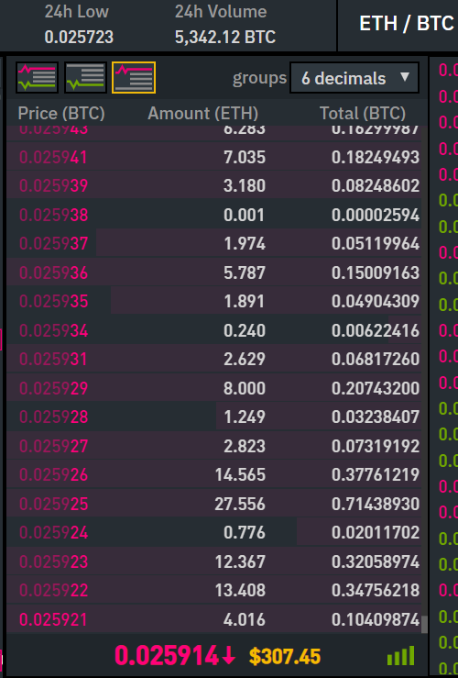

***Figure#2:*** *Live asks for ETH/BTC from Orderbook*

**FAQ:**

1. **Bid vs Ask:** The term *bid and ask* (also known as *bid and offer)* refers to a two-way price quotation that indicates the best price at which a security can be sold and bought at a given point in time. The [bid price](https://www.investopedia.com/terms/b/bidprice.asp) represents the **maximum** price that a buyer is willing to pay for a security. The [ask price](https://www.investopedia.com/terms/a/ask.asp) represents the **minimum** price that a [seller](https://www.investopedia.com/terms/s/seller.asp) is willing to receive. A trade or transaction occurs after the buyer and seller agree on a price for the security.
2. **Spread:** The difference between the bid and ask prices, or the spread, is a key indicator of the [liquidity](https://www.investopedia.com/terms/l/liquidity.asp) of the asset
3. Bid orders are listed from highest (preferred) to lowest (least preferred) bid values
4. Ask orders are listed from lowest (preferred) to highest (least preferred) ask values