# Installing and setting up Kubernetes Minikube

## Update system packages and Install dependencies
```bash
sudo apt update && sudo apt upgrade -y
sudo apt install -y curl wget apt-transport-https conntrack socat
```
## Install Docker, Kubectl and Minikube
### Install Docker
```bash
sudo apt install -y docker.io
sudo systemctl start docker
sudo systemctl enable docker
docker --version
```

### Install Kubectl
```bash
curl -LO "https://dl.k8s.io/release/$(curl -L -s https://dl.k8s.io/release/stable.txt)/bin/linux/amd64/kubectl"
chmod +x kubectl
sudo mv kubectl /usr/local/bin/
kubectl version –client
```

### Install Minikube
```bash
curl -LO https://storage.googleapis.com/minikube/releases/latest/minikube-linux-amd64
sudo install minikube-linux-amd64 /usr/local/bin/minikube
minikube version
```
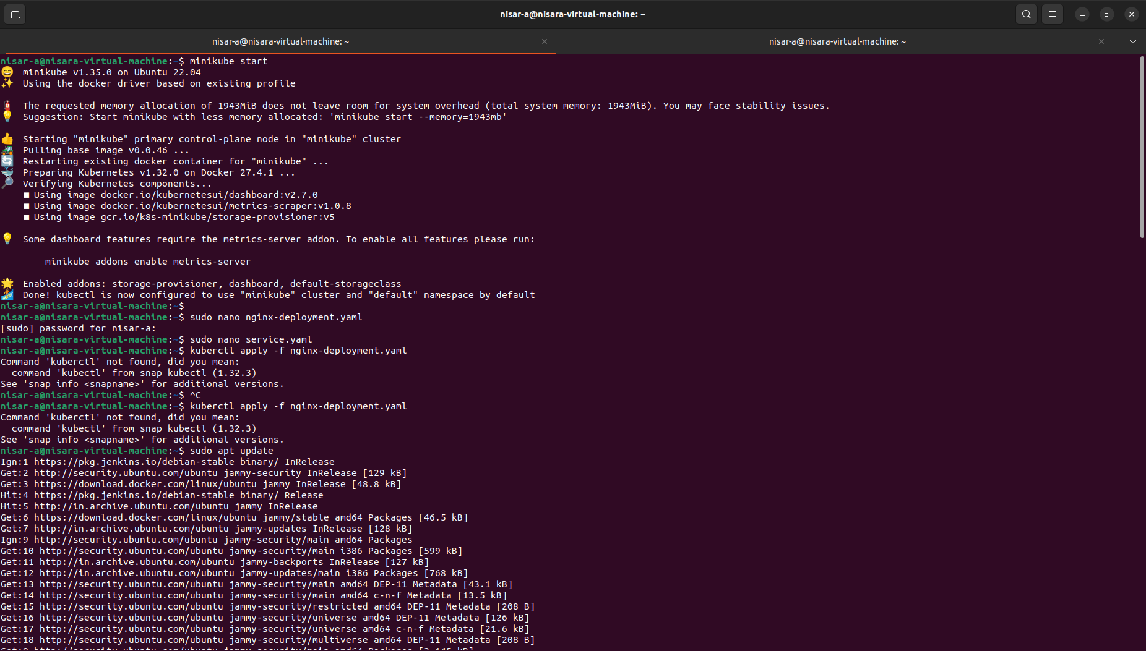
### Fix Docker setup
```bash
sudo usermod -aG docker $USER
reboot
```
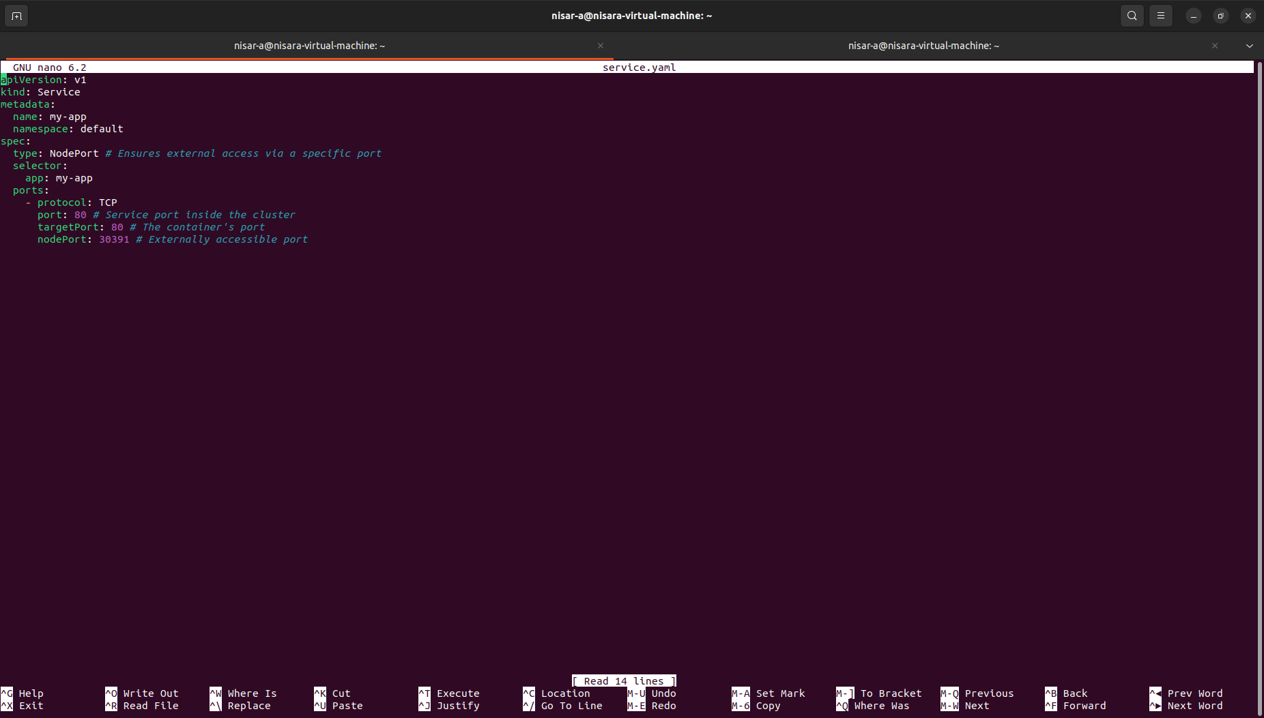
### Verify Installation after reboot
```bash
docker run hello-world
```
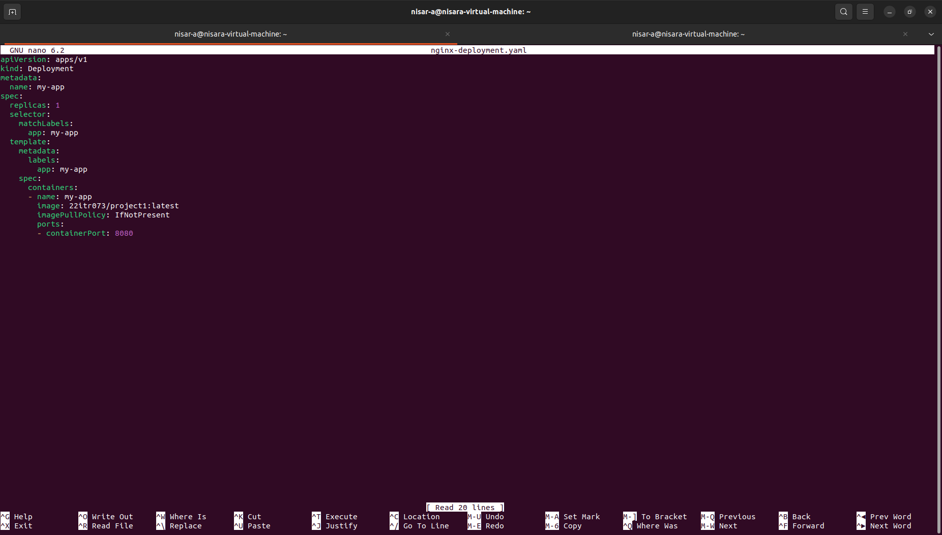

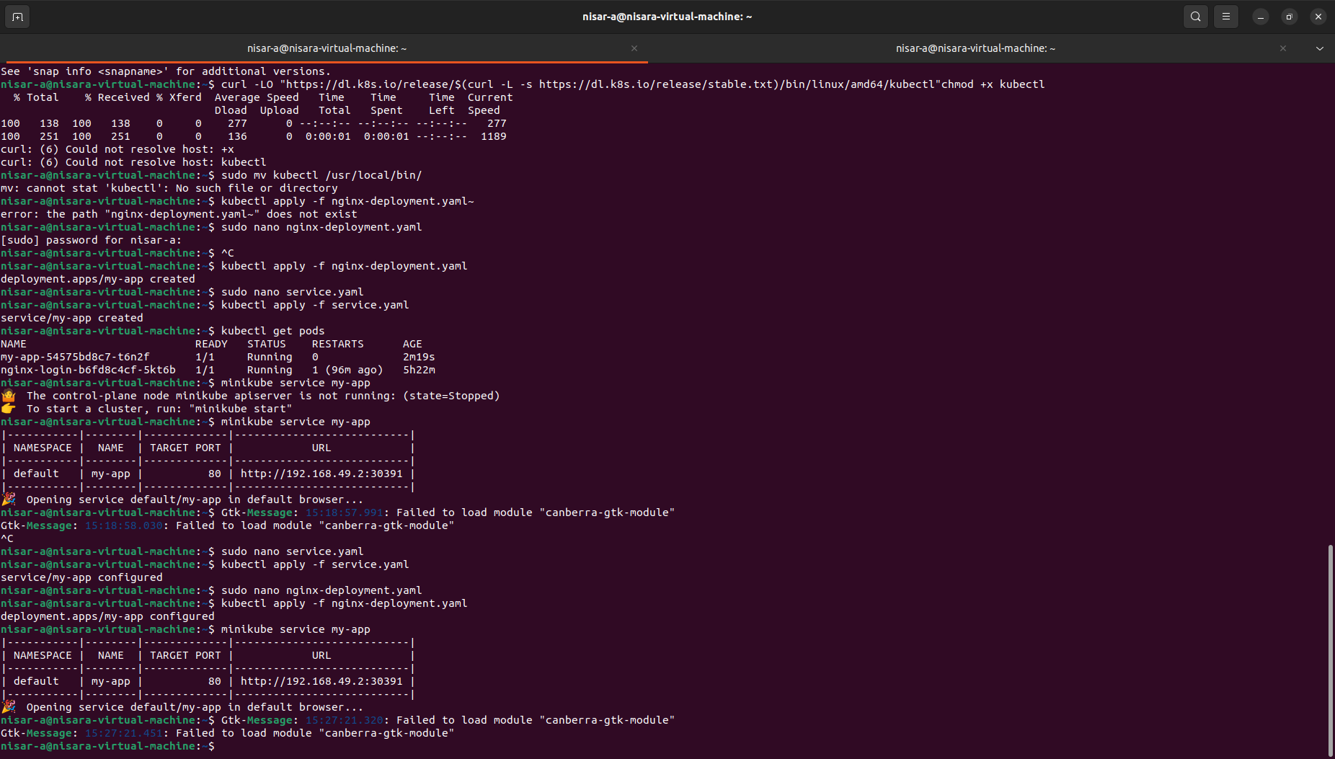

## Start and open Minikube
```bash
minikube start --driver=docker
minikube dashboard

