Net work Admin

Those how which have the following knowledge.

1

MCITP: Microsoft Certified Information technology Professional

CCNA : Cisco Certified Network Association

CCNP: Cisco Certified Network Professnal

ROUTING :

SWITCHING

CCIE: Cisco Certified Inter Network Expert

2

System Admin

MCITP

LINUX

UNIX

BSD

SUN SOLARIES

3

DATA BASE

ORICLE

SQL

MCITP

Mcsa: Microsoft Certified System Administration

MCSE: Microsoft Certified System Expert

MCITP

Microsoft Certified Information Technology professional

We have 5 exams

1 -- 70 up to 68 usd 50 Dumps

2 - 70 to 640

3- 70 - 642

4- 70- 643

5- 70- 647

MCTS

What is Networking

When two or more than two computers are connected with each other and they share same resources through media is called networking.

Types of Networks

1 network Design

2 Area Networks

3 Network Topology

4 Network Protocols

5 Wired VS Wireless Networks

Network Area

1 PAN personal area network

We use for small networks

Pan we use for person among computers and networks devices where close to one person

Example:

mouse , mobile , keyboard , printer, monitor ,

2 LAN Local Area Network

Is a network which has limited area. Or network which is used inside the building , houses ,offices , is called local area network

Requirements

1 pc or laptop computer

2 cable UTP /STP

3 connectors RJ 45 / RJ 11

4 Crimping Tool

5 Tester

6 Face Plate

7 Punch Panel

8 Switch

3 MAN

The third type is MAN Metropolitan Area Network , is a network which we usually connect

Two or more than LAN with each other .

4 WAN

Wide Area Network: which have unlimited area .

Example: province to province district to district

Network Design

1 peer to peer 2 Server Base or Domin

1 Peer to Peer :

In peer to peer or work group all the computer are connected with each other without any domin Base and work group are the computer are server as well a client

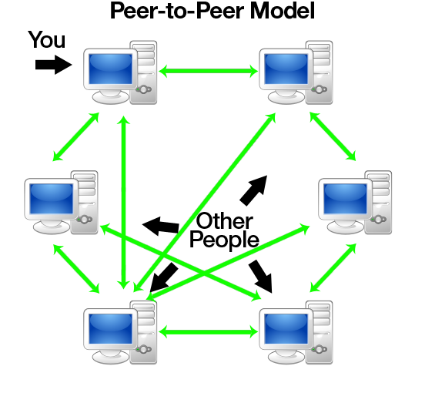

Server Base / Domin Bases

All the computers totally depend on server = FTS / SMTP

Server prviod services

Client accept services

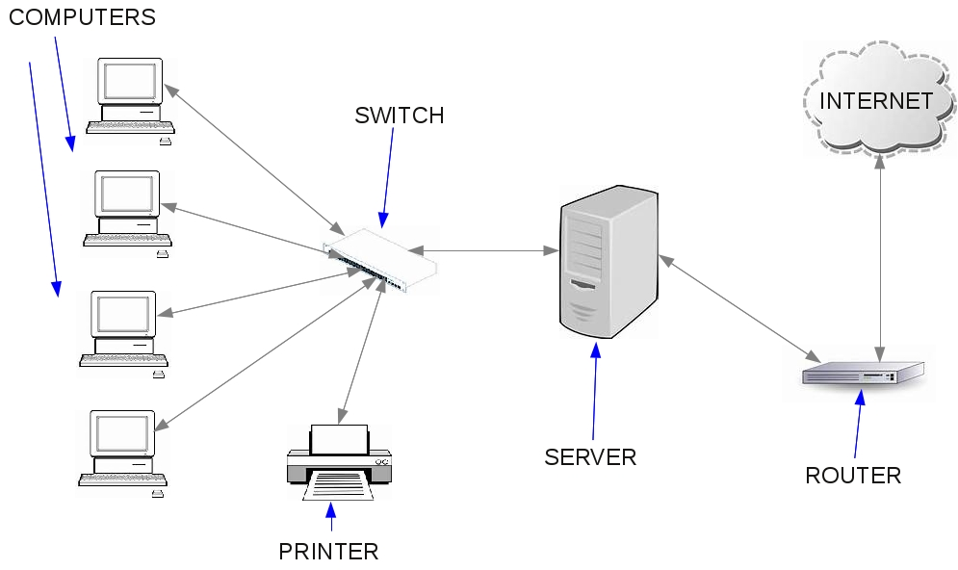

Network Topology

Topology is a latin word which shows physical structure or layout of computer.

شکل ظاهری یک کمپیوتر را بنام تپالوژی یاد میکند

Example

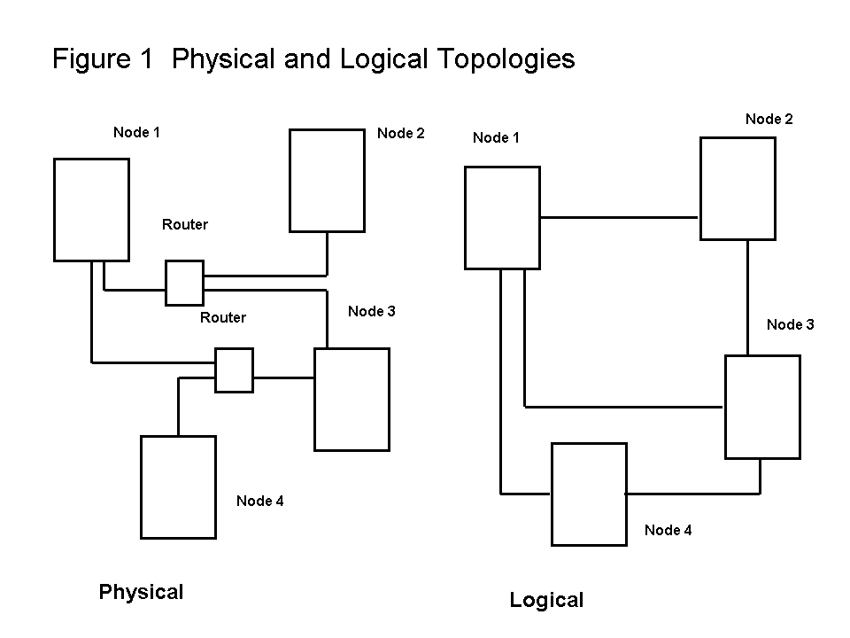

We have some deferent type of topology

1 bus topology

2 Ring Topology

3 Star Topology

4 Mesh Topology

5 tree Topology

6 Hybrid or Advanced Topology

BUS TOPOLOGY

In bus topology all computers connected with each others . as the data bounce to the both side of cable in order to not crash the data we us terminator .

Advantages: it is easy and cheap

Disadvantages : a break in a cable will prevent the whole computers from accessing the network .

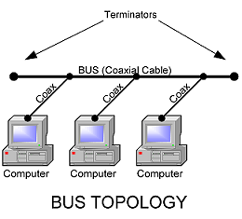

2 Ring Topology

In ring topology all the data goes in ship of ring it means circular fashion .

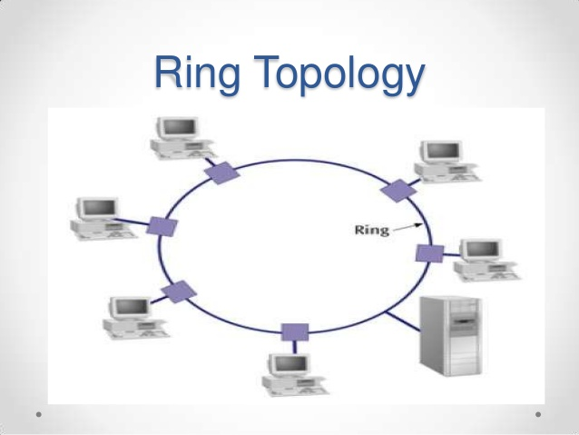

Multi station access unit

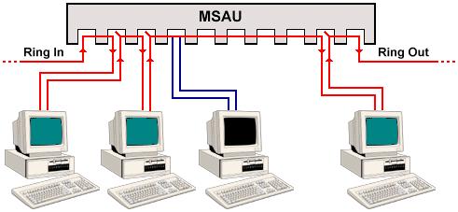

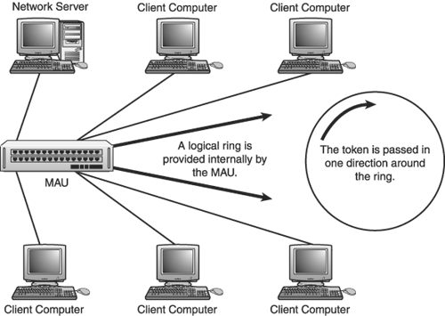

In ring topology: if we send a file to one of the computer it should pas all the computers and after vesting of all computers then it you can send it to the chosen computer .

Des advantages: if you shut down a computer all the computer will disconnect from network

3 Star Topology

All the computers are connected with centerlies location which is called switch or hub switch or hub is called external devices and it is one of the best topology

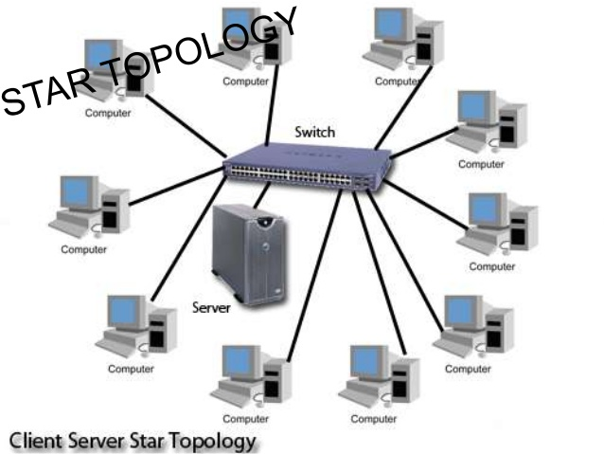

4 Mesh Topology

It is one of the fastest topology which all computers are connected with each others

15 line we use only for 6 PC

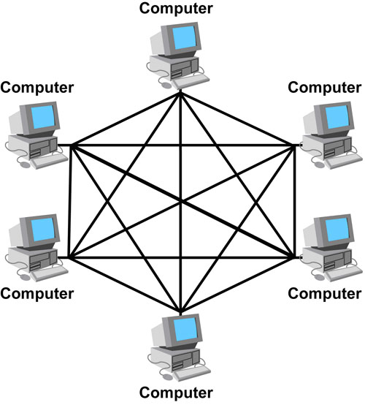

5 Tree Topology

The combination of bus topology and star topology is tree topology

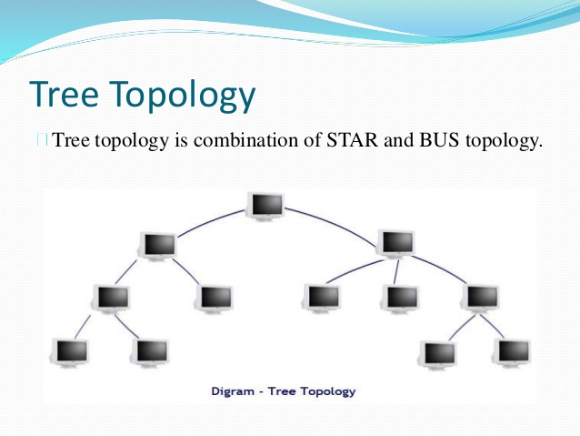

Hybrid Topology

The combination of all topology is called hybrid or Advanced topology

The hybrid topology can be combination of two or more basic topologies, such as bus , ring ,star ,mesh ,or three.

Hybrd networks combine more than two topologyies, which ,inturn , enable you to get advantages of the constituent toplogyies

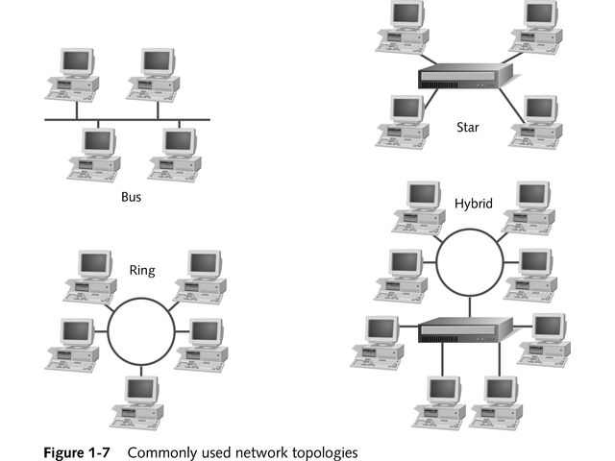

Network Protocol

1 standard Protocol 2 Property protocol

1 Standard protocol : TCP / IP

transition control protocol (internet protocol ) we use for communication among devices and computer

2 proerty protocol

We use it only for MAC computers

Wire / wireless

Media : anything that carry our massages from system to another system is called media .

1 bounded media 2 unbounded media

1 bounded media : these media has physical structures

* Twisted pair cable
* Fiber optic
* Coaxial cable

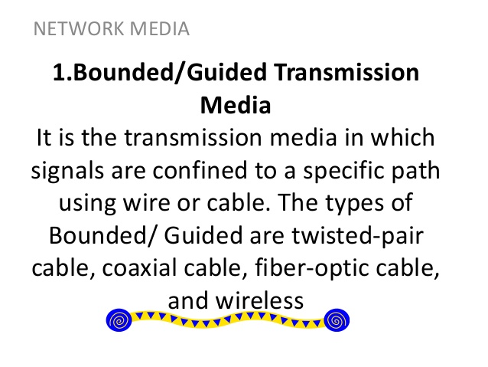

Twisted pair cable

We use it for network communication .

1 UTP : unshielded twisted Pair Cable

2 STP : shielded twisted pair cable

* 4 pairs 8 wires
* Semi color 4 solid color
* STP has high quality than UTP

We have some deferent types of UTP/STP cable

CAT 1 : we use for telephone system

CAT2 we use for network system ( 4MBPS)

CAT3 we use for network system ( 16MBPS)

CAT4 we use for network system ( 20MBPS)

CAT5 we use for network system ( 100MBPS)

CAT6 we use for network system ( more than 100MBPS to gegahits )

Cabling

We have 3 type of cable

1 straight cable - we use for deferent device

2 Crosse cable -pc to switch

3 Roll Cable - Switch to router

[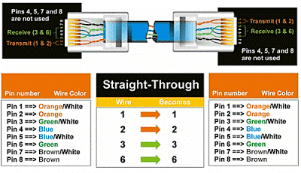](https://www.google.com.af/url?sa=i&rct=j&q=&esrc=s&source=images&cd=&cad=rja&uact=8&ved=0ahUKEwjN8a-Ei6fOAhXI6RQKHfS1C3MQjRwIBw&url=http://www.notesbymsgiri.co.in/networking/cnl-lab/assignment-i/straight-cross-over-cable&psig=AFQjCNHI-N5jqeUN0rtKRPNr2PfZVLb6yw&ust=1470376822893237)

2 - Cross Cable pc to pc switch to switch

[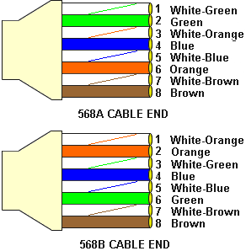](https://www.google.com.af/url?sa=i&rct=j&q=&esrc=s&source=images&cd=&cad=rja&uact=8&ved=0ahUKEwjnpK3yi6fOAhWEDBoKHYbnA5oQjRwIBw&url=http://www.jaytmedia.com/cisco/cables.html&bvm=bv.128617741,bs.1,d.d24&psig=AFQjCNET6VAL4QAgjExTS6YT01nfrvu8CQ&ust=1470377093308345)

[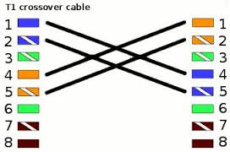](https://www.google.com.af/url?sa=i&rct=j&q=&esrc=s&source=images&cd=&cad=rja&uact=8&ved=0ahUKEwjGqNiOkKfOAhURahoKHaKFALcQjRwIBw&url=https://kb.sipadvantage.com/kb/index.php?View=entry&EntryID=105&bvm=bv.128617741,bs.1,d.d24&psig=AFQjCNEXdDOmcFgSIyutNiCzkbO0n51MWg&ust=1470378248259334)

3 Roll over cable is also called consul cable we used to connect router to PC

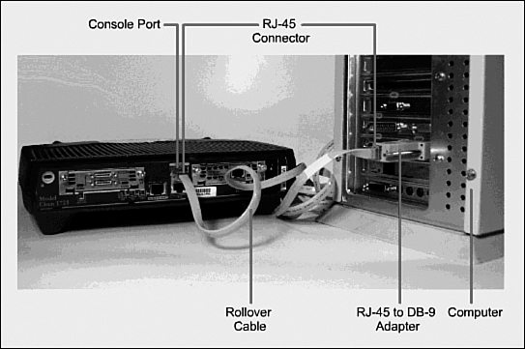

Network Devices

1 switch

2 Routers

3 Bridges

4 Repeater

1 Switch : is an external device which is use to connect local area network , switch is also

called 2 layer device.

1 manageable 2 unmanageable

1 manageable Cisco Catalyst for organization

2 Unmanageable TP LINK ,LINKSYS , D-LINK .3 COM

History of switch

Len Bossic Sandelernr

Sanfransico

2 Router

Router is an external device which have memory, CPU and deferent input and output devices. we can connect 2 or more than 2 area network with each other . Is used 2 deferent to LAN or more than 2 LAN with each other

Router Port

* Serial port : used to connect router to router
* Ethernet Port : used to connect router to switch
* Consul Port used to connect router with PC
* Auxiliary Port used for remote configuration , for far distance

Repeater : we use regenerate the data

Hub : is an external device we use to connect computers.

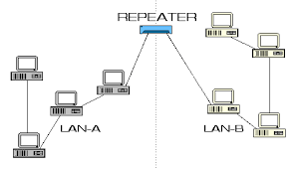

Hub – Broadcast Communication

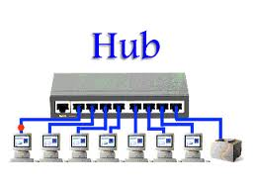

We have 3 type of communication

1 unicast communication - one to one - 80

2 multicast commuinication - ont grout – example teacher for student

3 Broad Cast Communication - one to all – ex: radio , TV

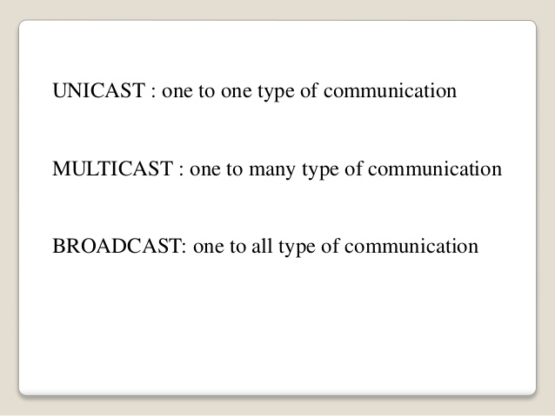

Bridge: it divide over segment into section

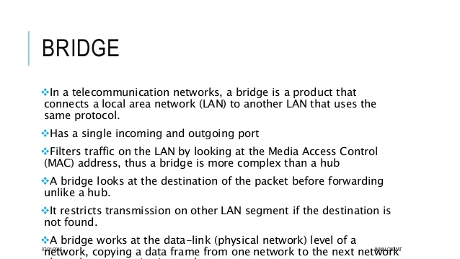

IP ADDRESS / internet Protocol

The collection of network is called internet . networks of networks is called internet

Protocol : way of communication between to computer is called protocol

Network of language is called protocol

Or set of rule and regulation is called protocol specification of something or someone or somewhere is called address

IP address types

We have 5 type of IP Address

1 IP Address Assignment

2 IP Address Classes

3 IP Address Portion

4 IP Address Version

5 IP Address Public and private

1 IP Address Assignment

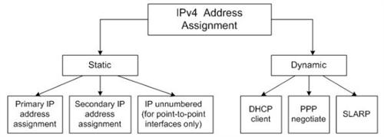

Static ip : those ip addresses which inter to computer by network admin or we can say . IP Address which enter by our own optional

RUN = NCPA.CPL

IP Address

Subnet mask

Defalt gateway

2 IP ADDRESS CALASSES = 1 Glassful 2 Classless

Class full 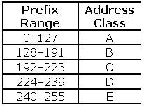

Classfull

A – 1 to 126

B- 128

* Class A default mask is 255.0.0.0
* Class B default mask is 255.255.0.0
* Class C Default mask 255.255.255.0

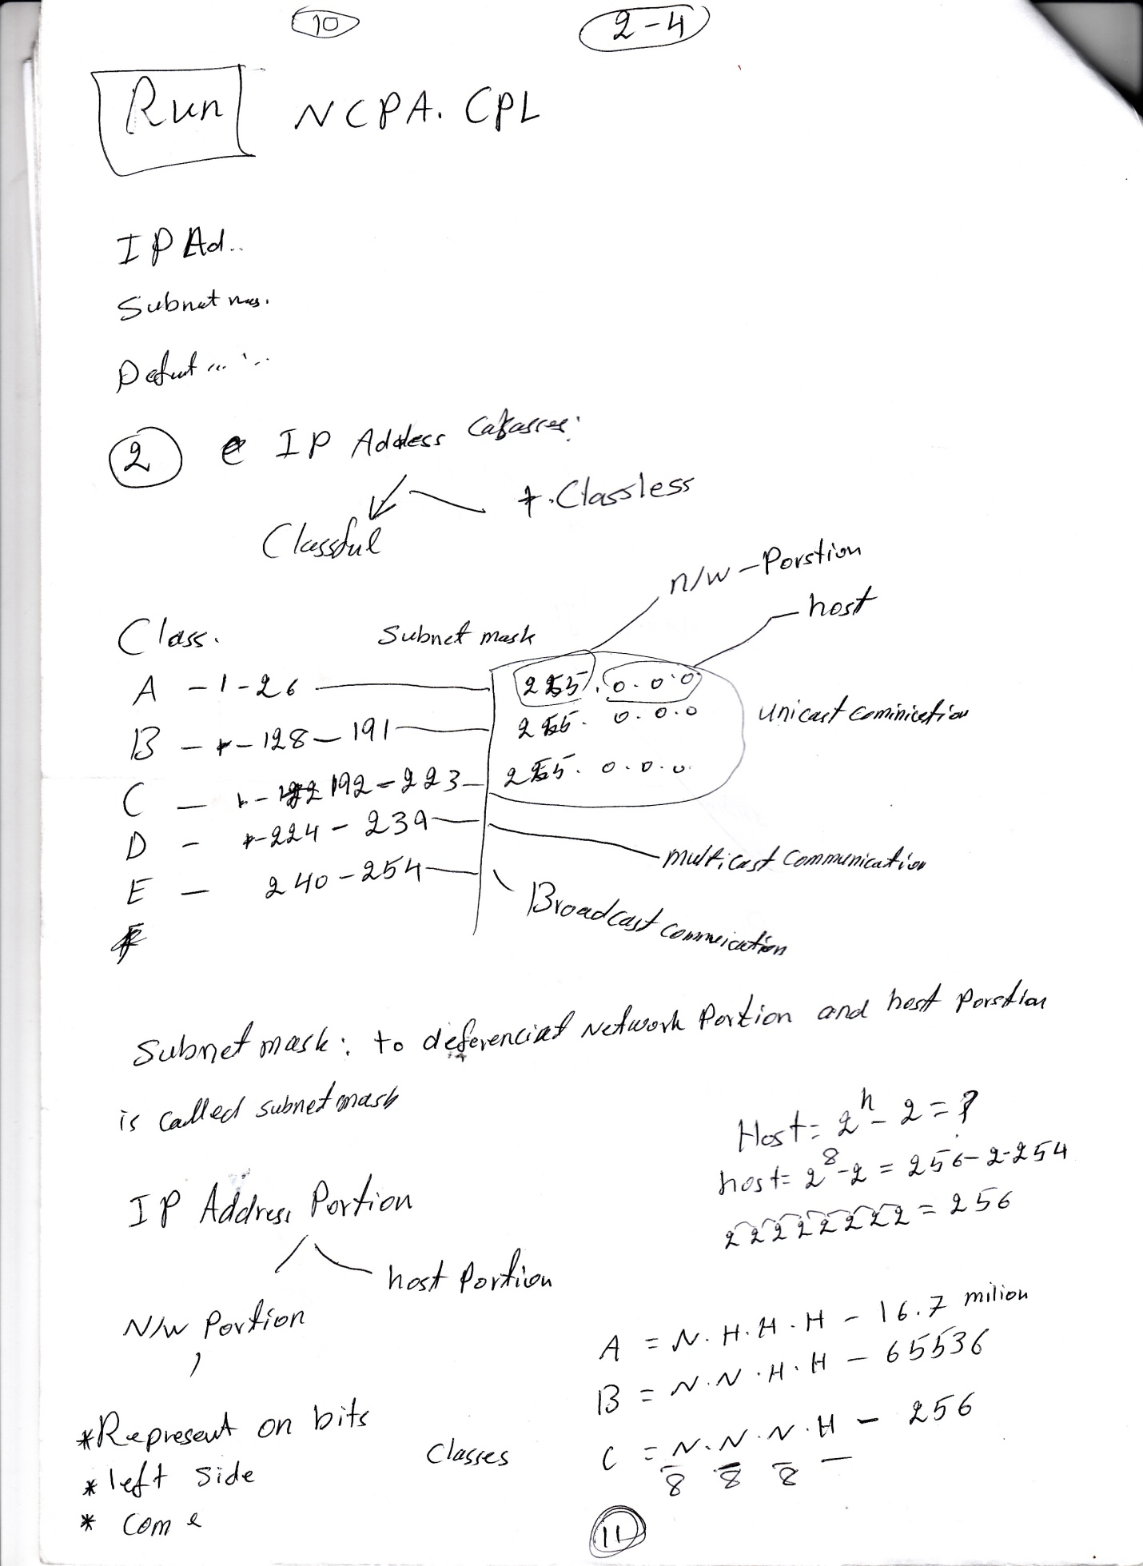

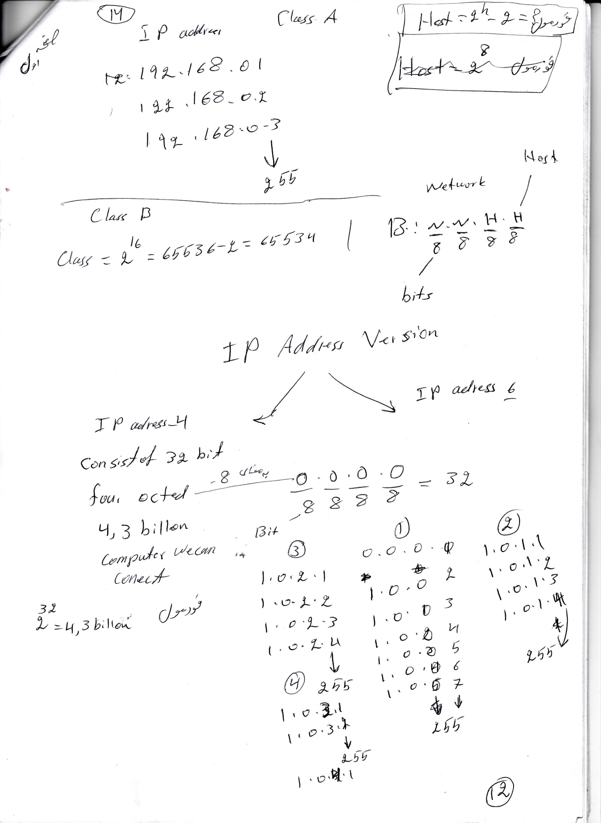

Ping

Packet Inter Network Group

We use to check communication between computer and Network devices.

1. Reply from Pc to Pc 100

100 communication is possible

2. Destination has unreachable

10.0.01 172.16.0.1

3. Request Time Out

Fire Wall is on

Ping 10.0.01

Request Time Out

Request Time Out

Request Time Out

Request Time Out

DNS

DNS is introduce for the first time in America .

HOST .TXT befor DNS was this Flat Structure

DNS is used for fast communication

DNS is used for the following server

Sever / etc

Active Directory + DNS = domain

DNS STRUCTURE

Hirrichcel structure

Like inverse tree

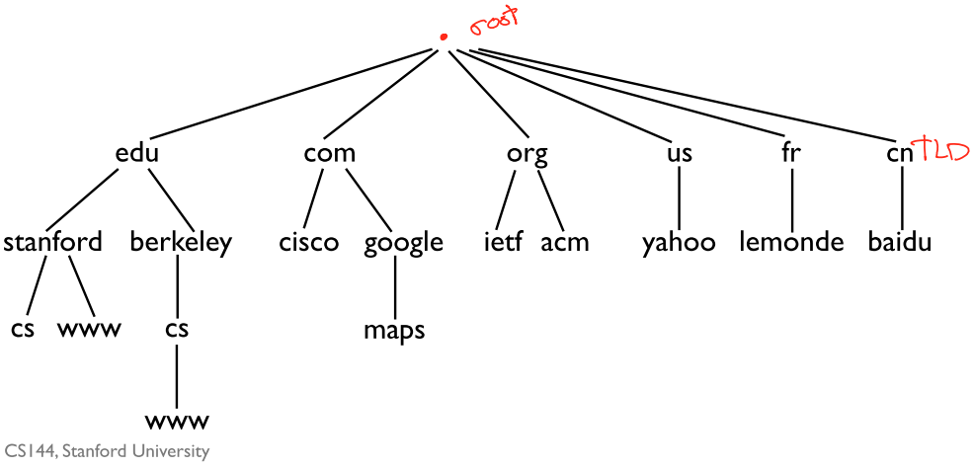

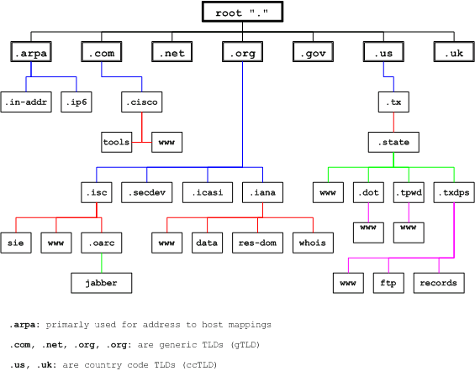

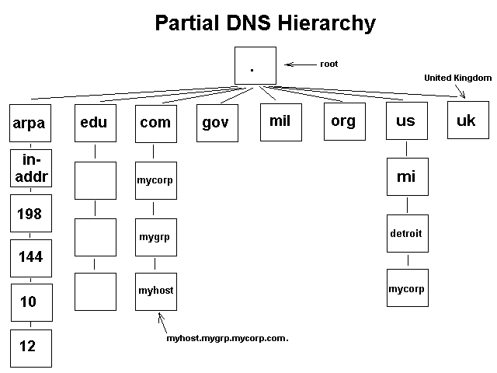

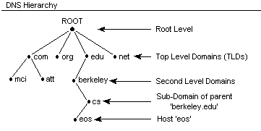

How To assign IP Address

We can assign ip address in Two ways

1.start = run = NCPA.CPL = ENTER

2.Right click on TCP/IP =Open N/W sharing center = enternet and assign four IP address

DNS

Domain Name System

We use DNS to change host into IP addres and IP address int host name

Host name [www.google.com](http://www.google.com)

10.0.01

2 . Phone Book

070 ……… Ali DNS

0700……… Wali

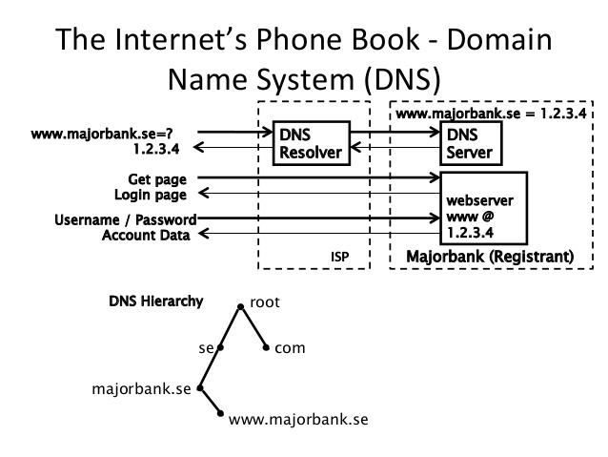

070 …… Ajmal

3. PC

TOP Level Domain or first Level Domain is divided into three categories

1. Technical infrastructure

We use for name resolution. Start + run = command

Ping 192.168.0.1 = enter

Ping a pc

2. Generic type level domain

Se used for organization

[www.japan.edu](http://www.japan.edu)

[www.shaheen.com](http://www.shaheen.com)

.gov

3. Country Code

[www.mazar.afgh](http://www.mazar.afgh)

[www.washinton.usa](http://www.washinton.usa)

[www.dehli.ind](http://www.dehli.ind)

DHCP

Dynamic host configuration protocol we use to assign IP addres from Server Mainline to the client

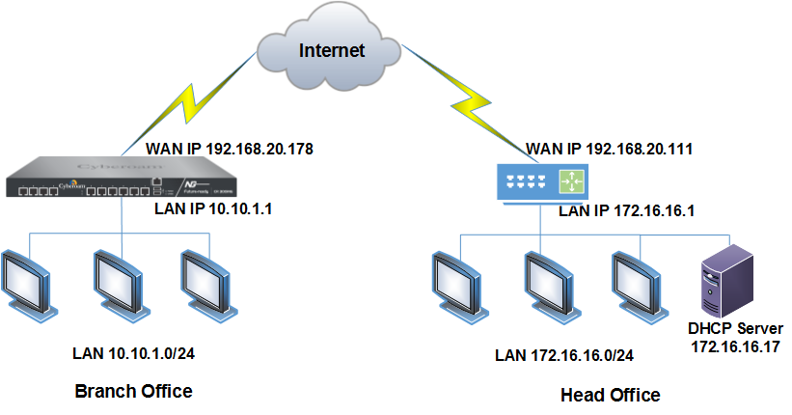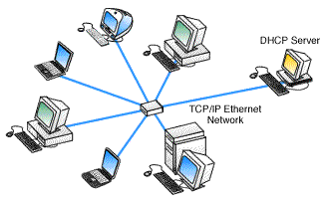

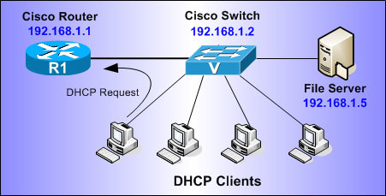

FTP

File transfer Protocol

To send large number of data from server mainlines to client side

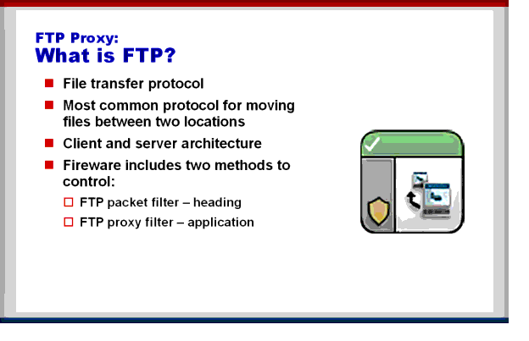

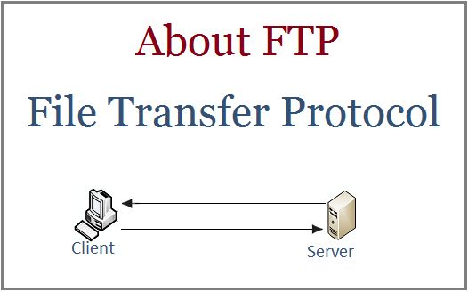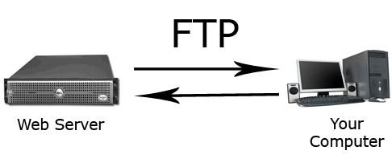

CCNA

Cisco Certified Network Associate (CCNA)

Cisco Certified Network Associate

Cisco Certified Network Associate (CCNA) is an entry-level certification for the Cisco certified professional program. The certification is geared towards junior network administrators.

WAN

EXAM:

201 101 UPT 250 USE

90 Minute

Multiple chase

Single chise

Drag and drop

De

Router