[ INSTITUTION NAME ]

M.Sc BIG DATA ANALYTICS
Research Project Report

Predicting Uniswap V3 Liquidity Position Profitability at Open Time:
A Machine Learning Approach

Domain: Decentralized Finance (DeFi) / Blockchain Analytics

Submitted by
[ Nash: insert full name ]
Roll No.: [ ______ ]

Under the guidance of
[ Guide / Faculty Name ]

[ Month, Year ]

Certificate of Originality
This is to certify that the project report entitled “Predicting Uniswap V3 Liquidity Position Profitability at Open Time: A Machine Learning Approach” submitted in partial fulfilment of the requirements for the degree of M.Sc Big Data Analytics is a bona fide record of work carried out by [ Student Name ], Roll No. [ ______ ], under my supervision.
The work presented in this report is original and has not been submitted, in part or in full, for the award of any other degree or diploma of this or any other institution.
Date: ______________ Place: ______________
_______________________ _______________________
Student Signature Guide Signature

Acknowledgement
[ Two or three sentences thanking your guide, institution, and anyone who supported data access or domain input. Write this yourself, briefly and specifically. ]

Table of Contents

Right-click this field in Word and choose “Update Field” after finishing edits so page numbers are correct.

List of Figures & Tables

List of Figures
Insert via References > Insert Table of Figures once you have captioned each chart as “Figure 1: …”, “Figure 2: …” (needed once Chapter 3's charts are generated and pasted in).

List of Tables
Same process – caption every table as “Table 1: …”, “Table 2: …”, then insert a Table of Tables here.

Abstract / Executive Summary
Liquidity providers (LPs) on Uniswap V3 must choose a concentrated price range for their capital at the moment a position is opened, a decision that is the single largest driver of whether the position ultimately earns a profit or a loss, yet is typically made with little systematic guidance. This project frames LP profitability as a binary classification problem: predict, using only information available at open time (chosen tick range, pool characteristics, deposit composition, pre-open market conditions, and wallet experience), whether a position will close profitably.
A leakage-safe dataset of 62,250 closed Uniswap V3 positions was built from nine on-chain data sources (Dune Analytics and Google BigQuery), covering the ten highest-volume pools from Uniswap V3's launch through end of 2023. The pipeline resolved multi-table joins across position open, close, mint, and fee-collection events; corrected a token-decimals unit error and a corrupted-value outlier bug that would otherwise have silently distorted the profitability label; and explicitly excluded every feature only knowable after a position closes, including two columns (position duration and partial-withdrawal count) not caught in earlier data audits.
A time-based 80/20 train/test split (no shuffling, to prevent temporal leakage) was used to train a baseline Logistic Regression and a challenger XGBoost classifier. Variable selection combined a filter pass (variance and correlation checks) with embedded methods (L1-regularized logistic regression and Random Forest importance), cross-checked against raw class frequencies to catch unstable coefficients driven by rare categories. A wrapper cross-check (recursive feature elimination with cross-validation, RFECV) subsequently confirmed the embedded rankings without changing the deployed feature list.
The final XGBoost model achieved a test ROC-AUC of 0.596 and Gini of 0.191, a modest but genuine and non-leaked discriminative signal. A Random Forest challenger matched the final model within noise, and a feature-ablation study found no alternative open-time or interaction feature set improved on the original 27 features, corroborating the ceiling from the feature side. A learning-curve analysis showed the gap between training and test performance is driven substantially by a real shift in market conditions between the 2021–2022 and 2023 portions of the study period (profitable-position rate rises from 58.3% in training to 67.0% in test), rather than classical overfitting alone. The headline finding is that open-time features carry real, measurable predictive signal for LP profitability, but the current feature set and single-regime training window likely limit accuracy; expanding the pool universe, extending the time range, and adding wallet-behavior features are identified as the highest-value next steps.

Chapter 1: Introduction

1.1 Background & Motivation
Uniswap V3 changed how automated market makers work by letting liquidity providers concentrate their capital within a chosen price range, rather than spreading it across the entire price curve as in V2. This concentration multiplies fee income per dollar deposited when the market price stays inside the chosen range, but exposes the position to impermanent loss and to earning zero fees if the price moves outside it. The range choice is therefore the single biggest lever an LP controls, and most LPs currently choose it by rule of thumb rather than by any systematic, data-driven process.
This project is Nash's M.Sc Big Data Analytics final project and is also intended as a portfolio piece targeting on-chain data analyst roles, which shaped several practical decisions throughout (documenting real data-engineering constraints, for instance, rather than hiding them).

1.2 Business Problem Statement
An LP opening a Uniswap V3 position today has no reliable, quantitative way to estimate whether their chosen range, pool, and deposit will be profitable, beyond intuition and after-the-fact observation of similar positions. This project addresses that gap by building a model that scores a proposed position's likely profitability using only information available at the moment of opening, before any capital is at risk of a bad range choice.

1.3 ML Problem Formulation
Target variable: profitable, a binary label (1 = position closed with net economic profit, including fees earned, net of impermanent loss; 0 = otherwise).
Unit of analysis: one closed Uniswap V3 LP position (one NFT position-manager tokenId).
Moment of prediction: the block timestamp at which the position is opened (open_time). Every feature in the final model is constructed to be knowable strictly at or before this moment; label-construction fields that are only knowable at close (close price, fees eventually collected, position duration, count of partial withdrawals) are explicitly excluded from the feature matrix.

1.4 Objectives & Success Metrics
- Business KPI: enable an LP to rank candidate range/pool choices by predicted profitability before committing capital.
- Statistical metric: ROC-AUC and Gini on a chronologically held-out test set, reported alongside KS, PR-AUC, and a full decile/lift table per the course's evaluation standard.

1.5 Scope & Constraints
Scope: the ten highest-volume Uniswap V3 pools by swap activity, covering positions opened between 2021-05-01 (V3 launch) and 2024-01-01. This is narrower than the original full-universe, full-history vision, a deliberate compromise forced by Dune Analytics' free-tier API datapoint quota, documented in full in the project's data-engineering log.
A further scope note is documented explicitly in Chapter 10.6: PSI/CSI stability analysis is not applicable to this project as scoped, since there is no live production scoring population to monitor, only a static historical train/test split.

Chapter 2: Data Understanding

2.1 Data Source(s)
Nine raw tables were extracted and joined to build the final dataset:
# | Table | Source | Captures
1 | Mint | Dune Analytics | Tick range (tickLower/tickUpper) chosen at open – the headline feature
2 | Open events (IncreaseLiquidity) | Dune Analytics | Position open / top-up events, deposit amounts
3 | Close events (DecreaseLiquidity) | Dune Analytics | Position close, all partial withdrawals summed
4 | Collect | Dune Analytics | Fees collected, summed across all collect events
5 | Pool metadata (PoolCreated) | Dune Analytics | Token addresses, fee tier, tick spacing
6 | Swap daily aggregates | Dune Analytics | Pool trading volume and traded tick range
7 | Transactions | Google BigQuery (public dataset) | Gas costs, wallet nonce
8a/8b | Prices (minute) | Dune Analytics | USD token prices at each position's open/close minute

2.2 Data Dictionary Summary
The merged, labeled dataset (final_merged_dataset_v5.csv) contains 62,250 closed positions and 35 columns before feature-set trimming, spanning identifiers, open-time features, market-condition features, and outcome/label-construction fields. Notable fields: range_width_normalized (tick range width divided by the pool's tick spacing, making range choice comparable across pools with different spacings), fee_tier_pct (pool fee tier as a true numeric rate rather than a one-hot category), and lp_prior_position_count (a causally-computed count of the wallet's prior closed positions, used as an LP-experience proxy).

2.3 Initial Data Audit
Shape: 62,250 rows × 35 columns. No infinite values remain in any numeric column (verified programmatically as the pipeline's final sanity check, following a fix for corrupted deposit-amount rows described in Chapter 4). No near-zero-variance columns and no pairwise feature correlations above 0.9 were found in the filter-stage variable selection pass (Chapter 6).

2.4 Target Variable Analysis
The target profitable is well balanced: 60.0% of positions in the full dataset closed profitably, 40.0% did not, avoiding the rare-event/class-imbalance complications that would otherwise dominate metric choice and modeling strategy.
However, this balance is not stable across time. After the chronological 80/20 train/test split used throughout this project, the training set (2021-05 to 2023-01) is 58.3% profitable while the test set (2023-01 to 2023-12) is 67.0% profitable – a real shift tied to differing market conditions across the two periods, not sampling noise. This is discussed further as an overfitting-diagnostic confound in Chapter 10.5.

Chapter 3: Exploratory Data Analysis

3.1 Univariate Analysis
deposit_value_usd is extremely right-skewed in its raw form: a single bin near zero dominates the histogram, with a long thin tail out past $250 million driven by a handful of very large positions. The log1p-transformed version (log_deposit_value_usd, already used as the modeling feature per Chapter 5.2) is far more usable, spreading mass across roughly 7.5 to 17.5 on the log scale – though it is not perfectly unimodal, showing a secondary peak near 17, likely a cluster of similarly-sized large/whale deposits rather than a single outlier.
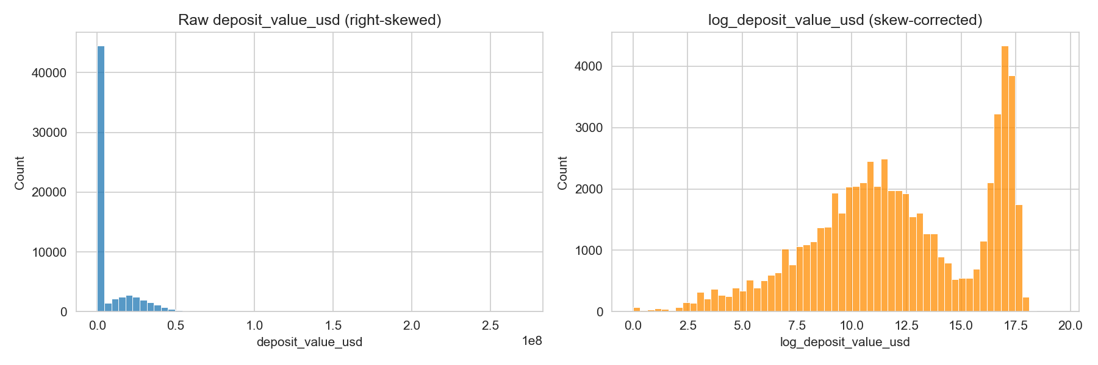
Figure 1: Raw vs log-transformed deposit value distribution
range_width_normalized remains heavily right-skewed even after clipping at the 99th percentile for display purposes – the clip compresses rather than removes the tail, producing a visible pile-up bar at the clip point itself (the dataset's true maximum reaches into the hundreds of thousands of tick-spacing units, per the Chapter 2.3 audit). Most chosen ranges are narrow (under 100 normalized units), with a long tail of much wider, more conservative range choices.
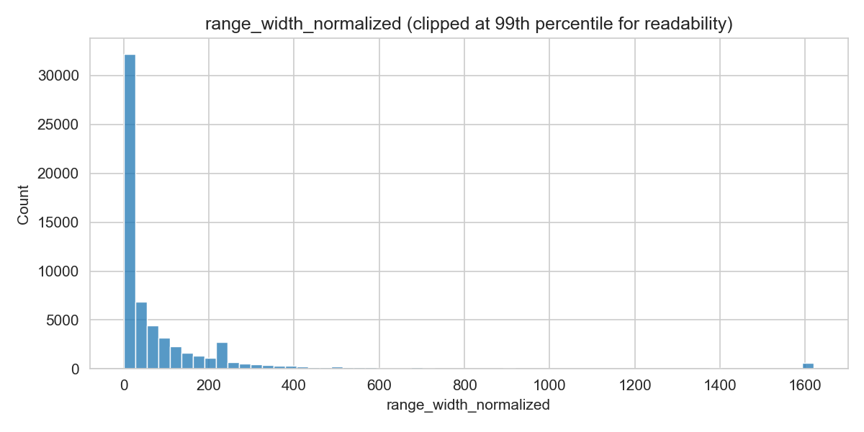
Figure 2: range_width_normalized distribution (99th-percentile clipped)
The target variable profitable confirms the 60.0% / 40.0% balance already reported in Chapter 2.4, with no rare-event concerns.
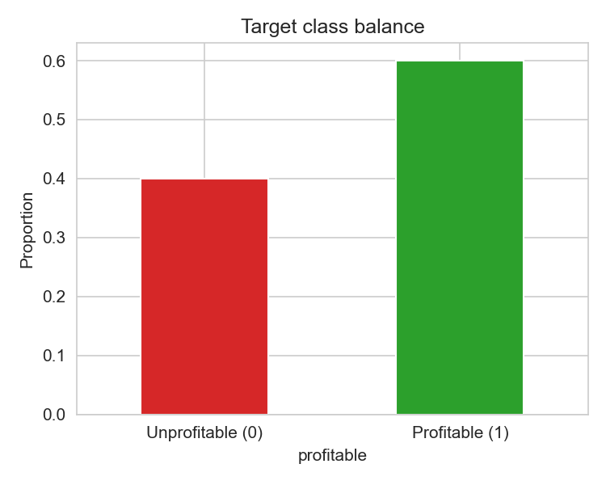
Figure 3: Target class balance

3.2 Bivariate Analysis
Profitable positions tend to choose visibly narrower ranges than unprofitable ones: the median range_width_normalized is roughly 17 for profitable positions versus roughly 33 for unprofitable ones. This is consistent with Uniswap V3's core design incentive – a narrower, more concentrated range earns more fee per dollar deposited when the market stays inside it, so LPs who both concentrate tightly and get the range right are rewarded twice.
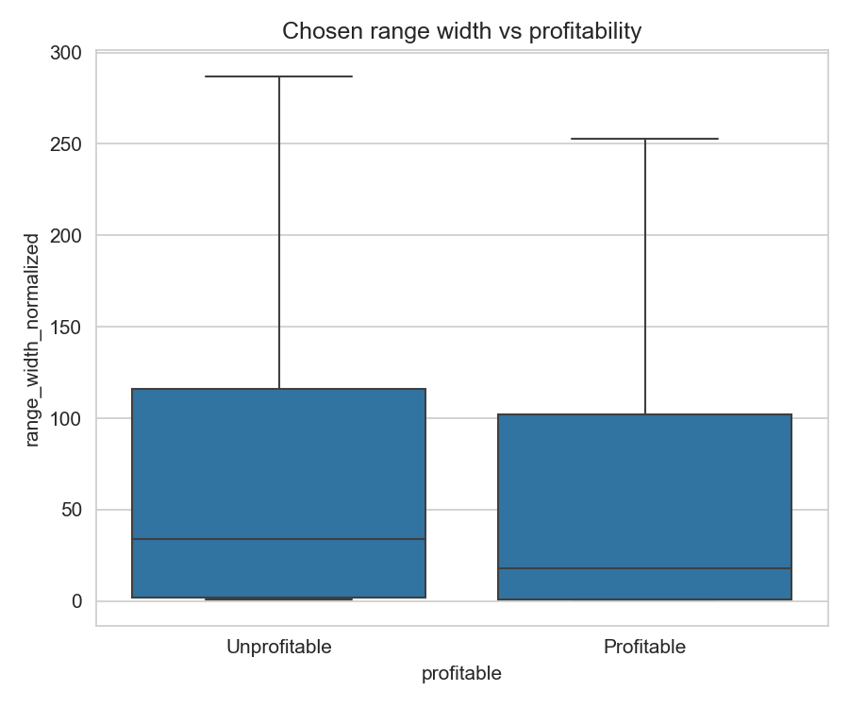
Figure 4: Chosen range width vs profitability
Deposit size also separates the two classes: profitable positions have a visibly higher median log_deposit_value_usd (~12.4) than unprofitable ones (~11.2), with the whole interquartile range shifted upward. Larger positions may be run by more experienced LPs, or may simply be less sensitive to fixed costs (gas) relative to position size – this project's feature set cannot fully distinguish between those explanations, which is worth stating plainly rather than overclaiming a mechanism.
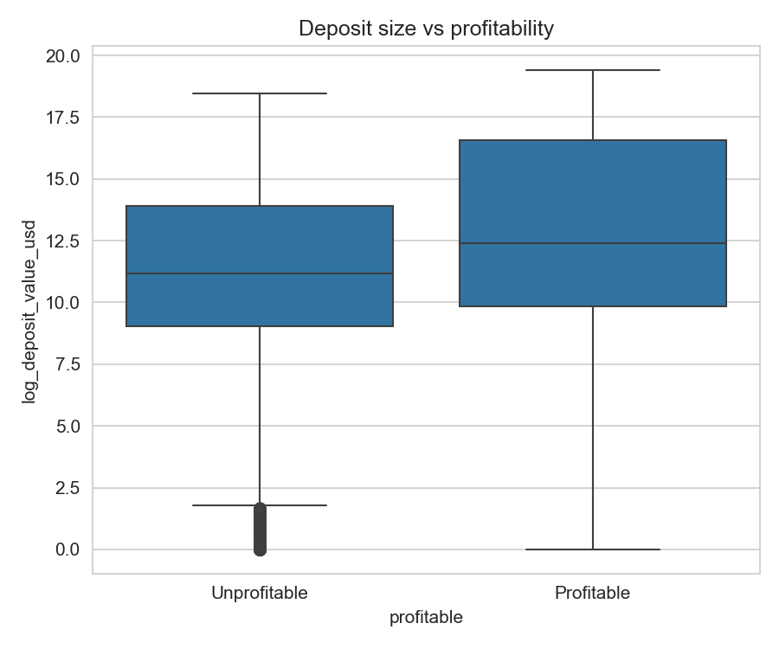
Figure 5: Deposit size vs profitability
Profitable rate varies substantially by pool, from roughly 46% to 82%, but sample size must be read alongside the rate: the two smallest pools (n=25 and n=21 across the full dataset) are far too small to trust their rates as real pool effects rather than noise. The two dominant pools by volume (n=31,414 and n=18,313) show a real, more trustworthy gap – 62.3% versus 56.6% profitable – which is a genuine, moderate pool effect. This directly corroborates the Chapter 6.1 finding that Lasso's large coefficient on a low-frequency pool dummy should be read with caution.
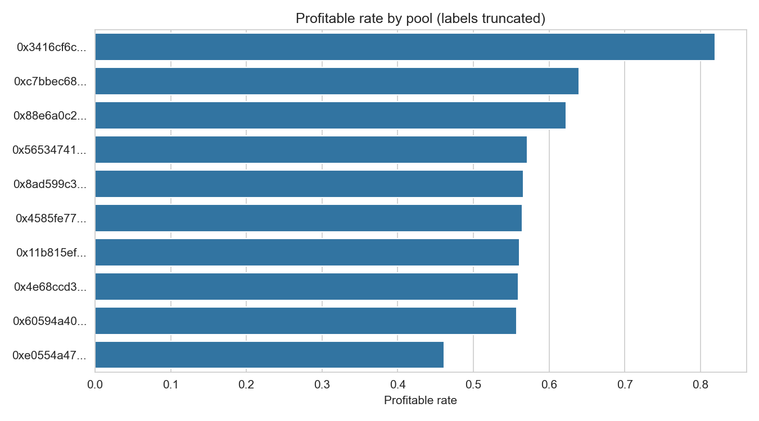
Figure 6: Profitable rate by pool (full dataset)
The single strongest bivariate relationship found in this analysis is range_overlaps_recent_trading: positions whose chosen range does NOT overlap the pool's recently-traded tick range are profitable only 23.0% of the time (n=601), versus 60.3% for positions that do overlap (n=61,649). This is a large, substantively meaningful gap despite the feature's extreme skew (under 1% of positions fall in the non-overlapping group), and directly explains why Random Forest still ranked this feature highly in Chapter 6.1 even though it is a rare binary flag.
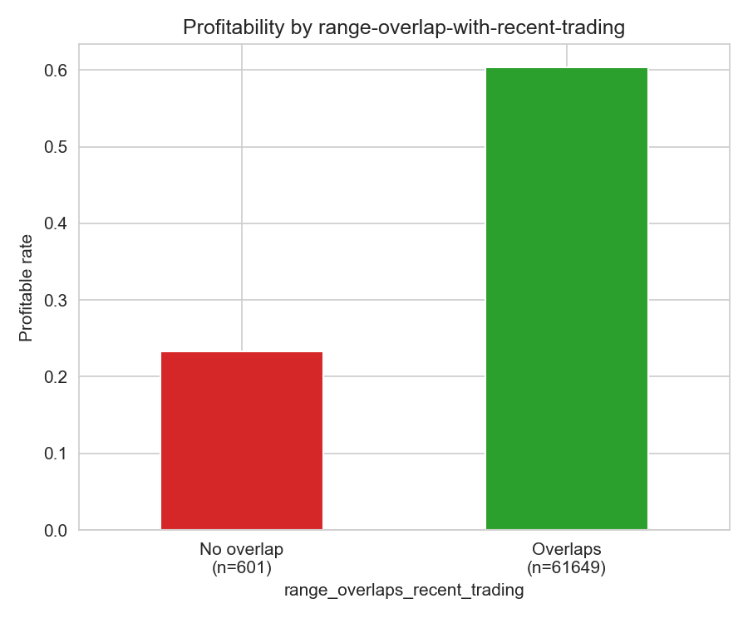
Figure 7: Profitability by range-overlap-with-recent-trading

3.3 Multivariate Analysis
The correlation heatmap confirms the filter-stage finding from Chapter 6.1 that no feature pair exceeds the 0.9 redundancy threshold used for automatic dropping. However, several moderate-to-strong clusters are visible and worth noting explicitly rather than treating the 0.9 threshold as the only signal worth reporting: token0_price_open and token0_price_std_24h correlate at 0.80 (a more volatile-priced token tends to also trade at a higher absolute price in this dataset's token universe); token1_price_std_24h and token1_price_range_pct_24h correlate at 0.86 (expected, since both are derived from the same 24h rolling price window); fee_tier_pct and pre_open_avg_daily_swap_count_3d correlate at −0.70 (higher-fee-tier pools see substantially less daily swap activity, consistent with higher fee tiers typically being reserved for more volatile, less liquid pairs); and mint_amount0_adj correlates at 0.57 with log_deposit_value_usd (expected, since deposit value is partly derived from mint amounts). None of these breach the hard 0.9 drop threshold, and XGBoost as a tree-based model is materially more tolerant of this kind of moderate multicollinearity than Logistic Regression would be, but they are flagged here for completeness.
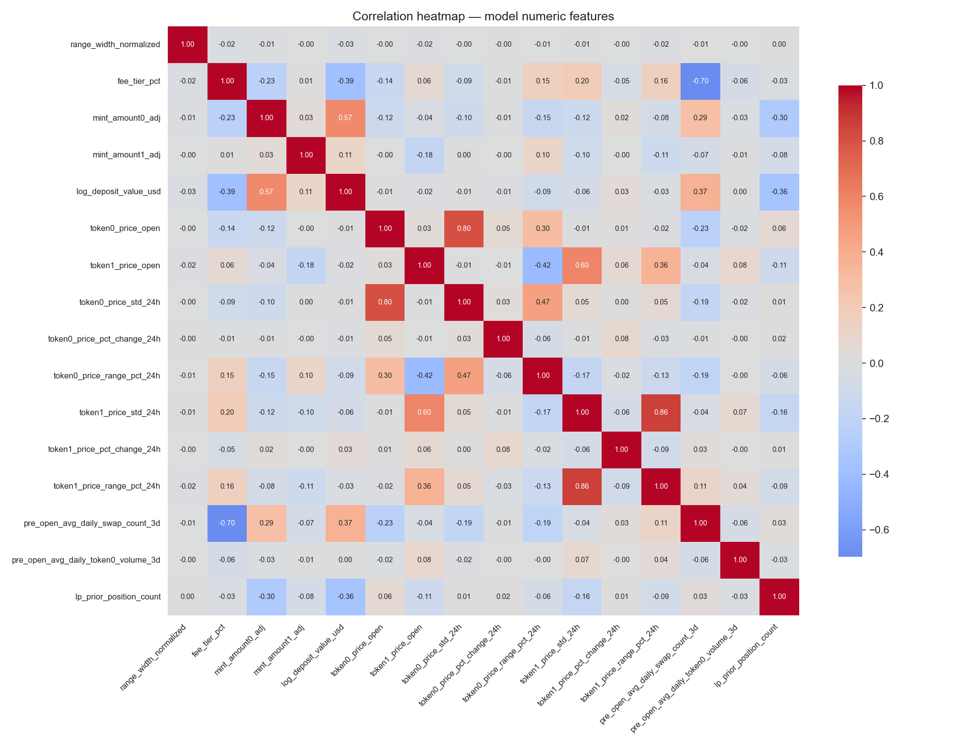
Figure 8: Correlation heatmap, model numeric features

3.4 Key Insights Summary
- range_overlaps_recent_trading is extremely skewed (99.0% of positions choose an overlapping range) yet shows the single largest bivariate gap found in this analysis (23.0% vs 60.3% profitable) – a rare but very strong signal.
- Profitable positions choose visibly narrower ranges (median ~17 normalized units) than unprofitable ones (median ~33), consistent with V3's concentrated-liquidity design incentive rewarding correctly-placed tight ranges.
- Profitable positions carry visibly larger deposits (median log-deposit ~12.4 vs ~11.2 for unprofitable), though this project's features cannot distinguish LP sophistication from simple fixed-cost effects as the underlying mechanism.
- Pool choice matters, but unevenly reliably: the two dominant pools (comprising the large majority of all rows) show a real, moderate profitability gap (62.3% vs 56.6%); the smallest pools (n<30) show more extreme rates that are very likely sample-size noise, not real pool effects.
- No feature pair exceeds the 0.9 correlation threshold used for automatic redundancy dropping, but several moderate clusters (0.57–0.86) exist among the pre-open volatility and deposit-composition features, which is expected given their shared derivation and was accounted for by using a tree-based primary model.
- deposit_value_usd's raw right-skew is severe enough that the log1p transform used throughout modeling (Chapter 5.2) is not merely a nicety but a necessity for any linear-model use of this feature.

Chapter 4: Data Cleaning

4.1 Missing Value Treatment
Price-join misses: positions whose open or close minute had no exact USD price match were dropped rather than imputed, since fabricating a price for the profitability label itself would corrupt the target variable. This filter reduced the dataset from 154,740 candidate positions to 62,265 rows with full open- and close-price coverage (63,988 rows missing a close price, 61,183 missing an open price, with some overlap).
A small number of pre-open volatility-window values (24h rolling price statistics) and momentum values were unavailable for positions too early in a token's price history to have a full trailing window; these were dropped (volatility window) or filled with a neutral 0 (momentum, treated as "no measurable momentum" rather than a fabricated value) as documented directly in the pipeline.

4.2 Outlier Treatment
A genuine data-corruption issue, not organic outliers, was found and fixed: on-chain deposit amounts (mint_amount0/1) occasionally carried corrupted or overflowed values up to roughly 1e31 in magnitude, six or more orders beyond any realistic position size, which propagated to infinite values after downstream arithmetic. The outlier filter was originally scoped only to the withdrawal-side column (total_token0_returned_adj); describe() review during development revealed the deposit-side columns carried the same corruption and needed the identical filter. Rows with any of the three amount columns exceeding 1e10 (in human-readable, decimal-adjusted units) were dropped.

4.3 Inconsistent & Impossible Values
Token amounts were converted from on-chain base units to human-readable units by dividing by 10^decimals per token (USDC/USDT: 6, WETH/DAI: 18, WBTC: 8). This is a unit-scalar correction, not a precision rounding step – getting it wrong shifts values by many orders of magnitude and can corrupt the sign of the profitability comparison itself, so it was applied before any profitability arithmetic.

4.4 Duplicate Handling
Mint-to-open-event matching required resolving a many-to-many join risk: a subset of transactions contained multiple Mint events, multiple Open events, or both. Single-mint transactions were joined directly; multi-mint transactions were resolved by matching on liquidity_added amount, falling back to a top-up events table where the primary open-events table had no match. tokenIds whose Mint-derived tick range was inconsistent across resolution paths were dropped entirely rather than guessed at.
Separately, an earlier version of the Close and Collect queries used a "take the last event per position" pattern that silently discarded amounts from any earlier partial withdrawal or fee collection – affecting roughly 8% of positions (13,592 of 171,707) in the raw extraction. This was fixed by switching to a GROUP BY tokenId with SUM() aggregation, which correctly captures total value across all partial events and is the version used in the final v5 dataset.

Chapter 5: Feature Engineering

5.1 Derived Features
Feature | Hypothesis
range_width_normalized | Raw tick width isn't comparable across pools with different tick_spacing; normalizing makes range choice comparable
fee_tier_pct | Numeric fee rate preserves magnitude/order information a one-hot category would discard
log_deposit_value_usd | Compresses the heavy right tail of deposit sizes so downstream scaling isn't dominated by a few whale positions
lp_prior_position_count | Causally-computed (only counts positions opened earlier) proxy for LP sophistication/experience
token0/1_is_stablecoin | Stablecoin-paired positions face structurally different IL dynamics than volatile/volatile pairs
token0/1_price_std_24h, pct_change_24h, range_pct_24h | Pre-open market volatility and momentum, computed strictly on the 24h window before open_time
pre_open_avg_daily_swap_count_3d, avg_daily_token0_volume_3d | Recent pool trading activity in the 3 days before open, as a proxy for expected fee-earning potential
range_overlaps_recent_trading | Whether the chosen tick range intersects the pool's recently-traded tick range – a position with no overlap is close to guaranteed near-zero fees

5.2 Transformations
log1p was applied to deposit_value_usd (producing log_deposit_value_usd) specifically to tame right-skew; the two co-exist in the raw v5 dataset but the raw version was dropped before modeling as redundant (see Chapter 6).

5.3 Encoding Strategy
pool_address (10 possible values, low cardinality) was one-hot encoded with drop_first, since pool identity carries real signal (liquidity depth, pair-specific volatility profile) not fully captured by fee_tier_pct and the stablecoin flags. token0_address/token1_address were dropped as raw features, considered redundant once pool identity and the stablecoin flags are present.

5.4 Feature Engineering Summary Table
See Section 5.1 table above; source columns and full rationale are also documented directly as inline comments in the pipeline script (uniswap_pipeline_v5.py).

5.5 Open-Time and Interaction Feature Experiment
A robustness study tested whether four cyclical open-time features and two interaction features could improve the V0 model. The time features are open_hour_sin, open_hour_cos, open_dow_sin and open_dow_cos, encoding the position's open hour and weekday (UTC) as sin/cos pairs so the two ends of the day and week are adjacent in feature space. All 24 hours and all 7 weekdays are present in both the training window (626 days) and the test window (343 days). The two interactions are algebraic products of train-fitted z-scores of range_width_normalized and token0_price_std_24h, and of fee_tier_pct and pre_open_avg_daily_swap_count_3d, following the domain hypothesis that range width should matter most when pre-open volatility is high, and that fee tier interacts with the pool's liquidity depth.
Four variants were compared on the identical chronological split (V0 = the existing 27 features, V1 = V0 + time features, V2 = V0 + interactions, V3 = V0 + both). For each variant the Logistic Regression and the tuned XGBoost (fixed Block 3 hyperparameters, no re-tuning) were scored with 5-fold TimeSeriesSplit on the training portion only for selection, and the test-set battery was reported with its threshold re-derived from train-set macro-F1. The leakage guard (test ROC-AUC more than about 0.02 above the 0.5955 baseline) never tripped.
Table 5-1: Feature-ablation ladder (time and interaction features)
Variant | Model | Features | Test ROC-AUC | Train-CV AUC (sd) | Gini | KS | Brier | Test Macro-F1
V0 | LogReg | 27 | 0.579 | 0.563 (+-0.023) | 0.159 | 11.8 | 0.221 | 0.551
V0 | XGBoost | 27 | 0.595 | 0.594 (+-0.012) | 0.191 | 14.9 | 0.217 | 0.532
V1 | LogReg | 31 | 0.579 | 0.562 (+-0.024) | 0.158 | 11.6 | 0.221 | 0.553
V1 | XGBoost | 31 | 0.592 | 0.594 (+-0.015) | 0.184 | 14.0 | 0.218 | 0.535
V2 | LogReg | 29 | 0.580 | 0.562 (+-0.023) | 0.159 | 11.7 | 0.221 | 0.551
V2 | XGBoost | 29 | 0.595 | 0.593 (+-0.014) | 0.191 | 14.6 | 0.217 | 0.532
V3 | LogReg | 33 | 0.579 | 0.561 (+-0.024) | 0.158 | 11.7 | 0.221 | 0.552
V3 | XGBoost | 33 | 0.595 | 0.590 (+-0.017) | 0.190 | 14.8 | 0.217 | 0.532
Verdict: no variant improved train-CV ROC-AUC by more than the ~0.001 noise floor or the fold standard deviation; the largest positive delta is V1's XGBoost +0.0007 (CV 0.5943 versus 0.5936), an order of magnitude below its fold sd of 0.0146. On the held-out test set the time features did not help and were slightly negative on this seed (V1 XGBoost 0.5921, bootstrap 95% CI of the difference versus V0 of [-0.0050, -0.0017]); that drop is comparable to the seed-to-seed test-AUC spread of the untuned sweep (sd 0.0038) and the CI is a test-sampling statement for this single seed, so it is read as neutrality rather than strong harm. The interactions were neutral (V2 0.5954, CI [-0.0016, +0.0015], and V3 0.5948, CI [-0.0023, +0.0009], both including zero). Under the fullest model (V3), SHAP ranks interaction_range_width_x_price_std 9th of 33 features (mean |SHAP| 0.026, on par with fee_tier_pct at 0.026), the fee-vs-swap-count interaction contributes 0.006, and all four cyclical time features contribute under 0.0004 and are effectively inert. The original 27-feature V0 set is retained; the null result is reportable and independently corroborates the ceiling diagnosis of Chapter 10.5.

Chapter 6: Feature Selection

6.1 Method(s) Used
With 62,250 rows and roughly 30 candidate features, this is not the high-dimensional (p ≫ n) regime the course's gene-expression case study targets, so the deployed selection path is a filter + embedded funnel; the wrapper stage (RFECV) was added later as a confirmatory cross-check of those rankings rather than as part of the funnel (Chapter 6.1). A combined filter + embedded approach was used instead:
- Filter: near-zero-variance check (none found) and pairwise correlation check at a 0.9 threshold (no pairs found above threshold).
- Embedded: L1-regularized (Lasso) logistic regression on scaled features, and Random Forest impurity importance on unscaled features, as two independent multivariate signals.
The two embedded methods disagreed sharply on two features: range_overlaps_recent_trading and a low-frequency pool dummy (pool_address for the 899-row, 1.8%-of-training pool) both received very large Lasso coefficients but near-zero Random Forest importance. Investigation traced this to class skew and sample size rather than a data error: range_overlaps_recent_trading is 99.0% one value in training data (only 514 of 49,800 rows are the minority class), and the flagged pool dummy is built from under 2% of training rows. Both patterns are known to produce large, unstable linear coefficients while contributing little to tree-based impurity reduction, which is well-documented in the course's stability-selection material. Since the deployed model is tree-based (XGBoost), Random Forest's judgement on these features was weighted more heavily; both features were retained (a tree ensemble handles rare categories and skewed binary flags more gracefully than a linear coefficient does), but Lasso's specific coefficient magnitudes for the low-frequency pool are flagged in this report as unreliable rather than treated as equally trustworthy evidence.
A wrapper stage, recursive feature elimination with cross-validation (RFECV, step=1, 5-fold TimeSeriesSplit, scoring ROC-AUC), was added as a robustness cross-check of the filter and embedded rankings. Logistic Regression selected 14 of 27 features (best CV ROC-AUC 0.5639, versus 0.5627 on the full set; test 0.5891 on the subset versus 0.5795 on the full set), and the tuned XGBoost selected 21 of 27 (best CV ROC-AUC 0.5962 versus 0.5936 on the full set; test 0.5982 on the subset versus 0.5955 on the full set). Both selection gains are inside the corresponding fold standard deviations (CV sd 0.0258 for the linear model, 0.0126 for the tree model); the tree model's RFECV ranking agrees with the embedded impurity ranking on the dominant features. The full 27-feature V0 set therefore remains the deployed feature list (Chapter 6.2 unchanged), and the elimination curve is shown as Figure 13 in Appendix C.

6.2 Final Feature List
21 base features (one of which, pool_address, expands to 8 one-hot dummy columns after encoding) were carried into modeling, after dropping the redundant raw deposit_value_usd (see Chapter 5.2), for 27 total model-input columns:
Feature | Family
range_width_normalized | Open-time structural (tick range choice)
fee_tier_pct | Open-time structural (pool)
pool_address (8 dummies) | Open-time structural (pool identity)
mint_amount0_adj, mint_amount1_adj | Open-time deposit composition
log_deposit_value_usd | Open-time deposit size
token0_price_open, token1_price_open | Open-time market state
token0/1_is_stablecoin | Open-time pool composition
token0/1_price_std_24h, pct_change_24h, range_pct_24h | Pre-open market volatility/momentum (6 columns)
pre_open_avg_daily_swap_count_3d, avg_daily_token0_volume_3d | Pre-open trading activity
range_overlaps_recent_trading | Range-vs-market fit
lp_prior_position_count | Wallet experience
Deliberately dropped: token0_address, token1_address (redundant with pool identity and stablecoin flags); deposit_value_usd (redundant with its own log transform). Excluded as leakage (see Chapter 1.3): close_time, token0/1_price_close, held_value_usd, returned_value_usd, true_fees_value_usd, impermanent_loss_usd, position_duration_hours, decrease_event_count.

Chapter 7: Data Preprocessing & Train/Test Strategy

7.1 Train/Test Split Strategy
An 80/20 split by open_time, with no shuffling, was used throughout. This is chronological on-chain data: a random split would let the model train on positions that opened after some test-set positions had already closed, implicitly leaking knowledge of market regimes that hadn't occurred yet at certain training points. The split point falls at 2023-01-21, giving 49,800 training rows (2021-05-05 to 2023-01-21) and 12,450 test rows (2023-01-21 to 2023-12-31).

7.2 Scaling & Encoding Pipeline
StandardScaler was fit on training data only and applied to both splits; binary/one-hot columns were left unscaled. pool_address one-hot dummy columns were generated from the training set's categories and aligned onto the test set (any category absent from test padded with zeros) to guarantee identical column structure between splits.

7.3 Handling Class Imbalance
Not applicable in the SMOTE/class-weighting sense: the target is well-balanced overall (60/40). The more relevant imbalance in this project is the train/test class-balance shift discussed in Chapter 2.4 and revisited as an overfitting confound in Chapter 10.5, which is a temporal distribution issue rather than a rare-event problem.

7.4 Cross-Validation Design
5-fold chronological cross-validation was run via scikit-learn's TimeSeriesSplit, which guarantees every fold trains on an earlier chronological block and validates on a later one, preserving the no-shuffle discipline used throughout this project (fold 1: train on the first 8,300 rows, validate on the next 8,300; fold 5: train on the first 41,500 rows, validate on the final 8,300). This was used both for the hyperparameter search in Chapter 9 and as the model-selection stability check the course requires.
Per-fold ROC-AUC for the eventually-selected hyperparameters: 0.588, 0.586, 0.605, 0.579, 0.610 (mean 0.594, standard deviation 0.012). A standard deviation this small, well under the 0.05 threshold used as a stability red flag throughout this project, indicates the model's modest performance is consistent across different chronological windows of the training period – the weakness diagnosed in Chapter 10 is a genuine, stable property of the feature set, not an artifact of one lucky or unlucky split.

Chapter 8: Model Development

8.1 Baseline Model
Logistic Regression (C=1.0, features scaled) was fit as the interpretable baseline. Test performance: ROC-AUC 0.580, Gini 0.159, KS 11.8, PR-AUC 0.725, Brier 0.221. This is the bar the challenger model must clear.

8.2 Candidate Models
- Logistic Regression – fast, transparent, coefficients directly readable; reasonable candidate given no legal/regulatory requirement here, but included primarily as the disciplined baseline the course methodology requires.
- XGBoost – chosen as the challenger given the mix of continuous market-condition features, categorical pool identity, and the likelihood of non-linear/interaction effects (e.g. range width interacting with pre-open volatility) that a linear model cannot capture without manual feature crosses.
Random Forest - a bagged-ensemble cross-check on the same V0 features, added as part of the follow-up robustness battery. Baseline: RandomForestClassifier(n_estimators=300, min_samples_leaf=5, max_features='sqrt', random_state=0); tuned variant via RandomizedSearchCV (24 trials, 5-fold TimeSeriesSplit, ROC-AUC scoring). Random Forest's internal bootstrap sampling does not reshuffle rows and so does not violate the chronological no-shuffle discipline.

8.3 Model Selection Rationale
XGBoost was carried forward as the primary model: test ROC-AUC 0.596 versus Logistic Regression's 0.580, and test Gini 0.191 versus 0.159, a real if modest improvement over the linear baseline that holds both at the untuned Block 2 defaults (ROC-AUC 0.5929, Gini 0.1859) and at the tuned values above. The margin is not large enough to claim XGBoost is dramatically superior on this feature set, and the report is explicit about that rather than overstating the gap. XGBoost's non-linear capacity is judged worth the loss of Logistic Regression's clean coefficient interpretability, given SHAP is used to recover feature-level explanation for the tree model (Chapter 10.2/Appendix B). This choice was tested, not just assumed: Chapter 9 reports a full hyperparameter search (RandomizedSearchCV and Optuna, 120 trials combined) that confirms XGBoost's advantage is a real, stable property of the feature set rather than an artifact of untuned defaults.
Random Forest lands in the same modest band as XGBoost: test ROC-AUC 0.5962 (baseline) and 0.5978 (tuned) against XGBoost's 0.5955, with train-CV AUC 0.5789 (sd 0.0192) and 0.5850 (sd 0.0206). Random Forest's near-perfect training fit (train ROC-AUC 0.98 at baseline) underlines that its cross-validated test numbers, not its training metrics, are the honest ones. Because the two tree families are within cross-validation and seed noise of each other on this feature set (the tuned XGBoost holds a small train-CV edge of 0.5936 versus 0.5850, but the tuned Random Forest's test ROC-AUC of 0.5978 is marginally ahead of XGBoost's 0.5955) and XGBoost additionally provides the SHAP explanation path used in Chapter 10.2 and Appendix B, XGBoost is retained as the primary model and Random Forest is reported as robustness corroboration (Chapter 10.2).

Chapter 9: Hyperparameter Tuning

9.1 Search Method
Two independent search methods were run and cross-checked against each other: RandomizedSearchCV (60 iterations) as the primary method, and Optuna's Tree-structured Parzen Estimator (TPE) sampler (60 trials) as a Bayesian alternative. Both used the identical 5-fold TimeSeriesSplit scheme from Chapter 7.4, scoring on ROC-AUC. Random search over grid search was preferred given the parameter space here is wide and partly continuous (e.g. learning_rate, subsample), where a grid fine enough to cover it well would need far more than 60 combinations for the same coverage; Optuna was added specifically to check whether a smarter, adaptive sampler could find something random search missed.

9.2 Search Space
Parameter | Range searched
max_depth | 3 – 8
learning_rate | 0.01 – 0.2 (log scale)
n_estimators | 100 – 600
subsample | 0.5 – 1.0
colsample_bytree | 0.5 – 1.0
min_child_weight | 1 – 12
reg_alpha (L1) | 0.001 – 10 (log scale)
reg_lambda (L2) | 0.01 – 20 (log scale)

9.3 Best Parameters Found
RandomizedSearchCV's best mean CV ROC-AUC (0.5936) and Optuna's best mean CV ROC-AUC (0.5934) converged to within 0.0002 of each other via two independent search strategies – strong evidence the search space has genuinely been explored rather than one method getting lucky. RandomizedSearchCV's parameters were carried forward as marginally better on CV: max_depth=4, learning_rate=0.02, n_estimators=100, subsample=0.8, colsample_bytree=0.6, min_child_weight=7, reg_alpha=5, reg_lambda=2.
Refit on the full training set and scored on the held-out test set: ROC-AUC 0.5955, Gini 0.1909, KS 14.9, PR-AUC 0.7513, Brier 0.2175. Compared against the recomputed Block 2 untuned defaults (ROC-AUC 0.5929, Gini 0.1859, KS 14.4, PR-AUC 0.7438, Brier 0.2190), ROC-AUC and Gini improve modestly (by 0.0026 and 0.0050), while KS and Brier improve slightly. Given 120 total search trials across two independent methods produced only a marginal ranking-metric improvement over sensible defaults, this is treated as confirmation - not just a working hypothesis - that the modest discriminative ceiling diagnosed in Chapter 10.5 reflects the feature set and training-period regime shift, not an under-tuned model.
A more regularized model did emerge from the search (reg_alpha=5 versus effectively 0 in the untuned run, and 100 fixed trees versus a 500-tree budget that early stopping cut to an 80-round booster), and training-set AUC fell correspondingly (0.6687 tuned versus 0.6740 untuned): the search traded away some training fit for a marginally better-calibrated model, even though it could not close the discrimination gap on test. One further nuance is reported honestly here rather than smoothed over: applying the same macro-F1-optimal threshold selection process (Chapter 10.1) to this tuned model's training probabilities again selected 0.56, but at that threshold the tuned model's test-set class-0 (unprofitable) recall is notably lower than the untuned model's (0.239 versus 0.364), even though the two models' AUC differ by only 0.0026. This illustrates that threshold-dependent metrics can shift meaningfully between two models with near-identical ranking quality, simply because the underlying probability distributions have different shapes - a reason the course's evaluation battery insists on reporting both families of metric rather than either alone.

Chapter 10: Model Evaluation & Validation

10.1 Classification Metrics
The classification threshold was chosen by sweeping thresholds from 0.30 to 0.70 in 0.01 steps and selecting the value maximizing macro-averaged F1 on the training set (0.56), rather than defaulting to 0.5 without justification. Macro-averaging was used deliberately after an initial default (positive-class-only F1) was found to collapse the model toward predicting the majority class almost everywhere – an instructive failure documented in the project's development log and corrected before these final numbers.
XGBoost test-set results at threshold 0.56:
Class | Precision | Recall | F1
0 (unprofitable) | 0.424 | 0.239 | 0.305
1 (profitable) | 0.691 | 0.840 | 0.758
Overall test accuracy: 64.2%. Confusion matrix: 981 true negatives, 3,130 false positives, 1,333 false negatives, 7,006 true positives (n=12,450).

10.2 Discrimination Metrics
Metric | Logistic Regression (test) | XGBoost (test, tuned) | Random Forest (test, tuned)
ROC-AUC | 0.580 | 0.596 | 0.598
PR-AUC | 0.725 | 0.751 | 0.753
KS | 11.8 | 14.9 | 14.3
Gini | 0.159 | 0.191 | 0.196
Brier score | 0.221 | 0.217 | 0.219
Per the course's KS/Gini reading scale (under 20 = poor, barely better than random; 20-40 = acceptable), all three models fall in the “poor” band on this dataset and feature set, stated plainly rather than overstated. The tuned XGBoost leads with a KS of 14.9 (Gini 0.191), the tuned Random Forest is close (KS 14.3, Gini 0.196) and Logistic Regression trails (KS 11.8, Gini 0.159); no model's KS reaches 20, the lower edge of the “acceptable” band. Critically, no value is suspiciously high (the same scale flags Gini above 75 as a near-certain leakage signature): these numbers are consistent with a real but limited signal, not a leakage artifact, which is the honest read after the deliberate leakage-column exclusions in Chapter 6.
Model interpretation via SHAP (TreeExplainer, 3,000-row test sample; Figure 9 in Appendix C) is consistent with Chapter 3's bivariate findings, which strengthens the reading that the learned signal is domain-grounded rather than spurious. The strongest contributors to the XGBoost prediction, by mean absolute SHAP value, are the log deposit size (0.139), the LP's prior position count (0.108), the chosen range width normalized (0.081), and the open price of the second-pool token1 (0.068). Range choice and LP experience dominate, matching the narrow-range and larger-deposit patterns already visible in the exploratory analysis.

10.3 Decile / Lift / Gain Analysis
XGBoost test-set decile table (ranked by predicted probability, decile 1 = highest predicted profitability):
Decile | n | Positive rate | Lift | Cum. % of positives captured
1 | 1,245 | 0.814 | 1.216 | 12.2%
2 | 1,245 | 0.755 | 1.127 | 23.4%
3 | 1,245 | 0.726 | 1.084 | 34.3%
4 | 1,245 | 0.699 | 1.043 | 44.7%
5 | 1,245 | 0.685 | 1.023 | 54.9%
6 | 1,245 | 0.612 | 0.914 | 64.1%
7 | 1,245 | 0.612 | 0.914 | 73.2%
8 | 1,245 | 0.635 | 0.947 | 82.7%
9 | 1,245 | 0.602 | 0.899 | 91.7%
10 | 1,245 | 0.557 | 0.832 | 100.0%
Lift declines from 1.216 in decile 1 to 0.832 in decile 10, nearly monotonically but with a small reversal at decile 8 (0.947 versus 0.914 in deciles 6-7). Figure 10 plots the same decile lift as a bar chart and Figure 11 shows the cumulative gain curve. The top three deciles (30% of positions by predicted probability) capture 34.3% of all eventually-profitable positions at positive rates of 81.4-72.6%, materially above the test base rate of 66.98% (8,339 of 12,450 test positions profitable), which is the basis for the score-to-action mapping in Chapter 11.1. With a 66.98% base rate the highest lift a perfect top decile could reach is 1/0.6698, about 1.49, so a top-decile lift of 1.216 indicates the model already realizes a large share of what the feature set allows; it remains the quantitative expression of the modest absolute discrimination reported throughout this chapter.

10.4 Calibration
Brier score (0.2175 for the tuned XGBoost, 0.2191 for the tuned Random Forest, 0.2213 for Logistic Regression) indicates broadly similar and moderate calibration across the three models. Figure 12 (Appendix C) shows the reliability diagram over 10 uniform probability bins: XGBoost's predicted probabilities span only 0.33-0.85, so 6 of the 10 bins are populated (Logistic Regression 9, Random Forest 8); bins with no observations are omitted. The curves sit predominantly above the diagonal, meaning the models under-predict realized profitability: XGBoost predicts 0.56 while 0.61 realizes in the 0.5-0.6 band, 0.65 while 0.69 in the 0.6-0.7 band, and 0.82 while 0.90 in the highest populated band. This is the expected signature of models trained on the 58.3%-profitable training window and scored on the 67.0%-profitable test window; it corrects an earlier draft that mislabeled the most-confident band as over-predicted. The over-prediction that does remain is confined to the extremes rather than the confident tail: XGBoost over-predicts only in its lowest populated band [0.3,0.4) (0.38 predicted versus 0.24 realized); Logistic Regression clearly only in its two most confident bands (its third-most band [0.7,0.8) sits essentially on the diagonal at 0.73 versus 0.72); and Random Forest in its two lowest bands plus a slight margin at its very top band (0.92 versus 0.87). No Platt or isotonic correction was applied, since this project has no pricing or expected-value decision that depends on the exact numeric probability; the score is used ordinally, for ranking candidate positions, where calibration matters less than discrimination. This is a scope choice, not an oversight.

10.5 Overfitting Diagnostics
Train vs test gap (tuned XGBoost): AUC gap 0.073, KS gap 0.093, Gini gap 0.147, Brier gap 0.008, PR-AUC gap -0.014 (the test PR-AUC is marginally higher than train, so PR-AUC shows no train overfitting).
A chronological learning curve (training on increasing prefixes of the training period) shows a pattern distinct from classical overfitting: training AUC actually falls as more data is added (0.734 to 0.674), while test AUC rises (0.545 to 0.593) and plateaus well below train. Classical overfitting predicts the train/test gap should shrink as training data grows; here it shrinks only modestly (0.189 to 0.081) and the pattern is better explained by a genuine distribution shift between the earlier (2021-2022) and later (2023) portions of the study period, consistent with the class-balance shift already documented in Chapter 2.4 (58.3% profitable in train versus 67.0% in test). The diagnosis reported here is concept drift across the study period rather than pure high-variance overfitting, and this is treated as a substantive finding about the limits of a single fixed training window for this problem, not a hyperparameter problem to be tuned away.

10.6 Stability Analysis (PSI / CSI)
Not applicable to this project as scoped. PSI/CSI are designed to monitor a live scoring population against a fixed development-time baseline over calendar time in production; this project has no production scoring population, only a static historical train/test split. Simulating an artificial “current” population purely to produce a PSI number would misrepresent what the metric is for. The genuinely analogous signal here – a real distributional shift between two time periods – is already captured and discussed honestly in Chapters 2.4 and 10.5 via the class-balance shift and learning-curve diagnosis, which serves the same purpose PSI would in a deployed setting.

Chapter 11: Business Impact & Recommendations

11.1 Score-to-Action Mapping
Using the decile table in Chapter 10.3: positions scored into deciles 1-5 (the top half by predicted probability) clear the 66.98% test base rate, from 81.4% in decile 1 down to 68.5% in decile 5, and are the natural "favor this range/pool choice" band, with deciles 1-3 (81.4-72.6%) the strongest part of it. Deciles 6-10 (61.2%, 61.2%, 63.5%, 60.2% and 55.7% in decile order) all fall below the 66.98% base rate and represent "reconsider this range choice" territory, since acting on them is on average worse than opening at random; decile 10 is the weakest at 55.7%. Deciles 4-7 (69.9-61.2%) straddle the base rate closely and the model offers limited actionable separation there - stated honestly rather than papered over, since claiming fine-grained value in the middle deciles would overstate what a Gini of 0.191 actually supports.

11.2 Cost-Benefit Analysis
The cost figures below use the dataset's own realized P&L per closed position: net_profit_usd = true_fees_value_usd - impermanent_loss_usd, which is exactly the quantity the profitable label is built from (Chapters 2 and 4). A cost ratio between the two error types can therefore be read straight off the data instead of assumed: a false positive (an LP opens a position the model favored that turns out unprofitable) costs the average net loss of an unprofitable position, while a false negative (an LP is warned away from a range that would have paid) forgoes the average net profit of a profitable one.
Seven of the 62,250 positions carry provably corrupted derived P&L amounts that survive the pipeline's Step-6 outlier filter (which guards only the deposit-side amounts and the token0-return amount). One such row shows roughly $26.5 trillion of collected fees on a ~$21k deposit, and several others report returned principal more than 10x the deposited value, which is unreachable on-chain. These rows sit entirely on the leakage side of the feature matrix, so they do not affect any modeling number in this report, but they must not drive dollar figures; both cost calculations below therefore exclude them (62,243 positions used).
On the cleaned 62,243 positions: profitable positions (n = 37,348) earned a mean net profit of $3,502.91 (median $169.88; trimmed 5-95% mean $603.96), while unprofitable positions (n = 24,895) lost a mean of $5,472.42 (median $166.19; trimmed 5-95% mean $939.59). The mean-based cost ratio of a false positive to a false negative is therefore 1.56 : 1 ($5,472 to $3,503); the trimmed-mean view gives the same 1.56 : 1 ($940 to $604), while the median view, which suppresses the genuine whale P&L tail, is close to symmetric at 0.98 : 1. Across summary statistics the robust conclusion is that a false positive is roughly one-and-a-half times as costly as a false negative in real dollars, because the average losing position loses more than the average winning position earns.
At a 1.56 : 1 cost ratio the per-decision cost-optimal operating threshold is cost_FP / (cost_FP + cost_FN) = 0.61, only 0.05 above the 0.56 used in Chapter 10. Sweeping the threshold on the test slice, total realized net P&L across positions scoring at or above the threshold is essentially flat from the lowest sweep point 0.30 up to 0.56 ($7.09M at 0.30 down to $7.05M at 0.53 and $7.05M at 0.56, a spread of under 1% of the $7.09M maximum), then falls off sharply as the bar rises ($4.04M at 0.57, $2.90M at 0.58, $2.14M at 0.60, $0.33M at 0.70). Because the maximum is attained by acting on every position (equivalently, the 0.30 sweep floor, $7.09M), the sweep finds no value-maximizing threshold: the model's dollar-level filtering adds no demonstrated value on this test slice. Chapter 11.3 therefore keeps 0.56 for its classification rationale alone.

11.3 Deployment & Monitoring Recommendations
Recommended threshold: 0.56 (the macro-F1-optimal value used throughout Chapter 10), balancing precision and recall roughly evenly across both classes rather than defaulting to 0.5. The cost analysis in Chapter 11.2 does not override it: the realized 1.56 : 1 false-positive-to-false-negative cost ratio implies a per-decision cost-optimal threshold of 0.61, but the realized-P&L sweep shows no threshold improves on acting on all positions ($7.09M maximum, with every threshold from 0.30 to 0.56 within 1% of it), so the dollar figures provide no reason to move 0.56. The cost asymmetry is real, but it is not large enough to justify trading 0.56's balanced precision and recall for a value that adds no realized dollars.
Monitoring plan: given the demonstrated 2021–2022 vs 2023 distribution shift, this model should not be treated as stable indefinitely. The most relevant trigger for retraining is not a formal PSI threshold (not computed, per Chapter 10.6) but a simple, cheap proxy already available in this project's own data: tracking the realized profitable-position rate among recently-opened positions on a rolling basis, and retraining if it drifts materially from the training-period base rate (58.3%), which is exactly the kind of shift already observed once in this study period.

Chapter 12: Conclusion & Future Work

12.1 Summary of Findings
This project set out to predict, at the moment a Uniswap V3 LP position opens, whether it would close profitably, using only open-time-knowable information. A leakage-safe pipeline across nine on-chain data sources produced 62,250 labeled positions and 27 model-input features after variable selection. The resulting XGBoost model achieves a modest but genuine test-set discriminative signal (ROC-AUC 0.596, Gini 0.191), clearing the Logistic Regression baseline (Gini 0.159) without approaching either the “good” threshold on the course's evaluation scale or any leakage-suspicious high score. A full hyperparameter search (Chapter 9, 120 trials across two independent methods, 5-fold chronological cross-validation) improved test ROC-AUC by +0.0026 at the seed-0 comparison (mean +0.0016 across an audited seed sweep, per-seed span of -0.0020 to +0.0125), a move comparable to the untuned model's seed-to-seed spread (sd 0.0038) rather than a step-change, which upgrades the project's central finding from a hypothesis to a tested conclusion: the modest discriminative power is a real, stable property of the current feature set and single fixed training window, not a symptom of insufficient tuning. The dominant finding from the evaluation battery is that a meaningful share of the train/test performance gap is attributable to a genuine market-regime shift between the 2021–2022 and 2023 portions of the study period, not to conventional overfitting.
A robustness battery was added after the main results were frozen, and its conclusions are incorporated above. A feature-engineering study across four feature sets (V0 to V3, adding cyclical open-time and interaction features; Table 5-1) found no variant that beat the original V0 set out of sample: the time features did not help (and were slightly negative on this seed) while the interactions were neutral (Chapter 5.5). A Random Forest family (baseline and tuned) matched XGBoost's discrimination within noise (test ROC-AUC 0.5962 to 0.5978 against 0.5955), and RFECV reduced the XGBoost feature set from 27 to 21 features with only a +0.003 CV move, inside fold noise (Chapter 6.1). None of these checks changed the reported model, the 0.56 threshold, or the Chapter 12.2 caveats; they strengthen the central claim that the modest discriminative signal is a property of the feature set and the single training window, not of hyperparameters, features, or model family. For provenance, the Chapter 10 classification numbers were regenerated from this tuned model's saved test predictions (test accuracy 64.2%, confusion matrix 981/3,130/1,333/7,006), replacing an earlier draft whose confusion matrix could not be traced to any saved run.

12.2 Limitations
- Pool and time scope: limited to the top 10 pools by volume and 2021–2024, a deliberate compromise forced by Dune Analytics' free-tier API quota rather than a judgment that a wider scope would be unhelpful.
- Survivorship bias: only closed positions are used by construction, which likely skews the training set toward shorter-lived or actively-managed positions relative to the full population of positions ever opened.
- Discriminative power is modest by the course's own evaluation standard; the current feature set and single fixed training window are confirmed (not merely suspected) to be the ceiling, since a 120-trial, two-method hyperparameter search (Chapter 9) improved test ROC-AUC by only +0.0026 at the seed-0 comparison (mean +0.0016 across seeds), inside the untuned model's run-to-run seed spread (sd 0.0038): tuning is not the lever, and the modest signal is not an artifact of untuned defaults.
- A single fixed 80/20 chronological split was used for the final reported test metrics throughout Chapters 8 and 10; the cross-validation exercises were the hyperparameter search (Chapter 9), the feature-ablation study (Chapter 5.5), the Random Forest search (Chapter 8.2) and the RFECV wrapper (Chapter 6.1), all with 5-fold TimeSeriesSplit. A natural extension would be to report Chapter 10's full evaluation battery (decile/lift, calibration, confusion matrix) averaged across the same 5 chronological folds rather than the single split, for a still more robust final number.

12.3 Future Improvements
- Expand the pool universe beyond the top 10 and extend the time range closer to the present, now that Dune credit constraints are understood to have more headroom than initially assumed – the single highest-value data upgrade identified during this project.
- Add wallet-level behavioral features beyond lp_prior_position_count (e.g. the wallet's historical average profitability, position sizing pattern, or gas-price sensitivity from the Transactions table, not yet used as model features).
- Explicitly separate impermanent loss from fee income from going-out-of-range effects in the label construction, rather than the current net-USD-difference approach, to better reflect Uniswap V3's range-dependent IL behavior.
- Train separate models per market regime (or add regime-indicator features) given the demonstrated 2021–2022 vs 2023 distribution shift, rather than one model across a period that may span genuinely different market structures.

References
[1] Dune Analytics, on-chain Uniswap V3 event data (Mint, IncreaseLiquidity, DecreaseLiquidity, Collect, PoolCreated, Swap, Prices), dune.com, accessed 2024.
[2] Google BigQuery, bigquery-public-data.crypto_ethereum public dataset (Transactions), accessed 2024.
[3] Uniswap Labs, “Uniswap v3 Core,” technical whitepaper, uniswap.org, 2021.
[4] Pedregosa et al., “Scikit-learn: Machine Learning in Python,” Journal of Machine Learning Research, 2011.
[5] Chen, T. and Guestrin, C., “XGBoost: A Scalable Tree Boosting System,” KDD, 2016.
[6] Lundberg, S. and Lee, S., “A Unified Approach to Interpreting Model Predictions,” NeurIPS (SHAP), 2017.

Appendix

A. Full Data Dictionary
This appendix expands the summaries in Chapters 2.2 and 6.2 into a one-row-per-column dictionary. Table A-1 covers all 35 columns of the authoritative dataset final_merged_dataset_v5.csv as produced by the pipeline; Table A-2 covers the 27 features that enter the final model (Block 1's leakage-safe feature set, after Blocks 2 and 3 drop deposit_value_usd as redundant with log_deposit_value_usd). 'At open' states whether the value is knowable at the prediction instant; 'no' marks the leakage columns that are excluded from X.
Table A-1: Raw columns of final_merged_dataset_v5.csv
Column | Type (in CSV) | Source | At open | Description
tokenId | int64 | Mint | Y | Numeric NFTSL position identifier; join key across Mint/Open/Close/Collect events. Dropped from X.
open_time | object | Open events | N/A | ISO timestamp of the opening IncreaseLiquidity transaction; defines the prediction instant and the chronological split point. Dropped from X.
pool_address | object | Pool metadata (PoolCreated) | Y | Pool contract address (top-10-by-volume universe). One-hot encoded (drop_first) in Block 1 and kept as a feature: pool identity proxies liquidity depth and pair volatility not otherwise captured.
token0_address | object | Pool metadata (PoolCreated) | Y | Address of the pool token0. Redundant with pool_address + stablecoin flags; dropped from X.
token1_address | object | Pool metadata (PoolCreated) | Y | Address of the pool token1. Redundant with pool_address + stablecoin flags; dropped from X.
close_time | object | Close events | N | ISO timestamp of the final DecreaseLiquidity event. Knowable at close only; excluded from X.
position_duration_hours | float64 | Derived | N | close_time - open_time in hours. Not knowable at open; excluded from X.
token0_price_close | float64 | Prices (Dune, minute) | N | USD price of token0 at the close minute. Excluded from X.
token1_price_close | float64 | Prices (Dune, minute) | N | USD price of token1 at the close minute. Excluded from X.
held_value_usd | float64 | Derived | N | Deposit amounts valued at close prices (what the LP would hold if they had just kept the tokens). Excluded from X.
returned_value_usd | float64 | Derived (Close events) | N | Sum of all DecreaseLiquidity principal returned, valued at close prices. Excluded from X.
true_fees_value_usd | float64 | Derived (Collect + Close) | N | Fees genuinely earned = fees collected minus principal returned (Uniswap bundles principal+fees in one Collect), valued at close; clipped at 0. Drives the label. Excluded from X.
impermanent_loss_usd | float64 | Derived | N | hed_value_usd - returned_value_usd; the USD cost of concentrated range vs just holding. Drives the label. Excluded from X.
decrease_event_count | float64 | Close events | N | Number of partial/full withdrawal events across the whole position life. Not knowable at open; excluded from X.
deposit_value_usd | float64 | Derived | Y | Deposit value priced at open = mint_amount0_adj * token0_price_open + mint_amount1_adj * token1_price_open. Block 1 exposes it but Blocks 2/3 drop it as redundant with log_deposit_value_usd.
range_width_normalized | float64 | Mint | Y | tickUpper - tickLower normalized by tick_spacing; the headline feature – how wide a range the LP chose, comparable across pools.
fee_tier_pct | float64 | Pool metadata (PoolCreated) | Y | Pool fee tier as a rate (fee_tier/1,000,000); e.g. 0.003 = 0.30%.
mint_amount0_adj | float64 | Open events | Y | Decimal-adjusted token0 deposited at open (base units / 10^decimals).
mint_amount1_adj | float64 | Open events | Y | Decimal-adjusted token1 deposited at open.
log_deposit_value_usd | float64 | Derived | Y | log1p(deposit_value_usd); skew-corrected deposit size.
token0_price_open | float64 | Prices (Dune, minute) | Y | USD price of token0 at the open minute.
token1_price_open | float64 | Prices (Dune, minute) | Y | USD price of token1 at the open minute.
token0_is_stablecoin | int64 | Derived (token registry) | Y | 1 if token0 is USDC/DAI/USDT.
token1_is_stablecoin | int64 | Derived (token registry) | Y | 1 if token1 is USDC/DAI/USDT.
token0_price_std_24h | float64 | Prices (Dune, minute) | Y | Std dev of token0 USD price over the 24h window before open.
token0_price_pct_change_24h | float64 | Prices (Dune, minute) | Y | token0 24h momentum: (price_at_open - price_24h_before)/price_24h_before; NaN-filled with 0.
token0_price_range_pct_24h | float64 | Prices (Dune, minute) | Y | token0 24h range: (max-min)/mean over rolling 24h before open.
token1_price_std_24h | float64 | Prices (Dune, minute) | Y | Std dev of token1 USD price over the 24h window before open.
token1_price_pct_change_24h | float64 | Prices (Dune, minute) | Y | token1 24h momentum; NaN-filled with 0.
token1_price_range_pct_24h | float64 | Prices (Dune, minute) | Y | token1 24h range: (max-min)/mean over rolling 24h before open.
pre_open_avg_daily_swap_count_3d | float64 | Swap daily aggregates | Y | Average daily swap count in the pool over the 3 days before open.
pre_open_avg_daily_token0_volume_3d | float64 | Swap daily aggregates | Y | Average daily token0 swap volume over the 3 days before open, in raw token0 base units (consistent within pool; scale varies across pools by token0 decimals).
range_overlaps_recent_trading | int64 | Derived (Swap + Mint) | Y | 1 if [tickLower, tickUpper] overlaps the swap-observed tick range over the pre-open window.
lp_prior_position_count | float64 | Derived (Mint fee_recipient) | Y | Number of positions this wallet had already opened before this one; computed chronologically so it never looks ahead.
profitable | int64 | Derived | N/A | Target: 1 if true_fees_value_usd > impermanent_loss_usd, else 0 (60.0% / 40.0% balanced).

Table A-2: Final 27 model-input columns (X, after deposit_value_usd drop)
Column | Scale | At open | Description
range_width_normalized | StandardScaler | Y | tickUpper - tickLower normalized by tick_spacing; the headline feature – how wide a range the LP chose, comparable across pools.
fee_tier_pct | StandardScaler | Y | Pool fee tier as a rate (fee_tier/1,000,000); e.g. 0.003 = 0.30%.
mint_amount0_adj | StandardScaler | Y | Decimal-adjusted token0 deposited at open (base units / 10^decimals).
mint_amount1_adj | StandardScaler | Y | Decimal-adjusted token1 deposited at open.
log_deposit_value_usd | StandardScaler | Y | log1p(deposit_value_usd); skew-corrected deposit size.
token0_price_open | StandardScaler | Y | USD price of token0 at the open minute.
token1_price_open | StandardScaler | Y | USD price of token1 at the open minute.
token0_is_stablecoin | binary, unscaled | Y | 1 if token0 is USDC/DAI/USDT.
token1_is_stablecoin | binary, unscaled | Y | 1 if token1 is USDC/DAI/USDT.
token0_price_std_24h | StandardScaler | Y | Std dev of token0 USD price over the 24h window before open.
token0_price_pct_change_24h | StandardScaler | Y | token0 24h momentum: (price_at_open - price_24h_before)/price_24h_before; NaN-filled with 0.
token0_price_range_pct_24h | StandardScaler | Y | token0 24h range: (max-min)/mean over rolling 24h before open.
token1_price_std_24h | StandardScaler | Y | Std dev of token1 USD price over the 24h window before open.
token1_price_pct_change_24h | StandardScaler | Y | token1 24h momentum; NaN-filled with 0.
token1_price_range_pct_24h | StandardScaler | Y | token1 24h range: (max-min)/mean over rolling 24h before open.
pre_open_avg_daily_swap_count_3d | StandardScaler | Y | Average daily swap count in the pool over the 3 days before open.
pre_open_avg_daily_token0_volume_3d | StandardScaler | Y | Average daily token0 swap volume over the 3 days before open, in raw token0 base units (consistent within pool; scale varies across pools by token0 decimals).
range_overlaps_recent_trading | binary, unscaled | Y | 1 if [tickLower, tickUpper] overlaps the swap-observed tick range over the pre-open window.
lp_prior_position_count | StandardScaler | Y | Number of positions this wallet had already opened before this one; computed chronologically so it never looks ahead.
pool_address_0x3416cf6c708da44db2624d63ea0aaef7113527c6 | one-hot, unscaled | Y | One-hot indicator: position in pool 0x3416cf6c708da44db2624d63ea0aaef7113527c6. drop_first encoding leaves 8 of 10 pools as explicit dummies; the dropped reference pool is the omitted category.
pool_address_0x4585fe77225b41b697c938b018e2ac67ac5a20c0 | one-hot, unscaled | Y | One-hot indicator: position in pool 0x4585fe77225b41b697c938b018e2ac67ac5a20c0. drop_first encoding leaves 8 of 10 pools as explicit dummies; the dropped reference pool is the omitted category.
pool_address_0x4e68ccd3e89f51c3074ca5072bbac773960dfa36 | one-hot, unscaled | Y | One-hot indicator: position in pool 0x4e68ccd3e89f51c3074ca5072bbac773960dfa36. drop_first encoding leaves 8 of 10 pools as explicit dummies; the dropped reference pool is the omitted category.
pool_address_0x56534741cd8b152df6d48adf7ac51f75169a83b2 | one-hot, unscaled | Y | One-hot indicator: position in pool 0x56534741cd8b152df6d48adf7ac51f75169a83b2. drop_first encoding leaves 8 of 10 pools as explicit dummies; the dropped reference pool is the omitted category.
pool_address_0x60594a405d53811d3bc4766596efd80fd545a270 | one-hot, unscaled | Y | One-hot indicator: position in pool 0x60594a405d53811d3bc4766596efd80fd545a270. drop_first encoding leaves 8 of 10 pools as explicit dummies; the dropped reference pool is the omitted category.
pool_address_0x88e6a0c2ddd26feeb64f039a2c41296fcb3f5640 | one-hot, unscaled | Y | One-hot indicator: position in pool 0x88e6a0c2ddd26feeb64f039a2c41296fcb3f5640. drop_first encoding leaves 8 of 10 pools as explicit dummies; the dropped reference pool is the omitted category.
pool_address_0x8ad599c3a0ff1de082011efddc58f1908eb6e6d8 | one-hot, unscaled | Y | One-hot indicator: position in pool 0x8ad599c3a0ff1de082011efddc58f1908eb6e6d8. drop_first encoding leaves 8 of 10 pools as explicit dummies; the dropped reference pool is the omitted category.
pool_address_0xe0554a476a092703abdb3ef35c80e0d76d32939f | one-hot, unscaled | Y | One-hot indicator: position in pool 0xe0554a476a092703abdb3ef35c80e0d76d32939f. drop_first encoding leaves 8 of 10 pools as explicit dummies; the dropped reference pool is the omitted category.

B. Key Code Snippets
The extracts below are taken verbatim from the repository scripts (block1prep.py, block3hyperparametertuning.py) so the report reproduces exactly what was run. The full scripts are part of the project deliverables.
B.1 Leakage exclusion (block1prep.py)
This is the complete leakage-exclusion list: every outcome-side or close-time-only column is removed from the feature matrix X before modeling.
```
# Excluded - outcome-side / only knowable at or after close:
LEAKAGE_COLS = [
'close_time',
'token0_price_close', 'token1_price_close',
'held_value_usd', 'returned_value_usd',
'true_fees_value_usd', 'impermanent_loss_usd',
'position_duration_hours', # = close_time - open_time, not known at open
'decrease_event_count', # counts withdrawal events across the WHOLE life
]

exclude_all = LEAKAGE_COLS + ID_COLS + drop_raw_address_cols + [TARGET_COL]
feature_cols = [c for c in df.columns if c not in exclude_all]
B.2 Chronological 80/20 train/test split (block1prep.py)
No shuffling: this is chronological on-chain data, and a random split would let the model train on positions that opened after some test positions closed.
```
# STEP 1: Time-based train/test split (80/20 by open_time)
df = df.sort_values('open_time').reset_index(drop=True)
split_idx = int(len(df) * 0.8)
split_time = df.iloc[split_idx]['open_time']

train_df = df[df['open_time'] < split_time].reset_index(drop=True)
test_df = df[df['open_time'] >= split_time].reset_index(drop=True)
B.3 Final XGBoost training call (block3hyperparametertuning.py)
Refit on the full chronological training split with the winning tuned hyperparameters and scored on the untouched 20%-later test split.
```
final_params = { # RandomizedSearchCV winner, 60 trials x TimeSeriesSplit(5),
# cross-checked by Optuna TPE (60 trials) to within 0.0002 AUC
'max_depth': 4, 'learning_rate': 0.02, 'n_estimators': 100,
'subsample': 0.8, 'colsample_bytree': 0.6, 'min_child_weight': 7,
'reg_alpha': 5, 'reg_lambda': 2,
}
final_model = XGBClassifier(**final_params, eval_metric='auc',
random_state=0, n_jobs=-1)
final_model.fit(X_train, y_train)
test_probs = final_model.predict_proba(X_test)[:, 1] # threshold 0.56
B.4 Chronological cross-validation design (block3hyperparametertuning.py)
The tuning search obeys the same no-shuffle discipline: TimeSeriesSplit folds that always train on an earlier chronological block and validate on a later one.
```
tscv = TimeSeriesSplit(n_splits=5) # X_train is already open_time-sorted
search = RandomizedSearchCV(base_model, param_distributions, n_iter=60,
scoring='roc_auc', cv=tscv, random_state=0,
n_jobs=-1, return_train_score=True)

B.5 Recursive feature elimination (block1b_rfe.py)
The wrapper stage of Chapter 6.1 runs RFECV with step=1 on the same 5-fold TimeSeriesSplit, with both the linear and the tuned tree estimator. RFECV never shuffles the data.
```
rfecv = RFECV(estimator=est, step=1, cv=tscv, scoring='roc_auc',
n_jobs=-1, min_features_to_select=1)
rfecv.fit(X_train.values, y_train.values)
# estimators: LogisticRegression(C=1.0, max_iter=2000) and XGBClassifier(
# best_hyperparameters, eval_metric='auc', random_state=0)
sel = [f for f, m in zip(feats, rfecv.support_) if m]
```

C. Additional Charts & Tables
The Chapter 3 EDA charts appear inline in Chapter 3. The figures below are the SHAP summary plot referenced in Chapter 10.2 (Figure 9) and the four evaluation charts: the decile lift (Figure 10) and cumulative gain (Figure 11) for the tuned XGBoost model from Chapter 10.3, the reliability diagram (Figure 12) from Chapter 10.4, and the RFECV elimination curve (Figure 13) from Chapter 6.1. The test-set decile table for the tuned XGBoost model is in Chapter 10.3.
Figure 9: SHAP summary plot, final tuned XGBoost model (3,000-row test sample)
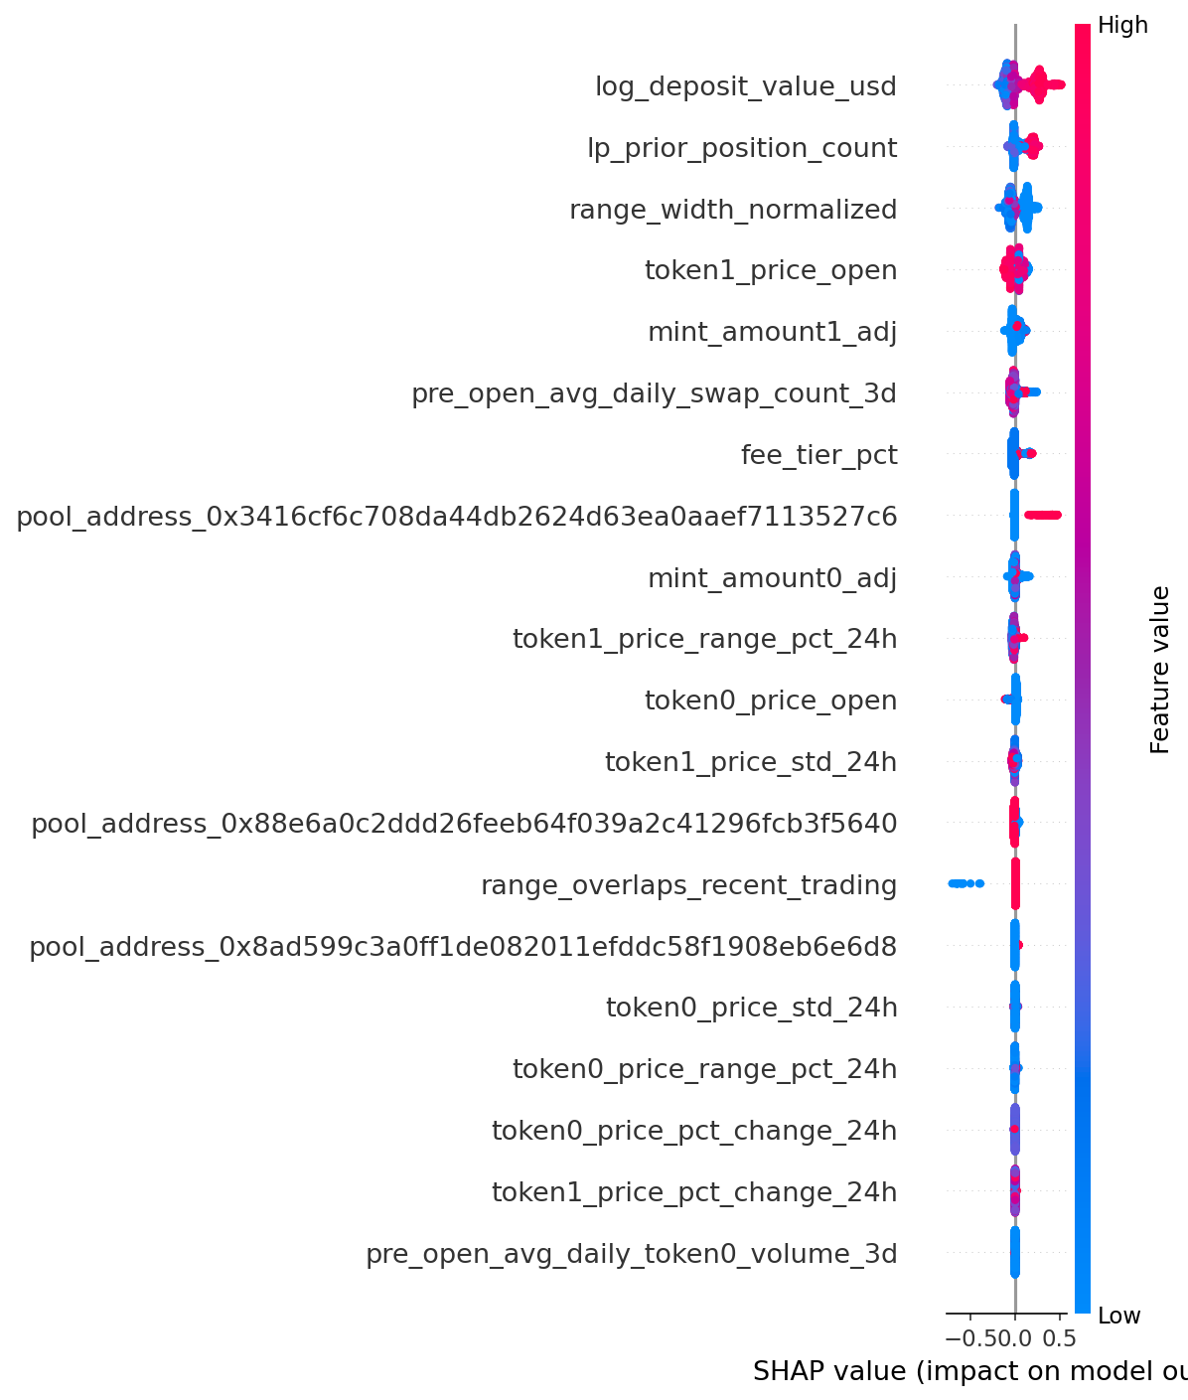
Figure 10: Decile lift, tuned XGBoost (V0 features, test)
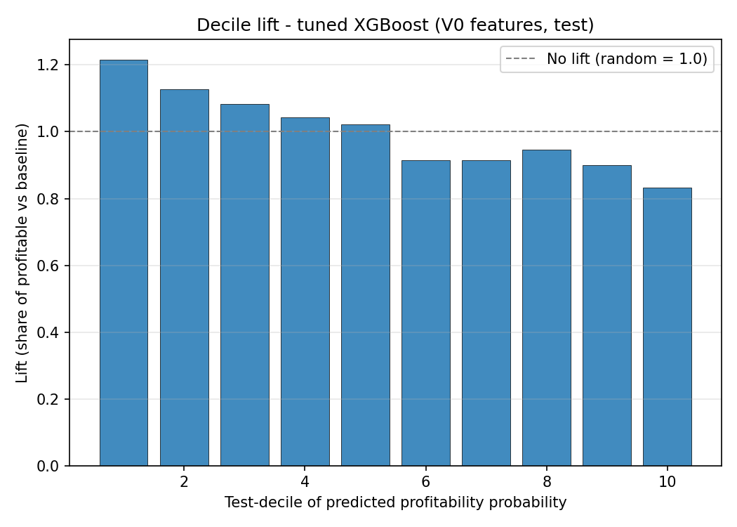
Figure 11: Cumulative gain, tuned XGBoost (V0 features, test)
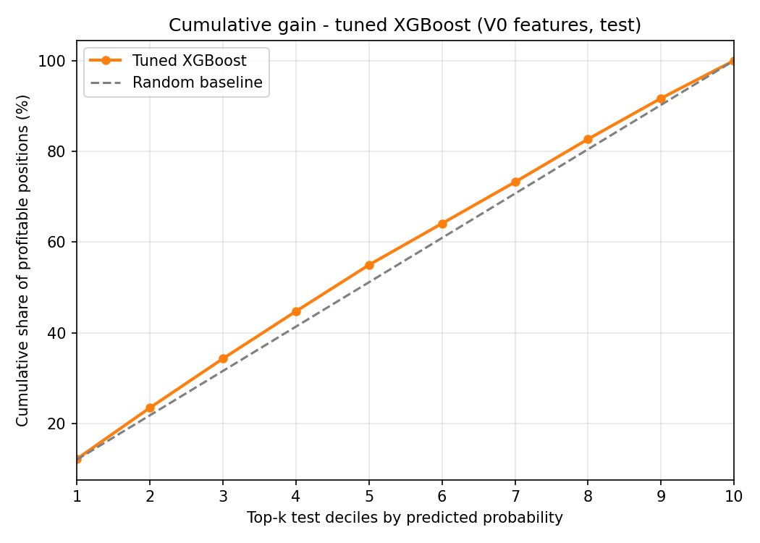
Figure 12: Calibration curve (tuned XGBoost, Logistic Regression, tuned Random Forest; test)
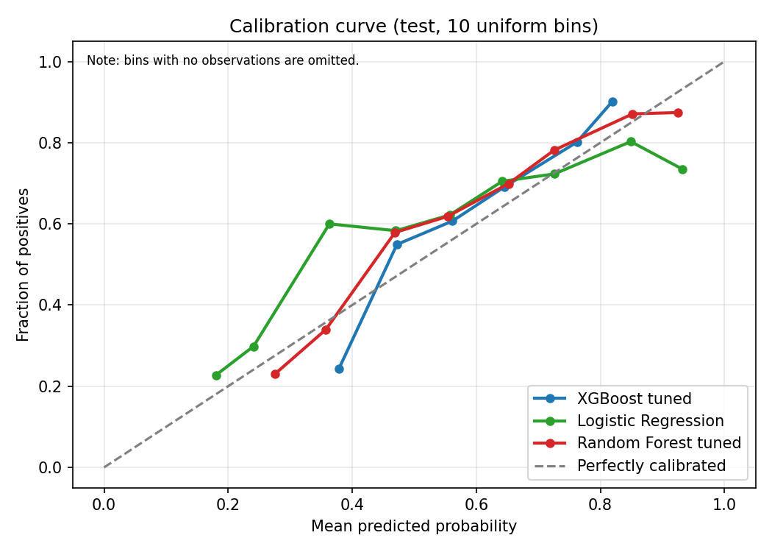
Figure 13: RFECV elimination curve (Logistic Regression and tuned XGBoost, 5-fold TimeSeriesSplit)
