Indian Institute of Technology, Kharagpur
Department of Computer Science and Engineering
Class Test 1
Object-Oriented Systems (CS60059)

Time= 50mins Max Marks=40
Important Instructions:
- Answer all questions
- No clarification to any of the questions shall be provided during examination. In case you have any questions, you can make any suitable assumptions you feel is absolutely necessary, but please write down your assumptions clearly.
- All answers should be brief and concise. Lengthy and irrelevant answers will be penalized.
Model Solutions

- Develop a class diagram to model the following: “A patient is a person having some symptoms of illness, and the patient can have many persons as relatives.” [4]

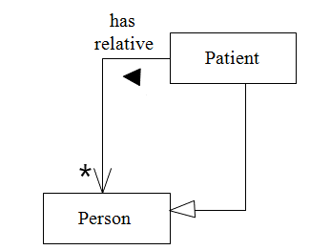

- Represent the following using a class diagram: A directory contains many files. A directory can contain many subdirectories, but has at most one parent directory. [5]
Model Ans:

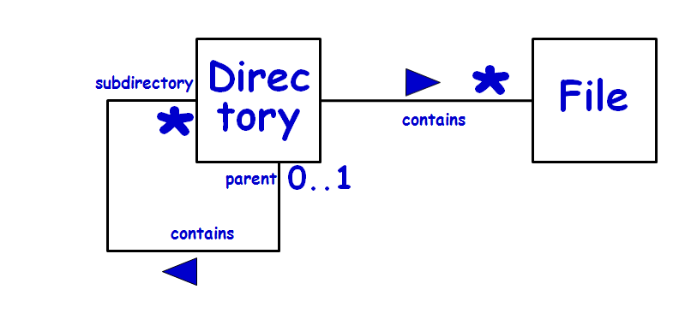

- Develop a class diagram for the following problem:
A hospital employs many doctors and has many registered patients. A patient can take an appointment with any of the doctors of the hospital on any specific date and at specific time. A patient can have multiple appointments even with the same doctor and even on the same day.

Show only classes and their relations; representation of attributes and methods for classes is not required. Write skeletal Java code for the Appointment class, as can be inferred from your class diagram. [7+2]

Model Answer:
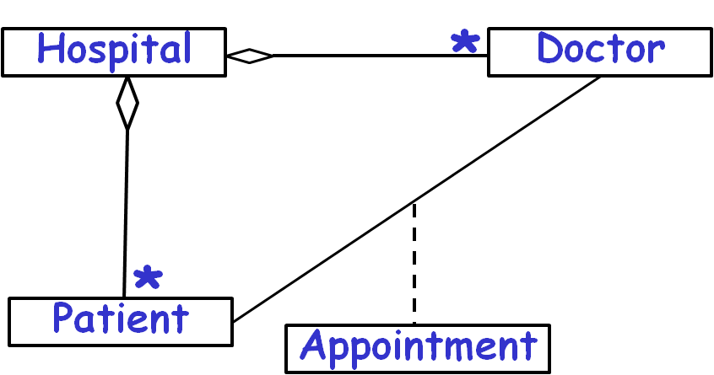

Class Appointment{
private Patient p;
private ArrayList <Doctor> doctors= new ArrayList <Doctor>();
}

- Draw a suitable UML class diagram to represent the following.
An Order consists of many Orderlines. Each Orderline refers to any single product, number of units ordered, the discount percentage applicable, and the total amount payable for the order line. There can be at most one order line for each product instance. The Order class should have putOL and getOL methods for adding an Orderline to an order and getting the details of an Orderline for a given Product.

Also write Java code for the Order class that [5+2]

Model Answer:

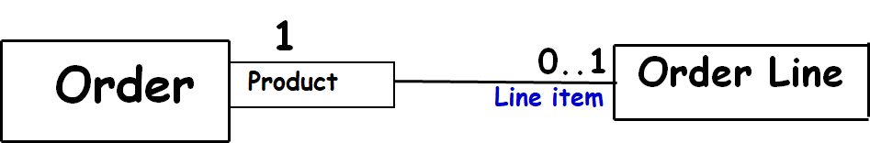

Class Order{
Map <Product, Orderline> ord = new HashMap<Product,Orderline>();
public OrderLine getOL(Product p) {return ord.get(p);}
public putOL(Product p, Orderline o) {
if(!ord.containsKey(p)) ord.put(p,o);}
}

- Consider a simple digital watch having 2 buttons labeled D and S. By default, the watch keeps displaying time (display mode) in hh:mm format, and the colon keeps flashing once every second. Pressing S button stops the time display and takes the watch to the set time mode. The set time mode has two sub modes: set hour and set minute. In the set time mode, the watch starts off in the set hour sub mode. In the set hour sub mode, pressing the D button, increments the hour display. Once the hour reading reaches 24, it resets to 00. Pressing S toggles between the set hour and set minute modes. In the set minute sub mode, pressing the D button, advances minute display. Once the minute reading reaches 60, it resets to 00. Pressing the buttons D and S together any time takes the watch to display mode and the watch resumes displaying the current time.
Develop the state chart model for the controller software of a watch whose behavior is described above. Use of composite states wherever required is recommended. [15]
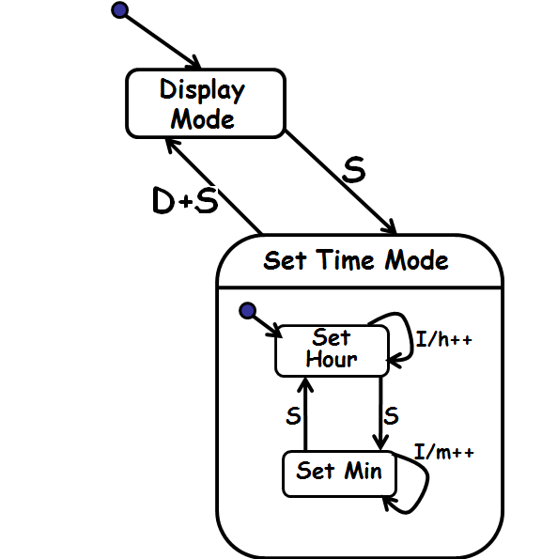

------------ The End ----------------

--- The End---

