OOS (CS60059) Class Test 2 02-11-2022
Time 60 mins. Marks: 40
Name: Roll Number:

- Consider the following Java code for generating a sequence of numbers using a singleton class called Sequence. The code for the getInstance method of the Sequence class is missing. Complete this missing code, assuming lazy instantiation. [4]
public class Sequence {
private static Sequence instance;
private static int counter;
private Sequence() {
counter = 0; }
public static synchronized Sequence getInstance(){
if(instance==null) // Lazy instantiation
{
instance = new Sequence();
}
return instance;
}
public static synchronized int getNext() {
return ++counter;
}
}
Each mistake deduct 1 mark

- Name the GRASP design pattern that can be used to improve the following design for a Graphical Editor application. Also write down the improved design arrived by using that pattern. [1+3]
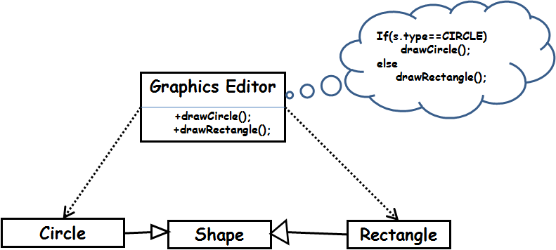
Ans: Indirection pattern
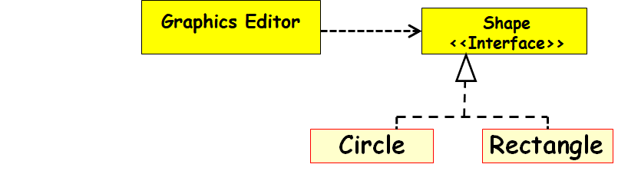
Each mistake deduct 1 mark

- A company has developed an HR (Human Resources) management system to automate its HR related book keeping activities. At present the company employs persons with basic degrees in accounting, computer, and management. These employee categories have different pay structure and service conditions. The employees are posted in any of the following three Departments: Office, Sale, and manufacturing. The programmer came up with the following design and has implemented the same. However, the company is at present undertaking an expansion, it is being felt that new employee types will be recruited and new Departments will be opened.
- Using at most two sentences explain the problems that the present HR software design can lead to. [2]
- Suggest a suitable design (class diagram) that can overcome your identified problems. Name the design pattern you are using. [4+1]

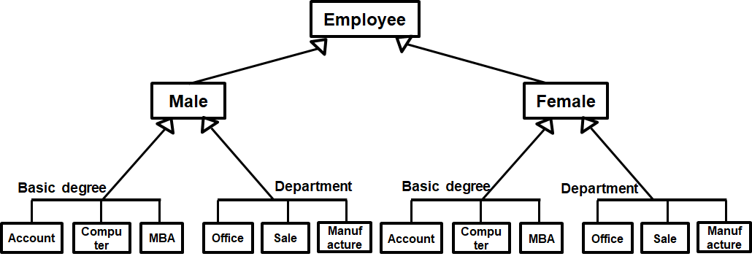

Ans:
- Reasons:
- Complexity arising due to proliferation of subclasses
- Difficult to modify: Addition of new types of emploees leads to changes to the employee.
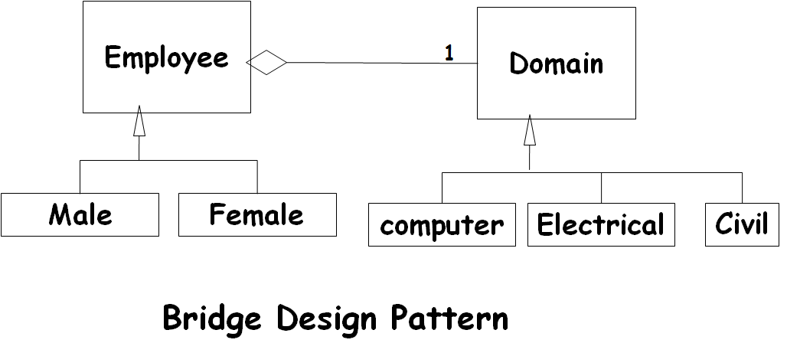
Each mistake deduct 1 mark

- Consider the following UML state machine diagram that models the state behaviour of an object of class named FSM that is part of a larger system.
- Give a design solution for an FSM object by using the State design Pattern. [4]
- Write skeletal Java Code corresponding to your state pattern solution for the class FSM. Among other things, your code must capture how the state changes take place on occurrence of an event. [4+2]
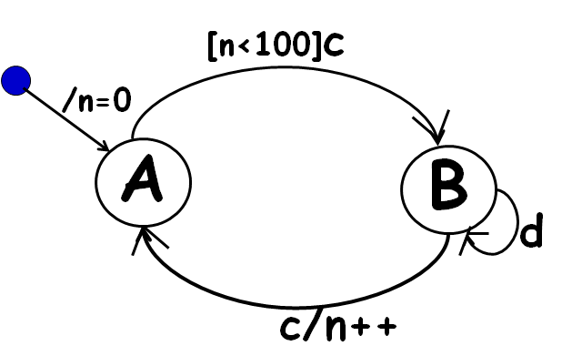
Ans:

*
State
<<abstract>>

FSM

A
B

Each mistake deduct 1 mark

class FSM {
private State[] states = { new A(), new B()};
private int n=0;
private int current = 0;
public void changeState(){current= current++ % 2};
public void c() { if(n<100 || current==1) changeState();
if(current==1) n++;
states[current].c();}
public void d() { states[current].d(); }
}
abstract class State {
public void c() { System.out.println( "error" ); }
public void d() { System.out.println( "error" ); }
}
class A extends State {
public void c() { }
public void d() { }
}
class B extends State {
public void c() { }
public void d() { }
}
Each mistake deduct 1 mark

- Assume that in a certain library, members can register their interest to receive notifications regarding any new books purchased by the library. A member may at anytime opt out of the notification option for which he might have registered. Assume that whenever a new book object is created in the library application, it would notify the registered members.
  - Give a solution to this problem (only class diagram) using the observer pattern . [5]
*
<<interface>>
Observer
Observable

Member
NewBookMonitor
report

Each mistake deduct 1 mark

  - Write skeletal Java code for your class design solution in Part a). You can use the built-in Java Observer/Observable, or you may write your own custom code. [5]
class NewBookMonitor extends Observable{
private Book b;
public void report(Book b) {
this.b=b;
}
Public Book getBookDetails(){
return b;}
}
Class Member Implements Observer{
void update(Observable sub, Object arg) {
sub.getBookDetails();}

Each mistake deduct 1 mark

- Draw the class diagram for the following Java code and identify the pattern it encodes. [4+1]
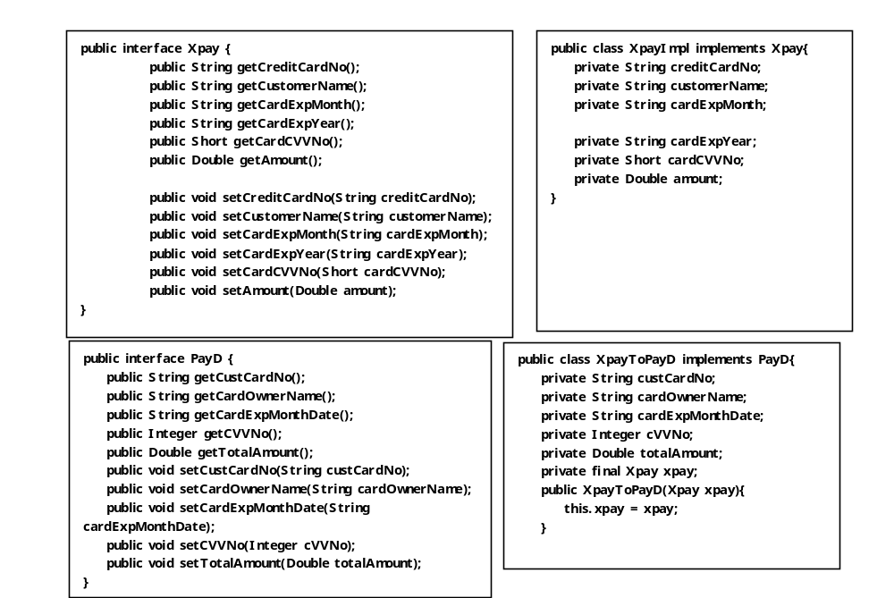
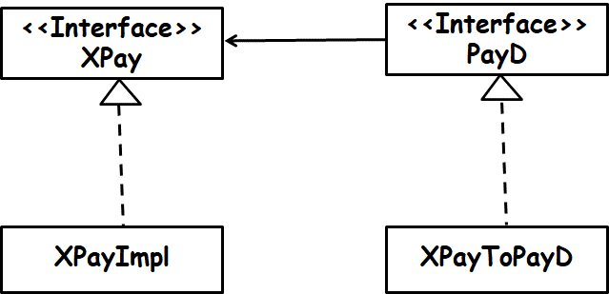
Ans:

Object Adapter Pattern

Each mistake deduct 1 mark
--------------- XXXXX ----------------

