EXPERIMENT NO: 1

**AIM**

Identification of resistors and capacitors.

**THEORY**

1. *Thevenin theorem*

Any linear electrical network containing only voltage sources, current sources and resistances can be replaced by an equivalent combination of a voltage source Vₜₕ in a series connection with a resistance Rₜₕ.

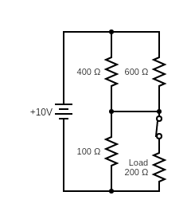For example, consider the following circuit.

The current through the load as measured using the circuit simulator comes out to be 10.87mA

The same can be derived using Thevenin’s theorem as shown below.

STEP 1: Finding Vₜₕ

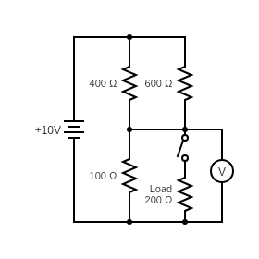

We disconnect the load from the circuit and measure the voltage drop across its end points.

*Rnet***=**  + 100 = 240 + 100 = 340 Ω

*Vₜₕ* = *I* * 100 = (10 / *Rnet* ) * 100 = 2.94 V

STEP 2: Finding Rₜₕ

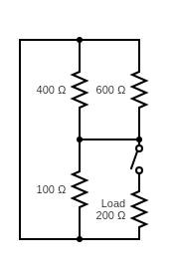

Resistance across end points of load =

$\frac{1}{\frac{1}{100}+\frac{1}{400}+\frac{1}{600}}$ = 70.59 Ω

STEP 3: Equivalent circuit

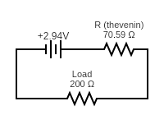

Current through load = $\frac{2.94}{200+70.59}$ = 10.87 mA

Which matches with the experimentally found value using the simulator.

1. *Voltage divider*

A voltage divider is a passive linear circuit that is used to lower the input voltage by a specific factor and get the corresponding output voltage.

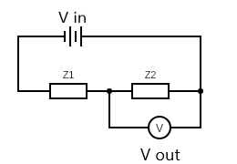

The current in the circuit is given by *I* = $\frac{Vin}{Z1+Z2}$

Thus, we get the output across *Z2* as follows

*Vout = I * Z2 = Vin \**

We define the transfer function *H* as the ratio of output voltage to input voltage.

*H = $\frac{Vout}{Vin}$ = $\frac{Z2}{Z1+Z2}$*

**PROCEDURE**

|  |  |  |  |  |  |
| --- | --- | --- | --- | --- | --- |
| Color | 1st Band | 2nd Band | 3rd Band | Multiplier (Ω) | Tolerance (%) |
| BLACK | 0 | 0 | 0 | X 1 |  |
| BROWN | 1 | 1 | 1 | X 10 | 1 |
| RED | 2 | 2 | 2 | X 100 | 2 |
| ORANGE | 3 | 3 | 3 | X 1K |  |
| YELLOW | 4 | 4 | 4 | X 10K |  |
| GREEN | 5 | 5 | 5 | X 100K | 0.5 |
| BLUE | 6 | 6 | 6 | X 1M | 0.25 |
| VIOLET | 7 | 7 | 7 | X 10M | 0.1 |
| GREY | 8 | 8 | 8 |  | 0.05 |
| WHITE | 9 | 9 | 9 |  |  |
| GOLD |  |  |  | X 0.1 | 5 |
| SILVER |  |  |  | X 0.01 | 10 |

1. *Identification of resistors*

* if the last band is absent then tolerance is 20%

For example, consider the following resistor:

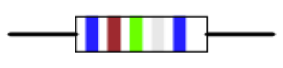

(image source: <http://vlabs.iitkgp.ernet.in/be/exp1/index.html>)

Band 1: Blue – 6

Band 2: Brown – 1

Band 3: Green – 5

Band 4: Silver – X 0.01 Ω

Band 5: Blue – ±0.25%

Ans. Hence the resistor value is given as 6.15 Ω ± 0.25%

1. *Identification of capacitors*

Large capacitors have their value printed on them directly. Small capacitors, on the other hand have 2 or 3 numbers written on them, sometimes followed by a letter. The first two numbers represent the capacitance in pico-farads. The third number (if present) represents the multiplier. The letter represents the tolerance.

|  |  |
| --- | --- |
| Third digit | Multiplier (pF) |
| 0 | 1 |
| 1 | 10 |
| 2 | 100 |
| 3 | 1K |
| 4 | 10K |
| 5 | 100K |
| 6 | Not used |
| 7 | Not used |
| 8 | 0.01 |
| 9 | 0.1 |

|  |  |
| --- | --- |
| Letter symbol | Tolerance |
| D | ±0.5 pF |
| F | ±1 % |
| G | ±2 % |
| H | ±3 % |
| J | ±5 % |
| K | ±10 % |
| M | ±20 % |
| P | +100 %, -0 % |
| Z | +80 %, -20 % |

For example, consider the following capacitor:

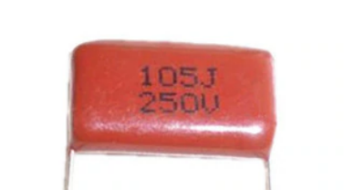

(image source: <https://www.aliexpress.com/item/1745908778.html>)

Ans. Capacitor value is 10 * 100K pF ± 5% = 1µF ± 5%

**DISCUSSION QUESTIONS**

Q. A capacitor is connected in series with a battery and an ammeter. What will you observe when the switch is closed?

A. As soon as the switch is closed, charge will flow from the battery onto the plate of the capacitor. This is an instantaneous process. Thus, we will observe that the ammeter momentarily flicks as the switch is closed and then comes back to zero.

Q. In the above circuit a two-way switch is installed which makes it possible to disconnect the battery from the circuit and put the capacitor directly in series with the ammeter. Initially the battery is in series with the capacitor and ammeter. Now the position of switch is changed. What will you observe?

A. Initially the capacitor was charged. As soon as we removed the battery from the circuit the plates of the capacitor become shorted and charge flows in the reverse direction as before. Thus, we will observe that now the ammeter flicks in the opposite direction compared to the direction it flicked during the charging process. Again, this too will be an instantaneous process.

**CONCLUSION**

We can now successfully identify a resistor and capacitor and find their values using the rules as discussed in the experiment.

*Report of*

*Nisarg Upadhyaya*

*19CS30031*