EXPERIMENT NO: 2

**AIM**

Study of RC, CR, RL, and LR circuits as passive filters.

**THEORY**

1. *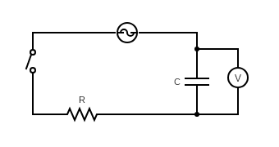Low Pass RC Filter*

Consider the following circuit with an AC voltage source *Vin* of angular frequency *w*, resistance *R* and capacitance *C*. Output *Vout* is measured across the capacitor.

Let impedance of circuit = *Z*, and current through circuit = *I* then we have

*Vin = I * Z* and *Vout = I * Xc*

On dividing the two we obtain

$\frac{Vout}{Vin}$*= $\frac{Xc}{Z}$ = $\frac{Xc}{R+Xc}$ = $\frac{\frac{1}{jwC}}{R+ \frac{1}{jwC}}$ = $\frac{1}{1+jwRC}$*

The magnitude in decibels can be calculated as

*Magnitude* = *20 $\log_{10}{(|\frac{Vout}{Vin}|)}$\** = *20 $\log_{10}{(|\frac{1}{1+jwRC}|)}$* = 20 $\log_{10}{(\frac{1}{\sqrt{1+ {(wRC)}^{2}}})}$

\**

The cut-off frequency (at which $\frac{Vout}{Vin}= \frac{1}{\sqrt{2}}$) is given by

*f3db =*

Note that for small values of *w* the voltage drop is primarily across the capacitor (the ratio of *Vout* to *Vin* is close to 1), and as we increase *w* the voltage drop across the capacitor starts to decrease and becomes almost zero for large frequencies. As we obtain a significant output only for the lower frequencies, we say that this circuit behaves as a Low Pass Filter.

1. *High Pass CR Filter*

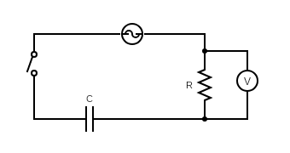Consider the following circuit with an AC voltage source *Vin* of angular frequency *w*, resistance *R* and capacitance *C*. Output *Vout* is measured across the resistor.

Let impedance of circuit = *Z*, and current through circuit = *I* then we have

*Vin = I * Z* and *Vout = I * R*

On dividing the two we obtain

*= = = =*

The magnitude in decibels can be calculated as

*Magnitude* = *20 $\log_{10}{(|\frac{Vout}{Vin}|)}$\** = *20 $\log_{10}{(|\frac{jwRC}{1+jwRC}|)}$* = 20 $\log_{10}{(\frac{wRC}{\sqrt{1+ {(wRC)}^{2}}})}$

\**

The cut-off frequency (at which $\frac{Vout}{Vin}= \frac{1}{\sqrt{2}}$) is given by

*f3db =*

Note that for large values of *w* the voltage drop is primarily across the resistor (the ratio of *Vout* to *Vin* is close to 1), and as we decrease *w* the voltage drop across the resistor starts to decrease and becomes almost zero for small frequencies. As we obtain a significant output only for the higher frequencies, we say that this circuit behaves as a High Pass Filter.

1. *Low Pass LR Filter*

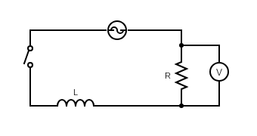

Consider the following circuit with an AC voltage source *Vin* of angular frequency *w*, resistance *R* and inductance *L*. Output *Vout* is measured across the resistor.

Let impedance of circuit = *Z*, and current through circuit = *I* then we have

*Vin = I * Z* and *Vout = I * R*

On dividing the two we obtain

*= = =*

The magnitude in decibels can be calculated as

*Magnitude* = *20 $\log_{10}{(|\frac{Vout}{Vin}|)}$\** = *20 $\log_{10}{(|\frac{R}{R+jwL}|)}$* = 20 $\log_{10}{(\frac{R}{\sqrt{R^{2}+ {(wL)}^{2}}})}$

\**

The cut-off frequency (at which $\frac{Vout}{Vin}= \frac{1}{\sqrt{2}}$) is given by

*f3db =*

Note that for small values of *w* the voltage drop is primarily across the resistor (the ratio of *Vout* to *Vin* is close to 1), and as we increase *w* the voltage drop across the resistor starts to decrease and becomes almost zero for large frequencies. As we obtain a significant output only for the lower frequencies, we say that this circuit behaves as a Low Pass Filter.

1. 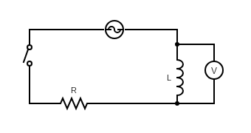*High Pass RL Filter*

Consider the following circuit with an AC voltage source *Vin* of angular frequency *w*, resistance *R* and inductance *L*. Output *Vout* is measured across the inductor.

Let impedance of circuit = *Z*, and current through circuit = *I* then we have

*Vin = I * Z* and *Vout = I * Xl*

On dividing the two we obtain

$\frac{Vout}{Vin}$*= $\frac{Xl}{Z}$ = $\frac{Xl}{R+Xl}$ = $\frac{jwL}{R +jwL }$*

The magnitude in decibels can be calculated as

*Magnitude* = *20 $\log_{10}{(|\frac{Vout}{Vin}|)}$\** = *20 $\log_{10}{(|\frac{jwL}{R+jwL}|)}$* = 20 $\log_{10}{(\frac{wL}{\sqrt{R^{2}+ {(wL)}^{2}}})}$

\**

The cut-off frequency (at which $\frac{Vout}{Vin}= \frac{1}{\sqrt{2}}$) is given by

*f3db =*

Note that for large values of *w* the voltage drop is primarily across the inductor (the ratio of *Vout* to *Vin* is close to 1), and as we decrease *w* the voltage drop across the inductor starts to decrease and becomes almost zero for small frequencies. As we obtain a significant output only for the higher frequencies, we say that this circuit behaves as a High Pass Filter.

**PROCEDURE**

The simulations are carried out in Falstad Simulator. For each filter the output voltage is measured for a particular input voltage at different frequencies. The observed values of magnitude (*20 $\log_{10}{(\frac{Vout}{Vin})}$\** ) are compared with the theoretical values (both in dB) obtained by using the transfer functions derived before and a graph of Magnitude vs Frequency is plotted for each filter.

1. *Low Pass RC Filter*

|  |  |  |  |  |
| --- | --- | --- | --- | --- |
| f (Hz) | Vin (V) | Vout (V) | Observed Magnitude (dB)  *20 \** | Theoretical Magnitude (dB)  *20 \** |
| 50 | 5 | 4.998 | -0.003 | -0.004 |
| 150 | 5 | 4.978 | -0.038 | -0.038 |
| 450 | 5 | 4.811 | -0.335 | -0.334 |
| 1300 | 5 | 3.872 | -2.221 | -2.220 |
| 3800 | 5 | 1.930 | -8.268 | -8.261 |
| 6500 | 5 | 1.185 | -12.505 | -12.475 |
| 11500 | 5 | 0.678 | -17.355 | -17.260 |
| 25000 | 5 | 0.301 | -24.408 | -23.940 |

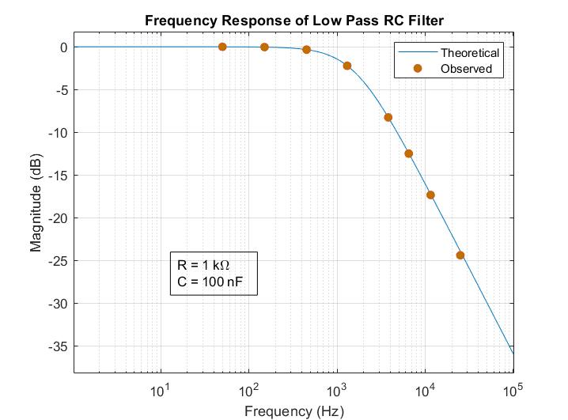 R = 1kΩ, C = 100nF, *f3db* = 1591.55Hz

1. *High Pass CR Filter*

R = 1kΩ, C = 100nF, *f3db* = 1591.55Hz

|  |  |  |  |  |
| --- | --- | --- | --- | --- |
| f (Hz) | Vin (V) | Vout (V) | Observed Magnitude (dB)  *20 \** | Theoretical Magnitude (dB)  *20 \** |
| 50 | 5 | 0.157 | -30.061 | -30.061 |
| 150 | 5 | 0.469 | -20.556 | -20.553 |
| 450 | 5 | 1.360 | -11.309 | -11.306 |
| 1300 | 5 | 3.163 | -3.977 | -3.977 |
| 3800 | 5 | 4.613 | -0.700 | -0.702 |
| 6500 | 5 | 4.857 | -0.252 | -0.253 |
| 11500 | 5 | 4.954 | -0.080 | -0.082 |
| 25000 | 5 | 4.982 | -0.031 | -0.018 |

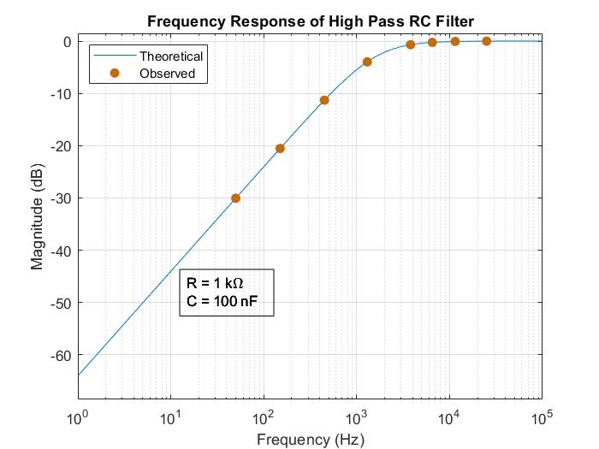

1. *Low Pass LR Filter*

|  |  |  |  |  |
| --- | --- | --- | --- | --- |
| f (Hz) | Vin (V) | Vout (V) | Observed Magnitude (dB)  *20 \** | Theoretical Magnitude (dB)  *20 \** |
| 50 | 5 | 4.939 | -0.107 | -0.106 |
| 150 | 5 | 4.523 | -0.871 | -0.871 |
| 450 | 5 | 2.887 | -4.770 | -4.769 |
| 1300 | 5 | 1.189 | -12.476 | -12.475 |
| 3800 | 5 | 0.417 | -21.577 | -21.569 |
| 6500 | 5 | 0.244 | -26.232 | -26.212 |
| 11500 | 5 | 0.137 | -31.245 | -31.160 |
| 25000 | 5 | 0.060 | -38.416 | -37.903 |

R = 1kΩ, L = 0.5H, *f3db* = 318.31Hz

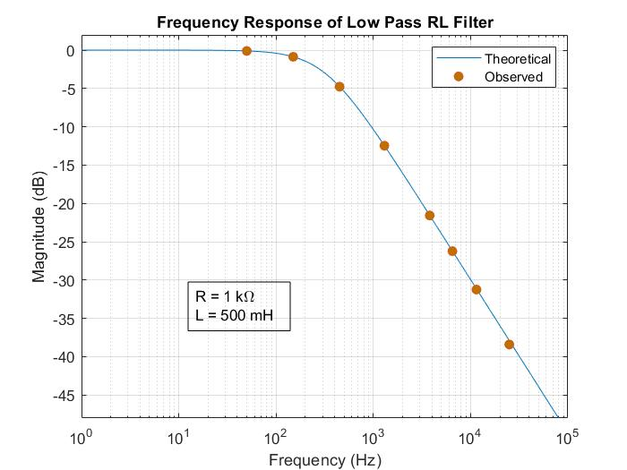

1. *High Pass RL Filter*

R = 1kΩ, L = 0.5H, *f3db* = 318.31Hz

|  |  |  |  |  |
| --- | --- | --- | --- | --- |
| f (Hz) | Vin (V) | Vout (V) | Observed Magnitude (dB)  *20 \** | Theoretical Magnitude (dB)  *20 \** |
| 50 | 5 | 0.776 | -16.182 | -16.184 |
| 150 | 5 | 2.131 | -7.408 | -7.406 |
| 450 | 5 | 4.082 | -1.762 | -1.762 |
| 1300 | 5 | 4.857 | -0.252 | -0.253 |
| 3800 | 5 | 4.983 | -0.030 | -0.030 |
| 6500 | 5 | 4.994 | -0.010 | -0.010 |
| 11500 | 5 | 4.998 | -0.003 | -0.003 |
| 25000 | 5 | 4.999 | -0.002 | -0.001 |

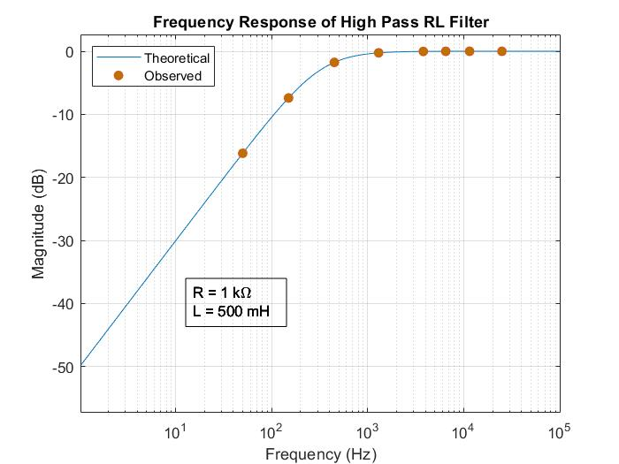

**CONCLUSION**

We have successfully analyzed the behavior of different high pass and low pass filters and understood their characteristics.

*Report of*

*Nisarg Upadhyaya*

*19CS30031*

*\*All graphs plotted using MATLAB*