EXPERIMENT NO: 3

**AIM**

To study the behavior of half wave and full wave rectifier with and without filter.

**THEORY**

1. *Half wave rectifier*

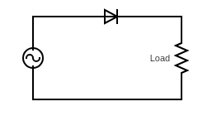If we measure the output across the load, we will observe that we only get non zero output for half the time period when the diode is in forward bias. When the diode is reverse biased the current through the load is 0 and so is the voltage drop across it. Thus, it is also called half-wave rectifier.

Let the input voltage be given by *Vs = Vm sin(wt)*

Then across the load we can find

$$V_{avg}=\frac{1}{T}*\int_{0}^{T}{V_{load}\left(t\right)dt}=\frac{1}{T}*\int_{0}^{T/2}{V_{m}sin\left(wt\right)dt=\frac{V_{m}}{π}}$$

$$V_{rms}=\sqrt{\frac{1}{T}*\int_{0}^{T}{{V_{load}}^{2}(t)dt}}=V_{m}*\sqrt{\frac{1}{T}*\int_{0}^{\frac{T}{2}}{\sin^{2}\left(wt\right)dt}}=\frac{V_{m}}{2}$$

$$Ripple factor=\frac{\sqrt{{V_{rms}}^{2}-{V_{avg}}^{2}}}{V_{avg}}=1.21$$

1. *Full wave rectifier*

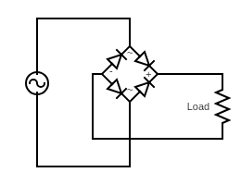If we measure the voltage across the load then in this case, we get non zero output for the complete time period. The output voltage is rectified (it is positive for both the half cycles of the input voltage). In the positive half cycle D2 and D4 conduct whereas in the negative half cycle D1 and D3 conduct. As we get non zero rectified output for the complete cycle it is also called full wave rectifier.

D1

D2

Let the input voltage be given by *Vs = Vm sin(wt)*

Then across the load we can find

$$V_{avg}=\frac{1}{T}*\int_{0}^{T}{V_{load}\left(t\right)dt}=\frac{1}{T}*\int_{0}^{T}{V_{m}sin\left(wt\right)dt=\frac{2V_{m}}{π}}$$

$$V_{rms}=\sqrt{\frac{1}{T}*\int_{0}^{T}{{V_{load}}^{2}(t)dt}}=V_{m}*\sqrt{\frac{1}{T}*\int_{0}^{T}{\sin^{2}\left(wt\right)dt}}=\frac{V_{m}}{\sqrt{2}}$$

$$Ripple factor=\frac{\sqrt{{V_{rms}}^{2}-{V_{avg}}^{2}}}{V_{avg}}=0.48$$

D3

D4

1. *Full wave rectifier with filter*

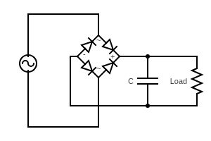If we add a capacitor with a suitable value across the load then due to the large time constant of the RC circuit the capacitor discharges slowly and hence while the rectified output drops down to zero the output across the load doesn’t change much and again as the rectified output starts rising it charges the capacitor back to the peak value before the whole process repeats again. We get the output across the load as shown by the red line in the graph below.

Vmax

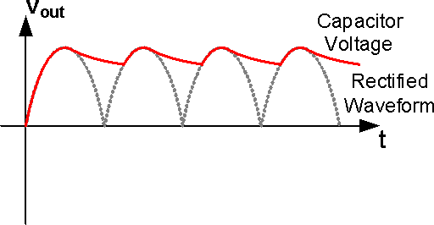

Vmin

, where t` is the time of discharging.

Now, if *RC >> T* (where *T* is the time period of the AC input) then we can approximate $e^{\frac{-t`}{RC}}$ using Taylor series.

$$e^{\frac{-t`}{RC}}=1-\frac{t`}{RC}=1-\frac{T}{2RC}$$

Where we approximated t` to T/2 as the discharging process is very slow and can be assumed to continue till the next peak of the rectified output is encountered. Using the above equations, we can now write

$$Ripple Voltage=\frac{V_{max}T}{2RC}=\frac{V_{max}}{2fRC}$$

**PROCEDURE**

1. *Half wave rectifier*

Select the half wave rectifier circuit in falstad circuit simulator. Set the value of load resistance to 1kohm, peak input voltage to 5V and frequency to 50Hz. Run the simulation and get the peak and rms value of the output voltage from the output waveform. Calculate the ripple factor and compare it with the theoretical value.

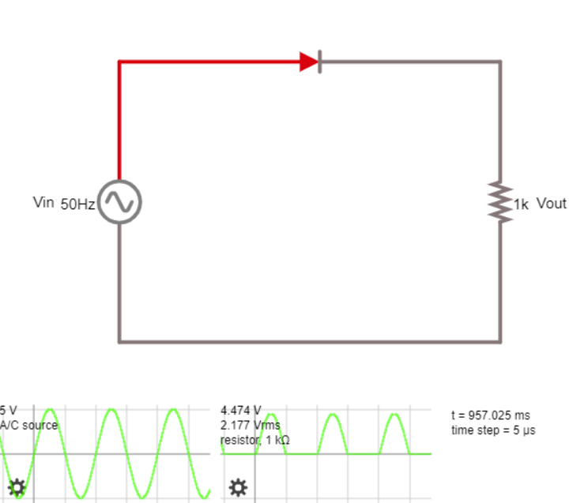

For *R =* 1kΩ

|  |  |  |  |
| --- | --- | --- | --- |
| *Vin* (peak) (V) | *Vout* (peak) (V) | *Vout* (rms) (V) | *Vout* (dc) (V) |
| 5 | 4.474 | 2.177 | 1.424 |

Observed ripple factor = $\frac{\sqrt{{V_{rms}}^{2}- {V_{dc}}^{2}}}{V_{dc}}$ = 1.16

Theoretical ripple factor = 1.21

Percentage error = $\frac{1.21-1.16}{1.21}*100$ = 4.13%

1. *Full wave rectifier*

Select the full wave rectifier circuit in falstad circuit simulator. Set the value of load resistance to 1kohm, peak input voltage to 5V and frequency to 50Hz. Run the simulation and get the peak and rms value of the output voltage from the output waveform. Calculate the ripple factor and compare it with the theoretical value.

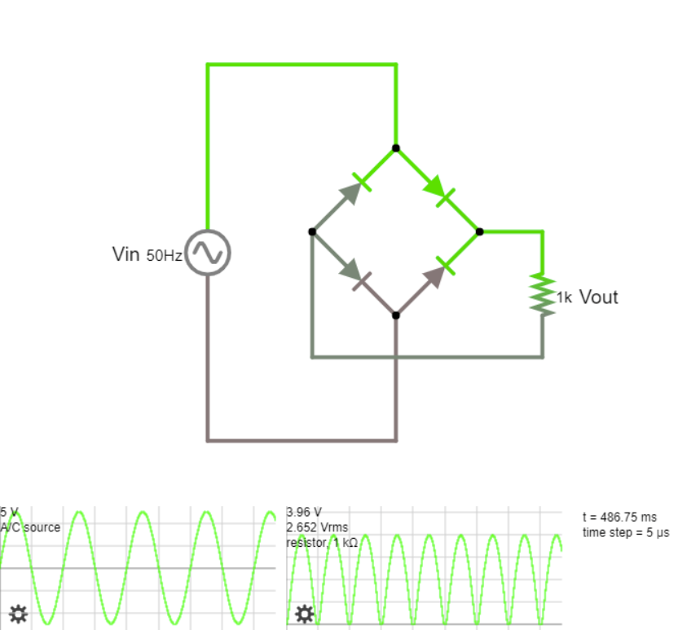

For *R =* 1kΩ

|  |  |  |  |
| --- | --- | --- | --- |
| *Vin* (peak) (V) | *Vout* (peak) (V) | *Vout* (rms) (V) | *Vout* (dc) (V) |
| 5 | 3.960 | 2.652 | 2.521 |

Observed ripple factor = $\frac{\sqrt{{V_{rms}}^{2}- {V_{dc}}^{2}}}{V_{dc}}$ = 0.33

Theoretical ripple factor = 0.48

Percentage error = $\frac{0.48-0.33}{0.48}*100$ = 31.25%

1. *Full wave rectifier with filter*

Select the full wave rectifier with filter circuit in falstad circuit simulator. Set the value of load resistance to 1kohm, parallel capacitance to 100uF, peak input voltage to 5V and frequency to 50Hz. Run the simulation and get the maximum and minimum values of the output voltage from the output waveform. Calculate the ripple voltage and compare it with the theoretical value.

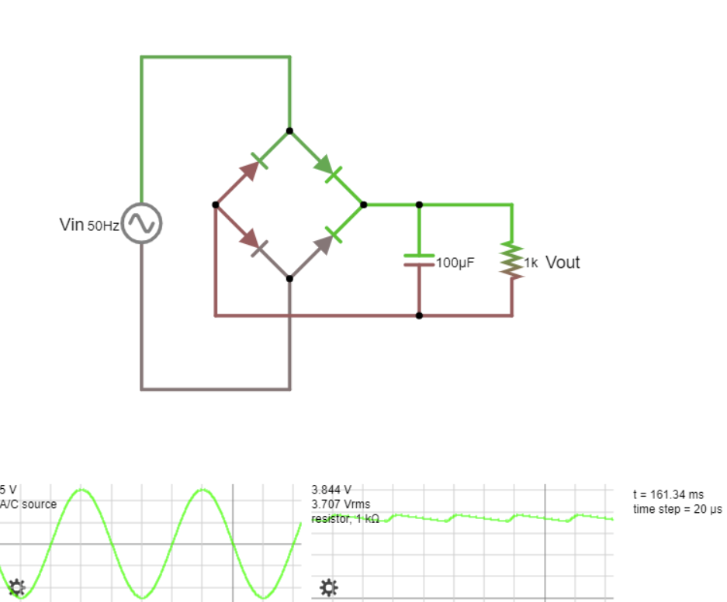

For *R =* 1kΩand *C* = 100uF

|  |  |  |  |
| --- | --- | --- | --- |
| *Vin* (peak) (V) | *Vout* (max) (V) | *Vout* (min) (V) | *Vripple* (*Vout, max* -*Vout, min*) (V) |
| 5 | 3.844 | 3.563 | 0.281 |

Observed ripple voltage = 0.281V

Theoretical ripple voltage = $\frac{V_{out, max} }{2fRC}$ = $\frac{3.844}{2*50*(1*{10}^{3})*(100*{10}^{-6})}$ = 0.384V

Percentage error = $\frac{0.384-0.281}{0.384}*100$ = 26.82%

**CONCLUSION**

We have successfully analyzed the behavior of half wave and full wave rectifiers with and without filter and learnt about the various characteristic quantities such as ripple factor, ripple voltage and AC, DC and RMS values of current and voltage in these circuits.

*Report of*

*Nisarg Upadhyaya*

*19CS30031*