EXPERIMENT NO: 4

**AIM**

Study of small signal common emitter amplifier.

**THEORY**

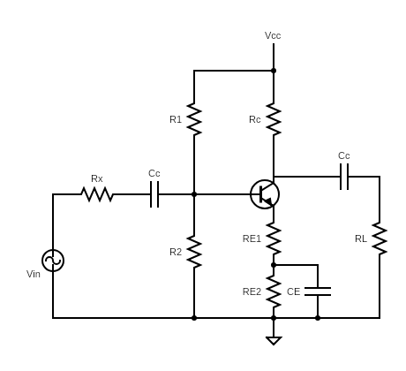

**FIGURE 1**

Bipolar junction transistors can be used as signal amplifiers when operated in their active region. However, for the amplification to take place the input signal amplitude must be small. If the input signal amplitude exceeds a certain value then the output starts getting clipped. The voltage after which the output starts getting clipped is denoted by *Vsm* and is known as the signal handling capacity of the BJT amplifier. One must ensure that the input voltage amplitude is well below the signal handling capacity. Also, the quotient point must be selected suitably so that the variation in voltage due to the input signal doesn’t drive the BJT into the cutoff or saturation mode. The frequency of the input signal also plays an important role in determining the gain of the amplifier. It is observed that for very small and very high frequencies the gain is only suboptimal. Maximum gain is observed at mid-range frequencies.

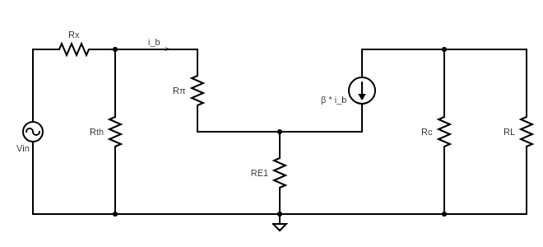SMALL SIGNAL AC EQUIVALENT CIRCUIT

**FIGURE 2**

To carry out the AC analysis of the amplifier we construct the small signal AC equivalent circuit. It is also called the hybrid-pi model. For the common emitter amplifier shown in figure 1, its hybrid-pi is the circuit shown in figure 2.

Here we have

$$R_{th}=R_{1}||R_{2}=\frac{R_{1}R_{2}}{R_{1}+R_{2}}$$

$$R_{π}=\frac{βV_{T}}{I_{CQ}},$$

$$where I_{CQ}=DC collector current at Q-point,$$

$$and V_{T}=thermal voltage at given temoerature.$$

Also, we define the input resistance as resistance as seen from the source which in this case comes out to be

$$R_{in}=R_{th}||{(R}_{π}+\left(1+β\right)R_{E1})$$

**PROCEDURE**

1. 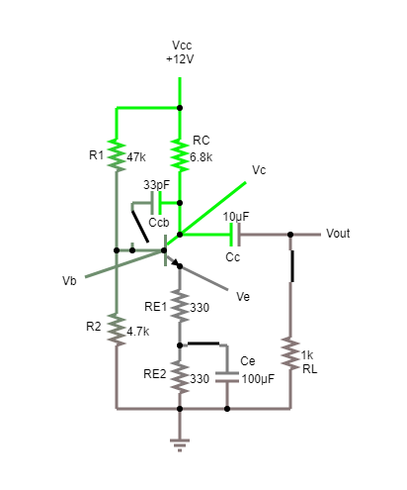*Measurement of DC conditions*

The transistor is in active region if the base emitter junction is forward biased and base collector junction is reverse biased. From the readings we can see that *VBE > 0* and *VCB > 0* which satisfy both the conditions. Hence the transistor is in active region and can be used as an amplifier.

|  |  |  |  |  |  |  |  |
| --- | --- | --- | --- | --- | --- | --- | --- |
| *VB*  *(V)* | *VC*  *(V)* | *VE*  *(V)* | *VBE*  *(V)* | *VCB*  *(V)* | *VCE*  *(V)* | *IC =*  *(mA)* | *IE =*  *(mA)* |
| 1.061 | 7.167 | 0.474 | 0.587 | 6.106 | 6.693 | 0.711 | 0.718 |

1. *Measurement of Signal Handling Capacity*
2. *Without Load Resistance*

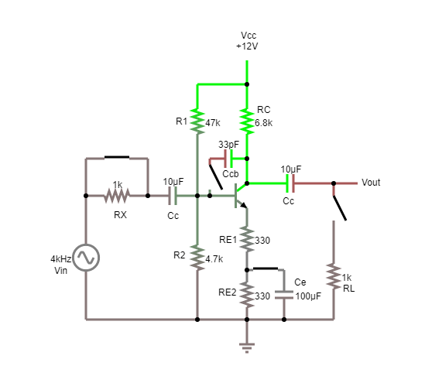

|  |  |  |
| --- | --- | --- |
| *Vin*  (V) | *Vout*  (V) | Gain = $\frac{Vout}{Vin}$ |
| 0.100 | 1.827 | 18.270 |
| 0.150 | 2.722 | 18.147 |
| 0.200 | 3.588 | 17.940 |
| 0.250 | 4.395 | 17.580 |
| 0.300 | 5.083 | 16.943 |
| 0.350  (output starts getting clipped) | 5.528 | 15.794 |
| 0.400 | 5.553 | 13.883 |
| 0.450 | 5.554 | 12.342 |
| 0.500 | 5.555 | 11.110 |

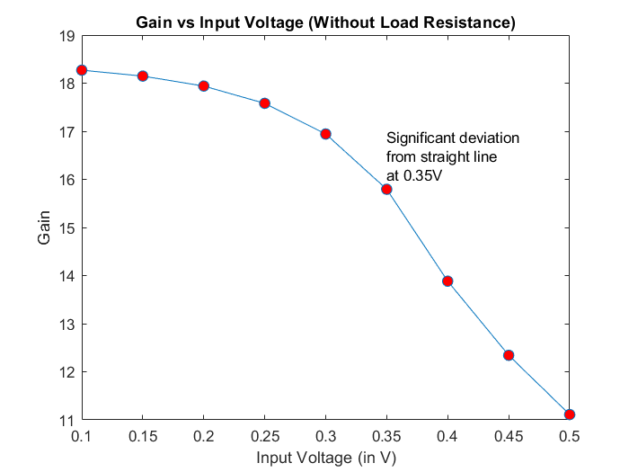

1. *With Load Resistance*

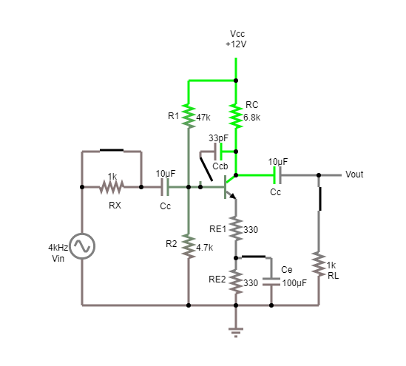

|  |  |  |
| --- | --- | --- |
| *Vin*  (V) | *Vout*  (V) | Gain = $\frac{Vout}{Vin}$ |
| 0.100 | 0.235 | 2.350 |
| 0.150 | 0.349 | 2.327 |
| 0.200 | 0.460 | 2.300 |
| 0.250 | 0.564 | 2.256 |
| 0.300  (output starts getting clipped) | 0.651 | 2.170 |
| 0.350 | 0.720 | 2.057 |
| 0.400 | 0.776 | 1.940 |
| 0.450 | 0.829 | 1.842 |
| 0.500 | 0.881 | 1.762 |

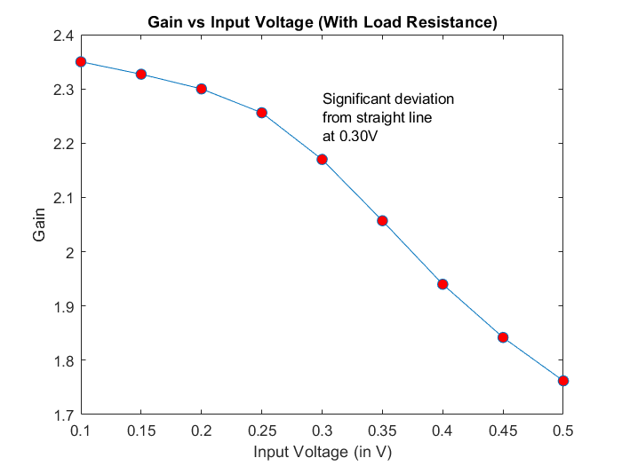

From the above two plots we can see that once the amplitude of the input voltage rises above 0.30-0.35V the output starts getting clipped. This is roughly where the small signal approximation fails. Also, the signal handling capacity is slightly reduced from 0.35V to 0.30V on introduction of a load resistance.

1. *Measurement of Frequency Response*
2. *Effect of Load Resistance*
   1. *With Load Resistance*

|  |  |  |  |
| --- | --- | --- | --- |
| *Vin*  (mV) | *Vout*  (mV) | Frequency  (Hz) | $$20*\log_{10}(\frac{Vout}{Vin})$$ (dB) |
| 100 | 113 | 5 | 1.062 |
| 100 | 173 | 10 | 4.761 |
| 100 | 204 | 15 | 6.193 |
| 100 | 225 | 20 | 7.044 |
| 100 | 231 | 50 | 7.272 |
| 100 | 232 | 500 | 7.310 |
| 100 | 232 | 1k | 7.310 |
| 100 | 232 | 10k | 7.310 |
| 100 | 232 | 100k | 7.310 |
| 100 | 231 | 1M | 7.272 |
| 100 | 227 | 3M | 7.121 |
| 100 | 219 | 5M | 6.809 |
| 100 | 208 | 7M | 6.361 |
| 100 | 189 | 10M | 5.529 |
| 100 | 157 | 15M | 3.918 |
| 100 | 128 | 20M | 2.144 |

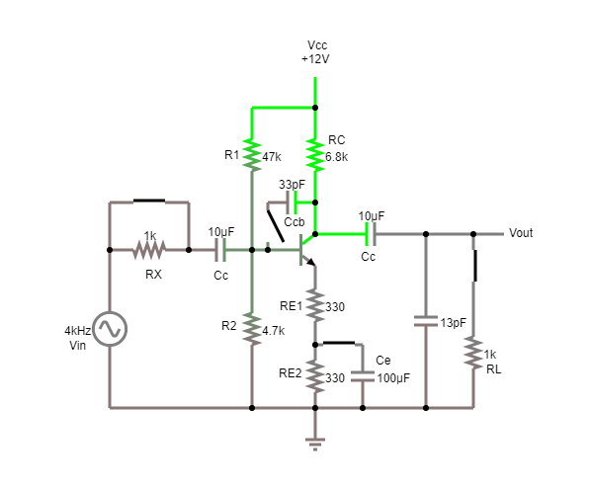

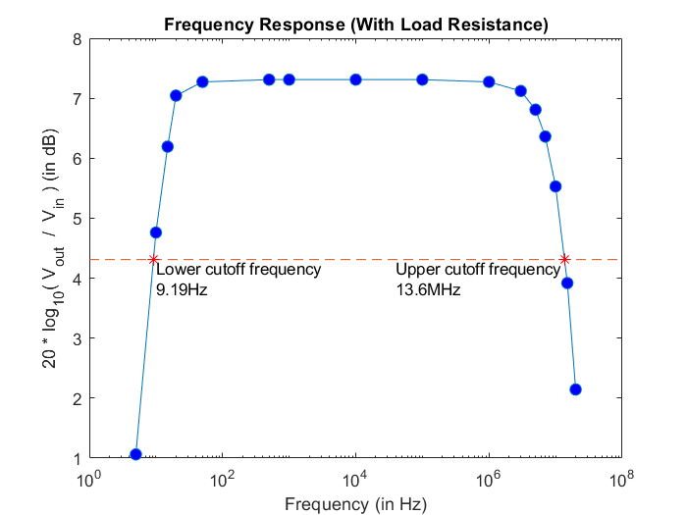

To get the lower and upper cutoff frequencies we plot the -3dB line (i.e., maximum gain (in dB) – 3) which in this case is 7.31 – 3 = 4.31, and find the intercepts with the frequency response curve. In this case the lower cut off frequency comes out to be 9.19 Hz and the upper cutoff frequency comes out to be 13.6 MHz.

* 1. *Without Load Resistance*

|  |  |  |  |
| --- | --- | --- | --- |
| *Vin*  (V) | *Vout*  (V) | Frequency  (Hz) | $$20*\log_{10}(\frac{Vout}{Vin})$$ (dB) |
| 0.1 | 0.248 | 1 | 7.889 |
| 0.1 | 0.467 | 2 | 13.386 |
| 0.1 | 0.654 | 3 | 16.312 |
| 0.1 | 0.812 | 4 | 18.191 |
| 0.1 | 0.947 | 5 | 19.527 |
| 0.1 | 1.372 | 10 | 22.747 |
| 0.1 | 1.785 | 50 | 25.033 |
| 0.1 | 1.812 | 500 | 25.163 |
| 0.1 | 1.812 | 1k | 25.163 |
| 0.1 | 1.812 | 10k | 25.163 |
| 0.1 | 1.809 | 100k | 25.149 |
| 0.1 | 1.585 | 1M | 24.001 |
| 0.1 | 1.189 | 2M | 21.504 |
| 0.1 | 0.919 | 3M | 19.266 |
| 0.1 | 0.698 | 4M | 16.877 |
| 0.1 | 0.617 | 5M | 15.806 |
| 0.1 | 0.316 | 10M | 9.994 |

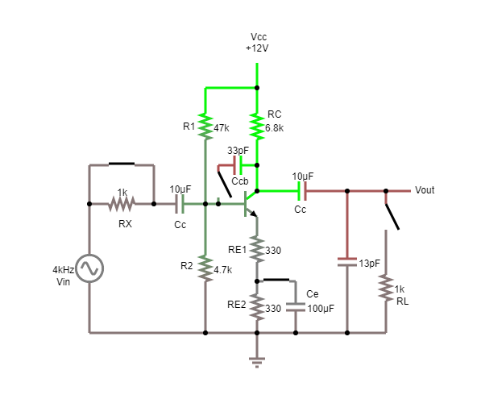

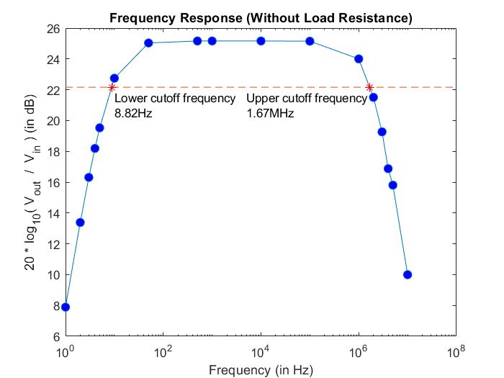

To get the lower and upper cutoff frequencies we plot the -3dB line (i.e., maximum gain (in dB) – 3) which in this case is 25.163 – 3 = 22.163, and find the intercepts with the frequency response curve. In this case the lower cut off frequency comes out to be 8.82 Hz and the upper cutoff frequency comes out to be 1.67 MHz.

It can be observed that in the absence of the load resistance ( $∞$ resistance) we obtain a much higher gain compared to when the load resistance is present (finite resistance). This is due to the fact that the collector current flows through a parallel combination of *RC* and *RL* and thus the output voltage is given by *IC*(RC||RL).* Now as we keep on increasing *RL*, the parallel resistance keeps on increasing which leads to the higher output voltage as observed.

1. *Effect of CE* 
   1. *CE disconnected, i.e., emitter resistance not bypassed*

|  |  |  |  |
| --- | --- | --- | --- |
| *Vin*  (V) | *Vout*  (V) | Frequency  (Hz) | $$20*\log_{10}(\frac{Vout}{Vin})$$ (dB) |
| 0.1 | 0.111 | 10 | 0.906 |
| 0.1 | 0.118 | 15 | 1.438 |
| 0.1 | 0.121 | 20 | 1.656 |
| 0.1 | 0.123 | 50 | 1.798 |
| 0.1 | 0.124 | 500 | 1.868 |
| 0.1 | 0.124 | 1k | 1.868 |
| 0.1 | 0.124 | 10k | 1.868 |
| 0.1 | 0.124 | 100k | 1.868 |
| 0.1 | 0.122 | 1M | 1.727 |
| 0.1 | 0.121 | 2M | 1.656 |
| 0.1 | 0.119 | 3M | 1.511 |
| 0.1 | 0.118 | 4M | 1.438 |
| 0.1 | 0.115 | 5M | 1.214 |

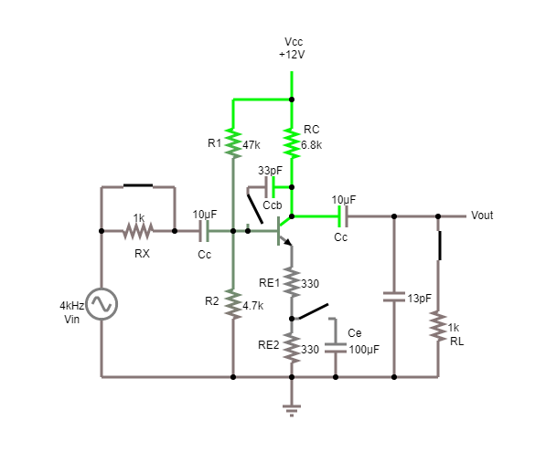

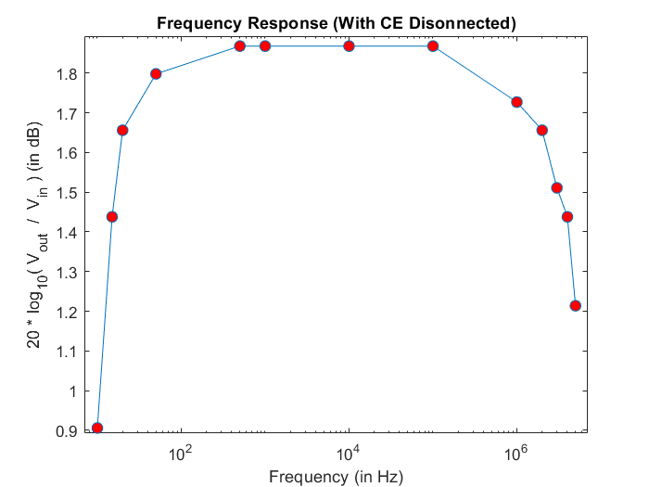

With the load resistance connected, if *CE* is kept connected (part 3.A.a) we obtained a maximum gain of 7.31. However, with *CE* disconnected we are getting a maximum gain of only 1.868. This is due to the fact that with *CE* present the resistance *RE2* is bypassed due to the low reactance of the capacitor at high frequencies. The reduction in emitter resistance leads to an increase in the gain.

* 1. *CE connected to emitter, i.e., emitter resistance completely bypassed*

|  |  |  |  |
| --- | --- | --- | --- |
| *Vin*  (mV) | *Vout*  (mV) | Frequency  (Hz) | $$20*\log_{10}(\frac{Vout}{Vin})$$ (dB) |
| 10 | 19 | 5 | 5.575 |
| 10 | 44 | 10 | 12.869 |
| 10 | 66 | 15 | 16.391 |
| 10 | 85 | 20 | 18.588 |
| 10 | 157 | 50 | 23.918 |
| 10 | 213 | 500 | 26.568 |
| 10 | 214 | 1k | 26.608 |
| 10 | 214 | 10k | 26.608 |
| 10 | 214 | 100k | 26.608 |
| 10 | 214 | 1M | 26.608 |
| 10 | 204 | 5M | 26.193 |
| 10 | 179 | 10M | 25.057 |
| 10 | 151 | 15M | 23.580 |
| 10 | 126 | 20M | 22.007 |
| 10 | 111 | 25M | 20.906 |
| 10 | 76 | 40M | 17.616 |
| 10 | 63 | 50M | 15.987 |

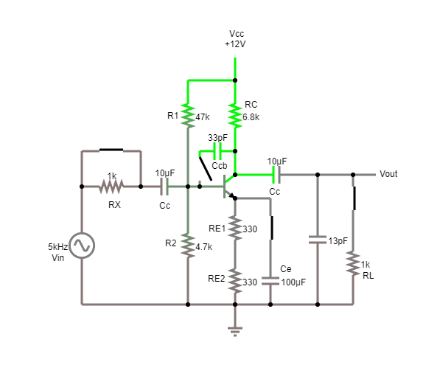

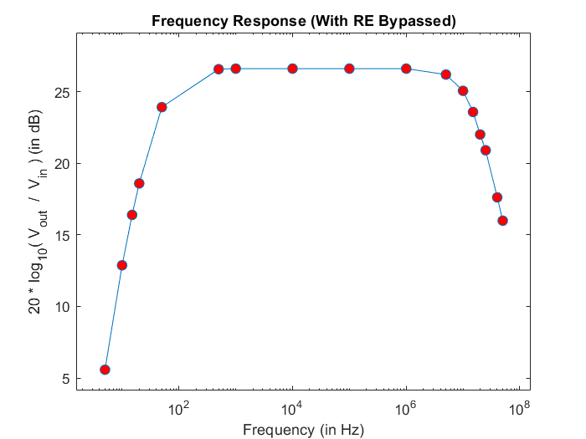

Completely bypassing the emitter resistance further increases the gain. Compared to the maximum gain of 7.31 in part 3.A.a here we obtain a maximum gain of 26.608.

1. *Effect of Miller Capacitance*
   1. *Miller Capacitance Connected*

|  |  |  |  |
| --- | --- | --- | --- |
| *Vin*  (mV) | *Vout*  (mV) | Frequency  (Hz) | $$20*\log_{10}(\frac{Vout}{Vin})$$ (dB) |
| 100 | 119 | 7 | 1.511 |
| 100 | 128 | 8 | 2.144 |
| 100 | 141 | 10 | 2.984 |
| 100 | 161 | 15 | 4.137 |
| 100 | 170 | 20 | 4.609 |
| 100 | 182 | 50 | 5.201 |
| 100 | 185 | 500 | 5.343 |
| 100 | 185 | 1k | 5.343 |
| 100 | 184 | 10k | 5.296 |
| 100 | 183 | 100k | 5.249 |
| 100 | 172 | 500k | 4.711 |
| 100 | 160 | 750k | 4.082 |
| 100 | 145 | 1M | 3.227 |
| 100 | 119 | 1.5M | 1.511 |

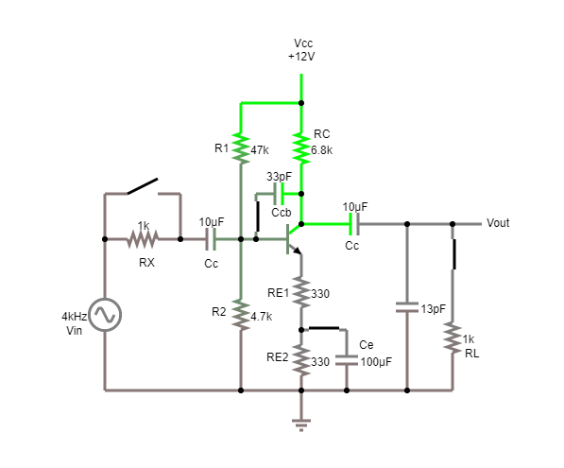

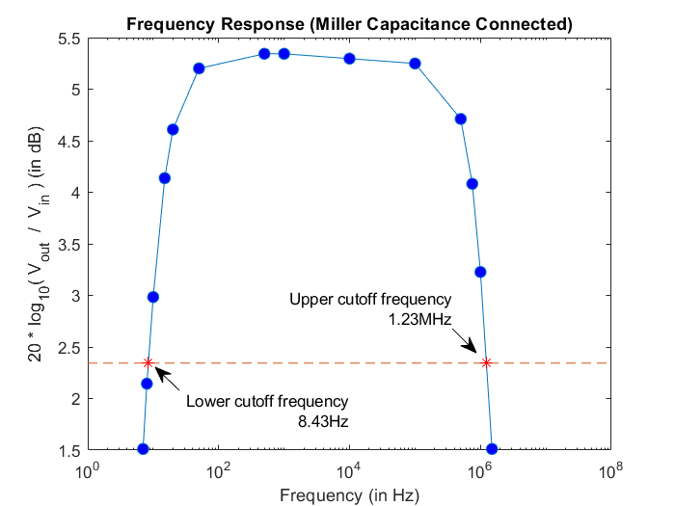

To get the lower and upper cutoff frequencies we plot the -3dB line (i.e., maximum gain (in dB) – 3) which in this case is 5.343 – 3 = 2.343, and find the intercepts with the frequency response curve. In this case the lower cut off frequency comes out to be 8.43 Hz and the upper cutoff frequency comes out to be 1.23 MHz.

* 1. *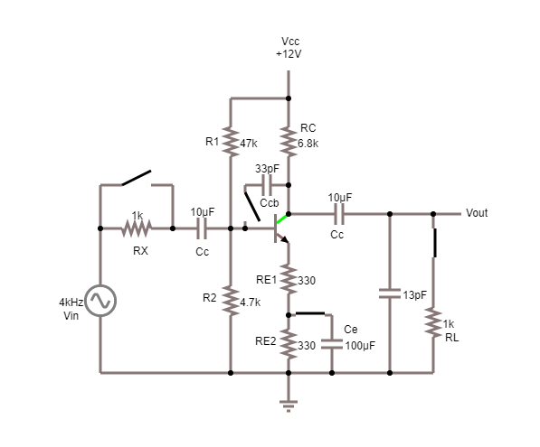Miller Capacitance Disconnected*

|  |  |  |  |
| --- | --- | --- | --- |
| *Vin*  (mV) | *Vout*  (mV) | Frequency  (Hz) | $$20*\log_{10}(\frac{Vout}{Vin})$$ (dB) |
| 100 | 119 | 7 | 1.511 |
| 100 | 142 | 10 | 3.046 |
| 100 | 161 | 15 | 4.137 |
| 100 | 170 | 20 | 4.609 |
| 100 | 182 | 50 | 5.201 |
| 100 | 185 | 500 | 5.343 |
| 100 | 185 | 1k | 5.343 |
| 100 | 185 | 10k | 5.343 |
| 100 | 185 | 100k | 5.343 |
| 100 | 185 | 1M | 5.343 |
| 100 | 172 | 5M | 4.711 |
| 100 | 148 | 10M | 3.405 |
| 100 | 122 | 15M | 1.727 |

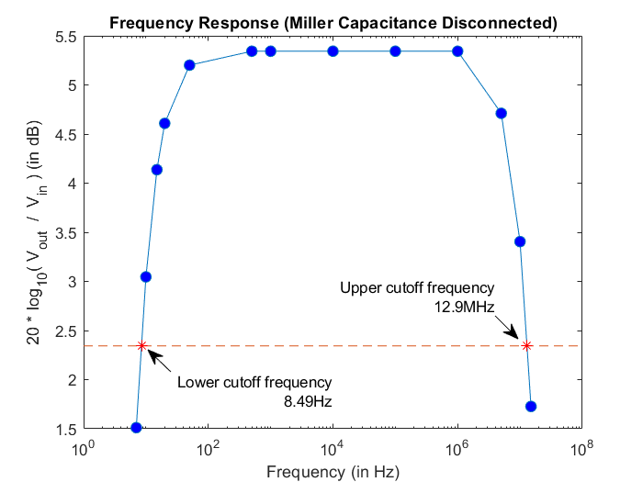

To get the lower and upper cutoff frequencies we plot the -3dB line (i.e., maximum gain (in dB) – 3) which in this case is 5.343 – 3 = 2.343, and find the intercepts with the frequency response curve. In this case the lower cut off frequency comes out to be 8.49 Hz and the upper cutoff frequency comes out to be 12.9 MHz.

It can be observed that with Miller Capacitance connected we get an upper cutoff frequency of 1.23MHz whereas with the Miller Capacitance disconnected we get the same as 12.9 MHz. The shorter frequency response in the former case is due to the fact that the Miller Capacitance acts as a parasitic transistor capacitance which leads to an early drop in gain.

1. *Measurement of Resistance in the Mid-Frequency Range*

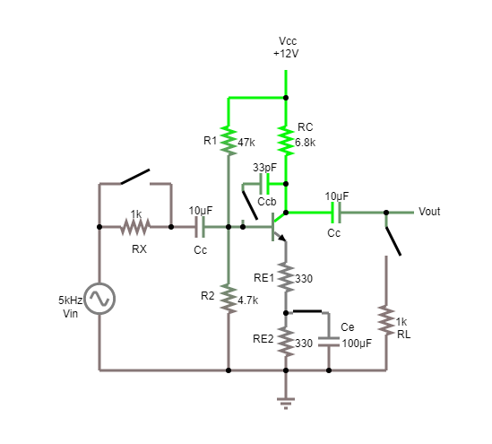

1. *Input Resistance*

$$V_{in}=0.1 V, { I}_{in|0}=26.07 μA, { R}_{x}=1kΩ, { V}_{out|R_{x}}=1.444 V, { V}_{out|0}=1.809 V$$

Calculated:

$$R_{in}=\frac{V_{in}}{{ I}_{in|0}}=\left(\frac{0.1}{26.07*{10}^{-6}}\right) Ω=3835.83 Ω$$

Experimental:

$$R_{in}=(R_{x}*\frac{V_{out|R_{x}}}{V_{out|0}-V_{out|R_{x}}})-R_{s}=(\frac{{10}^{3}*1.444}{1.809-1.444}-0) Ω=3956.16 Ω$$

Percentage Error:

$$\% error=\left|\frac{3956.16-3835.83}{3835.83}\right|*100=3.14\%$$

1. *Output Resistance*

$$R_{c}=6.8kΩ{, { R}_{L}=1 kΩ, V}_{out|∞}=1.813 V, { V}_{out|R_{L}}=0.232 V$$

Calculated:

$$R_{out}=R_{C}=6800 Ω$$

Experimental:

$$R_{out}=R_{L}*\frac{V_{out|∞}-V_{out|R_{L}}}{V_{out|R_{L}}}=\frac{{10}^{3}*(1.813-0.232) }{0.232} Ω=6814 Ω$$

Percentage Error:

$$\% error=\left|\frac{6814-6800}{6800}\right|*100=0.21\%$$

**CONCLUSION**

We have thoroughly discussed the common emitter amplifier. We discussed the response of the amplifier to both, the changes in the amplitude as well as the frequency of the input signal. DC analysis of the circuit gives us the Q-point which is an important factor in determining whether the transistor can be used as an amplifier with the present biasing. The change in frequency response due to presence of various resistances and capacitors plays an important role in designing modern day transistors used in electronics and communication devices.

*Report of*

*Nisarg Upadhyaya*

*19CS30031*

*\*All graphs plotted using MATLAB*