EXPERIMENT NO: 5

**AIM**

Studies on analog circuits using op amps

**THEORY**

An operational amplifier or op amp is fundamentally a voltage amplifying device. It is a three terminal device consisting of two inputs and one output. One of the input terminals is called “inverting” and denoted by a minus (-) sign. The other one being “non-inverting” and denoted by a plus (+) sign. Some properties of an ideal op amp are as follows:

1. It has an infinite open-loop gain.
2. It has an infinite input resistance.
3. It has zero output resistance.
4. It has infinite bandwidth.
5. It has zero offset, i.e., the output is exactly zero when the input to the op amp is zero

INVERTING AMPLIFIER

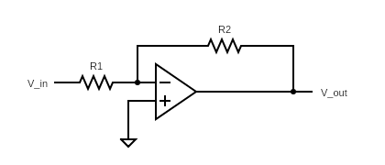In this case we have

$$V_{out}=-{\frac{R_{2}}{R_{1}}V}_{in}$$

NON-INVERTING AMPLIFIER

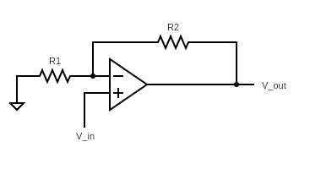In this case we have

$$V_{out}=(1+{\frac{R_{2}}{R_{1}})V}_{in}$$

**PROCEDURE**

1. *Inverting Amplifier*

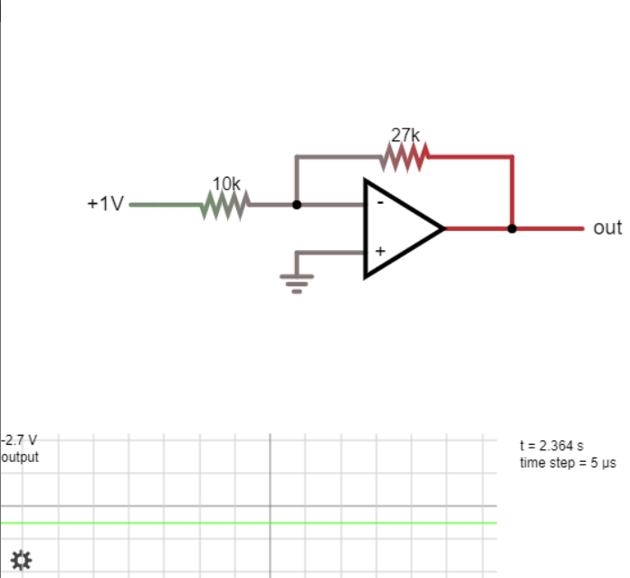

Variation of $V_{out}$ with $R_{f}$

(for $V_{in}=1V$ and $R_{i}=10kΩ$)

|  |  |
| --- | --- |
| $$R_{f}$$ $$(kohm)$$ | $$V_{out}$$ (volts) |
| 10 | -1 |
| 27 | -2.7 |
| 47 | -4.7 |
| 100 | -10 |
| 120 | -12 |
| 140 | -12 |
| 150 | -12 |

Voltage transfer characteristics of inverting amplifier (for $R_{f}=2kΩ$ and $R_{i}=1kΩ$)

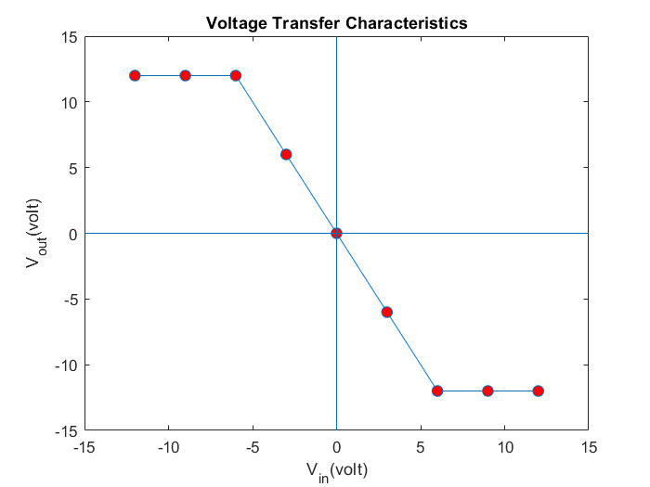

|  |  |
| --- | --- |
| $$V_{in}$$ (volts) | $$V_{out}$$ (volts) |
| 12 | -12 |
| 9 | -12 |
| 6 | -12 |
| 3 | -6 |
| 0 | 0 |
| -3 | 6 |
| -6 | 12 |
| -9 | 12 |
| -12 | 12 |

It can be observed that the output saturates after a certain maximum and minimum value. The reason for this is the fact that the output voltage cannot surpass the supply voltage given to the op amp.

1. *Non-inverting Amplifier*

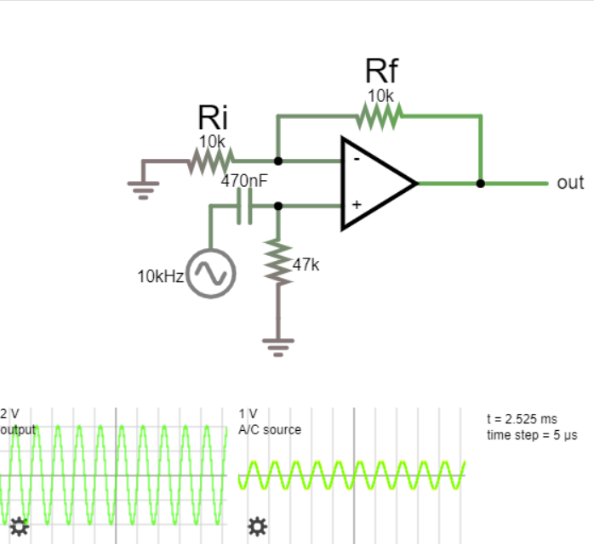

As expected from the theoretical formula the gain in this case comes out to be $$1+\frac{R_{f}}{R_{i}}$$

As we have Rf=Ri, the expected gain is 2 which is verified as when an input of 1V is fed to the op amp we get an output of 2V. The frequency response of the op amp for $R_{f}=R_{i}=10kΩ$ is attached below.

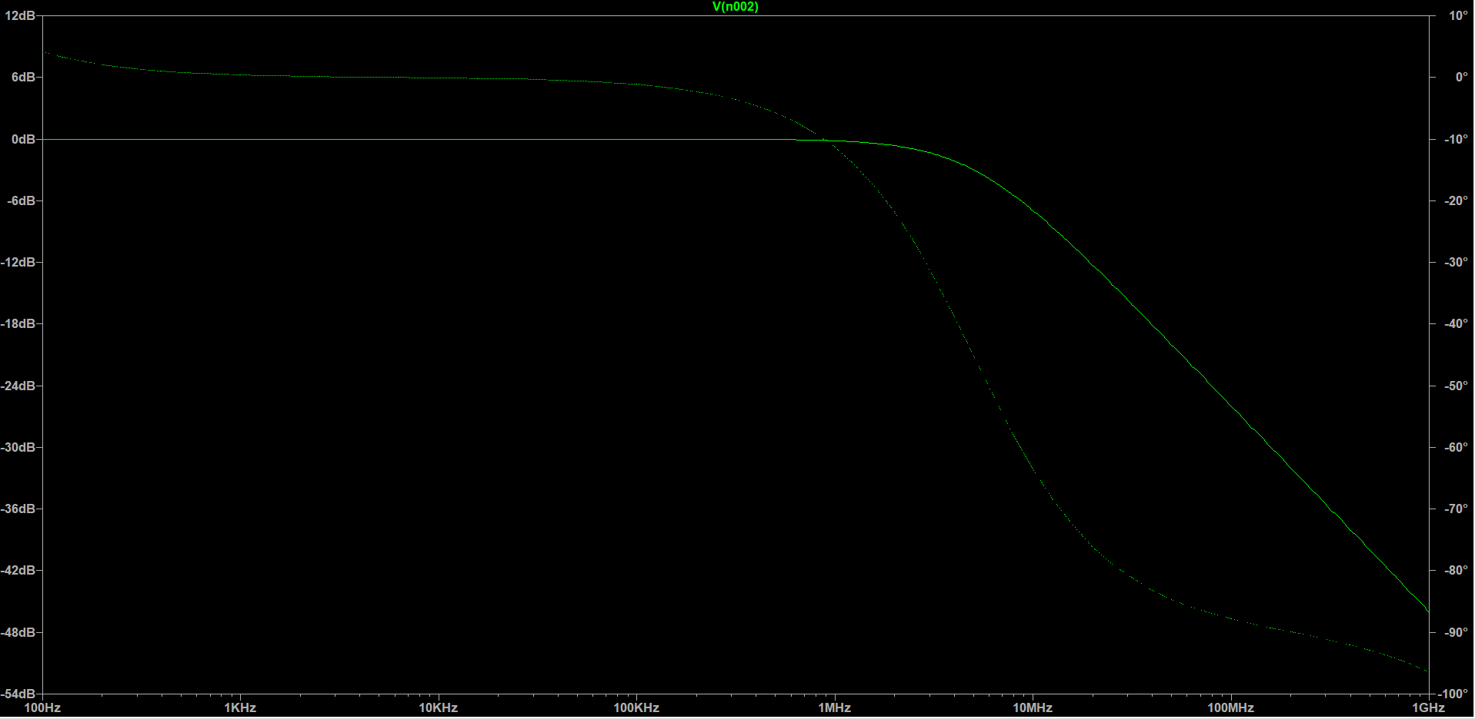

From the frequency response graph the -3dB roll off frequency comes out to be 4.97MHz.

1. *Summing Amplifier*

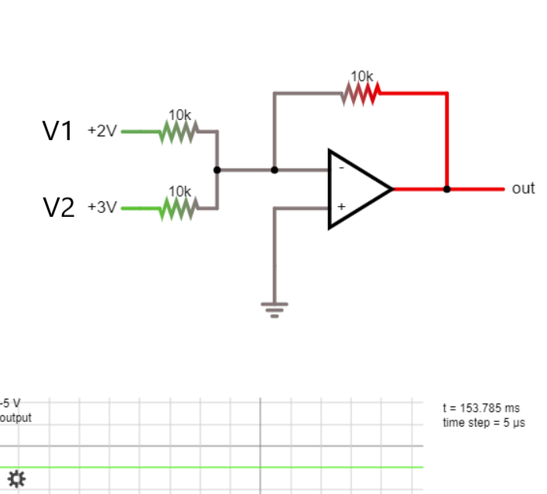For a summing amplifier the output is given as – (V1 +V2). As it can be seen that when V1=2V and V2=3V we obtain Vout = -5V which is the expected value. A summing amplifier can be used to impose a DC offset on an AC signal as shown in the figure below.

|  |  |  |  |
| --- | --- | --- | --- |
| V1  (V) | V2  (dc signal) (V) | Vout  (peak)  (V) | DC offset  (V) |
| 1V 1kHz  AC signal | 6.5 | -5.5 | -6.5 |
| 5.5 | -4.5 | -5.5 |
| 4.5 | -3.5 | -4.5 |
| 3.5 | -2.5 | -3.5 |
| 2.5 | -1.5 | -2.5 |
| 1.5 | -0.5 | -1.5 |
| 0.5 | 0.5 | -0.5 |
| -0.5 | 1.5 | 0.5 |
| -1.5 | 2.5 | 1.5 |
| -2.5 | 3.5 | 2.5 |
| -3.5 | 4.5 | 3.5 |
| -4.5 | 5.5 | 4.5 |
| -5.5 | 6.5 | 5.5 |
| -6.5 | 7.5 | 6.5 |
| -7.5 | 8.5 | 7.5 |

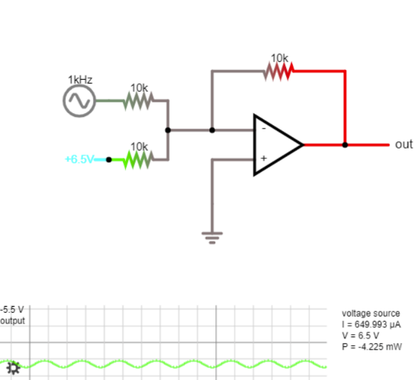

1. *Differential Amplifier*

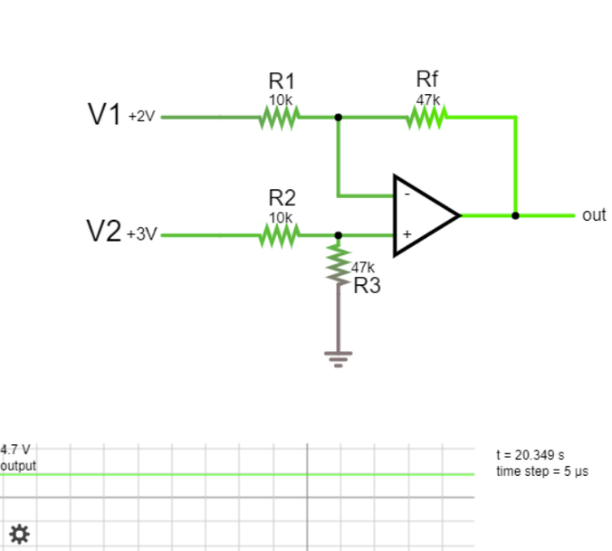

For the adjacent circuit the general relationship between output and input voltages is given by

$$V_{out}=V_{2}\frac{(\frac{R_{3}}{R_{2}})}{\left(1+\frac{R_{3}}{R_{2}}\right)}(1+\frac{R_{f}}{R_{1}})-V_{1}(\frac{R_{f}}{R_{1}})$$

The experimentally determined value of $V_{out}$ for

$$V_{1}=2V, V_{2}=3V, R_{1}=R_{2}=10kΩ, R_{3}=47kΩ, R_{f}=27kΩ$$

comes to be 3.752 which is in agreement with the theoretical value of 3.753V.

If we take $\frac{R_{f}}{R_{1}}=\frac{R_{3}}{R_{2}}$ we have $V_{out}={(V}_{2}-V_{1})(\frac{R_{f}}{R_{1}})$, i.e., output voltage is directly proportional to the difference of the input voltages. This is verified by taking $R_{f}=47kΩ$ and varying $V_{2}$.

|  |  |  |  |
| --- | --- | --- | --- |
| V1  (V) | V2  (V) | Rf  (kohm) | Vout  (V) |
| 2 | 3 | 47 | 4.7 |
| 2 | 4 | 47 | 9.4 |
| 2 | 5 | 47 | 14.1 |

1. *Differentiator*

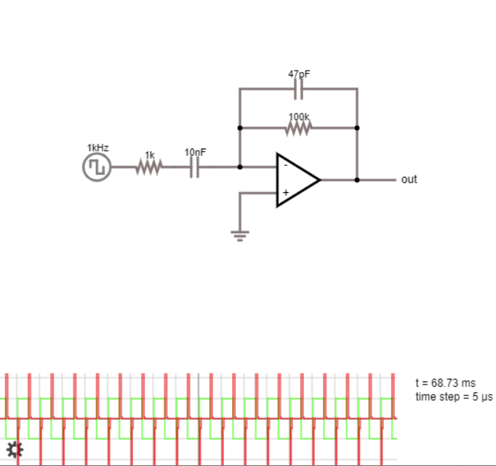

For the given circuit the output is given by

$$V_{out}=-RC\frac{dV_{in}}{dt}$$

Thus, we obtain an output with the same frequency as that of the input signal with the magnitude dependent on the slope of the input signal. For some common input signals the following results are obtained:

|  |  |
| --- | --- |
| Input waveform | Output waveform |
| Square | Impulse |
| Triangle | Square |
| Sinusoidal | Sinusoidal  (90-degree phase shifted) |

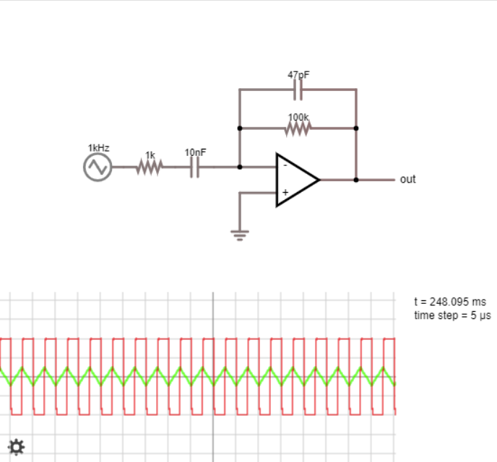

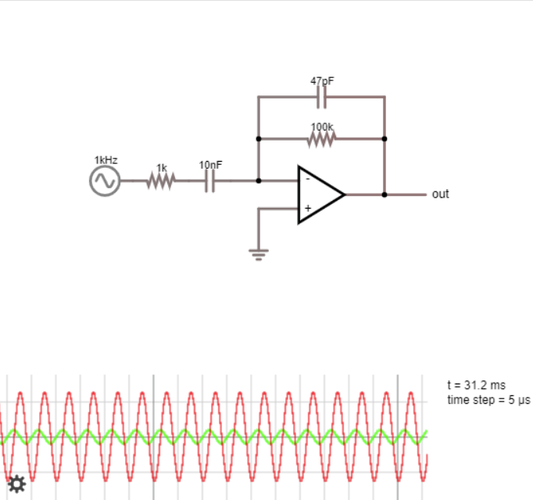

1. *Integrator*

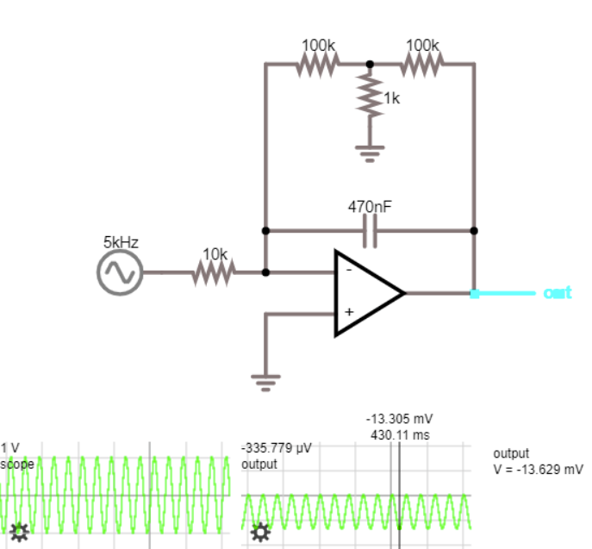

For the given circuit the output is given by

$$V_{out}=-\frac{1}{RC}\int{V_{in}dt}$$

Thus, for a sine wave input we expect a phase shift of 90 degrees and it is confirmed through the simulation. The maximum magnitude of the output waveform, i.e., 13.305mV occurs at half the time period when area under the sine curve becomes maximum. In the second half of the time period the output voltage again falls back to zero as the total area for a complete time period under a sine curve is zero. 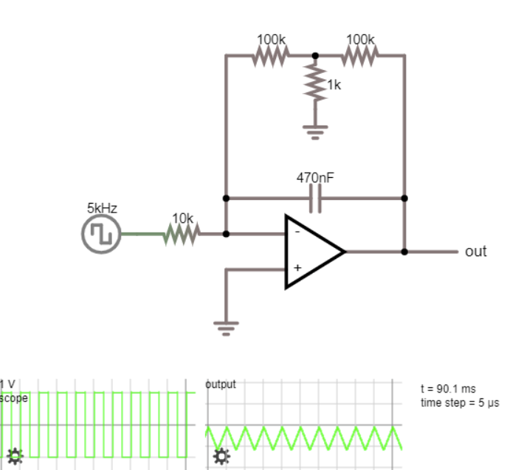For a square wave a triangular wave output is obtained. The frequency response of the circuit for a square wave is performed and the following results are obtained:

|  |  |  |
| --- | --- | --- |
| Vin | Frequency  (kHz) | Vout  (maximum magnitude)  (mV) |
| 1V square wave | 1 | -104.763 |
| 2 | -56.299 |
| 3 | -35.217 |
| 4 | -29.021 |
| 5 | -22.555 |
| 6 | -20.565 |
| 7 | -15.936 |
| 8 | -14.231 |
| 9 | -12.321 |
| 10 | -11.151 |

**CONCLUSION**

We have successfully analyzed different types of op amp circuits and studied their characteristic behaviors. We have also learnt about some operations which can be carried out on analog signals using op amp circuits such as integration and differentiation.

*Report of*

*Nisarg Upadhyaya*

*19CS30031*