PROJECT REPORT
ON
UEORMS - UNIVERSAL ENTERPRISE OPERATIONS AND RESOURCE MANAGEMENT SYSTEM
B.Tech Final Year Project

Prepared By
Nisarg Bhavsar and Team

Guided By
Project Guide and Faculty Mentor

Department of Information Technology
Faculty of Technology
Academic Year: 2025-2026
Submission Date: March 03, 2026

CANDIDATE DECLARATION
I hereby declare that this report titled 'UEORMS - Universal Enterprise Operations and Resource Management System' is my original work completed under proper guidance and has not been submitted elsewhere for award of any degree.
Candidate Name: Nisarg Bhavsar
Enrollment No.: __________________
Date: __________________
Signature: __________________

CERTIFICATE
This is to certify that the project work titled 'UEORMS - Universal Enterprise Operations and Resource Management System' is a bona fide work carried out during academic year 2025-2026 under supervision and satisfies B.Tech project requirements.
Project Guide: __________________
Head of Department: __________________
Date: __________________

ACKNOWLEDGEMENT
I express sincere gratitude to my project guide, faculty members, and peers for continuous support, technical direction, and review. Their guidance improved architecture, implementation quality, and test coverage.
I also thank the institution for providing resources and a conducive environment for successful completion.

ABSTRACT
UEORMS (Universal Enterprise Operations and Resource Management System) is a multi-tenant Software as a Service (SaaS) enterprise resource planning platform that integrates inventory, finance, human resources, customer relationship management, purchase, sales, projects, assets, documents, communication, and reporting in a unified environment.
The solution uses React for frontend, Node.js and Express for backend services, and PostgreSQL with Prisma for data persistence. The implementation enforces role-based access control (RBAC), JSON Web Token (JWT) authentication, workflow approvals, and audit logging. Repository analysis indicates broad module coverage with secure API endpoints and production-oriented architecture.

TABLE OF CONTENTS
Right-click and update field

LIST OF FIGURES
Right-click and update field

LIST OF TABLES
Right-click and update field

1. INTRODUCTION

1.1 Project Details
Attribute | Value
Project Name | UEORMS - Universal Enterprise Operations and Resource Management System
Project Type | Multi-tenant SaaS ERP
Academic Year | 2025-2026
Technology Stack | React, Node.js, Express, PostgreSQL, Prisma, Flutter
Backend Modules | 19
Database Models | 125
Frontend Pages | 124
Estimated API Endpoints | 574
Table 1.1: UEORMS Project Details

1.2 Purpose
UEORMS provides a centralized and secure ERP platform to automate enterprise workflows, enforce approvals, and improve operational visibility.

1.3 Scope
The scope covers tenant-aware operations across HR, Finance, Inventory, CRM, Manufacturing, Purchase, Sales, Projects, Assets, Documents, Communication, and Reporting.

1.4 Objectives
- Automate workflows with measurable controls.
- Provide secure role-based access governance.
- Improve data consistency and traceability.
- Enable scalable modular expansion.

1.5 Technology and Literature Review
The architecture follows layered enterprise design with frontend SPA, backend APIs, and relational persistence with schema migrations.
Layer | Tools | Rationale
Presentation | React, Vite, Tailwind | Fast modular UI delivery
Application | Node.js, Express, JWT, RBAC | Secure API orchestration
Data | PostgreSQL, Prisma ORM | Relational integrity and maintainability
Integration | WebSockets, Email, Stripe, Razorpay | Operational communication and billing
Table 1.2: Technology Stack Rationale

1.6 Acronyms and Abbreviations
Acronym | Full Form
ERP | Enterprise Resource Planning
RBAC | Role-Based Access Control
JWT | JSON Web Token
BOM | Bill of Materials
API | Application Programming Interface
SaaS | Software as a Service
Table 1.3: Acronyms and Abbreviations

2. PROJECT MANAGEMENT

2.1 Feasibility Study

2.1.1 Technical Feasibility
The selected stack is mature and supports modular enterprise-grade development.

2.1.2 Time Schedule Feasibility
The project progressed through incremental milestones with regular integration checks.

2.1.3 Operational Feasibility
Role-specific dashboards align with practical user responsibilities.

2.1.4 Implementation Feasibility
Setup scripts and migration support make deployment repeatable.

2.2 Project Planning

2.2.1 Project Development Approach and Justification
A modular route-controller-service architecture was used to parallelize development and reduce coupling.

2.2.2 Project Plan
- Phase I: Auth, Tenant, RBAC foundation
- Phase II: Inventory, Finance, Manufacturing, Reports
- Phase III: HR, CRM, Projects, Purchase, Documents, Communication
- Phase IV: Testing hardening and deployment readiness

2.2.3 Milestones and Deliverables
Milestone | Deliverable | Status
Architecture Baseline | Core auth, schema, secure routing | Completed
Functional Expansion | Domain modules and UI pages | Completed
Data + Analytics | Reporting and exports | Completed
QA and Documentation | Testing guides and technical docs | Completed
Table 2.1: Milestones and Deliverables

2.2.4 Roles and Responsibilities
- Developer team: implementation and integration
- Guide: design review and quality oversight
- Stakeholders: acceptance validation

2.2.5 Group Dependencies
Dependencies were managed using shared middleware, standardized APIs, and staged integration.

2.3 Project Scheduling
Scheduling followed build-validate-document cycles with regression verification at each phase.

3. SYSTEM REQUIREMENT STUDY

3.1 Study of Current System
Legacy operations often rely on disconnected tools and spreadsheets, causing delays and data inconsistencies.

3.2 Problems and Weaknesses of Current System
- Data duplication across departments
- Manual approvals without traceability
- Delayed reporting and reconciliation
- Inconsistent access control

3.3 User Characteristics
- Admin: governance and configuration
- Manager: approvals and KPIs
- Employee: transaction workflows
- Finance/HR: compliance-sensitive operations

3.4 Hardware and Software Requirements

3.4.1 Hardware Requirements
- 8 GB RAM or higher
- Dual-core processor or better
- Sufficient storage for dependencies and DB

3.4.2 Software Requirements
- Node.js 18+
- PostgreSQL 14+
- NPM
- Modern browser
- Git

3.5 Constraints

3.5.1 Regulatory Policies
Tenant isolation and auditability are mandatory.

3.5.2 Hardware Limitations
Low-resource environments impact heavy reports.

3.5.3 Interfaces to Other Applications
Secure contracts required for integrations.

3.5.4 Parallel Operations
Concurrent writes need transaction safety.

3.5.5 Higher Order Language Requirements
Modern JavaScript tooling is required.

3.5.6 Reliability Requirements
Rollback-safe operations for critical flows.

3.5.7 Criticality of the Application
Downtime affects finance and operations.

3.5.8 Safety and Security Consideration
JWT, RBAC, and secure headers are required.

3.6 Assumptions and Dependencies
- Stable database and network
- Proper tenant-role setup
- Seed data initialization completed

3.7 Functional Requirements (Retained and Refined from Base Report)
R-ID | Area | Requirement Statement
R1 | Registration and Authentication | System shall provide secure registration and JWT-based login.
R2 | Tenant Management | System shall isolate and configure each tenant separately.
R3 | User and Role Management | System shall assign roles and enforce permission checks.
R4 | Master Data | System shall maintain centralized product and reference data.
R5 | BOM Management | System shall support BOM creation and version control.
R6 | Manufacturing | System shall manage work orders and material usage.
R7 | Inventory | System shall track multi-warehouse stock and transfers.
R8 | Reordering | System shall trigger low-stock alerts by threshold.
R9 | Procurement | System shall process requisition, PO, and receipts.
R10 | Sales | System shall process lead-to-order and invoicing flow.
R11 | Human Resources | System shall support attendance, leave, and payroll inputs.
R12 | Finance | System shall support journal posting and expense processing.
R13 | Reports | System shall generate role-based analytics and exports.
R14 | RBAC | System shall deny unauthorized actions at route level.
R15 | Workflow | System shall support configurable approval chains.
R16 | Audit Logging | System shall record critical user actions.
R17 | Notifications | System shall deliver workflow and system alerts.
R18 | Vendor/Quality | System shall store supplier and quality evaluation metrics.
Table 3.1: Consolidated Functional Requirements

3.8 Non-Functional Requirements
Category | Requirement | Target
Performance | API response time | 95% requests under 500 ms
Security | Authentication | JWT on protected endpoints
Security | Authorization | RBAC checks for module actions
Reliability | Data integrity | Transactional rollback on failure
Usability | Responsive UI | Desktop and mobile layouts
Maintainability | Modular code | Service-layer separation
Table 3.2: Non-Functional Requirements

4. SYSTEM ANALYSIS

4.1 Requirements of New System (SRS)

4.1.1 User Requirements
- Role-specific dashboards
- Visible workflow status and approvals
- Exportable reports and search features

4.1.2 System Requirements
- Tenant-aware data isolation
- Consistent REST APIs
- Audit-ready transactional operations

4.2 Features of New System
UEORMS includes integrated modules for HR, Finance, Inventory, CRM, Manufacturing, Purchase, Sales, Projects, Assets, Documents, Communication, and Reporting.

4.3 Navigation Chart
Figure 4.1 illustrates major user navigation from login to module operations and reporting.
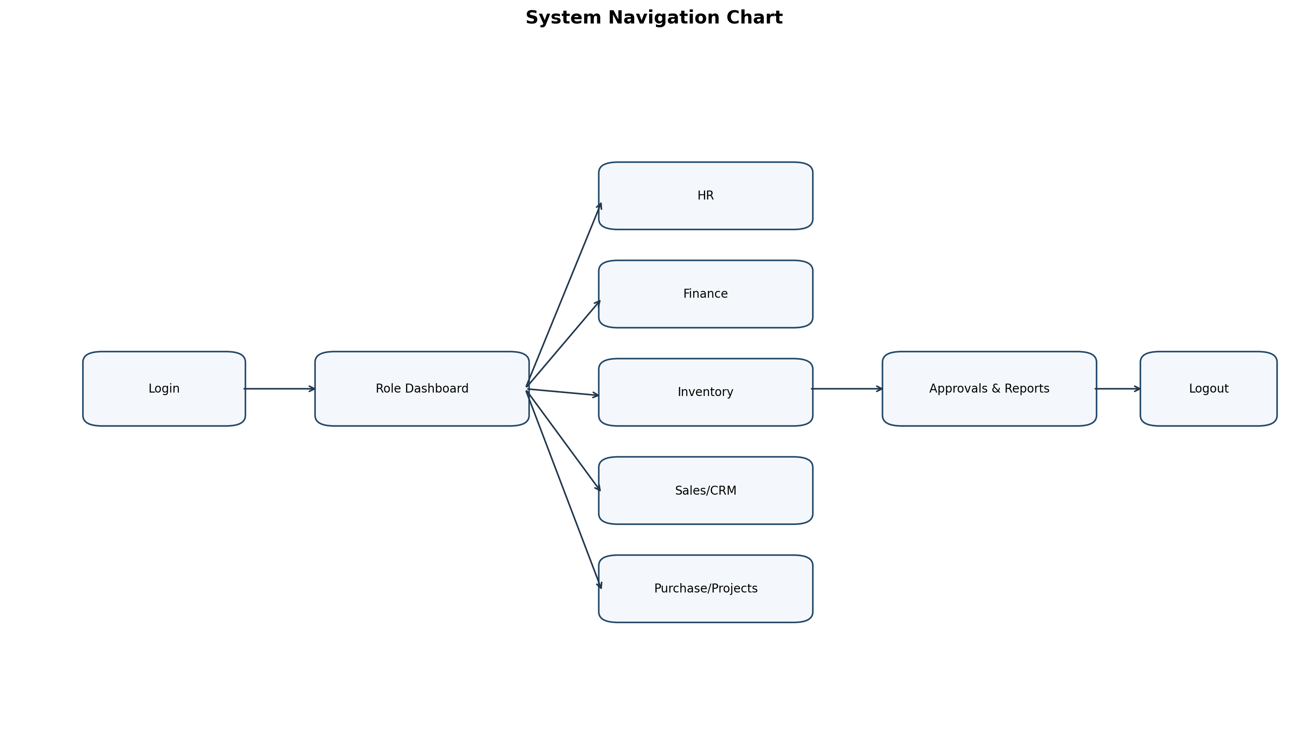
Figure 4.1: System Navigation Chart

4.4 Use Case Diagram
Figure 4.2 presents primary actor interactions including Admin, Manager, Employee, Finance, HR, Inventory, and Sales.
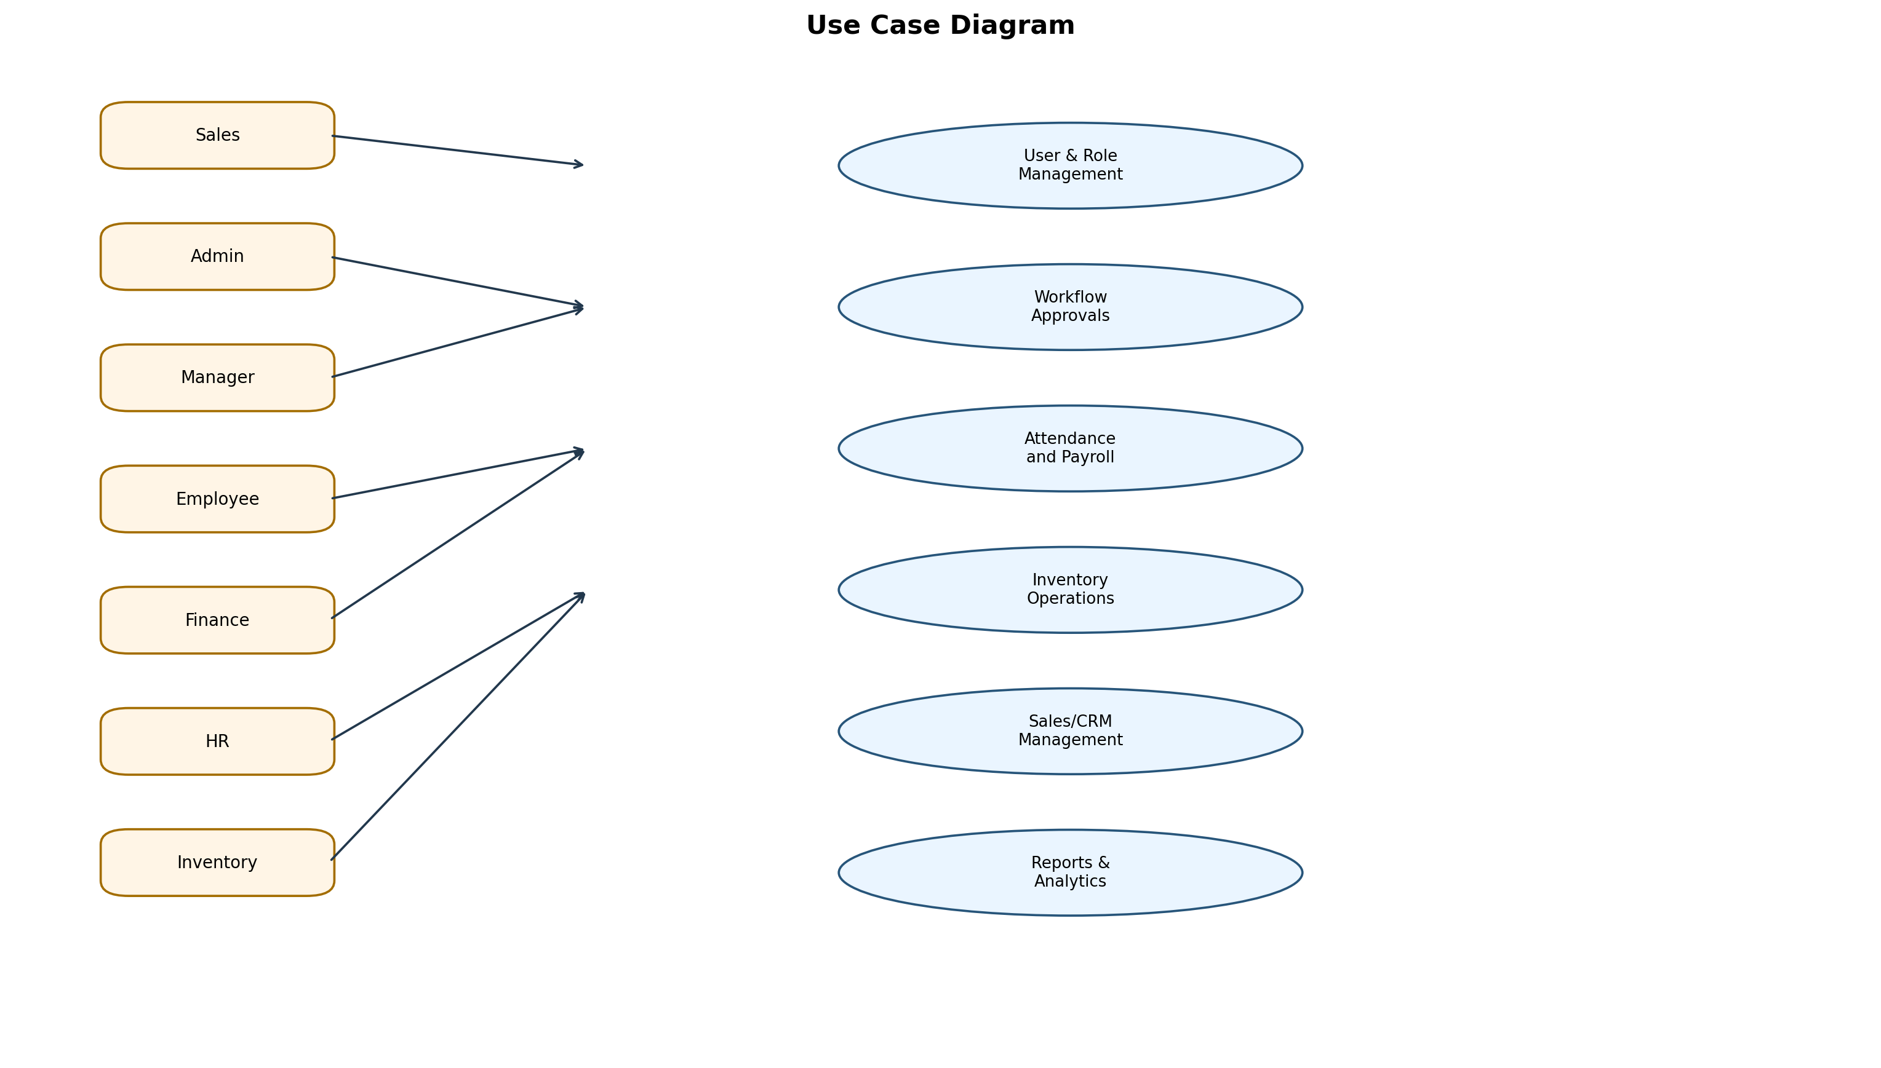
Figure 4.2: Use Case Diagram for Major Actors

4.5 Class Diagram
Figure 4.3 models key classes and relationships used by backend services.
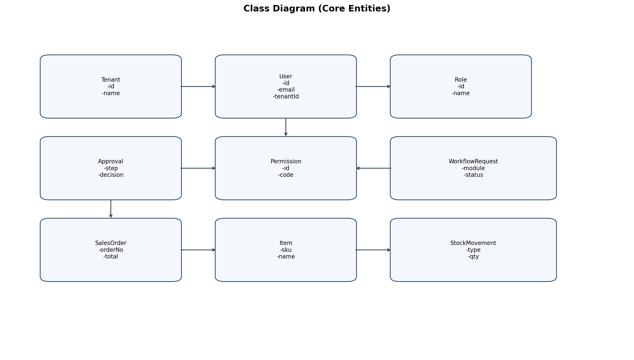
Figure 4.3: Class Diagram of Core Entities

4.6 System Activity
Figure 4.4 captures the activity flow for login, request creation, and approval processing.
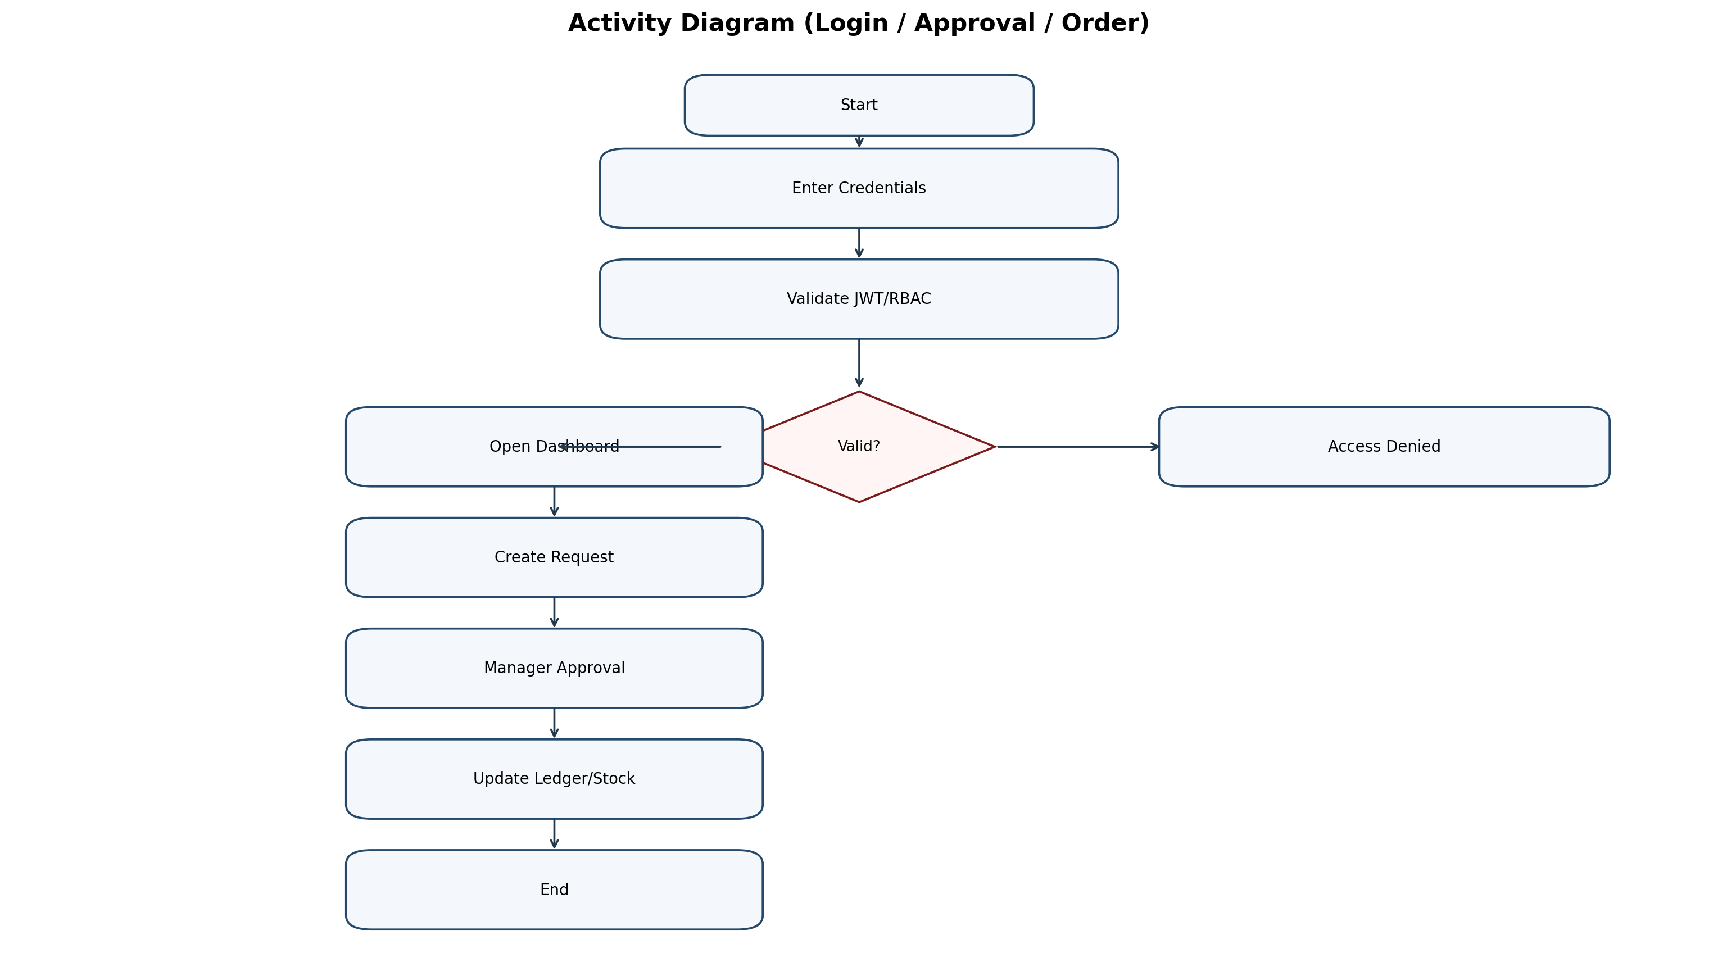
Figure 4.4: Activity Diagram (Login/Approval/Order)

4.7 Sequence Diagram
Figure 4.5 combines login sequence and purchase-to-approval sequence.
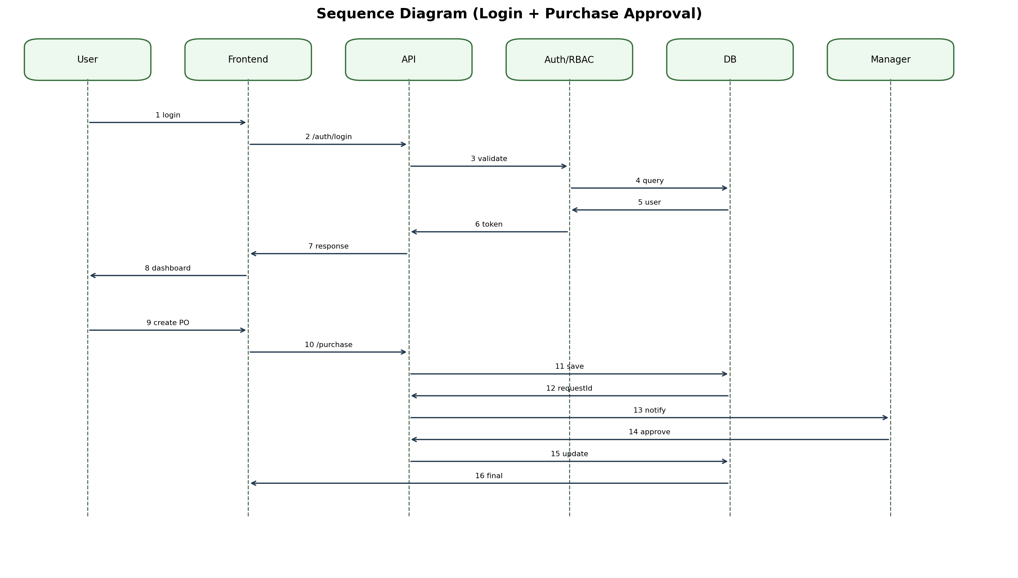
Figure 4.5: Sequence Diagram (Login and Purchase Approval)

4.8 ER Diagram
Figure 4.6 outlines key database entities and foreign-key relationships.
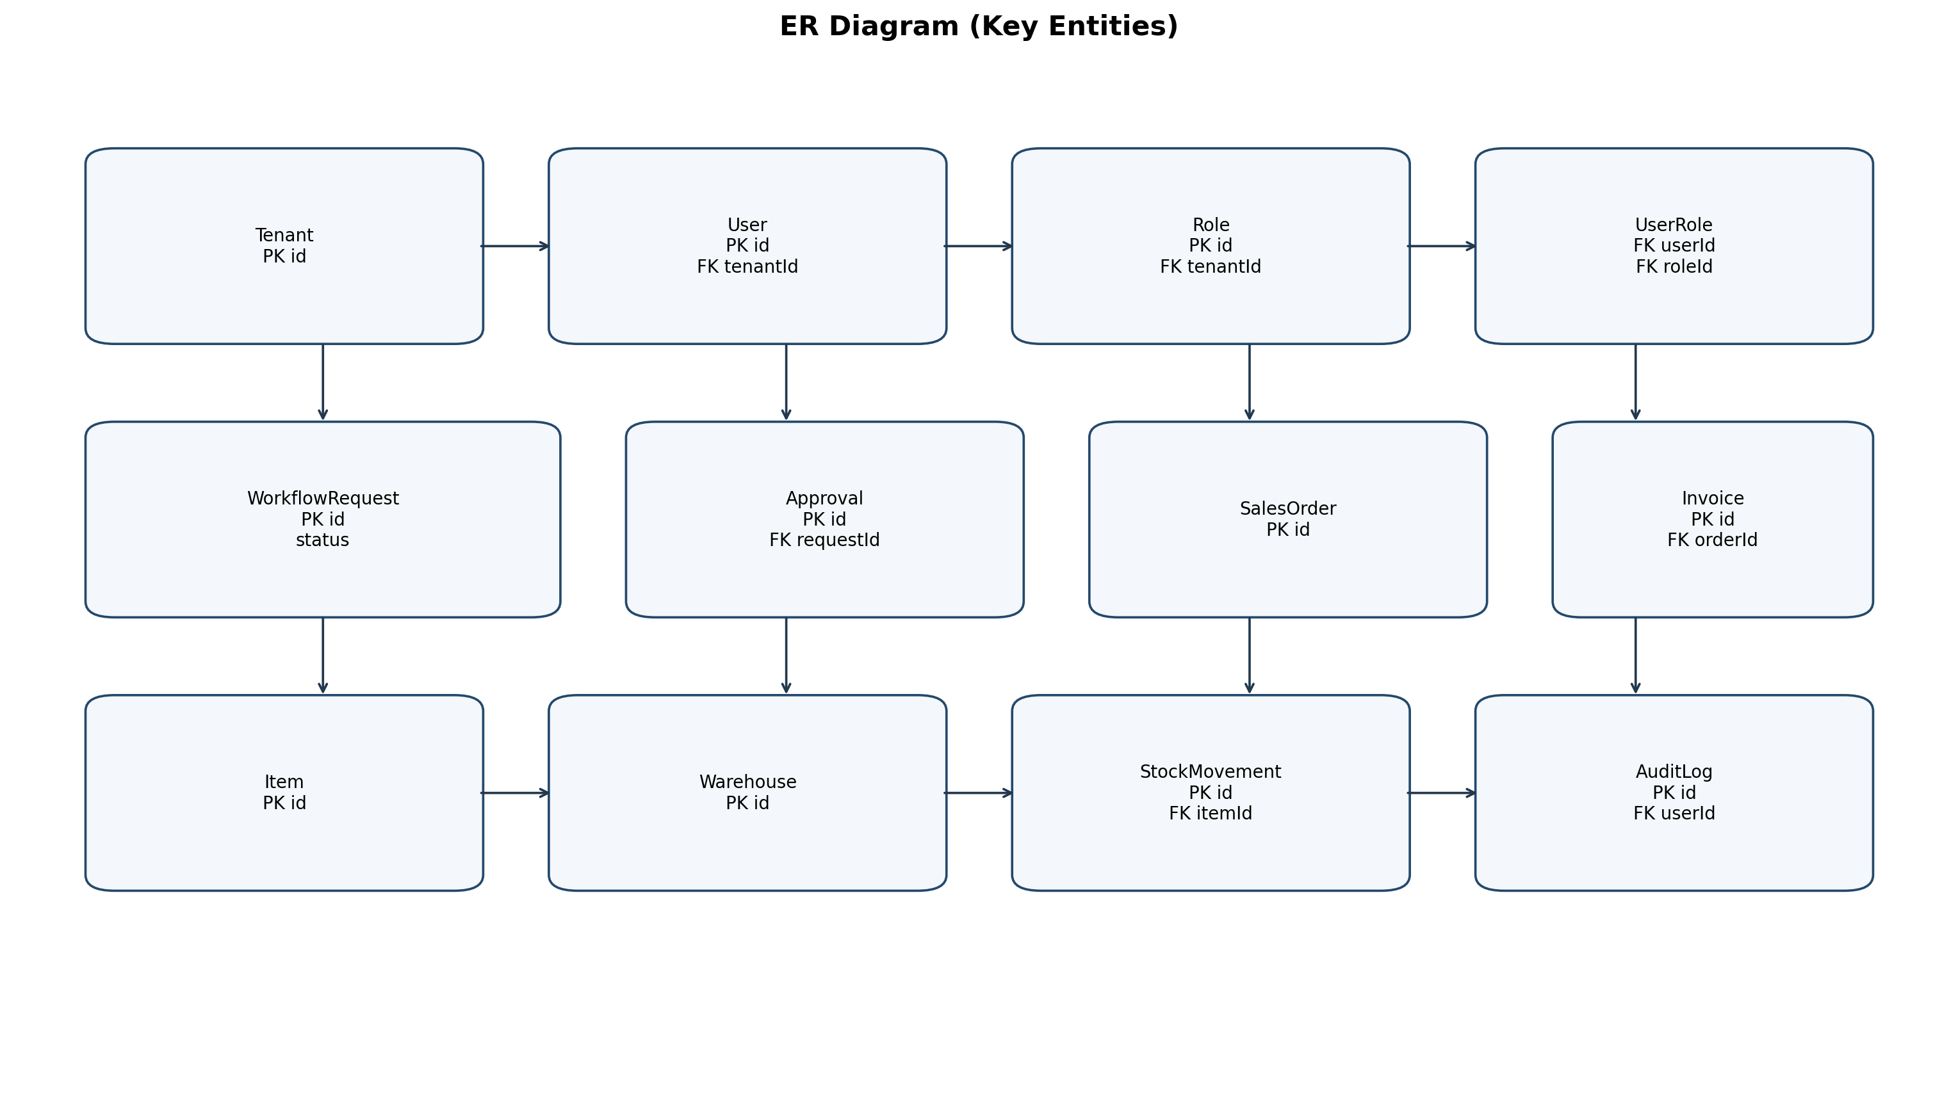
Figure 4.6: ER Diagram of Key Entities

5. SYSTEM DESIGN

5.1 System Architecture Study

5.1.1 Component Diagram
Figure 5.1 shows component-level interaction between clients, API layer, services, ORM, and database.
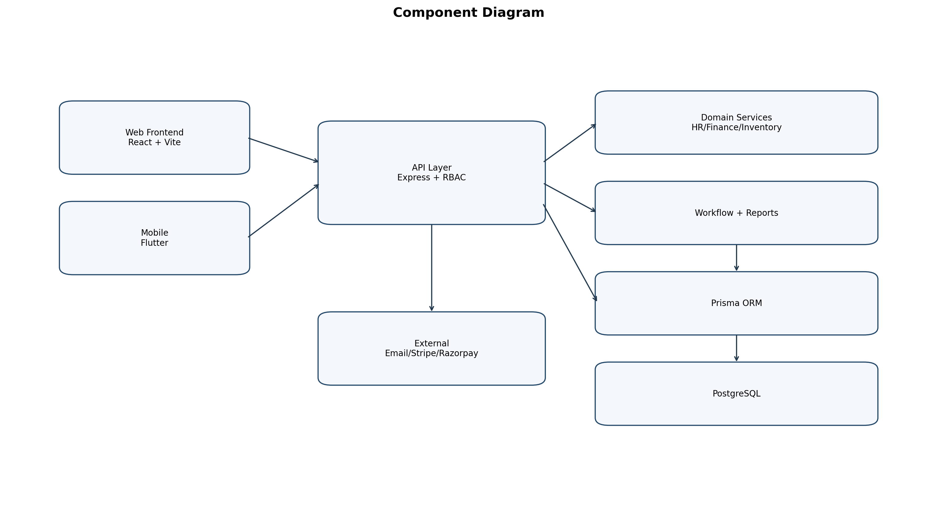
Figure 5.1: Component Diagram

5.1.2 Deployment Diagram
Figure 5.2 presents deployment architecture with cloud hosting, app server, worker, storage, and external providers.
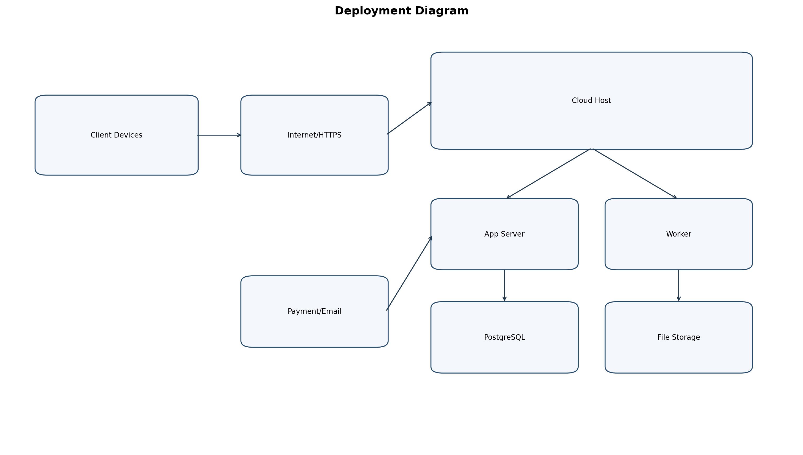
Figure 5.2: Deployment Diagram

5.2 Database Design

5.2.1 Table and Relationship
The data model currently contains 125 Prisma models with tenant-aware relationships and transactional constraints.
Domain | Representative Entities
Identity and Access | Tenant, User, Role, Permission, UserRole
Workflow | Workflow, WorkflowStep, WorkflowRequest, Approval, AuditLog
Inventory | Item, Warehouse, WarehouseStock, StockMovement, LotBatch
Finance | ChartOfAccounts, JournalEntry, LedgerEntry, ExpenseClaim
HR | Employee, Attendance, LeaveRequest, PayrollCycle
Sales/Purchase | SalesOrder, SalesInvoice, PurchaseOrder, GoodsReceipt
Communication | Conversation, Message, Announcement, Notification
Table 5.1: Domain-Wise Data Model Summary

5.2.2 Logical Description of Data
All business transactions maintain tenant, actor, timestamp, and status metadata for traceability and compliance.

5.3 Input/Output and Interface Design

5.3.1 State Transition/UML Diagram
Operational entities follow controlled state transitions (Draft, Pending, Approved, Rejected, Completed) governed by RBAC and workflows.

5.3.2 Interface Design
UI design follows dashboard-list-form-detail patterns with validation, filters, and role-aware actions.

6. IMPLEMENTATION PLANNING

6.1 Implementation Environment
- Frontend: React + Vite
- Backend: Node.js + Express
- Database: PostgreSQL + Prisma
- Tooling: npm scripts, migration and seed utilities

6.2 Program/Modules Specification
Module | Scope | Capabilities
HR | People operations | Attendance, leave, payroll workflows
Finance | Accounting and approvals | Expenses, journal, ledger, payments
Inventory | Warehouse operations | Stock movements and approvals
CRM | Customer lifecycle | Leads, deals, communications
Manufacturing | Production | BOM and work order lifecycle
Purchase | Procurement | Requisitions, POs, receipts
Sales | Revenue | Orders, invoices, payment tracking
Projects | Delivery | Planning, capacity, timesheets
Assets | Asset lifecycle | Allocation, maintenance, depreciation
Documents | Document control | Folders, upload, permissions
Communication | Collaboration | Channels, messaging, announcements
Table 6.1: Module Specifications
Repository metrics: 19 backend modules, 124 frontend pages, and approximately 574 routed endpoints.

6.3 Coding Standards
- Consistent REST naming and HTTP semantics
- Service-layer business rules
- Validation and secure error handling
- Tenant and RBAC enforcement on secured routes

7. TESTING

7.1 Testing Plan
Testing focused on authentication, authorization, transactional workflows, and report correctness.

7.2 Testing Strategy
- Module-level API validation
- Role-based access testing
- Cross-module integration scenarios
- Regression checks after enhancements

7.3 Testing Methods
- Functional testing
- Integration testing
- Regression testing
- Boundary validation
- Error-path testing

7.4 Test Cases

7.4.1 Purpose
Validate system correctness, security, and expected operational output.

7.4.2 Required Input
Configured tenant, seeded data, valid user accounts, and JWT tokens.

7.4.3 Expected Result
Authorized requests succeed, unauthorized actions are blocked, and data consistency is preserved.
ID | Module | Scenario | Input | Expected
TC-01 | Auth | Valid login | Email+Password | JWT and dashboard
TC-02 | RBAC | Unauthorized access | No permission | 403 response
TC-03 | Inventory | Stock transfer | Warehouse+qty | Pending movement
TC-04 | Finance | Journal posting | Balanced lines | Ledger entries
TC-05 | HR | Payroll run | Attendance data | Payslips generated
TC-06 | Purchase | Approval | Pending requisition | Approved status
Table 7.1: Representative Test Cases

8. USER MANUAL

8.1 Getting Started
- Run backend and frontend dev servers
- Login with authorized credentials
- Open module menus from sidebar

8.2 Features and Navigation
Users access role-based dashboards and perform module workflows through list-form-approval patterns.
Module | User Flow | Output
Inventory | Create movement -> Approve -> Complete | Stock and audit update
Finance | Create claim/journal -> Approve -> Post | Ledger/report update
HR | Attendance -> Leave -> Payroll | Payslip/disbursement records
Purchase | Requisition -> PO -> Receipt | Vendor and stock update
Sales | Lead -> Order -> Invoice | Revenue tracking
Table 8.1: User Manual Workflow Summary

8.3 Troubleshooting and Support
- Check API health endpoint
- Verify JWT expiry and role mapping
- Inspect backend logs
- Re-run migration/setup scripts when needed

9. LIMITATION AND FUTURE ENHANCEMENT

9.1 Current Limitations
- Some advanced integrations remain extension scope
- Heavy analytics can require background workers
- Initial onboarding still uses setup scripts

9.2 Future Enhancements
- Event-driven async processing
- Predictive analytics and forecasting
- Extended mobile parity
- Enterprise SSO integration
- Enhanced observability dashboards

10. CONCLUSION AND DISCUSSION

10.1 Conclusions
UEORMS demonstrates a comprehensive multi-tenant ERP implementation with modular architecture, secure access controls, and strong functional coverage.

10.2 Discussion

10.2.1 Self-Analysis of Project Viabilities
The architecture is viable for scale due to clear module boundaries, reusable middleware, and schema-driven data consistency.

10.2.2 Problem Encountered and Possible Solutions
- Cross-module complexity managed via standardized contracts
- Concurrency risks handled with database transactions
- Permission mismatch reduced through centralized RBAC checks

10.2.3 Summary of Project Work
The project covers architecture, implementation, integration, testing, and documentation for submission-ready evaluation.

REFERENCES
1. React Documentation - https://react.dev/
2. Vite Documentation - https://vitejs.dev/
3. Node.js Documentation - https://nodejs.org/docs/
4. Express Documentation - https://expressjs.com/
5. Prisma Documentation - https://www.prisma.io/docs/
6. PostgreSQL Documentation - https://www.postgresql.org/docs/
7. JWT Introduction - https://jwt.io/introduction
8. Tailwind CSS - https://tailwindcss.com/docs
9. Stripe API - https://docs.stripe.com/api
10. Razorpay API - https://razorpay.com/docs/api/
11. Internal source: report/ERP_SYSTEM_PROJECT_REPORT_2026.md
12. Internal source: report/old_project_report.docx

APPENDIX

Appendix A: API Route Summary
Route File | Count | Sample Endpoints
crm.routes.js | 49 | POST /customers; GET /customers; GET /customers/:id; PUT /customers/:id
communication.routes.js | 47 | GET /conversations; GET /conversations/:id; POST /conversations; PUT /conversations/:id
purchase.routes.js | 33 | GET /vendors; GET /vendors/:id; POST /vendors; PUT /vendors/:id
sales.routes.js | 32 | GET /quotations; POST /quotations; PUT /quotations/:id; DELETE /quotations/:id
document.routes.js | 27 | GET /statistics; POST /upload; POST /folders; GET /folders
manufacturing.routes.js | 27 | POST /bom; GET /bom; GET /bom/:id; GET /bom/product/:productId
accounting.routes.js | 25 | POST /chart-of-accounts; GET /chart-of-accounts; GET /chart-of-accounts/hierarchy; POST /chart-of-accounts/initialize
project.routes.js | 23 | GET /dashboard; GET /tasks; POST /; GET /
ap.routes.js | 21 | GET /bills; GET /bills/:id; POST /bills; PUT /bills/:id
payroll.routes.js | 19 | POST /components; GET /components; PUT /components/:id; POST /tax-config
billing.routes.js | 17 | GET /public/plans; GET /subscription; GET /plans; POST /subscription/change-plan
employee.routes.js | 17 | POST /; PUT /:id; DELETE /:id; POST /assign-manager
attendance.routes.js | 16 | POST /clock-in; POST /clock-out; GET /clock-status/:employeeId; POST /shifts
timesheet.routes.js | 14 | GET /get-or-create; POST /; GET /; GET /summary
report.routes.js | 13 | GET /financial/profit-loss; GET /financial/balance-sheet; GET /hr/analytics; GET /inventory
asset.routes.js | 11 | POST /categories; GET /categories; GET /categories/:id; PUT /categories/:id
branch.routes.js | 10 | POST /; GET /; GET /main; GET /:id
data-import-export.routes.js | 10 | POST /import/items; POST /import/warehouses; POST /import/journal-entries; GET /export/items
integration.routes.js | 10 | POST /sync-inventory/:movementId; POST /sync-sales/:orderId; POST /sync-payroll/:cycleId; POST /sync-manufacturing/:workOrderId
reporting.routes.js | 10 | GET /dashboard-summary; GET /income-statement; GET /balance-sheet; GET /inventory-summary
Table A.1: Top API Route Files

Appendix B: Key Database Tables
Index | Model
1 | CompanyConfig
2 | Plan
3 | PlanModule
4 | Subscription
5 | SubscriptionItem
6 | SubscriptionPayment
7 | BillingEvent
8 | PendingRegistration
9 | User
10 | Role
11 | Permission
12 | RolePermission
13 | UserRole
14 | Department
15 | Workflow
16 | WorkflowStep
17 | AuditLog
18 | Tenant
19 | Item
20 | SalesQuotation
21 | SalesOrder
22 | SalesInvoice
23 | InvoicePayment
24 | SalesOrderTracking
25 | UserInvite
26 | Approval
27 | SystemOption
28 | WorkflowRequest
29 | Employee
30 | LeaveType
31 | LeaveRequest
32 | ExpenseCategory
33 | ExpenseClaim
34 | Task
35 | SalaryStructure
36 | WorkReport
37 | Notification
38 | Customer
39 | Contact
40 | Lead
Table B.1: Key Prisma Models

Appendix C: Setup Guide
1. Install dependencies: npm run setup
2. Configure backend environment variables
3. Run migrations: npx prisma migrate deploy
4. Start servers: npm run dev
5. Validate login and dashboard access

Appendix D: Screenshot and Flow Index
Generated flow/diagram artifacts are provided in report/diagrams as editable .mmd and image .png files. UI module paths are available under frontend/src/pages.

