BMO
MECH AVATAR
End-to-End Sequence Diagrams, API Gateway & Lambda Integration

Document Type | Cloud Integration Reference
API Gateway Stage | dev
Audience | Cloud Engineering Team
Version | 2. (Updated)
Date | March 2026

Change Log (v2.0)

This version includes updates to Lambda 06 and Lambda 08. All changes are backward compatible with the existing frontend integration.

Lambda 08 Changes
- HS256 JWT authentication (primary) with Cognito fallback for backward compatibility
- API Gateway v2 (HTTP API) support added alongside REST API
- Improved CORS origin matching with dynamic resolution
- Stage prefix stripping for flexible path handling
- New environment variables: JWT_SECRET, JWT_EXPIRY_SECONDS

Lambda 06 Changes
- New feature: Query caching with configurable TTL
- Enhanced response schema with additional metadata fields

Integration Impact
- All existing API endpoints work unchanged
- Request formats remain identical
- Core response fields unchanged
- New response fields are additive (optional for frontend to consume)

Table of Contents

1. Executive Summary
2. Architecture Overview
3. End-to-End Sequence Diagrams
3.1 User Authentication Flow
3.2 Chat Query Flow (REST API)
3.3 Chat Query Flow (WebSocket Streaming)
3.4 Document Upload Flow
3.5 Document Ingestion Pipeline
4. API Gateway Configuration
4.1 REST API Endpoints
4.2 WebSocket API Routes
4.3 Lambda Integrations
5. OpenAPI/Swagger Specification
6. Nginx Configuration
7. Environment Variables & Secrets (UPDATED)
8. DynamoDB Tables (UPDATED)
9. IAM Roles & Policies
10. Response Schema Changes (NEW)

1. Executive Summary

This document provides cloud engineers with a comprehensive guide to replicate the MECH Avatar architecture from the Lab account to the Dev account. It covers the end-to-end integration between the Angular frontend, Nginx reverse proxy, AWS API Gateway, Lambda functions, and backend services including OpenSearch Serverless, DynamoDB, S3, and Amazon Bedrock.

Key Integration Points:
- Frontend (Angular) served via Nginx on port 80
- Nginx proxies /api/* to REST API Gateway and /ws/* to WebSocket API Gateway
- REST API Gateway routes to Lambda 08 (Unified API Handler)
- WebSocket API Gateway routes to Lambda 09 (WebSocket Manager)
- Lambda 08 invokes Lambda 06 (Query Processor) for chat queries
- Document uploads trigger S3 events → Lambda 01 → Step Functions pipeline

What's New in v2.0:
- Dual authentication: HS256 JWT (primary)
- API Gateway HTTP API support for lower latency

2. Architecture Overview

2.1 System Components

Component | Technology | Purpose
Frontend | Angular | Single-page chat interface with persona selection
Reverse Proxy | Nginx (Docker) | Routes /api/* to REST API, /ws/* to WebSocket API
REST API | API Gateway (REST + HTTP) | Auth, chat, document endpoints → Lambda 08
WebSocket API | API Gateway (WS) | Real-time streaming → Lambda 09
API Handler | Lambda 08 (v2.0) | Unified handler: auth (HS256+Cognito), routing, rate limiting
Query Engine | Lambda 06 (v2.0) | RAG engine: hybrid search + Bedrock Claude Sonnet 4
Vector Store | OpenSearch Serverless | Hybrid KNN + BM25 index for document chunks
Storage | S3 + DynamoDB | Documents in S3, metadata/sessions/cache in DynamoDB

2.2 High-Level Architecture Diagram

The following diagram shows all system components and their interactions:
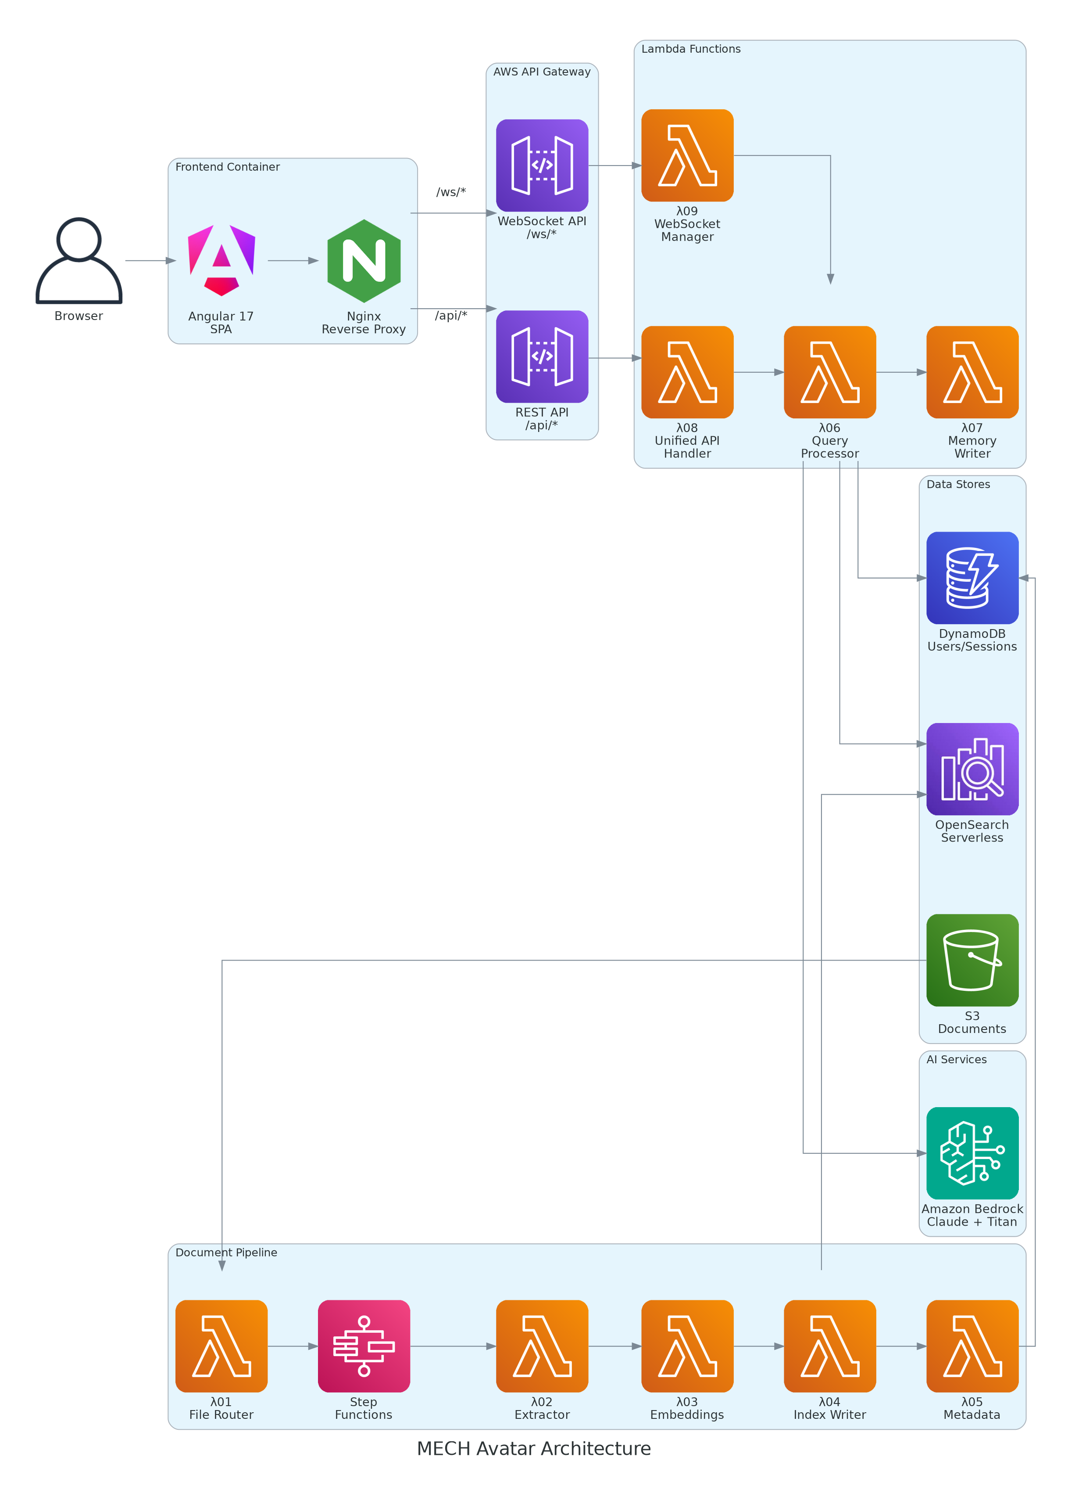
Figure 2.1: MECH Avatar System Architecture

2.3 Network Flow Diagram

The network topology showing data flow from browser to AWS services:
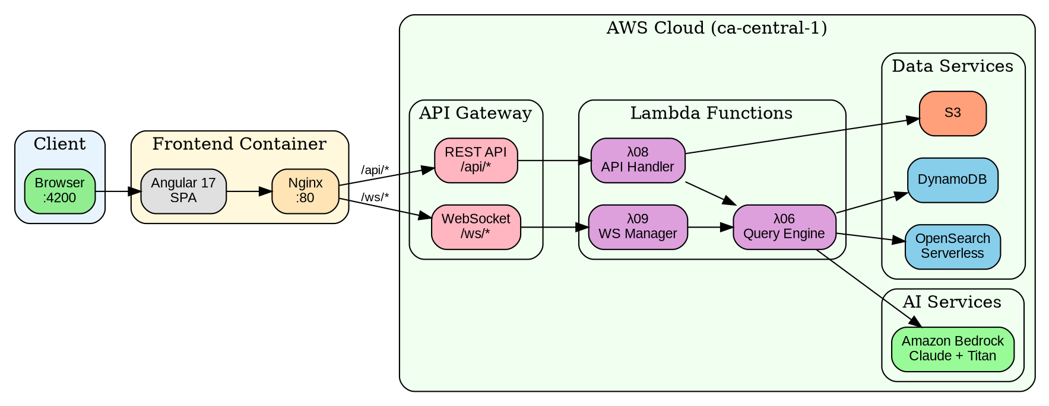
Figure 2.2: Network Flow Topology

3. End-to-End Sequence Diagrams

This section provides detailed sequence diagrams for each major flow in the system. These diagrams show the exact API calls, Lambda invocations, and data transformations that occur.

3.1 User Authentication Flow (UPDATED)
The authentication flow now supports dual modes: HS256 JWT (primary) for DynamoDB-backed auth, and Cognito base64 decode (fallback) for backward compatibility.
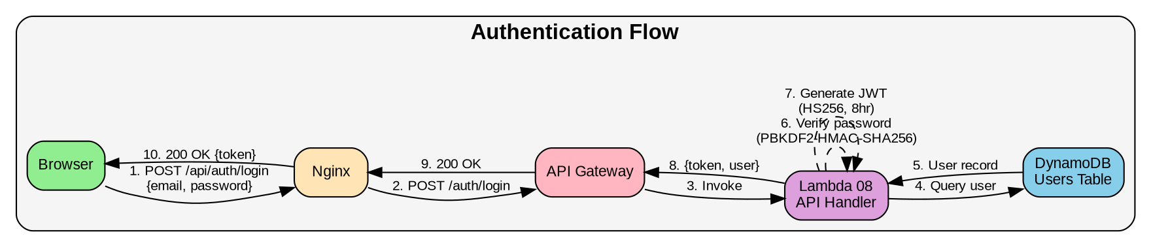
Figure 3.1: User Authentication Sequence

JWT Token Structure (HS256 - Primary):
{
"header": { "alg": "HS256", "typ": "JWT" },
"payload": {
"sub": "user_id",
"email": "user@bmo.com",
"name": "User Name",
"persona": "developer",
"iat": 1710000000,
"exp": 1710028800 // 8 hours (configurable via JWT_EXPIRY_SECONDS)
},
"signature": "HMAC-SHA256(header.payload, JWT_SECRET)"
}
Authentication Priority:
- Primary: HS256 JWT verified with JWT_SECRET from SSM/Secrets Manager
- Fallback: Base64-decoded Cognito token (no signature verification)
- Dev bypass: ALLOW_ANONYMOUS=true or DISABLE_JWT=true (dev only!)

3.2 Chat Query Flow (REST API)

This flow is used when the frontend calls the REST endpoint. Lambda 06 now includes query caching, Doc↔Code linking, and confidence calibration.
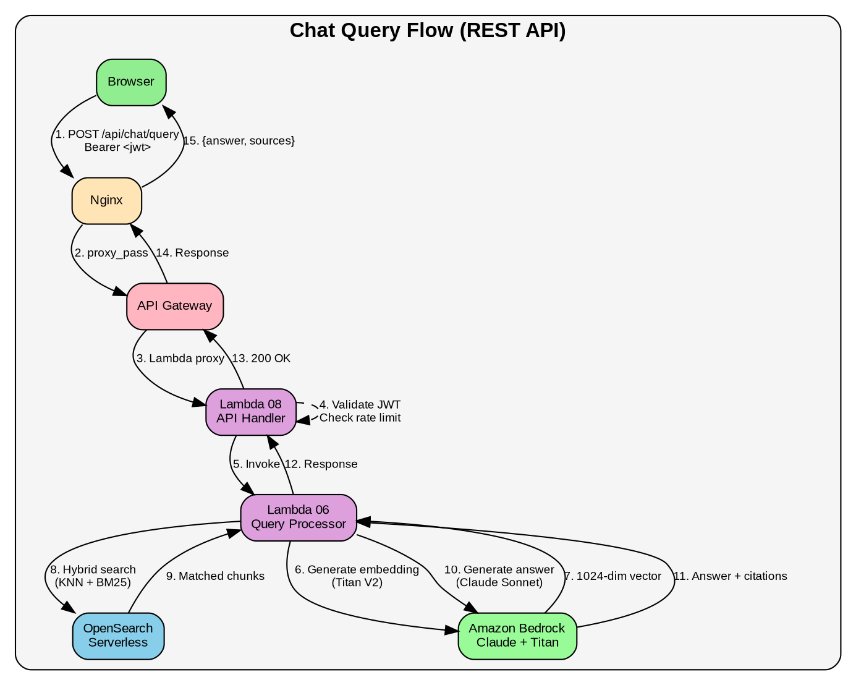
Figure 3.2: REST API Chat Query Sequence

3.3 Chat Query Flow (WebSocket Streaming)

This flow enables real-time token-by-token streaming of responses to the frontend. The WebSocket connection is maintained by Lambda 09 which streams chunks back to the client.
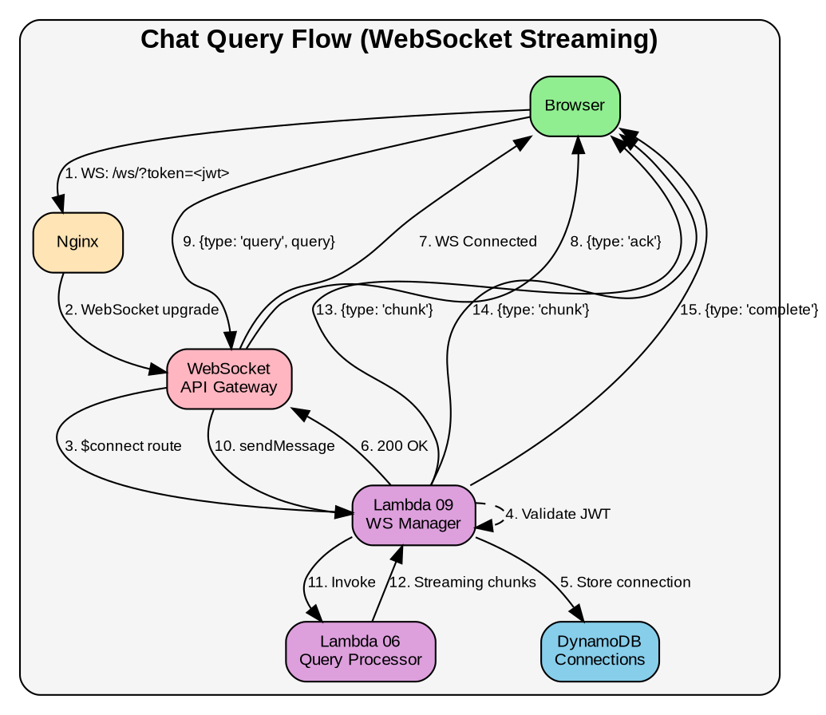
Figure 3.3: WebSocket Streaming Sequence

3.5 Document Ingestion Pipeline

After S3 upload, the document goes through a Step Functions pipeline for extraction, embedding, and indexing. Each Lambda handles a specific stage of the pipeline.
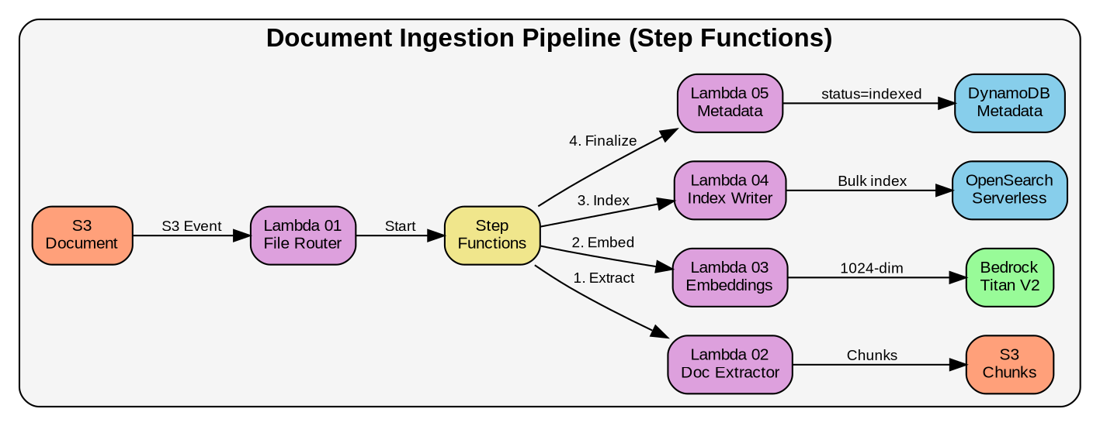
Figure 3.5: Document Ingestion Pipeline

Pipeline Stages:
- Lambda 02 (Extractor): Downloads document from S3, extracts text (PDF/DOCX/XLSX), creates semantic chunks (1500 tokens target)
- Lambda 03 (Embeddings): Generates Titan V2 1024-dimensional embeddings for each chunk
- Lambda 04 (Index Writer): Bulk indexes embeddings into OpenSearch Serverless
- Lambda 05 (Metadata): Updates DynamoDB with final status and chunk count

4. API Gateway Configuration

4.1 REST API Endpoints

API Gateway ID: g95hdf84lk
Base URL: https://g95hdf84lk.execute-api.ca-central-1.amazonaws.com/dev

Note: Lambda 08 now also supports HTTP API (API Gateway v2) for lower latency. Both REST and HTTP API formats are handled automatically.

Method | Resource Path | Lambda Integration | Auth Required
POST | /auth/login | Lambda 08 (PROXY) | No
POST | /auth/register | Lambda 08 (PROXY) | No
POST | /auth/refresh | Lambda 08 (PROXY) | Bearer Token
POST | /chat/query | Lambda 08 (PROXY) | Bearer Token (HS256 or Cognito)
GET | /chat/history/{session_id} | Lambda 08 (PROXY) | Bearer Token
POST | /documents/upload | Lambda 08 (PROXY) | Bearer Token
GET | /documents/status/{document_id} | Lambda 08 (PROXY) | Bearer Token
GET | /documents/list | Lambda 08 (PROXY) | Bearer Token
DELETE | /documents/{document_id} | Lambda 08 (PROXY) | Bearer Token
GET | /personas | Lambda 08 (PROXY) | Bearer Token
GET | /admin/analytics | Lambda 08 (PROXY) | Bearer Token (Admin)
OPTIONS | /{proxy+} | MOCK (CORS preflight) | No

4.2 WebSocket API Routes

WebSocket API ID: [ws-api-id]
Endpoint: wss://[ws-api-id].execute-api.ca-central-1.amazonaws.com/dev

Route Key | Lambda Integration | Description
$connect | Lambda 09 (WS Manager) | Validates JWT from query string, stores connection in DynamoDB
$disconnect | Lambda 09 (WS Manager) | Removes connection from DynamoDB
sendMessage | Lambda 09 (WS Manager) | Processes query, streams response via post_to_connection
$default | Lambda 09 (WS Manager) | Handles ping/pong and unknown message types

7. Environment Variables & Secrets (UPDATED)

All Lambda functions require specific environment variables. Store secrets in AWS Secrets Manager or SSM Parameter Store.

7.1 Lambda 08 (Unified API Handler) - UPDATED

Variable | Value / Description | Status
AWS_DEFAULT_REGION | ca-central-1 | Unchanged
LAMBDA_06_ARN | arn:aws:lambda:ca-central-1:[account]:function:mech-avatar-lambda-06 | Unchanged
S3_BUCKET_NAME | mech-avatar-lab-raw | Unchanged
JWT_SECRET | (from SSM/Secrets Manager) - REQUIRED for HS256 auth | Required
JWT_EXPIRY_SECONDS | 28800 (8 hours) - Token expiry time | NEW
COGNITO_USER_POOL_ID | [pool-id] - For fallback auth | Optional (fallback)
COGNITO_APP_CLIENT_ID | [client-id] - For fallback auth | Optional (fallback)
USERS_TABLE | mech-avatar-users | NEW
DOCUMENTS_TABLE | mech-avatar-documents | Unchanged
ALLOWED_ORIGINS | http://localhost:4200,https://mech-avatar.bmo.com | Unchanged
RATE_LIMIT_REQUESTS | 10 | Unchanged
ALLOW_ANONYMOUS | false (set true for dev only!) | NEW - Dev bypass

7.2 Lambda 06 (Query Processor) - UPDATED

Variable | Value / Description | Status
OPENSEARCH_HOST | [collection-id].ca-central-1.aoss.amazonaws.com | Unchanged
OPENSEARCH_INDEX | mech-avatar-documents | Unchanged
EMBEDDING_MODEL | amazon.titan-embed-text-v2:0 | Unchanged
TOP_K | 12 (was 8) | UPDATED
MIN_SCORE | 0.25 (was 0.6) | UPDATED
DOC_CODE_LINKS_TABLE | mech-avatar-doc-code-links | NEW
ENABLE_QUERY_CACHE | true - Enable response caching | NEW
CACHE_TTL_HOURS | 24 - Cache time-to-live | NEW
PAGEINDEX_INDEX | mech-avatar-pageindex | NEW
ENABLE_HYBRID_SEARCH | true | Unchanged
ENABLE_MEMORY | true | Unchanged

8. DynamoDB Tables (UPDATED)

Table Name | Partition Key | Sort Key | Status
mech-avatar-users | user_id (S) | - | Unchanged
mech-avatar-user-sessions | session_id (S) | - | Unchanged
mech-avatar-memory | session_id (S) | timestamp (S) | Unchanged
mech-avatar-documents | document_id (S) | - | Unchanged
mech-avatar-websocket-connections | connection_id (S) | - | Unchanged
mech-avatar-rate-limits | user_id (S) | - | Unchanged
mech-avatar-doc-code-links | identifier (S) | - | NEW - Doc↔Code linking
mech-avatar-query-cache | cache_key (S) | - | NEW - Query response cache

10. Response Schema Changes (NEW)

Lambda 06 response schema has been enhanced with additional metadata. All new fields are additive and optional for frontend consumption. Existing integrations will continue to work unchanged.

10.1 New Response Fields

// Enhanced Chat Query Response
{
"statusCode": 200,
"body": {
// Existing fields (unchanged)
"answer": "...",
"sources": [...],
"intent": "code_lookup",
"intent_confidence": 0.92,

// NEW fields
"retrieval_mode": "hybrid", // semantic | hybrid | keyword
"mech_domain": "cobol_program", // Domain classification
"query_resolved": "...", // Resolved query (if different)

"grounding": {
"status": "verified",
"groundedness_score": 0.95,
"citations_found": 3,
"literals_found": ["MYABC", "WS-AMOUNT"],
"literals_missing": []
},

"confidence": { // NEW - Haiku-as-judge
"score": 0.87,
"calibrated": true
},

"advanced_rag": { // NEW - RAG pipeline metadata
"hyde_used": true,
"query_decomposition": 2,
"cross_encoder_reranked": true,
"self_consistency_used": false,
"self_rag_used": false,
"multi_hop_used": true, // NEW
"multi_hop_iterations": 2, // NEW
"entity_extraction_used": true,
"entities_found": 5,
"query_cache_enabled": true // NEW
},

"metrics": {
"total_ms": 2450,
"breakdown": { ... },
"tokens": { "input": 3200, "output": 850 },
"cache_stats": { "hits": 12, "misses": 3 } // NEW
}
}
}

10.2 Enhanced Source Object

// Enhanced Source Citation
{
// Existing fields (unchanged)
"file_name": "MYABC.cbl",
"document_id": "doc-abc123",
"page_number": 5,
"section_title": "WORKING-STORAGE SECTION",
"relevance_score": 0.92,
"content_type": "cobol",

// NEW fields
"chunk_type": "code_block", // code_block | prose | table | heading
"line_start": 150, // Source line numbers
"line_end": 175,
"identifiers": ["WS-AMOUNT", "PIC-9"], // Code identifiers found
"heading_hierarchy": [ // PageIndex navigation path
"IDENTIFICATION DIVISION",
"DATA DIVISION",
"WORKING-STORAGE SECTION"
],
"pageindex_node_id": "node-xyz",
"mentioned_identifiers": ["PERFORM-CALC"],
"retrieval_reason": "identifier_match" // Why this chunk was retrieved
}

