BMO
MECH AVATAR
End-to-End Sequence Diagrams, API Gateway & Lambda Integration

Document Type | Cloud Integration Reference
Account | BMO Lab
Region | ca-central-1
API Gateway Stage | dev
Audience | Cloud Engineering Team
Date | March 2026

Table of Contents

1. Executive Summary
2. Architecture Overview
3. End-to-End Sequence Diagrams
3.1 User Authentication Flow
3.2 Chat Query Flow (REST API)
3.3 Chat Query Flow (WebSocket Streaming)
3.4 Document Upload Flow
3.5 Document Ingestion Pipeline
4. API Gateway Configuration
4.1 REST API Endpoints
4.2 WebSocket API Routes
4.3 Lambda Integrations
5. OpenAPI/Swagger Specification
6. Nginx Configuration
7. Environment Variables & Secrets
8. DynamoDB Tables
9. IAM Roles & Policies

1. Executive Summary

This document provides cloud engineers with a comprehensive guide to replicate the MECH Avatar architecture from the Lab account to the Dev account. It covers the end-to-end integration between the Angular frontend, Nginx reverse proxy, AWS API Gateway, Lambda functions, and backend services including OpenSearch Serverless, DynamoDB, S3, and Amazon Bedrock.

Key Integration Points:
- Frontend (Angular) served via Nginx on port 80
- Nginx proxies /api/* to REST API Gateway and /ws/* to WebSocket API Gateway
- REST API Gateway routes to Lambda 08 (Unified API Handler)
- WebSocket API Gateway routes to Lambda 09 (WebSocket Manager)
- Lambda 08 invokes Lambda 06 (Query Processor) for chat queries
- Document uploads trigger S3 events → Lambda 01 → Step Functions pipeline

2. Architecture Overview

2.1 System Components

Component | Technology | Purpose
Frontend | Angular 17 + Tailwind | Single-page chat interface with persona selection
Reverse Proxy | Nginx (Docker) | Routes /api/* to REST API, /ws/* to WebSocket API
REST API | API Gateway (REST) | Auth, chat, document endpoints → Lambda 08
WebSocket API | API Gateway (WS) | Real-time streaming → Lambda 09
API Handler | Lambda 08 | Unified handler: auth, routing, rate limiting
Query Engine | Lambda 06 | RAG engine: hybrid search + Bedrock Claude
Vector Store | OpenSearch Serverless | Hybrid KNN + BM25 index for document chunks
LLM Provider | Amazon Bedrock | Claude Sonnet (generation), Titan V2 (embeddings)
Storage | S3 + DynamoDB | Documents in S3, metadata/sessions in DynamoDB

2.2 High-Level Architecture Diagram

The following diagram shows all system components and their interactions:
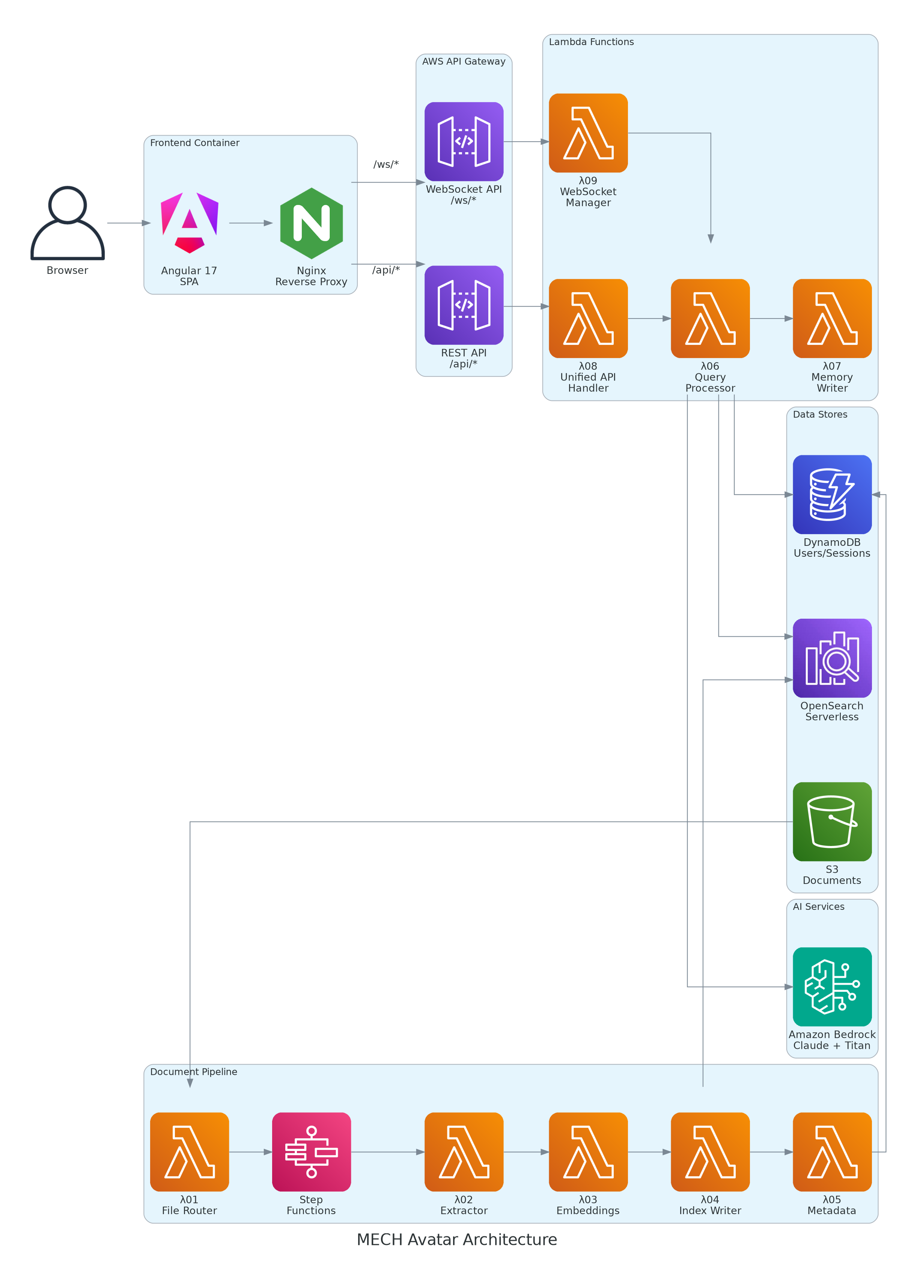
Figure 2.1: MECH Avatar System Architecture

2.3 Network Flow Diagram

The network topology showing data flow from browser to AWS services:
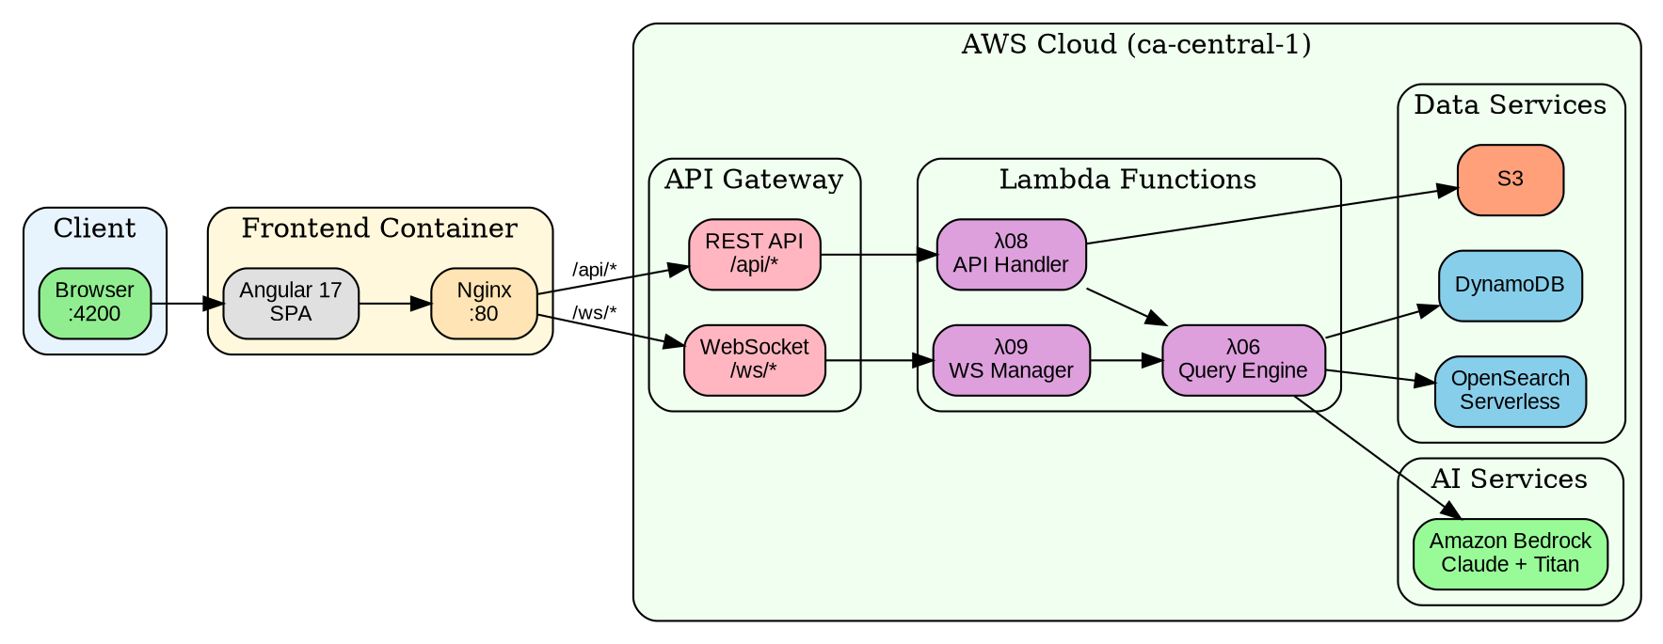
Figure 2.2: Network Flow Topology

3. End-to-End Sequence Diagrams
This section provides detailed sequence diagrams for each major flow in the system. These diagrams show the exact API calls, Lambda invocations, and data transformations that occur.

3.1 User Authentication Flow
The authentication flow uses DynamoDB-backed JWT tokens (HS256 signed). No Cognito or Azure AD is used in the current implementation.
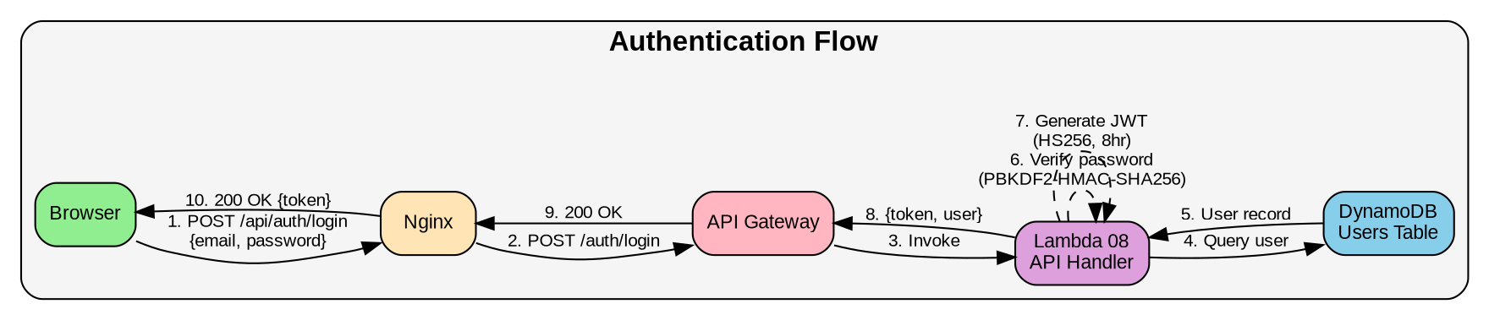
Figure 3.1: User Authentication Sequence
JWT Token Structure:
{
"header": { "alg": "HS256", "typ": "JWT" },
"payload": {
"sub": "user_id",
"email": "user@bmo.com",
"name": "User Name",
"persona": "developer",
"iat": 1710000000,
"exp": 1710028800 // 8 hours
},
"signature": "HMAC-SHA256(header.payload, JWT_SECRET)"
}

3.2 Chat Query Flow (REST API)

This flow is used when the frontend calls the REST endpoint for non-streaming responses. The request flows through Nginx, API Gateway, Lambda 08, and Lambda 06 which orchestrates the RAG pipeline.
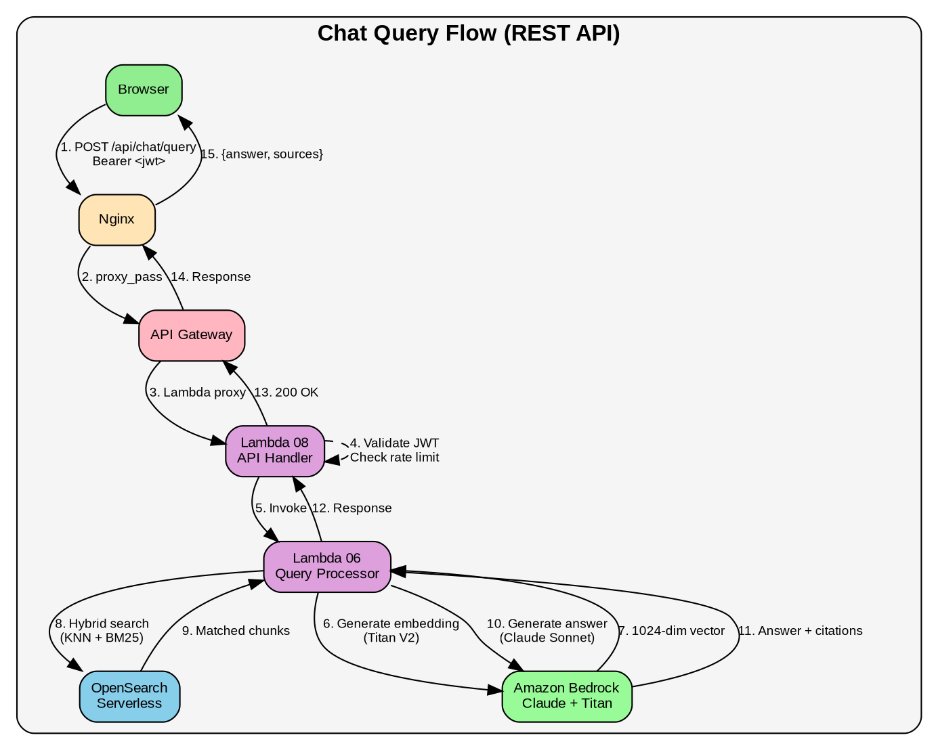
Figure 3.2: REST API Chat Query Sequence

3.3 Chat Query Flow (WebSocket Streaming)

This flow enables real-time token-by-token streaming of responses to the frontend. The WebSocket connection is maintained by Lambda 09 which streams chunks back to the client.
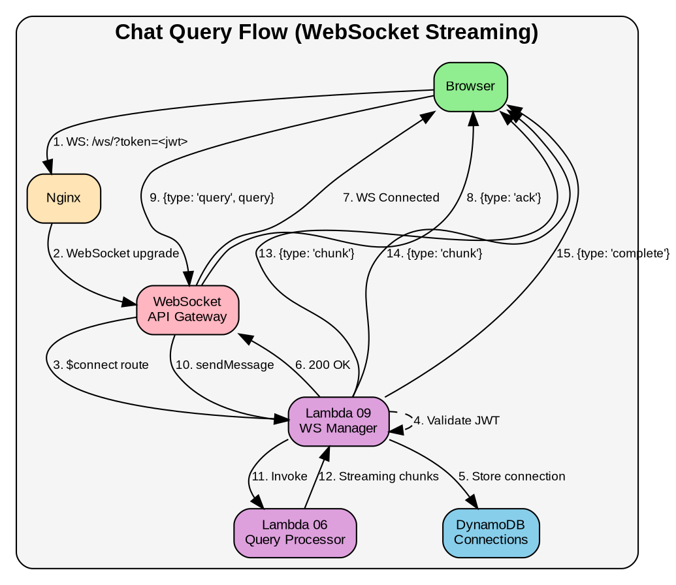
Figure 3.3: WebSocket Streaming Sequence

3.5 Document Ingestion Pipeline

After S3 upload, the document goes through a Step Functions pipeline for extraction, embedding, and indexing. Each Lambda handles a specific stage of the pipeline.
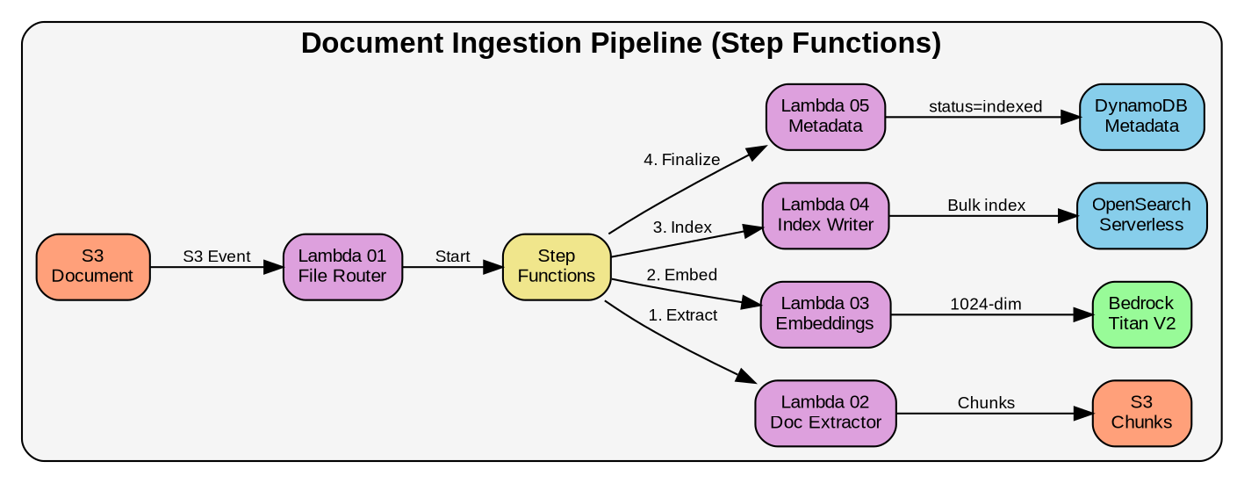
Figure 3.5: Document Ingestion Pipeline

Pipeline Stages:
- Lambda 02 (Extractor): Downloads document from S3, extracts text (PDF/DOCX/XLSX), creates semantic chunks (1500 tokens target)
- Lambda 03 (Embeddings): Generates Titan V2 1024-dimensional embeddings for each chunk
- Lambda 04 (Index Writer): Bulk indexes embeddings into OpenSearch Serverless
- Lambda 05 (Metadata): Updates DynamoDB with final status and chunk count

4. API Gateway Configuration

4.1 REST API Endpoints

API Gateway ID: g95hdf84lk
Base URL: https://g95hdf84lk.execute-api.ca-central-1.amazonaws.com/dev

Method | Resource Path | Lambda Integration | Auth Required
POST | /auth/login | Lambda 08 (PROXY) | No
POST | /auth/register | Lambda 08 (PROXY) | No
POST | /auth/refresh | Lambda 08 (PROXY) | Bearer Token
POST | /chat/query | Lambda 08 (PROXY) | Bearer Token
GET | /chat/history/{session_id} | Lambda 08 (PROXY) | Bearer Token
POST | /documents/upload | Lambda 08 (PROXY) | Bearer Token
GET | /documents/status/{document_id} | Lambda 08 (PROXY) | Bearer Token
GET | /documents/list | Lambda 08 (PROXY) | Bearer Token
DELETE | /documents/{document_id} | Lambda 08 (PROXY) | Bearer Token
GET | /personas | Lambda 08 (PROXY) | Bearer Token
OPTIONS | /{proxy+} | MOCK (CORS preflight) | No

4.2 WebSocket API Routes

WebSocket API ID: [ws-api-id]
Endpoint: wss://[ws-api-id].execute-api.ca-central-1.amazonaws.com/dev
Route Key | Lambda Integration | Description
$connect | Lambda 09 (WS Manager) | Validates JWT from query string, stores connection in DynamoDB
$disconnect | Lambda 09 (WS Manager) | Removes connection from DynamoDB
sendMessage | Lambda 09 (WS Manager) | Processes query, streams response via post_to_connection
$default | Lambda 09 (WS Manager) | Handles ping/pong and unknown message types

4.3 Lambda Integration Configuration

Both APIs use Lambda Proxy integration (AWS_PROXY) which passes the full request to Lambda and expects a properly formatted response.

Integration Request Configuration:
Integration Type: AWS_PROXY
Lambda Function: arn:aws:lambda:ca-central-1:[account]:function:mech-avatar-lambda-08
Invocation Type: RequestResponse (synchronous)
Timeout: 29000ms (just under API Gateway 30s limit)

Mapping Templates: None (proxy integration passes raw event)

Request Passthrough: WHEN_NO_MATCH

5. OpenAPI/Swagger Specification

The following is the OpenAPI 3.0 specification for the MECH Avatar REST API. This can be imported into API Gateway.

openapi: 3.0.1
info:
title: MECH Avatar API
description: RAG-powered AI assistant for BMO documentation
version: 2.0.0
servers:
- url: https://g95hdf84lk.execute-api.ca-central-1.amazonaws.com/dev

paths:
/auth/login:
post:
summary: User login
requestBody:
required: true
content:
application/json:
schema:
type: object
required: [email, password]
properties:
email: { type: string, format: email }
password: { type: string, minLength: 8 }
responses:
200:
description: Login successful
content:
application/json:
schema:
type: object
properties:
token: { type: string }
user: { $ref: '#/components/schemas/User' }
401: { description: Invalid credentials }

/chat/query:
post:
summary: Send chat query
security: [{ bearerAuth: [] }]
requestBody:
required: true
content:
application/json:
schema:
type: object
required: [query]
properties:
query: { type: string, minLength: 1, maxLength: 500 }
session_id: { type: string }
persona: { type: string, enum: [developer, business_analyst,
qa_tester, support_engineer, architect, compliance_officer] }
responses:
200:
description: Query response
content:
application/json:
schema: { $ref: '#/components/schemas/ChatQueryResponse' }
429: { description: Rate limit exceeded }

/documents/upload:
post:
summary: Request presigned upload URL
security: [{ bearerAuth: [] }]
requestBody:
required: true
content:
application/json:
schema:
type: object
required: [file_name, file_type, file_size]
properties:
file_name: { type: string }
file_type: { type: string }
file_size: { type: integer, maximum: 104857600 }
responses:
200:
description: Presigned URL generated
content:
application/json:
schema:
type: object
properties:
document_id: { type: string }
upload_url: { type: string, format: uri }

components:
securitySchemes:
bearerAuth:
type: http
scheme: bearer
bearerFormat: JWT

6. Nginx Configuration

The Nginx reverse proxy serves the Angular frontend and routes API/WebSocket traffic to AWS. Below is the complete production configuration.

6.1 Main Server Configuration

# /etc/nginx/nginx.conf

worker_processes auto;
error_log /var/log/nginx/error.log warn;

http {
include /etc/nginx/mime.types;
default_type application/octet-stream;

# Performance
sendfile on;
tcp_nopush on;
keepalive_timeout 65;
client_max_body_size 100M;

# Gzip compression
gzip on;
gzip_types application/javascript application/json text/css;

# Rate limiting
limit_req_zone $binary_remote_addr zone=api_limit:10m rate=100r/m;

server {
listen 80;
server_name _;
root /usr/share/nginx/html;

# REST API proxy
location /api/ {
limit_req zone=api_limit burst=20 nodelay;
proxy_pass https://g95hdf84lk.execute-api.ca-central-1.amazonaws.com/dev/;
proxy_http_version 1.1;
proxy_ssl_server_name on;
proxy_set_header Host g95hdf84lk.execute-api.ca-central-1.amazonaws.com;
proxy_set_header X-Real-IP $remote_addr;
proxy_read_timeout 300s;
}

# WebSocket proxy
location /ws/ {
proxy_pass https://[WS-API-ID].execute-api.ca-central-1.amazonaws.com/dev/;
proxy_http_version 1.1;
proxy_ssl_server_name on;
proxy_set_header Upgrade $http_upgrade;
proxy_set_header Connection "upgrade";
proxy_read_timeout 300s;
proxy_buffering off;
}

# Angular SPA fallback
location / {
try_files $uri $uri/ /index.html;
}
}
}

7. Environment Variables & Secrets
All Lambda functions require specific environment variables. Store secrets in AWS Secrets Manager or SSM Parameter Store.

7.1 Lambda 08 (Unified API Handler)

Variable | Value / Description | Secret?
AWS_DEFAULT_REGION | ca-central-1 | No
LAMBDA_06_ARN | arn:aws:lambda:ca-central-1:[account]:function:mech-avatar-lambda-06 | No
S3_BUCKET_NAME | mech-avatar-lab-raw | No
DOCUMENTS_TABLE | mech-avatar-documents | No
USERS_TABLE | mech-avatar-users | No
JWT_SECRET | (from SSM/Secrets Manager) | YES
JWT_EXPIRY_SECONDS | 28800 (8 hours) | No
ALLOWED_ORIGINS | http://localhost:4200,https://mech-avatar.bmo.com | No
RATE_LIMIT_REQUESTS | 10 | No

7.2 Lambda 06 (Query Processor)

Variable | Value / Description | Secret?
OPENSEARCH_HOST | [collection-id].ca-central-1.aoss.amazonaws.com | No
OPENSEARCH_INDEX | mech-avatar-documents | No
EMBEDDING_MODEL | amazon.titan-embed-text-v2:0 | No
TOP_K | 15 | No
ENABLE_HYBRID_SEARCH | true | No

8. DynamoDB Tables

Table Name | Partition Key | Sort Key | Purpose
mech-avatar-users | user_id (S) | - | User accounts
mech-avatar-user-sessions | session_id (S) | - | Chat sessions
mech-avatar-memory | session_id (S) | timestamp (S) | Conversation history
mech-avatar-documents | document_id (S) | - | Document metadata
mech-avatar-websocket-connections | connection_id (S) | - | Active WS connections
mech-avatar-rate-limits | user_id (S) | - | Rate limit counters

9. IAM Roles & Policies

9.1 Lambda 08 Execution Role

{
"Version": "2012-10-17",
"Statement": [
{
"Effect": "Allow",
"Action": ["logs:CreateLogGroup", "logs:CreateLogStream", "logs:PutLogEvents"],
"Resource": "arn:aws:logs:ca-central-1:*:*"
},
{
"Effect": "Allow",
"Action": ["dynamodb:GetItem", "dynamodb:PutItem", "dynamodb:UpdateItem",
"dynamodb:DeleteItem", "dynamodb:Query", "dynamodb:Scan"],
"Resource": ["arn:aws:dynamodb:ca-central-1:*:table/mech-avatar-*"]
},
{
"Effect": "Allow",
"Action": ["s3:PutObject", "s3:GetObject"],
"Resource": "arn:aws:s3:::mech-avatar-*/*"
},
{
"Effect": "Allow",
"Action": "lambda:InvokeFunction",
"Resource": ["arn:aws:lambda:ca-central-1:*:function:mech-avatar-lambda-06",
"arn:aws:lambda:ca-central-1:*:function:mech-avatar-lambda-07"]
}
]
}

