# **GROUP MEMBERS :** Nisarg Godhani [22bce096]

# 

# **SERVICE :** GSRTC

# **SERVICE BLUEPRINT :**

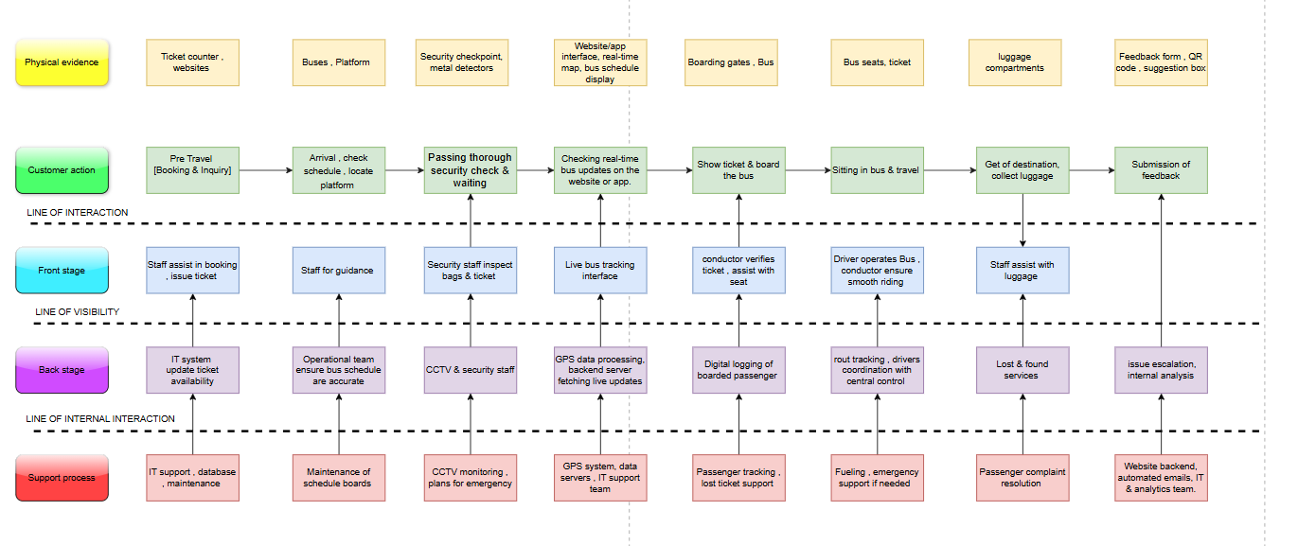

**1. Overview of the Blueprint :**

The blueprint visually represents the end-to-end passenger journey in GSRTC, showing customer actions, front-stage interactions, back-stage processes, and support functions. It also includes the physical evidence of service at various touchpoints.

**2. Layers of Service Blueprint :`**

The diagram is divided into several layers:

**A. Physical Evidence :**

* **Ticket counters, websites** – Passengers use counters or online platforms to book tickets conveniently.
* **Buses, platforms** – Designated areas where passengers wait and board their buses.
* **Security checkpoints, metal detectors** – Safety measures to screen passengers and their belongings before boarding.
* **Real-time tracking apps** – Digital platforms providing real-time bus location and schedule updates.
* **Boarding gates, buses** – Entry points where passengers verify tickets and board the bus.
* **Bus seats, tickets** – Assigned seats and tickets ensure organized and comfortable travel.
* **Luggage compartments** – Storage spaces for passengers to safely keep their baggage during the journey.
* **Feedback forms, QR codes** – Tools for passengers to share their travel experiences and suggestions.

**B. Customer Actions :**

* **Pre-travel booking & inquiry** – Passengers book tickets and gather information before the journey.
* **Arrival, check schedule, locate platform** – Customers check their bus schedules and find the boarding area.
* **Passing through security check & waiting** – Passengers undergo security checks and wait for boarding.
* **Checking real-time bus updates** – Customers track bus arrivals via website or app for timely updates.
* **Showing ticket & boarding the bus** – Passengers present their tickets and enter the bus.
* **Sitting in the bus & travel** – The journey begins as passengers settle into their assigned seats.
* **Getting off at the destination, collecting luggage** – Passengers disembark and retrieve their belongings.
* **Submission of feedback** – Customers provide input on their travel experience for service improvement.

**C. Front Stage (Visible Interactions) :**

* **Staff assist in booking, issue ticket** – Booking agents help passengers purchase and print tickets.
* **Staff for guidance** – Support personnel provide directions and assist passengers at the station.
* **Security staff inspect bags & tickets** – Security personnel check passenger tickets and luggage for safety.
* **Live bus tracking interface** – Real-time tracking screens help passengers monitor their bus location.
* **Conductor verifies ticket, assists with seating** – Conductors confirm tickets and help passengers find seats.
* **Driver operates the bus, conductor ensures smooth riding** – The driver navigates the route while the conductor manages onboard services.
* **Staff assist with luggage** – Helpers aid passengers with handling and retrieving their baggage.
* **Issue escalation, internal analysis** – Staff members review passenger feedback and address service complaints.

**D. Back Stage (Internal Operations) :**

* **IT system updates ticket availability** – Digital ticketing systems manage seat reservations and availability.
* **Operational team ensures bus schedule accuracy** – Teams coordinate bus timings and update schedule boards.
* **CCTV & security staff** – Surveillance personnel monitor security footage for safety compliance.
* **GPS data processing, backend fetching live updates** – IT systems continuously track and update bus movements.
* **Digital logging of boarded passengers** – Passenger boarding data is recorded electronically for tracking.
* **Route tracking, driver coordination with control center** – Bus routes are monitored for efficiency and driver assistance.
* **Lost & found services** – A system to help passengers recover lost belongings.
* **Issue escalation, internal analysis** – Internal teams analyze complaints and feedback to improve services.

**E. Support Processes (Backend Infrastructure) :**

* **IT support, database maintenance** – Technical teams manage booking systems and data storage.
* **Maintenance of schedule boards** – Regular updates ensure schedule boards display accurate information.
* **CCTV monitoring, emergency plans** – Security staff oversee live surveillance and handle emergency situations.
* **GPS systems, data servers, IT support team** – Backend infrastructure processes real-time tracking data.
* **Passenger tracking, lost ticket support** – Systems help recover lost tickets and track passenger records.
* **Fueling, emergency support if needed** – Fuel management ensures uninterrupted service, with emergency plans in place.
* **Passenger complaint resolution** – Customer service teams handle complaints and provide solutions.
* **Website backend, automated emails, IT & analytics team** – Digital platforms analyze passenger data and automate communication.

**3. Key Insights & Importance :**

* **Seamless Passenger Experience**: The blueprint ensures a smooth journey from booking to feedback submission.
* **Security & Monitoring**: Multiple layers of security, including CCTV, security personnel, and backend surveillance, ensure safety.
* **Technology Integration**: GPS tracking, real-time updates, and IT support improve efficiency.
* **Customer Support & Feedback**: The system allows passengers to report lost items, submit complaints, and provide feedback for service improvements.

**4. Conclusion :**

This service blueprint of GSRTC provides a structured view of how the corporation manages passenger journeys efficiently. It highlights the importance of digital integration, security, backend support, and passenger assistance to enhance customer satisfaction.