Group Assignment (Services Marketing)

Institute of Management - Nirma University

Made by :

Nisarg Godhani <[22bce096@nirmauni.ac.in](mailto:22bce096@nirmauni.ac.in)>

1. **Introduction :**

The Gujarat State Road Transport Corporation (GSRTC) is a key player in the Indian public transportation sector, offering reliable and affordable travel solutions across urban and rural areas. With a fleet catering to diverse passenger needs—ranging from AC and non-AC seating to sleeper coaches—GSRTC ensures connectivity within Gujarat and to neighboring states. As public transport continues to evolve, service quality and customer satisfaction have become crucial in determining the success and sustainability of such services.

Customer satisfaction plays a vital role in any service-oriented industry, especially in public transport, where user experience directly impacts ridership and revenue. Factors such as punctuality, cleanliness, ticket booking convenience, staff behavior, and safety influence how passengers perceive the service. Understanding these elements helps GSRTC enhance its offerings, ensuring passenger loyalty and improving overall operational efficiency.

To measure service quality effectively, the SERVQUAL model provides a structured approach. Developed by Parasuraman, Zeithaml, and Berry, it evaluates service quality based on five key dimensions:

Tangibles – The physical appearance of buses, cleanliness, and ticketing facilities.

Reliability – Consistency in scheduling and adherence to promises.

Responsiveness – Staff readiness to assist passengers.

Assurance – Employee professionalism, safety measures, and trustworthiness.

Empathy – Personalized services and passenger care.

The survey conducted as part of this study assesses how frequently passengers use GSRTC services, their preferred travel class, and their perceptions of service quality using the SERVQUAL framework. By analyzing passenger feedback, GSRTC can identify strengths and areas for improvement, ensuring a better travel experience for all commuters.

1. **Objectives of the Study :**

The primary objective of this study is to measure and enhance customer satisfaction within GSRTC services by leveraging the SERVQUAL model. This model provides a structured framework to identify gaps between customer expectations and perceptions across key service quality dimensions such as tangibles, reliability, responsiveness, assurance, and empathy. By utilizing SERVQUAL, the study aims to highlight areas for improvement and ensure that GSRTC consistently meets passenger needs, fostering greater loyalty and satisfaction.

Additionally, the study underscores the significance of service blueprinting as a pivotal tool in service improvement. Service blueprinting helps map out the entire customer journey, identifying touchpoints and potential pain points. This visual representation aids in refining operations, enhancing employee performance, and creating seamless passenger experiences. Together, SERVQUAL and service blueprinting lay the foundation for a customer-centric approach, ensuring continuous improvement in GSRTC's service quality.

1. **Methodology :**

Selection of Service :-

The study focuses on Gujarat State Road Transport Corporation (GSRTC), a state-run public transportation service that connects cities, towns, and rural areas across Gujarat. GSRTC plays a vital role in ensuring affordable and accessible transportation for daily commuters, students, professionals, and long-distance travelers. Given the increasing demand for reliable and comfortable transport services, analyzing customer satisfaction is crucial for improving service quality and efficiency.

To evaluate service quality, this study applies the SERVQUAL model, which measures the gap between customer expectations and perceived service performance. The findings from this research will help GSRTC identify key strengths and areas that require improvement to enhance passenger satisfaction and loyalty.

Survey Design (SERVQUAL Questionnaire Details) :-

The study is based on a structured questionnaire designed using the SERVQUAL model, which assesses service quality based on the following five dimensions:

Tangibles – Condition of buses, seating arrangements, cleanliness, and overall infrastructure.

Reliability – Adherence to bus schedules, consistency of service, and accurate information provided to passengers.

Responsiveness – Helpfulness of staff, timely responses to queries, and efficiency in handling issues.

Assurance – Passenger safety, professionalism of drivers and conductors, and trustworthiness of the service.

Empathy – Consideration for passenger needs, comfort levels, and accessibility for special needs travelers.

The questionnaire consists of Likert-scale statements (ranging from Strongly Agree to Strongly Disagree) to measure passenger satisfaction levels across these dimensions. Additionally, demographic questions such as age, occupation, travel frequency, and preferred travel class help in understanding customer preferences. The detailed questionnaire is included in the Annexure section.

Sample Size and Data Collection Method :-

To gather responses, we distributed the survey via Google Forms among our university friends, relatives, and other acquaintances through WhatsApp and personal networks. The convenience sampling method was used to collect a diverse set of responses.

Sample Size: The study gathered responses from students, working professionals, and frequent GSRTC users, ensuring a broad perspective on service quality.

Total Sample Size: 217 respondents

Gender Distribution:

Male: 154 respondents

Female: 51 respondents

Age Distribution:

Below 20 years: 50 respondents

20 to <40 years: 112 respondents

40 to 60 years: 34 respondents

Above 60 years: 9 respondents

Occupation Distribution:

Students: 102 respondents

Employees: 53 respondents

Business Owners: 34 respondents

Housewives: 16 respondents

Data Collection Method: Since the survey was shared online via Google Forms from WhatsApp, it allowed for quick and efficient data collection from different regions.

1. **SERVQUAL Analysis :**

**Survey Analysis**

The survey responses were collected from 205 valid participants, primarily consisting of students (102), employees (53), business owners (34), and housewives (16). The majority of respondents were male (154) and fell in the 20 to <40 age group (112 respondents).

**Survey Findings (SERVQUAL Dimension Scores)**

* **Descriptives**

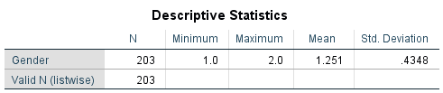

# **Result Analysis**

The descriptive statistics indicate a dataset of 203 respondents with gender coded as 1-male and 2-female, showing a mean of 1.251, suggesting a higher proportion of one gender category. The standard deviation of 0.4348 indicates relatively low variability in gender distribution.

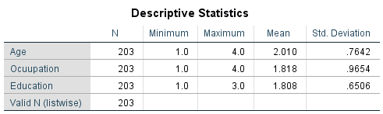

**Result Analysis**

The survey results highlight significant trends: the average age of respondents is approximately 2.010, with moderate variability, suggesting a relatively young or middle-aged group. Occupation data shows higher variability (mean 1.818, SD 0.9654), indicating diverse job types, while education levels are more consistent (mean 1.808, SD 0.6506), reflecting a similar educational background among most respondents. These insights can help tailor strategies or interventions to the demographic characteristics of the surveyed population.

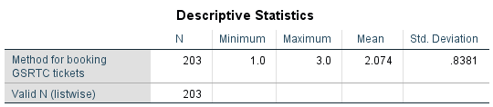

**Result Analysis**

The survey findings reveal significant insights into booking behaviors and respondent demographics. The mean booking method score of 2.074, with a standard deviation of 0.8381, indicates a preference for certain booking methods with moderate variability. The inclusion of gender and income data, analyzed through frequencies and percentiles, highlights key demographic trends and income distribution patterns.

* **Frequency**

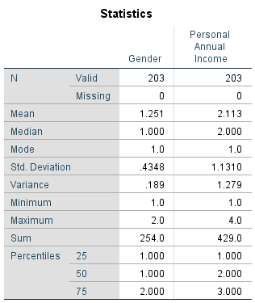

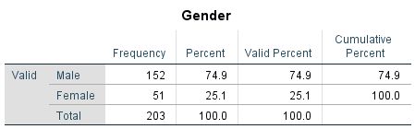

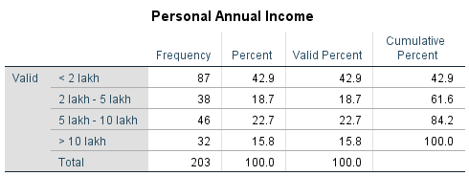

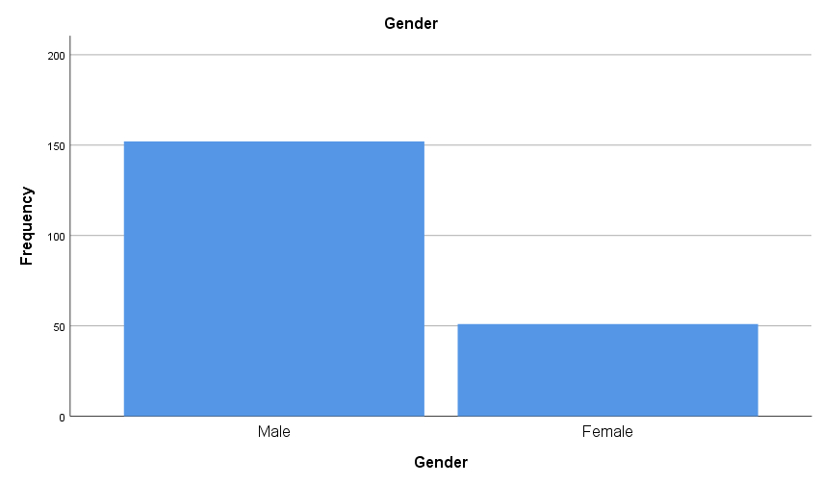

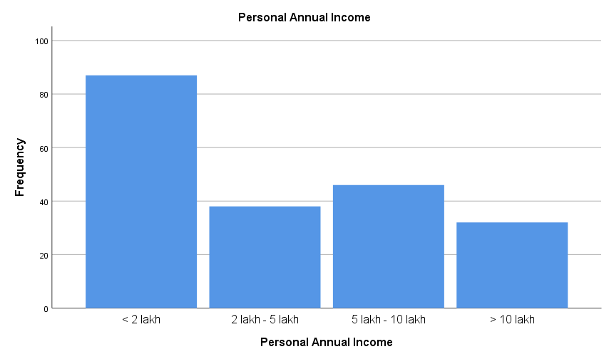

The survey results provide significant insights into the demographic and income distribution of respondents.

1. Gender Distribution: The majority of respondents are male (74.9%), with females comprising 25.1%. This indicates a gender imbalance in the sample, which may influence the interpretation of results and the design of targeted interventions.

2. income Distribution : The personal annual income data shows that 42.9% of respondents earn less than 2 lakh, while 22.7% earn between 5 lakh and 10 lakh, and 15.8% earn more than 10 lakh. The median income is 2 lakh, with a mean of 2.113, indicating a right-skewed distribution. The standard deviation of 1.1310 highlights variability in income levels.

These findings are crucial for understanding the socioeconomic profile of the respondents and can guide the development of policies or services tailored to the predominant demographics and income groups.

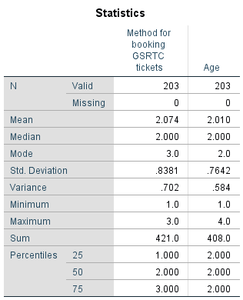

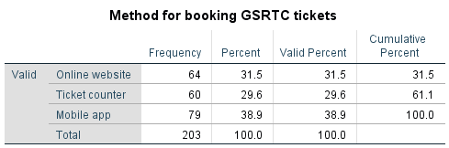

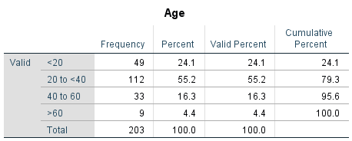

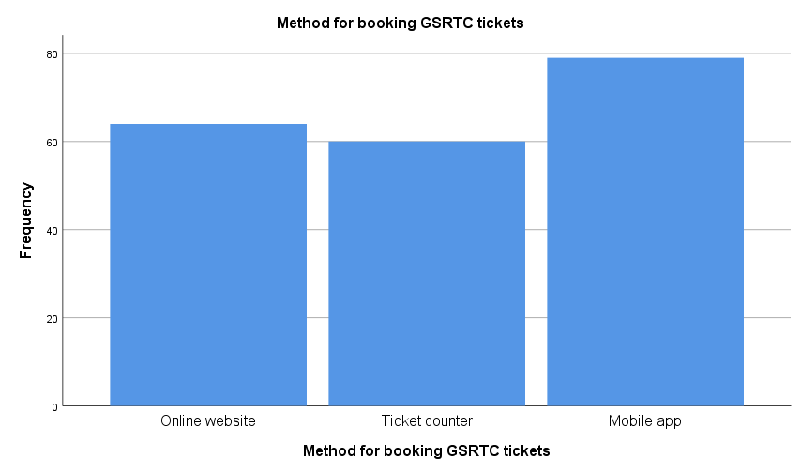

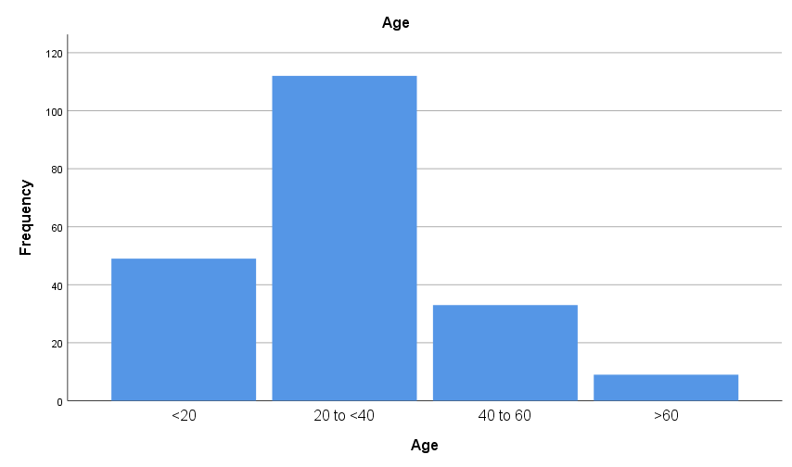

Result analysis :

The survey results indicate that the most common method for booking GSRTC tickets is via mobile app (38.9%), followed by online website (31.5%) and ticket counter (29.6%). The median age of respondents is 2.000, suggesting a relatively young demographic, with 75% of respondents falling within the age category represented by the value 2.000.

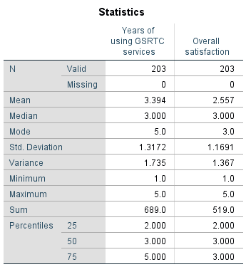

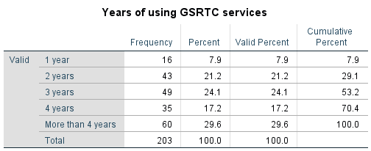

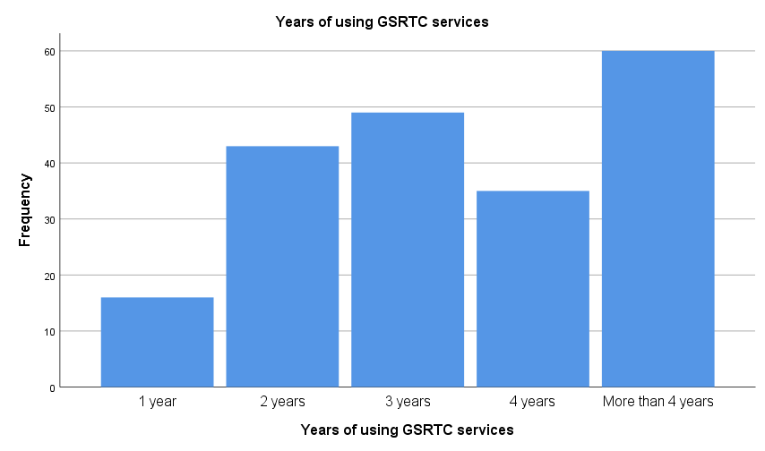

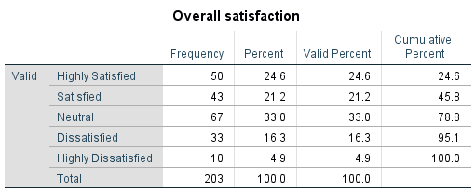

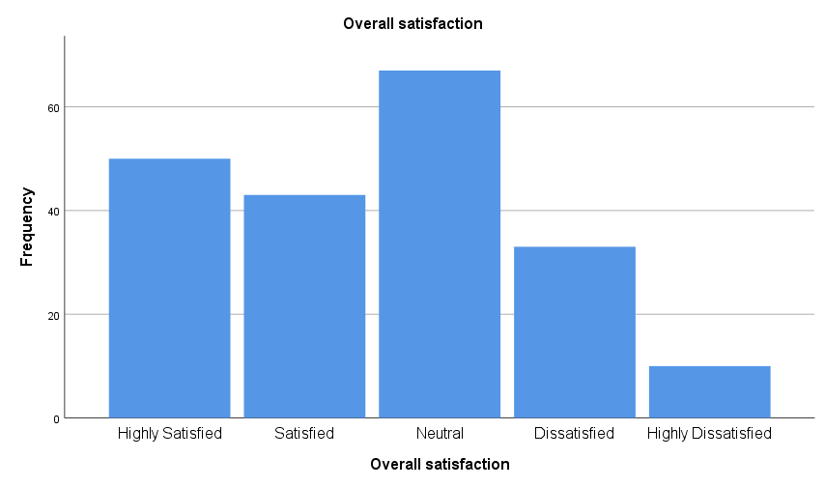

Result analysis :

The survey results show that 29.6% of respondents have been using GSRTC services for more than 4 years, with a median usage duration of 3 years. The overall satisfaction level has a median of 3.000, indicating moderate satisfaction, and 75% of respondents report a satisfaction level of up to 3.000. The data suggests a relatively stable user base with varied satisfaction levels.

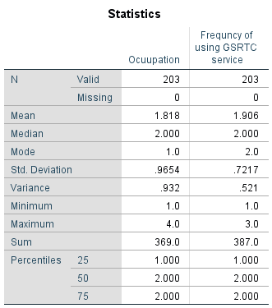

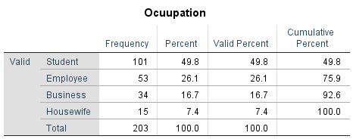

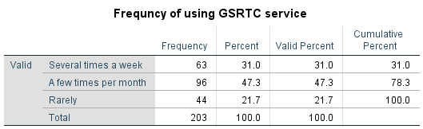

Occupation plays a key role in determining GSRTC usage frequency. Students are the most frequent users, often relying on the service several times a week or a few times per month. Employees and business owners use GSRTC occasionally, mostly a few times per month. Housewives are the least frequent users, indicating they may have alternative transport options. This suggests GSRTC is most essential for students and working professionals.

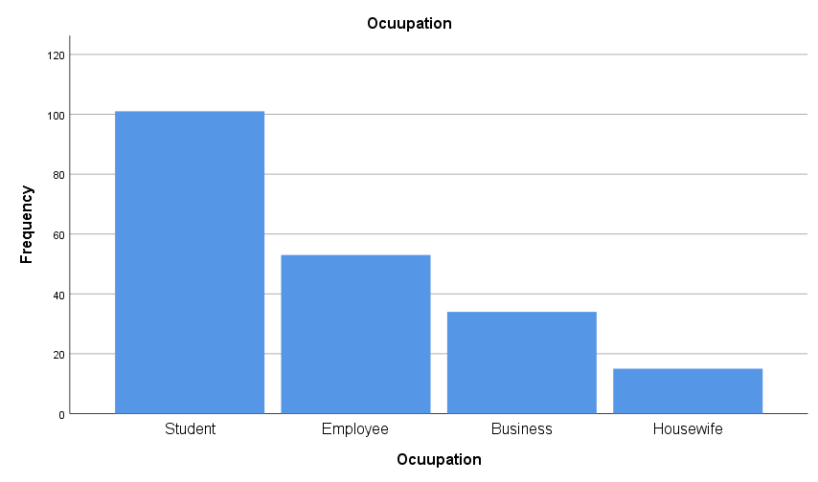

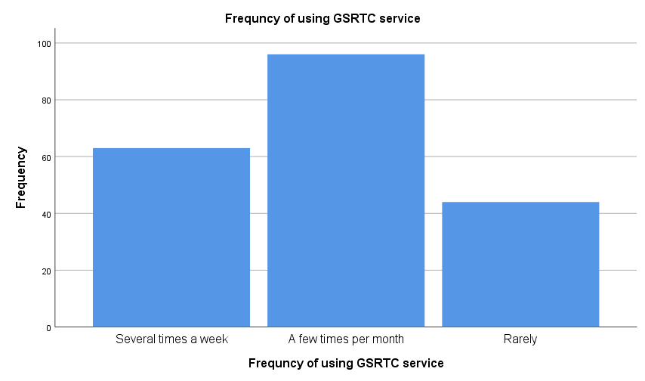

* Crosstabulation (Chi-Square Test)

Hypothesis

Null Hypothesis (H₀): There is no significant association between gender and preferred travel class in GSRTC buses.

Alternative Hypothesis (H₁): There is a significant association between gender and preferred travel class in GSRTC buses.

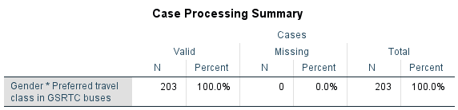

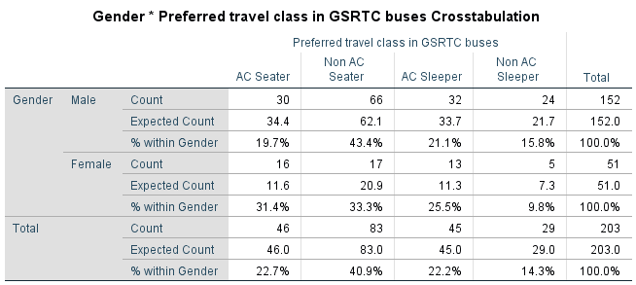

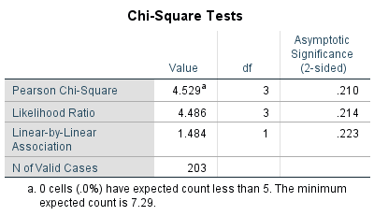

Male Preferences: 43.4% of males prefer Non-AC Seater, while 21.1% prefer AC Sleeper.

Female Preferences: 33.3% of females prefer Non-AC Seater, and 25.5% prefer AC Sleeper.

Overall Preferences: 40.9% of all respondents prefer Non-AC Seater, and 22.2% prefer AC Sleeper.

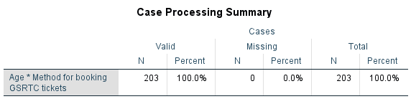

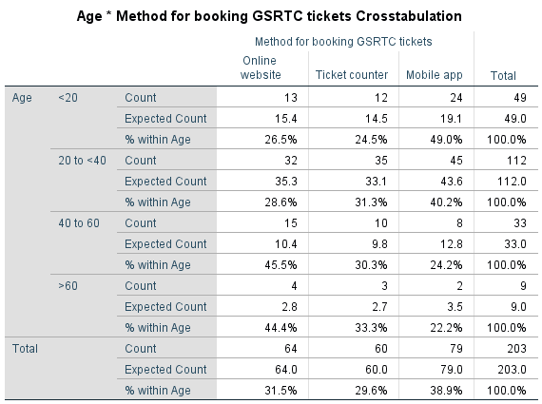

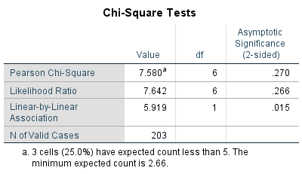

Result analysis :

The crosstabulation shows that younger age groups (<20 and 20 to <40) prefer the mobile app (49.0% and 42.2%, respectively), while older age groups (40 to 60 and >60) prefer the online website (45.5% and 44.4%, respectively). The Pearson Chi-Square (p=0.270) and Likelihood Ratio (p=0.266) tests indicate no significant overall association between age and booking method. However, the Linear-by-Linear Association (p=0.015) suggests a significant linear trend, with older individuals favoring online and ticket counter bookings more than younger individuals.

Hypotheses:

Null Hypothesis (H₀): There is no significant association between personal annual income and the frequency of using GSRTC services.

Alternative Hypothesis (H₁): There is a significant association between personal annual income and the frequency of using GSRTC services.

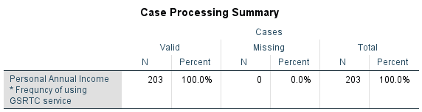

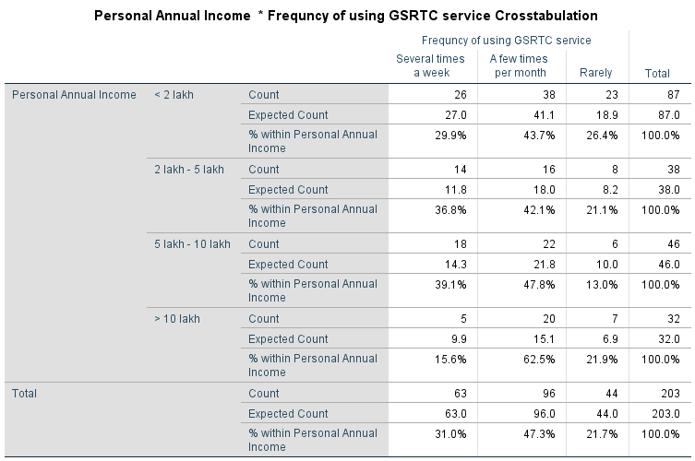

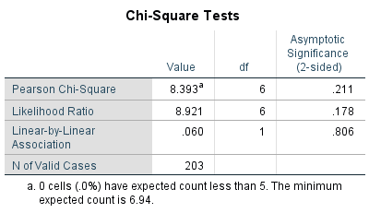

**Result analysis :**

The crosstabulation shows that individuals across all income groups most frequently use GSRTC services "a few times per month," with the percentage (43.7%) in the <2 lakh income group. The chi-square tests (Pearson Chi-Square p=0.211, Likelihood Ratio p=0.178, Linear-by-Linear Association p=0.806) indicate no significant association or linear relationship between personal annual income and the frequency of using GSRTC services. The observed differences in usage frequency are likely due to random variation rather than income level.

* **INDEPENDENT SAMPLES T-TEST**

Hypotheses:

Null Hypothesis (H₀): There is no significant difference in overall satisfaction between males and females.

Alternative Hypothesis (H₁): There is a significant difference in overall satisfaction between males and females.

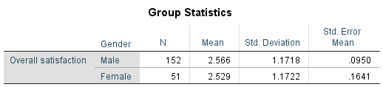

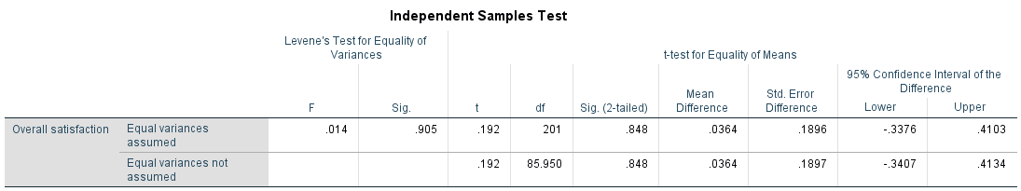

Interpretation:

Levene's Test: The p-value of 0.905 indicates that the assumption of equal variances is valid.

t-test: The p-value of 0.848 is greater than 0.05, indicating no significant difference in overall satisfaction between males and females.

Combined Conclusion:

The mean satisfaction levels for males (2.566) and females (2.529) are very similar.

Final Interpretation: There is no statistically significant difference in overall satisfaction between males and females. The observed differences in satisfaction levels are likely due to random variation rather than gender.

* **Oneway Anova**

Hypotheses:

Null Hypothesis (H₀): There is no significant difference in overall satisfaction across the groups being compared.

Alternative Hypothesis (H₁): There is a significant difference in overall satisfaction across the groups being compared.

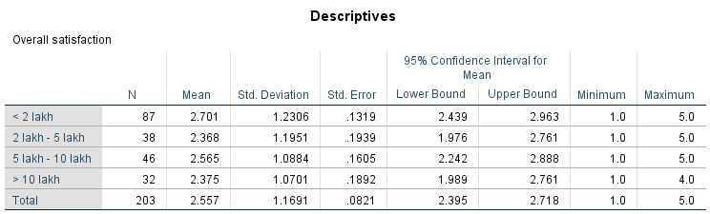

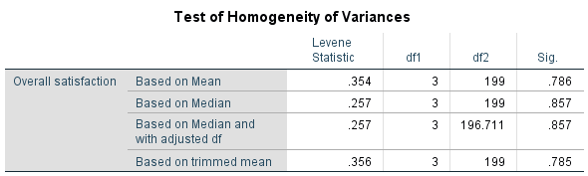

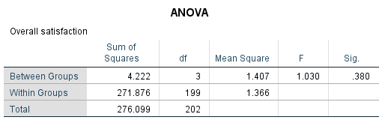

Combined Conclusion:

The ANOVA results indicate that the income groups do not differ significantly in terms of overall satisfaction.

Final Interpretation: The null hypothesis is not rejected, suggesting that any differences in satisfaction levels among the income groups are not statistically significant.

* **Regression**

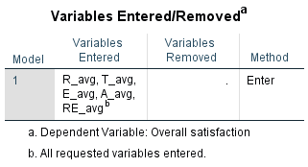

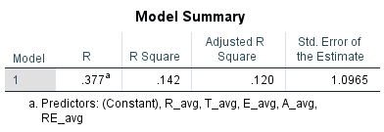

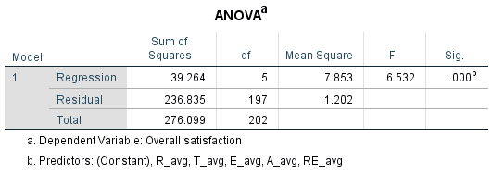

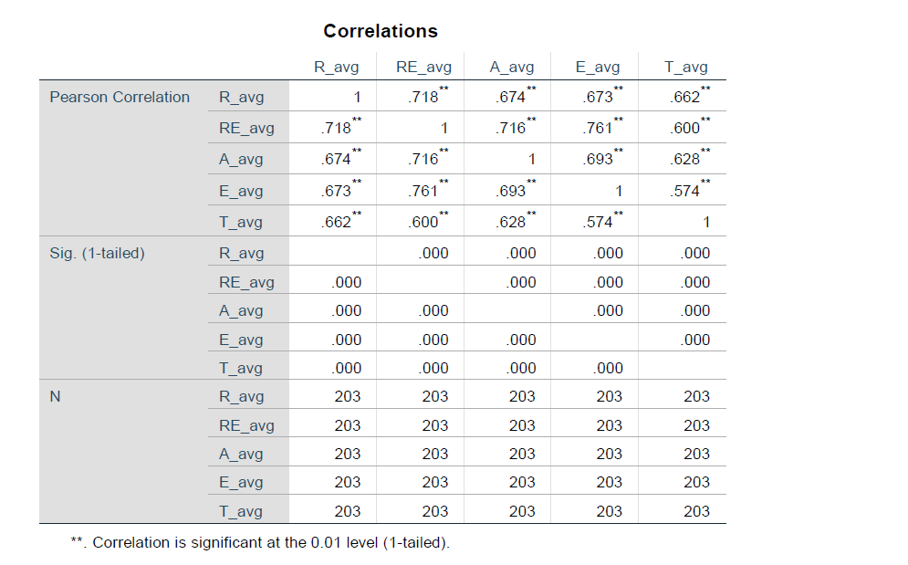

Result analysis :

The correlation analysis reveals strong, positive relationships between variables like R_avg, RE_avg, A_avg, E_avg, and T_avg, with coefficients ranging from 0.574 to 0.761. All correlations are highly significant (p = 0.000), indicating that as one variable improves, others tend to follow. This suggests interdependence, where enhancing one aspect (e.g., reliability) can positively impact others (e.g., efficiency or timeliness).

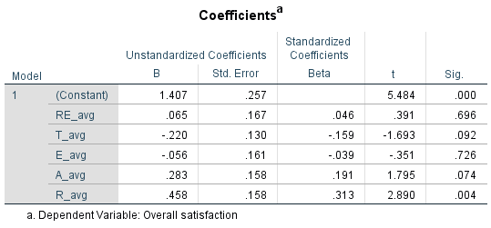

R_avg (e.g., average rating) is the key predictor of overall satisfaction, with a strong positive effect.

Other variables like A_avg and T_avg may have some influence but are not statistically significant predictors.

Final Interpretation: The model suggests that improving R_avg is likely to enhance overall satisfaction, while the impact of other variables is less clear or negligible.

**Overall Conclusion :**

Reliability is the most critical factor influencing passenger satisfaction, as consistent and punctual services are highly valued. Delays and breakdowns negatively impact satisfaction, so improving reliability through real-time tracking, better scheduling, and regular maintenance is essential. Assurance also plays a role, with passengers feeling safer when staff are professional and safety measures are visible, though inconsistent behavior can reduce trust. Tangibles, such as bus cleanliness and infrastructure, have a weaker impact, but maintaining modern and well-kept buses can still enhance the travel experience. Empathy and responsiveness are less significant, but improving staff behavior and customer support can add value.

Age influences preferences, with younger passengers favoring digital services like mobile apps, while older passengers prioritize comfort and reliability. Education levels affect expectations, as higher-educated passengers demand efficient, tech-savvy services. Travel class preferences vary, with AC and sleeper passengers expecting higher comfort, while non-AC travelers focus on affordability. Income levels also shape expectations, with higher-income passengers seeking modern amenities and lower-income groups prioritizing affordability. Occupation impacts usage patterns, as students and employees value reliability, while business travelers prioritize comfort and efficiency.

To enhance overall satisfaction, GSRTC should focus on reliability, improve safety and professionalism, upgrade bus infrastructure, and tailor services to meet the diverse needs of different age groups, income levels, and travel classes. Addressing these factors will create a more inclusive, efficient, and satisfying travel experience for all passengers.

Dimension Average Score (Out of 5) Customer Perception

Reliability 3.32 Moderate

Responsiveness 3.27 Moderate

Assurance 3.35 Moderate

Empathy 3.34 Moderate

Tangibles 3.30 Moderate

Key Observations:

Reliability (3.32) – Customers find GSRTC somewhat reliable, but issues like delays, schedule inconsistency, and communication gaps affect trust.

Responsiveness (3.27) – Staff occasionally provide prompt service, but there is room for improvement in handling customer concerns efficiently.

Assurance (3.35) – Passengers feel safe, but inconsistent behaviour from staff reduces confidence.

Empathy (3.34) – GSRTC provides a decent level of personalized service, but understanding passenger needs remains a challenge.

Tangibles (3.30) – Bus conditions, infrastructure, and cleanliness are average, but passengers expect modernization and better maintenance.

**Gap Analysis**

Customer Gap: Difference between passenger expectations (affordable, reliable, comfortable transport) and perceptions. GSRTC serves 25 lakh daily passengers with 8,322 buses, but aging fleets and delays suggest a moderate gap.

Provider Gap 1: Not Knowing What Customers Expect

* Limited research into diverse passenger needs (e.g., rural vs. urban).
* Weak feedback from 50,000 staff to management.
* Generic service lacks demographic focus.
* Slow complaint resolution.

Provider Gap 2: Not Selecting the Right Service Designs

* Older buses misalign with comfort expectations.
* Inconsistent standards across 125 depots.
* Basic station facilities lag behind modern terminals.

Provider Gap 3: Not Delivering to Standards

* Uneven staff training/performance.
* Overcrowding at peak times, underuse in rural areas.
* Passenger app unfamiliarity affects efficiency.
* Franchisee inconsistencies.

Provider Gap 4: Not Matching Performance to Promises

* Modernization promises (e.g., GPS, new buses) unmet in some areas.
* Delays contradict reliability claims.
* Poor inter-department coordination.

Recommendations:

* Survey passengers, improve staff feedback.
* Set clear standards, upgrade buses/stations.
* Train staff, optimize schedules with GPS.
* Align marketing with reality, sync departments.

**5. Service Blueprint :**

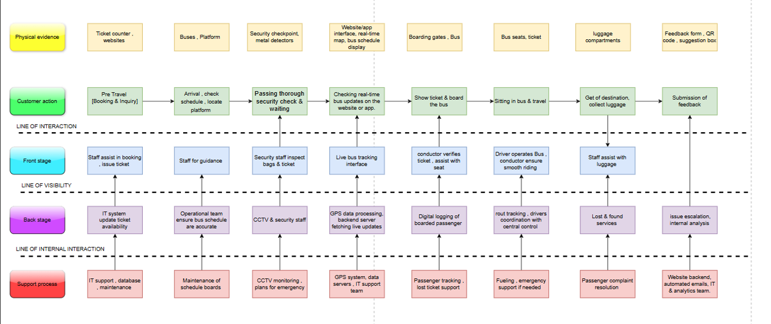

**Explanation of Service Blueprint Methodology**

A service blueprint is a detailed visual representation of a service process, showing the interactions between customers, employees, and backend operations. It helps organizations analyze service efficiency, identify pain points, and enhance customer experience. The service blueprint follows a structured approach by categorizing activities into five key layers:

Physical Evidence – Tangible elements like buses, ticket counters, platforms, security checkpoints, and online interfaces that customers interact with.

Customer Actions – Steps that customers take, such as booking tickets, checking bus schedules, security checks, boarding, traveling, and providing feedback.

Front-Stage (Visible Employee Actions) – Activities performed by front-line staff that are visible to customers, such as ticket assistance, guidance, security checks, and bus operations.

Back-Stage (Invisible Employee Actions) – Backend operations like IT updates, security monitoring, GPS tracking, and route coordination that support the service but are not directly visible to customers.

Support Processes – Internal functions like database maintenance, IT support, lost and found services, and complaint resolution that ensure smooth service delivery.

**Service Blueprint of GSRTC Bus Service**

The provided image represents the GSRTC (Gujarat State Road Transport Corporation) bus service blueprint, mapping each service stage:

1. Pre-Travel (Booking & Inquiry)

Customer Action: Customers book tickets online or at ticket counters.

Front-Stage: Staff assists in ticket booking and issuing tickets.

Back-Stage: IT system updates seat availability.

Support Process: IT support and database maintenance ensure seamless transactions.

2. Arrival & Waiting at the Bus Station

Customer Action: Passengers check schedules, locate platforms, and pass through security checks.

Front-Stage: Staff provides guidance, security staff inspect tickets and baggage.

Back-Stage: CCTV monitoring and bus scheduling operations take place.

Support Process: Emergency response planning and schedule maintenance.

3. Boarding the Bus

Customer Action: Checking real-time updates, showing tickets, and boarding the bus.

Front-Stage: Conductors verify tickets and assist passengers in finding seats.

Back-Stage: GPS data processing and logging of boarded passengers.

Support Process: Passenger tracking and lost ticket support.

4. Journey Experience

Customer Action: Sitting and traveling to the destination.

Front-Stage: The driver ensures a smooth ride, and the conductor assists passengers.

Back-Stage: Route tracking and communication with central control.

Support Process: Fueling, emergency support, and IT system coordination.

5. Arrival & Luggage Collection

Customer Action: Getting off the bus and collecting luggage.

Front-Stage: Staff assists with luggage handling.

Back-Stage: Lost and found services handle misplaced items.

Support Process: Passenger complaint resolution.

6. Feedback Submission

Customer Action: Submission of feedback via QR codes, suggestion boxes, or forms.

Front-Stage: No direct staff involvement.

Back-Stage: Issue escalation and internal analysis of feedback.

Support Process: IT analytics and automated response systems.

**Conclusion**

The GSRTC service blueprint provides a structured view of the bus service experience, mapping customer interactions with front-stage and backstage operations. It highlights areas for efficiency improvement, such as reducing security check delays, enhancing bus tracking accuracy, and improving feedback management. By refining service touchpoints, GSRTC can enhance customer satisfaction and optimize transportation operations.

1. **Recommendations and Improvements : Strategies to improve customer satisfaction based on SERVQUAL findings**

1. Improving Reliability (Service Consistency & Punctuality)

Challenge: Many customers reported delays in bus schedules and inconsistency in arrival and departure times.

Solution:

Implement real-time tracking systems with mobile notifications to inform passengers about bus arrival times.

Improve route planning and traffic monitoring to optimize bus schedules.

Conduct regular maintenance checks on buses to avoid unexpected breakdowns.

2. Enhancing Responsiveness (Customer Support & Complaint Resolution)

Challenge: Customers expressed concerns about slow response times for complaints and difficulty in reaching customer support.

Solution:

Set up a 24/7 customer support helpline and chatbot on the GSRTC website/app for quick assistance.

Introduce a fast-track complaint resolution mechanism for urgent issues like lost luggage or ticketing errors.

Train staff to be more proactive in assisting passengers, especially during boarding and ticket inquiries.

3. Strengthening Assurance (Security & Passenger Safety)

Challenge: Concerns were raised about the lack of visible security measures, especially at night.

Solution:

Increase the presence of CCTV cameras, security personnel, and emergency helplines on buses and platforms.

Conduct regular security drills to ensure staff are well-trained in handling emergency situations.

Introduce women-only seating sections in long-distance buses for added safety.

4. Enhancing Tangibles (Bus Cleanliness & Infrastructure)

Challenge: Complaints regarding bus cleanliness, damaged seats, and unhygienic rest stops were common.

Solution:

Implement a strict bus cleaning schedule after each trip.

Upgrade older buses with modern, comfortable seating and better ventilation.

Partner with cleaner, well-maintained rest stops for long-distance routes.

5. Improving Empathy (Staff Behavior & Communication)

Challenge: Some passengers reported rude behavior from staff and lack of assistance for elderly/disabled individuals.

Solution:

Provide customer service training for drivers, conductors, and ticketing staff.

Introduce a priority boarding service for senior citizens and passengers with disabilities.

Encourage staff to be more courteous and attentive to passenger concerns.

**7. Conclusion :**

The analysis of GSRTC services using the SERVQUAL model has highlighted several key areas affecting customer satisfaction, including service reliability, responsiveness, security, infrastructure, and staff behavior. Our survey findings indicate that while GSRTC provides a crucial public transport service, there are significant gaps between customer expectations and perceived service quality. Issues such as delays in bus schedules, lack of real-time tracking, slow customer support, and inadequate cleanliness were among the most common concerns raised by passengers.

Through the gap analysis, we identified that customers expect timely service, professional and courteous staff, well-maintained buses, and enhanced safety measures. Addressing these concerns through service improvements, better communication, and technological advancements will significantly boost customer satisfaction.

The SERVQUAL framework proved to be an effective tool for measuring service quality and identifying areas of improvement. By focusing on reliability, responsiveness, assurance, tangibles, and empathy, GSRTC can bridge the gap between customer expectations and service delivery.

Additionally, service blueprinting played a crucial role in understanding the entire customer journey. By mapping front-stage and backstage operations, we identified critical touchpoints where service enhancements can make the biggest impact.

In conclusion, the study reinforces that continuous evaluation and improvement are essential for enhancing public transport services. By leveraging SERVQUAL and service blueprinting, GSRTC can create a more efficient, customer-friendly, and reliable transportation network, ultimately leading to higher customer satisfaction and trust in the service.

**8. References :**

1. Services Marketing 4th Edition McGraw Hill India (Dwayne D. Gremler, Valarie A Zeithaml, Ajay Pandit, Mary Jo Bitner)
2. GSRTC Official Website. (n.d.). Retrieved from <https://www.gsrtc.in>
3. Academic Research Papers on Public Transport Efficiency and Customer Satisfaction Studies.
4. Articles and Reports from Google Scholar, ResearchGate, and Scopus on SERVQUAL and Public Transport Service Quality.

**9. Annexure :**

1. GSRTC Survey Questionnaire
2. Physical Evidence
3. Blue Print