# Step 1: Import Libraries
import numpy as np
import pandas as pd
from sklearn.model_selection import train_test_split
from sklearn.linear_model import LinearRegression
from sklearn.metrics import mean_absolute_error, r2_score

# Step 2: Create Sample Agricultural Dataset
data = {
"Rainfall": [450, 520, 390, 610, 480, 530, 410, 590],
"Temperature": [22, 20, 25, 19, 23, 21, 24, 18],
"Nitrogen": [0.8, 1.0, 0.6, 1.2, 0.9, 1.1, 0.7, 1.3],
"Fertilizer": [120, 140, 100, 160, 130, 150, 110, 170],
"Yield": [3.5, 4.2, 2.9, 4.8, 3.8, 4.4, 3.1, 5.0]
}

df = pd.DataFrame(data)

# Step 3: Define Features (X) and Target (y)
X = df[["Rainfall", "Temperature", "Nitrogen", "Fertilizer"]]
y = df["Yield"]

print(X)
print(y)

# Step 4: Split Data into Training and Testing Sets
X_train, X_test, y_train, y_test = train_test_split(X, y, test_size=0.25, random_state=42)

print(X_train)
print(X_test)

# Step 5: Train Model
model = LinearRegression()
model.fit(X_train, y_train)

# Step 6: Make Predictions
y_pred = model.predict(X_test)

# Step 7: Evaluate Model
mae = mean_absolute_error(y_test, y_pred)
r2 = r2_score(y_test, y_pred)

print("Mean Absolute Error:", round(mae, 2))
print("R2 Score:", round(r2, 2))

# Step 8: Predict Yield for New Farm Conditions
new_data = np.array([[500, 21, 1.0, 145]]) # Rainfall, Temp, Nitrogen, Fertilizer
predicted_yield = model.predict(new_data)

print("Predicted Yield (tons/hectare):", round(predicted_yield[0], 2))

MAE (Mean Absolute Error)
Average prediction error in tons/hectare.

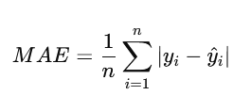

R² Score
Measures how well the model explains variance.
- 1.0 → perfect
- 0 → useless
- Negative → worse than guessing

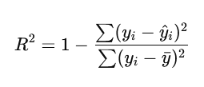
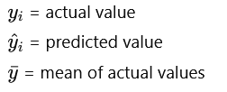

Model Error vs Total Variance in Data

