**LAB ASSIGNMENTS 7: AWS EKS**

Name:Nisarga Kunder

Step-1:Creating A private registery

Step-2 Pushing Image To ECR registery

Image created successfully

Step3 -Creating EKS CLUSTER:

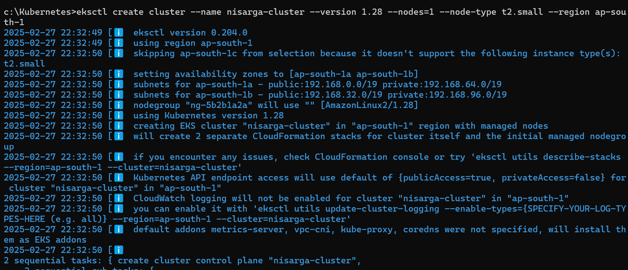

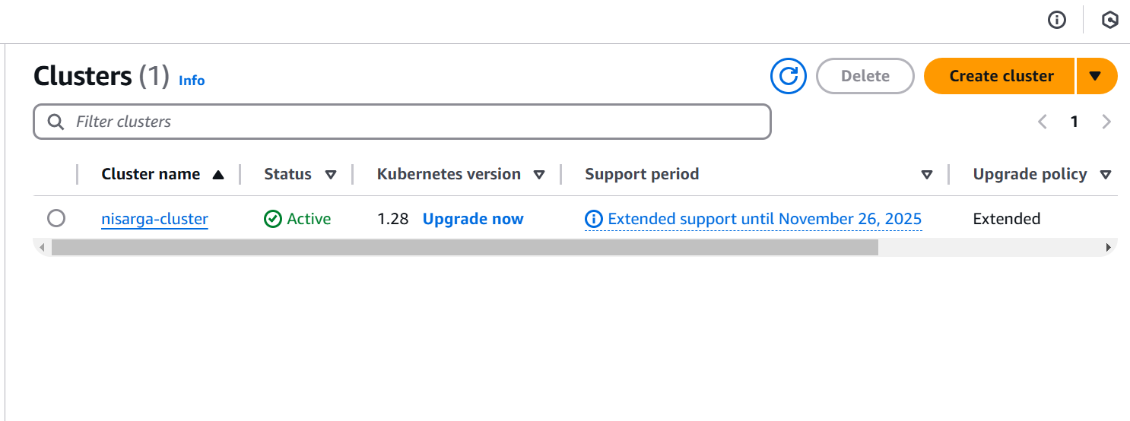

Step 4-Configuring Kubectl to use EKS CLUSTER

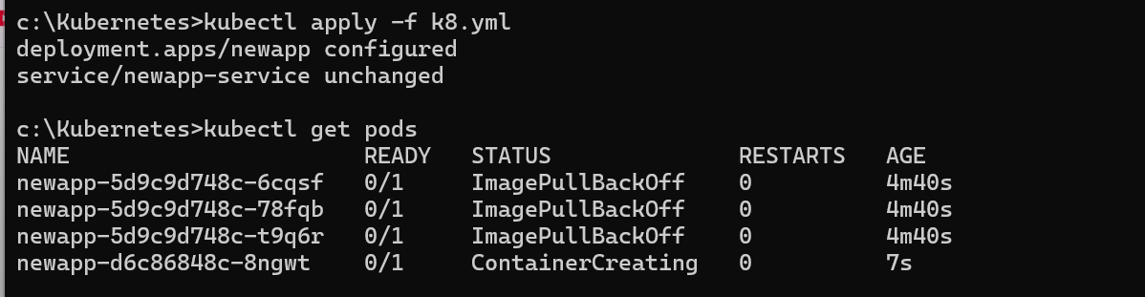

Load balancer is also created along with deployment nd services

Step-5 spring boot is successfully deployed on EKS

