**LAB ASSIGNMENTS 3: AWS RDS  and DynamoDB**

**AWS RDS**

Step -1 Creating RD service-mysql

Step-2 Checking on Postman

Adding entries to database

Step1-Creating Dynamo Db table

Step2-Adding Data Through Spring boot

Step-3 Other Post Functions and Queries

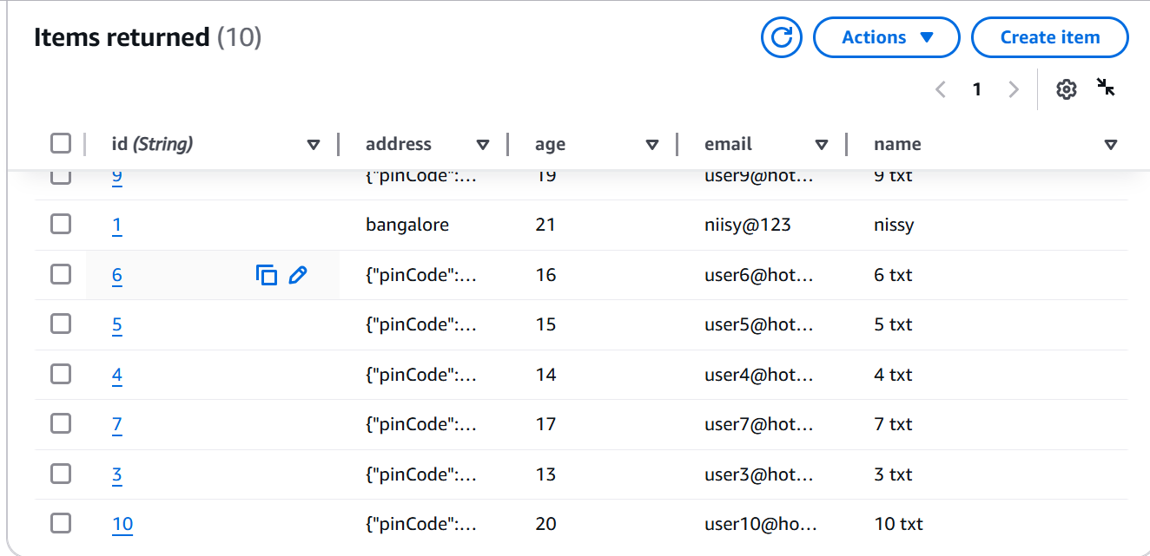

Age between 12-22

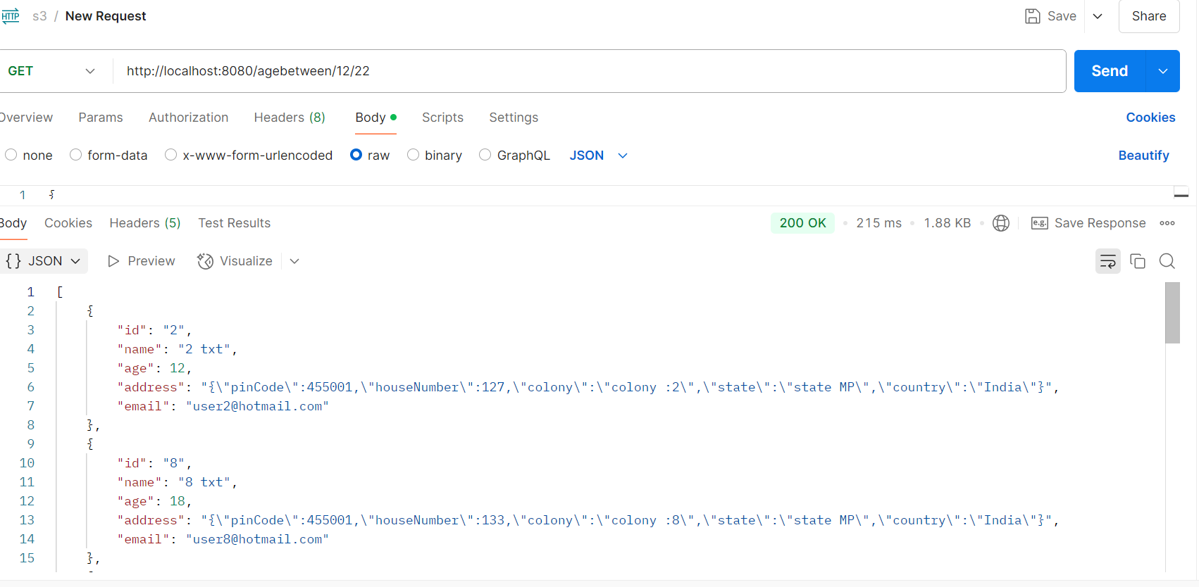

Checking on aws console

Age between 12-22 and particular email

Update operation:

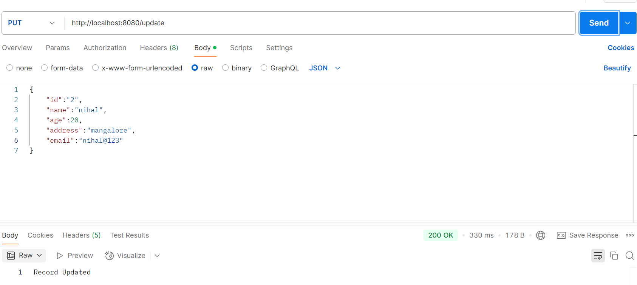

Delete Operation:

