**LAB ASSIGNMENTS 5: AWS Lambda**

Name:Nisarga Kunder

Step 1-Creating a Function

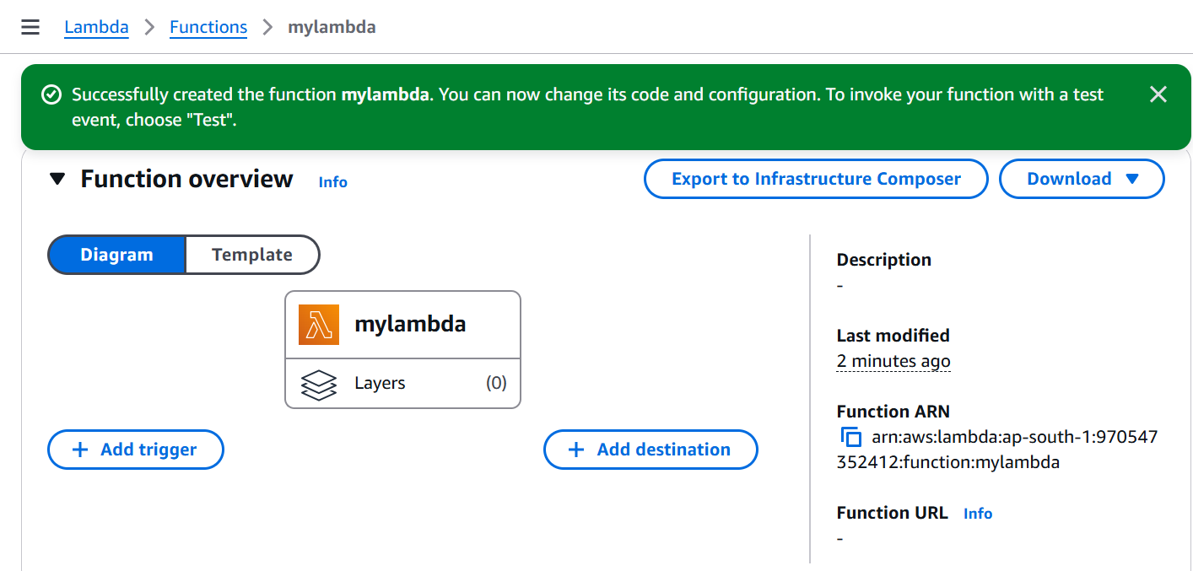

Step2-Uploading Java jar file

Step-3:Changing the Handler

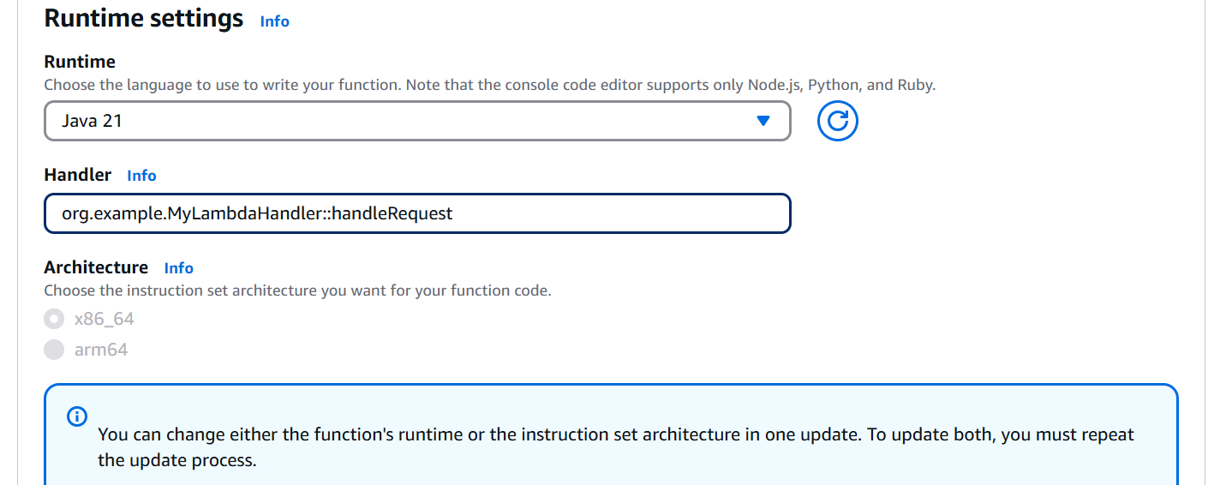

Step-4:Creating Test Event

Step-5 Checking Execution Logs(Cloudwatch)

