New git branch

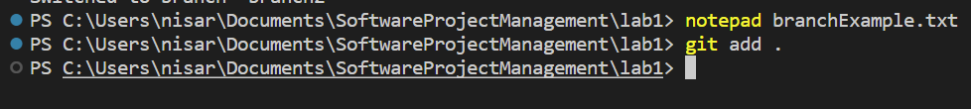

Screenshot of branchExample.txt inside the new branch

branchExample.txt does not exist in master branch

