Nisarg Patel

Lab 1

Task 1

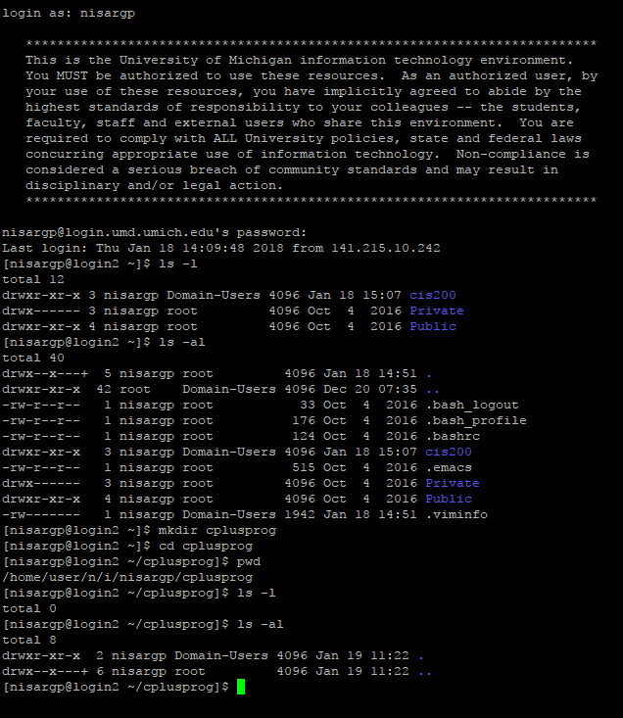

I learned the commands ls –al, ls –l, mkdir, cd, and pwd. ls –al lists all files including hidden I the directory. Ls –l only lists visible files. Cd changes directory and pwd prints the path of the current directory. Difficulties faced were using the commands in the right directory.

Task 2

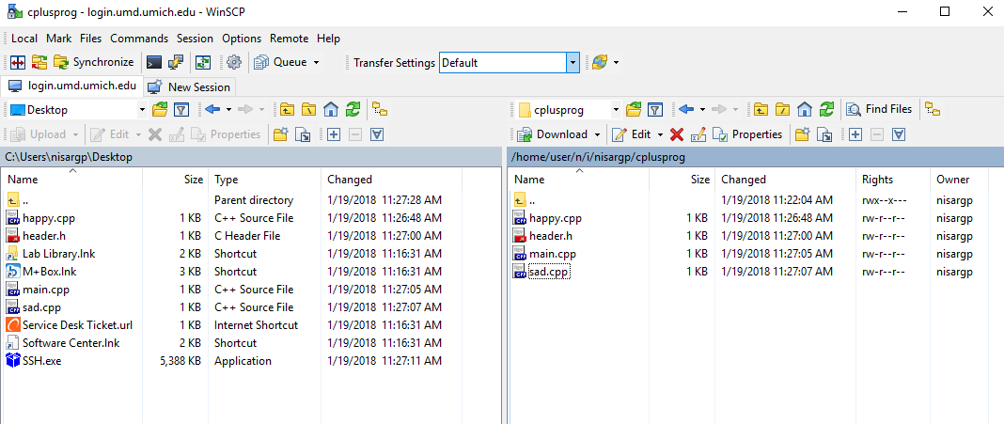

I learned how to transfer a file from local drive to my UNIX server. Difficulty was to locate the file in local drive with so many directories.

Task 3

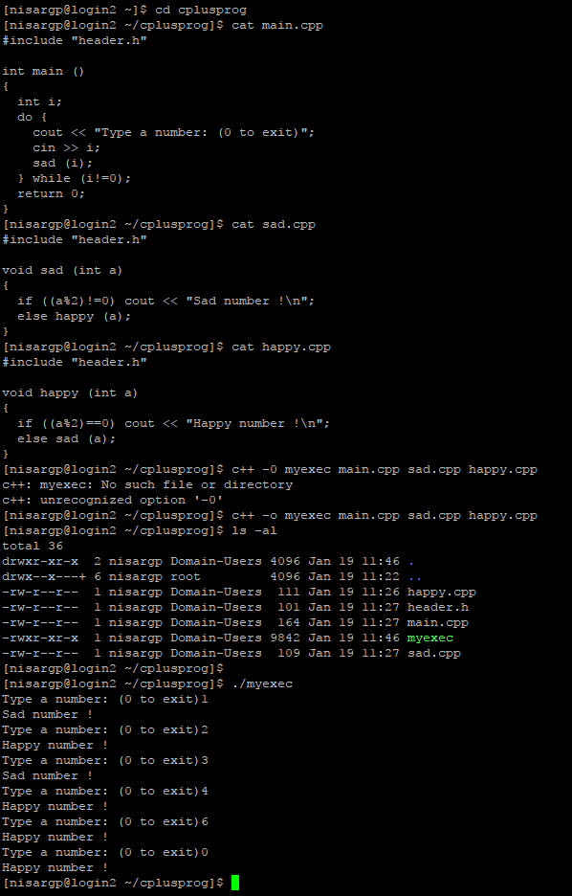

I learned to compile the file and make an executable file in the specified directory. I had no difficulties in that. The commands I used to compile three .cpp files was c++ -o command. This let me put all the files I wanted to compile right next to each other.

Task 4 – No changes done

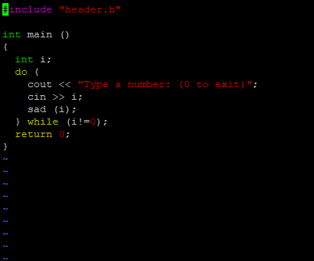

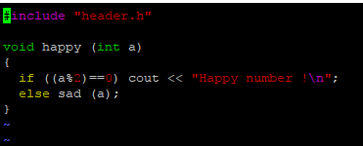

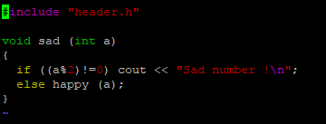

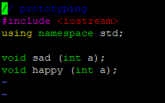 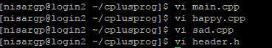

There was no changes done in this task. I used the editor to check the code to see if it is correct using the command vi to bring it up. I learned some of the functions in vi such as :q! to close out and :wq to save. No difficulties.

Task 5

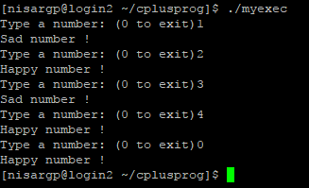 I learned how to run the executable files I this task. Using the command, ./myexec, I ran the program in that file and gave inputs as necessary to check. It turned out the even numbers were happy numbers including 0 and odd numbers were sad numbers.

Task 6

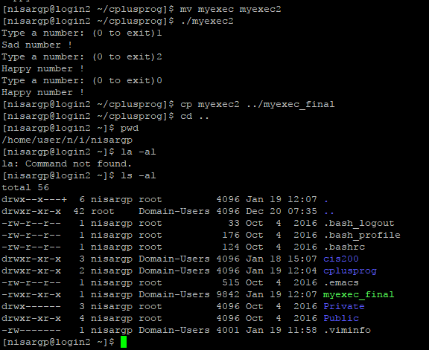

In this task, I learned the commands rm to delete all files, mv to change a file name, cp to copy and paste a file. I used these to change the file name of the executable file, run it, and copy it to parent directory. There was no need to delete .o files as there were none

Task 7

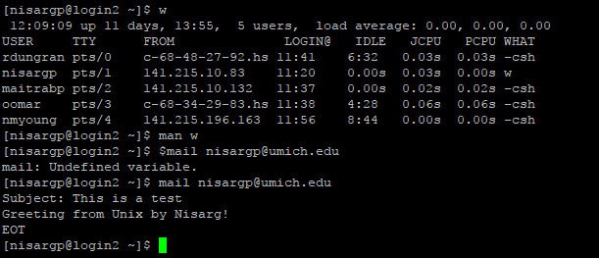

In this task, I learned the commands w to see who is logged in the system, man w to show instruction on w, and the mail command to send email. Using these commands, I went through the mailing process by providing my UM-D account email, a subject of the email, and a short message. By pressing Ctrl+D, the email was sent successfully. Only difficulty I faced was to understand how to call the mail function, but understood in the next try.