1. **Code**

**Car.cpp**

#include "Car.h"

Car::Car()

{

raceCarStatus = false;

}

void Car::setRaceCarStatus(bool thisStatus)

{

raceCarStatus = thisStatus;

}

bool Car::getRaceCarStatus()

{

return raceCarStatus;

}

**Car.h**

#pragma once

#pragma once

#ifndef CAR_H

#define CAR_H

#include "Vehicle.h"

class Car : public Vehicle{

public:

Car();

void setRaceCarStatus(bool thisStatus);

bool getRaceCarStatus();

private:

bool raceCarStatus;

};

#endif // !CAR_H

**Vehicle.cpp**

#include "Vehicle.h"

using namespace std;

Vehicle::Vehicle()

{

age = 0;

price = 0.0;

}

void Vehicle::setAge(int thisAge)

{

age = thisAge;

}

void Vehicle::setPrice(float thisPrice)

{

price = thisPrice;

}

int Vehicle::getAge()

{

return age;

}

float Vehicle::getPrice()

{

return price;

}

**Vehicle.h**

#pragma once

#ifndef VECHICLE_H

#define VEHICLE_H

#include <iostream>

#include <string>

using namespace std;

class Vehicle

{

public:

Vehicle();

void setAge(int thisAge);

void setPrice(float thisPrice);

int getAge();

float getPrice();

private:

int age;

float price;

};

#endif

**Stub_main_VehicleCar.cpp**

#include "Car.h"

int main()

{

Car Civic;

int tempAge;

float tempPrice;

do {

cout << "Civic's age: ";

cin >> tempAge;

if (tempAge < 0)

{

cout << endl << "Invalid input. Car cannot be negative years old" << endl;

}

} while (tempAge < 0);

Civic.setAge(tempAge);

cout << "Age stored is " << Civic.getAge() << endl;

do {

cout << "How old is your Car now?: ";

cin >> tempAge;

if (tempAge < Civic.getAge())

{

cout << endl << "Invalid input. Age cannot be less than what is stored before." << endl;

}

else if (tempAge < 0)

{

cout << endl << "Invalid input. Car cannot be negative years old" << endl;

}

} while (tempAge < Civic.getAge() || tempAge < 0);

Civic.setAge(tempAge);

cout << "Age of Car stored" << endl;

do {

cout << "Car's price: ";

cin >> tempPrice;

if (tempPrice < 0)

{

cout << endl << "Invalid input. Price value cannot be negative" << endl;

}

} while (tempPrice < 0);

Civic.setPrice(tempPrice);

cout << "Price stored is $" << Civic.getPrice() << endl;

do {

cout << endl << "How much is your Car worth now?: ";

cin >> tempPrice;

if (tempPrice > Civic.getPrice())

{

cout << endl << "Invalid input. You cannot sell your Car more than its\nprevious worth" << endl;

}

else if (tempPrice < 0)

{

cout << endl << "Invalid input. Price value cannot be negative" << endl;

}

} while (tempPrice > Civic.getPrice() || tempPrice < 0);

Civic.setPrice(tempPrice);

cout << "Price of Car stored" << endl;

int tempStatus;

do {

cout << "Type 1 if it IS a race car and type 0 if it IS NOT a race car: ";

cin >> tempStatus;

if (tempStatus < 0 || tempStatus > 1)

{

cout << endl << "Invalid input. Please try again with number 1 or number 0" << endl;

}

} while (tempStatus < 0 || tempStatus > 1);

Civic.setRaceCarStatus(tempStatus);

cout << "Race Car Status stored" << endl;

if (Civic.getRaceCarStatus())

{

cout << "Your car, CIvic, IS a race car" << endl;

}

else {

cout << "Your car, Civic, IS NOT a race car" << endl;

}

return 0;

}

1. **Test Plan**

|  |  |  |  |  |  |  |
| --- | --- | --- | --- | --- | --- | --- |
| Test Strategy | Test Number | Description | Input | Expected Output | Actual Output | Pass/Fail |
| Valid | 1 | Age of car is greater than previously stored value | Previously stored variable = 10  New = 15 | “Age of car stored” | “Age of car stored” | Pass |
| Valid | 2 | Price of car is less than previously stored value unless storing it 1st time | Previously stored variable = 50000  New = 12000 | “Price of car stored” | “Price of Car stored” | Pass |
| Valid | 3 | Price value is always positive | Price = 50,000 | “Price of car stored” | “Price stored is $50000” | Pass |
| Valid | 4 | User enters corresponding number for choosing either true or false for race car status | User enter “1” for true for car status | “Race Car Status stored” | “Race Car Status stored” | Pass |
| Valid | 5 | Age value is always positive | Age = 10 | “Age of car stored” | “Age stored is 10” | Pass |
| Invalid | 1 | Age of car is more than previously stored value | Previously stored variable = “10”  New = 5:” | “Invalid input. Age cannot be less than what is stored before” | “Invalid input. Age cannot be less than what is stored before” | Pass |
| Invalid | 2 | Price of car is more than previously stored value unless storing it 1st time | Previously stored variable = “20,000”  New = “30,000” | “Invalid input. You cannot sell your car more than its previous worth” | “Invalid input. You cannot sell your car more than its previous worth” | Pass |
| Invalid | 3 | Price value is negative | Price value = -50, 000 | “Invalid input. Price value cannot be negative” | “Invalid input. Price value cannot be negative” | Pass |
| Invalid | 4 | User enters number not corresponding to choosing either true or false for race car status | User enters “10” for true for race car status | “Invalid input. Please try again with number 1 or number 0” | “Invalid input. Please try again with number 1 or number 0” | Pass |
| Invalid | 5 | Age value is negative | Age = -50 | “Invalid input. Car cannot be negative years old” | “Invalid input. Car cannot be negative years old” | Pass |

1. **Screenshots**

Valid Test Case 1:

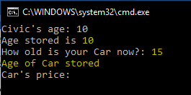

Valid Test Case 2:

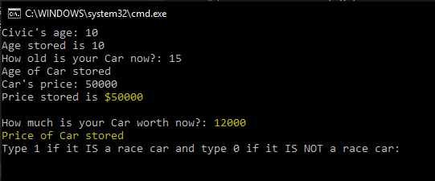

Valid Test Case 3:

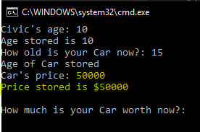

Valid Test Case 4:

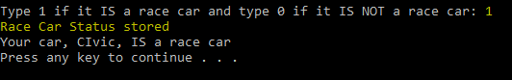

Valid Test Case 5:

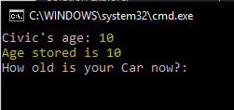

Invalid Test Case 1:

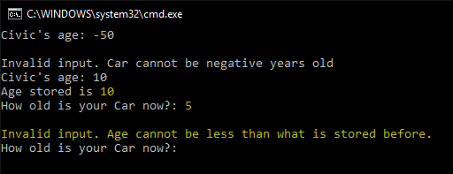

Invalid Test Case 2:

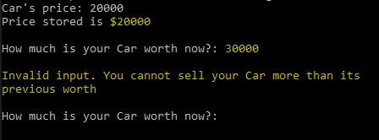

Invalid Test Case 3:

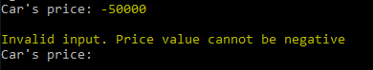

Invalid Test Case 4:

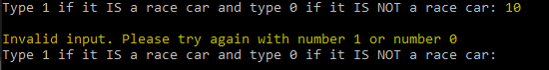

Invalid Test Case 5:

