1. **Code**

**Vehicle.cpp**

#include "Vehicle.h"

using namespace std;

Vehicle::Vehicle()

{

age = 0;

price = 0.0;

}

void Vehicle::setAge(int thisAge)

{

age = thisAge;

}

void Vehicle::setPrice(float thisPrice)

{

price = thisPrice;

}

int Vehicle::getAge()

{

return age;

}

float Vehicle::getPrice()

{

return price;

}

**Vehicle.h**

#pragma once

#ifndef VECHICLE_H

#define VEHICLE_H

#include <iostream>

#include <string>

using namespace std;

class Vehicle

{

public:

Vehicle();

void setAge(int thisAge);

void setPrice(float thisPrice);

int getAge();

float getPrice();

private:

int age;

float price;

};

#endif

**Stub_main_Vehicle.cpp**

#include "Vehicle.h"

using namespace std;

int main()

{

Vehicle myVehicle;

int tempAge;

float tempPrice;

do {

cout << "Vehicle's age: ";

cin >> tempAge;

if (tempAge < 0)

{

cout << endl << "Invalid input. Vehicle cannot be negative years old" << endl;

}

} while (tempAge < 0);

myVehicle.setAge(tempAge);

cout << "Age stored is " << myVehicle.getAge() << endl;

do {

cout << "How old is your Vehicle now?: ";

cin >> tempAge;

if (tempAge < myVehicle.getAge())

{

cout << endl << "Invalid input. Age cannot be less than what is stored before." << endl;

}

else if (tempAge < 0)

{

cout << endl << "Invalid input. Vehicle cannot be negative years old" << endl;

}

} while (tempAge < myVehicle.getAge() || tempAge < 0);

myVehicle.setAge(tempAge);

cout << "Age of Vehicle stored" << endl;

do {

cout << "Vehicle's price: ";

cin >> tempPrice;

if (tempPrice < 0)

{

cout << endl << "Invalid input. Price value cannot be negative" << endl;

}

} while (tempPrice < 0);

myVehicle.setPrice(tempPrice);

cout << "Price stored is $" << myVehicle.getPrice() << endl;

do {

cout << endl << "How much is your Vehicle worth now?: ";

cin >> tempPrice;

if (tempPrice > myVehicle.getPrice())

{

cout << endl << "Invalid input. You cannot sell your Vehicle more than its\nprevious worth" << endl;

}

else if (tempPrice < 0)

{

cout << endl << "Invalid input. Price value cannot be negative" << endl;

}

} while (tempPrice > myVehicle.getPrice() || tempPrice < 0);

myVehicle.setPrice(tempPrice);

cout << "Price of Vehicle stored" << endl;

return 0;

}

1. **Test Plan**

|  |  |  |  |  |  |  |
| --- | --- | --- | --- | --- | --- | --- |
| Test Strategy | Test Number | Description | Input | Expected Output | Actual Output | Pass/Fail |
| Valid | 1 | Age of vehicle is greater than previously stored value | Previously stored variable = 10  New = 15 | “Age of vehicle stored” | “Age of vehicle stored” | Pass |
| Valid | 2 | Price of vehicle is less than previously stored value unless storing it 1st time | Previously stored variable = 50000  New = 10000 | “Price of vehicle stored” | “Price of vehicle stored” | Pass |
| Valid | 3 | Price value is always positive | Price = 50,000 | “Price stored is $50000” | “Price stored is $50000” | Pass |
| Valid | 4 | Age value is always positive | Age = 10 | “Age stored is 10” | “Age stored is 10” | Pass |
| Invalid | 1 | Age of vehicle is more than previously stored value | Previously stored variable = 15  New = 5 | “Invalid input. Age cannot be less than what is stored before” | “Invalid input. Age cannot be less than what is stored before” | Pass |
| Invalid | 2 | Price of vehicle is more than previously stored value unless storing it 1st time | Previously stored variable = “20,000”  New = “30,000” | “Invalid input. You cannot sell your vehicle more than its previous worth” | “Invalid input. You cannot sell your vehicle more than its previous worth” | Pass |
| Invalid | 3 | Price value is negative | Price value = -50, 000 | “Invalid input. Price value cannot be negative” |  |  |

1. **Screenshots**

Valid Test Case 1:

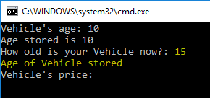

Valid Test Case 2:

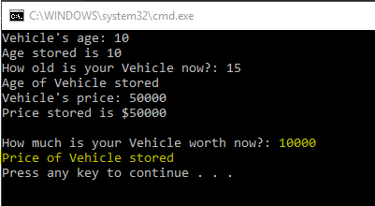

Valid Test Case 3:

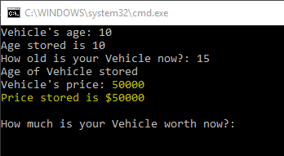

Valid Test Case 4:

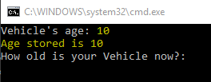

Invalid test Case 1:

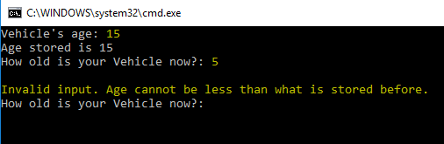

Invalid Test Case 2:

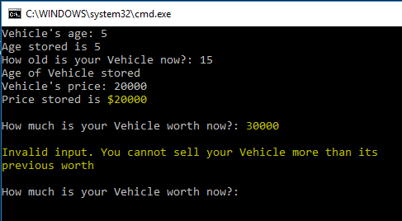

Invalid Test Case 3:

