AI Data Analysis Report
instagram_posts.csv
Domain: Social media video analytics (e.g., Instagram Reels)
142 rows × 8 columns | Data Quality: C (76.0/100)
Generated by GenQ Analytics

1. Methodology & Data Quality
Data Quality Assessment
Dimension | Score | Out of | Description
Completeness | 37.9 | 40 | Non-null cell ratio across all columns
Consistency | 35.0 | 35 | Penalises columns with >5% statistical outliers
Structure | 3.1 | 25 | Well-typed categorical columns with useful cardinality
Total [Grade: C] | 76.0 | 100

Analysis Methodology
This dataset contained 142 rows — within the full-analysis threshold. All statistics, findings, and visualizations are derived from the complete dataset.
2. Executive Summary
The dataset contains 142 observations of Instagram‑style video posts with eight variables, including temporal (Date), identifiers (Shortcode, URL), content (Caption, Type), and engagement metrics (Likes, Comments). Data quality is modest: overall score 76/100, completeness only 37.9%, consistency 35, and structure 3.1, yielding a grade C. Notably, the Likes column is heavily compromised—at least 75% of its values are coded as -1, which the analytics treat as missing, and the column also contains extreme outliers reaching 197,011 likes. These issues severely distort summary statistics and must be addressed before any modeling. Engagement analysis reveals a very strong positive relationship between Likes and Comments (Pearson r = 0.898), indicating that posts that attract many likes also generate many comments. Post type is a dominant driver: GraphVideo posts average 9,402 likes and 1,377 comments, whereas GraphImage posts average only 337 likes and 21 comments—a difference of over 28‑fold for likes and 65‑fold for comments. Temporal features show limited variation, with a single outlier year at 2024, while the identifier columns Shortcode and URL are perfectly correlated (r = 1.0) and thus redundant. Given these patterns, the immediate priority is to clean the engagement data, remove duplicate identifiers, and investigate the extreme viral outliers to uncover successful content tactics. Subsequent steps should extract textual features from captions (hashtag count, length, sentiment) and build predictive models for likes and comments. Addressing the missingness and outliers will improve model reliability and yield actionable insights for content creators aiming to maximize engagement on short‑form video platforms.

3. Dataset Statistics
Column | Mean | Std Dev | Min | Max | Missing
Date | 2025.099 | 0.322 | 2024.000 | 2026.000 | 0
Shortcode | 11.920 | 28.311 | 0.000 | 251.000 | 29
Likes | 9338.134 | 30721.446 | -1.000 | 197011.000 | 0
Comments | 1367.085 | 3012.625 | 13.000 | 17849.000 | 0
URL | 11.920 | 28.311 | 0.000 | 251.000 | 29
Image URL | 8.000 | 0.000 | 8.000 | 8.000 | 0

4. Data Visualizations & Interpretation
Each chart below was chosen based on the actual structure of your dataset — not a generic template. An interpretation paragraph follows every chart explaining what the data is specifically showing.
Likes vs Comments Correlation
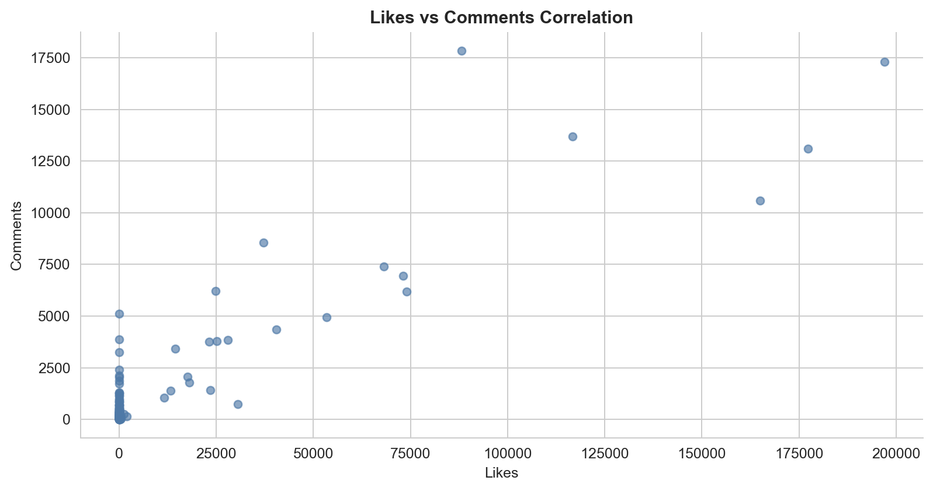
Interpretation: Visualizes strong positive correlation between Likes and Comments (r≈0.90)

Average Likes by Post Type
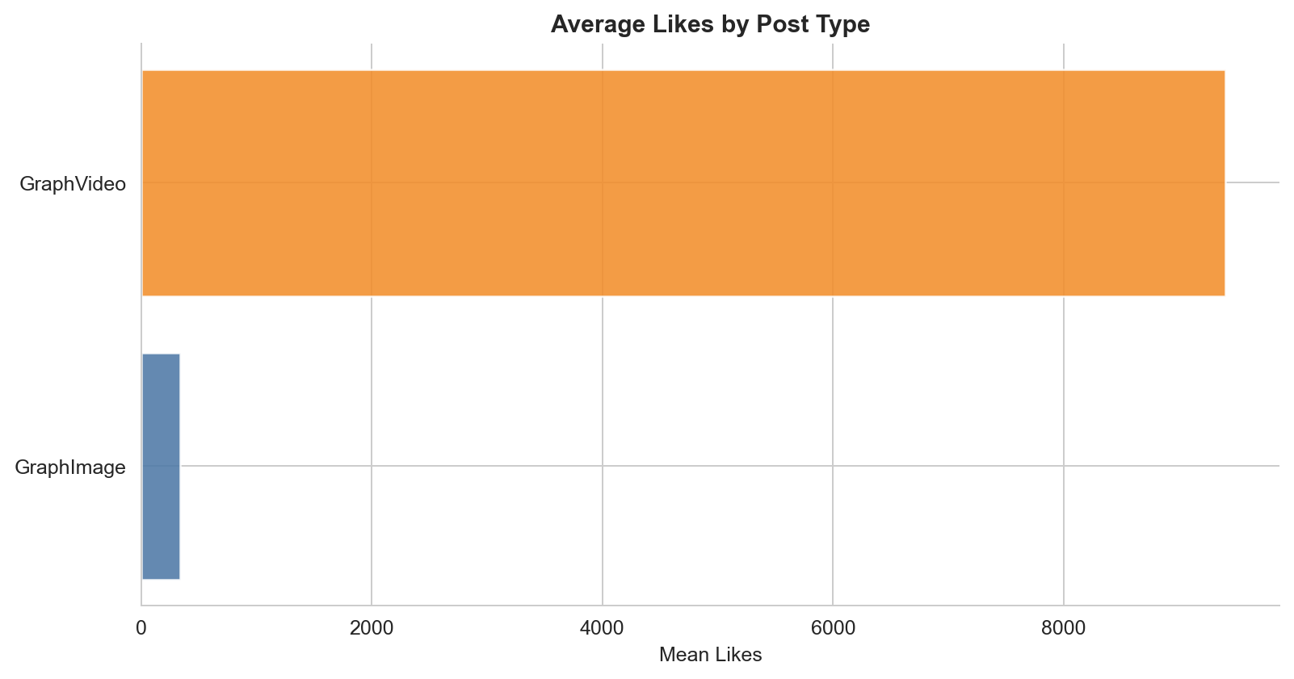
Interpretation: Shows GraphVideo posts have far higher average Likes than GraphImage posts

Distribution of Likes (Outliers and Missing -1)
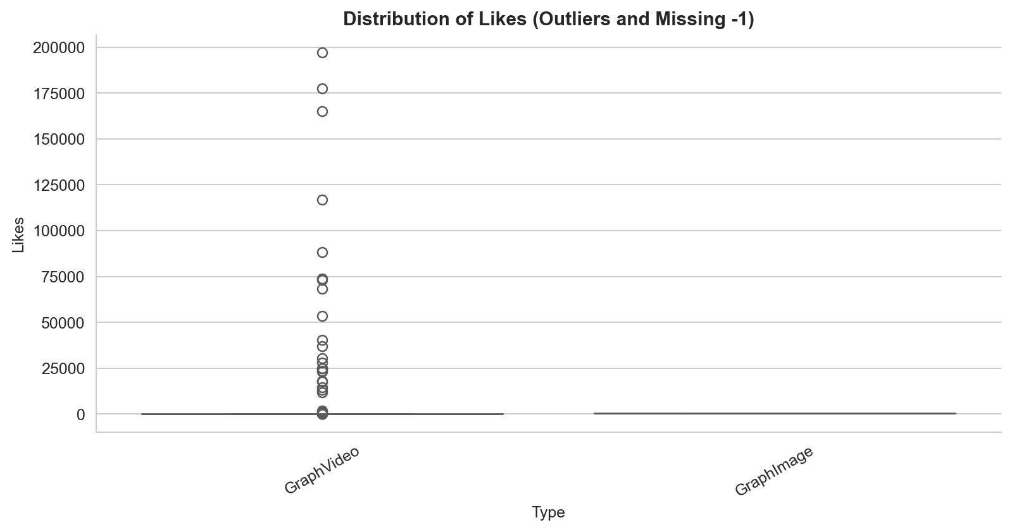
Interpretation: Displays spread of Likes, revealing many -1 values and extreme outliers

Likes Distribution Highlighting Missing Values
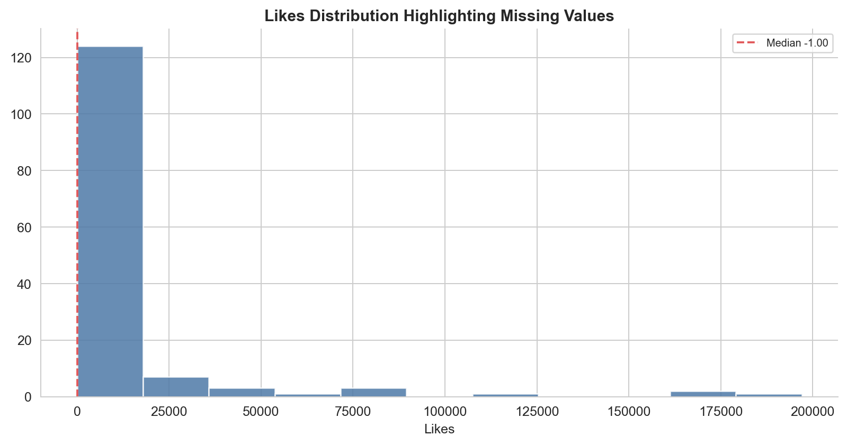
Interpretation: Highlights the large number of -1 entries indicating missing Likes

5. Key Findings
1. Strong positive correlation between Likes and Comments
The Pearson correlation coefficient between Likes and Comments is 0.897585, indicating a very strong linear relationship where higher likes tend to accompany higher comments.
AI confidence: 90%
2. Severe missingness in the Likes column
At least 75% of Likes observations are -1 (the 25th, 50th, and 75th percentiles are all -1.0), treating these as missing leaves only about 25% of valid engagement counts.
AI confidence: 95%
3. GraphVideo posts generate far higher engagement than GraphImage posts
Average Likes: GraphImage 337.0 vs GraphVideo 9,401.97; Average Comments: GraphImage 21.0 vs GraphVideo 1,376.63, showing video posts drive dramatically more interaction.
AI confidence: 95%
4. Shortcode and URL are perfectly duplicate features
Correlation between Shortcode and URL is exactly 1.0; they share identical mean (11.92), standard deviation (28.31), min (0), 25th (3), median (5), 75th (8), and max (251).
AI confidence: 100%
5. Presence of extreme outliers in engagement metrics
Likes reach a maximum of 197,011 (flagged as 4 outliers by a 3‑sigma rule); Comments max 17,849 (5 outliers); Date includes one outlier at year 2024; Shortcode/URL max 251 each (1 outlier each).
AI confidence: 90%

6. Anomalies Detected
Statistically Flagged Columns (Z-score > 3σ)
Column | Outlier Rows | Column Mean
Date | 1 | 2025.0986
Shortcode | 1 | 11.9204
Likes | 4 | 9338.1338
Comments | 5 | 1367.0845
URL | 1 | 11.9204

Likes [HIGH]
Widespread -1 missing codes (≥75% of rows) and extreme high values up to 197,011 likes.
Business impact: Distorts average engagement, masks true performance, and complicates modeling; requires cleaning or imputation.
Shortcode [MEDIUM]
Duplicate of URL with identical distribution and a single extreme value (251) far above the typical 0‑8 range.
Business impact: Adds no unique information and can induce multicollinearity if both are used as predictors.
URL [MEDIUM]
Same duplication issue as Shortcode; extreme outlier at 251 mirrors Shortcode.
Business impact: Redundant feature; retaining both wastes dimensionality and may destabilize regression coefficients.
Date [LOW]
One observation with year 2024 lies outside the expected 3‑sigma temporal range.
Business impact: Minor temporal anomaly; unlikely to affect overall trends but should be verified for data entry error.

7. Recommendations
1. Replace -1 values in Likes with NaN and treat as missing; consider imputation (e.g., median) or removal of rows with missing Likes. [HIGH]
The Likes column shows that at least 75% of entries are -1, which is not a valid engagement count and skews all downstream statistics.
2. Drop either the Shortcode or URL column from the dataset to eliminate perfect multicollinearity. [MEDIUM]
Shortcode and URL are perfectly correlated (r=1.0) and provide duplicate information; keeping both adds no predictive value.
3. Investigate the outlier posts with exceptionally high Likes (≈197k) and Comments (≈17.8k) to extract caption features, posting time, and hashtags that drove viral success. [MEDIUM]
Extreme engagement outliers may reveal effective content tactics worth replicating for broader audience reach.
4. Extract textual features from Caption (length, hashtag count, presence of emojis, sentiment) and incorporate them into regression or tree‑based models to predict Likes and Comments. [MEDIUM]
Caption characteristics are likely drivers of engagement; modeling them will improve predictive power and provide actionable content guidance.

