**Documentation for Question1 and Question2**

**Question 1**

**Test Cases**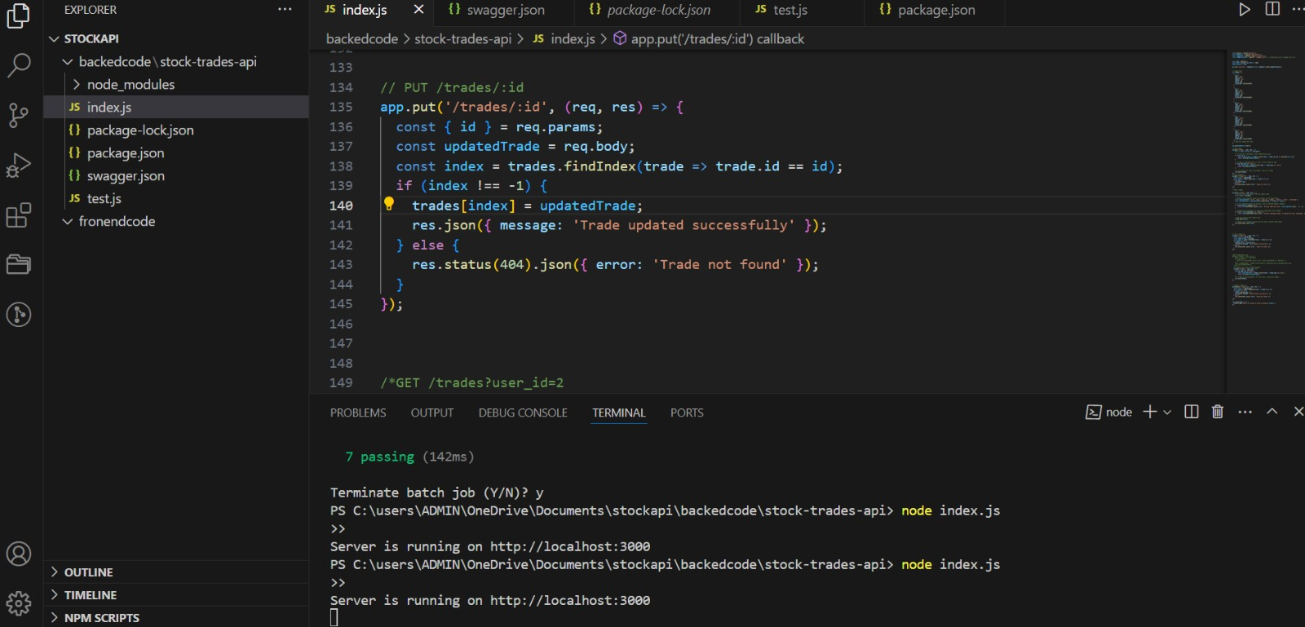

**API ENDPOINTS**

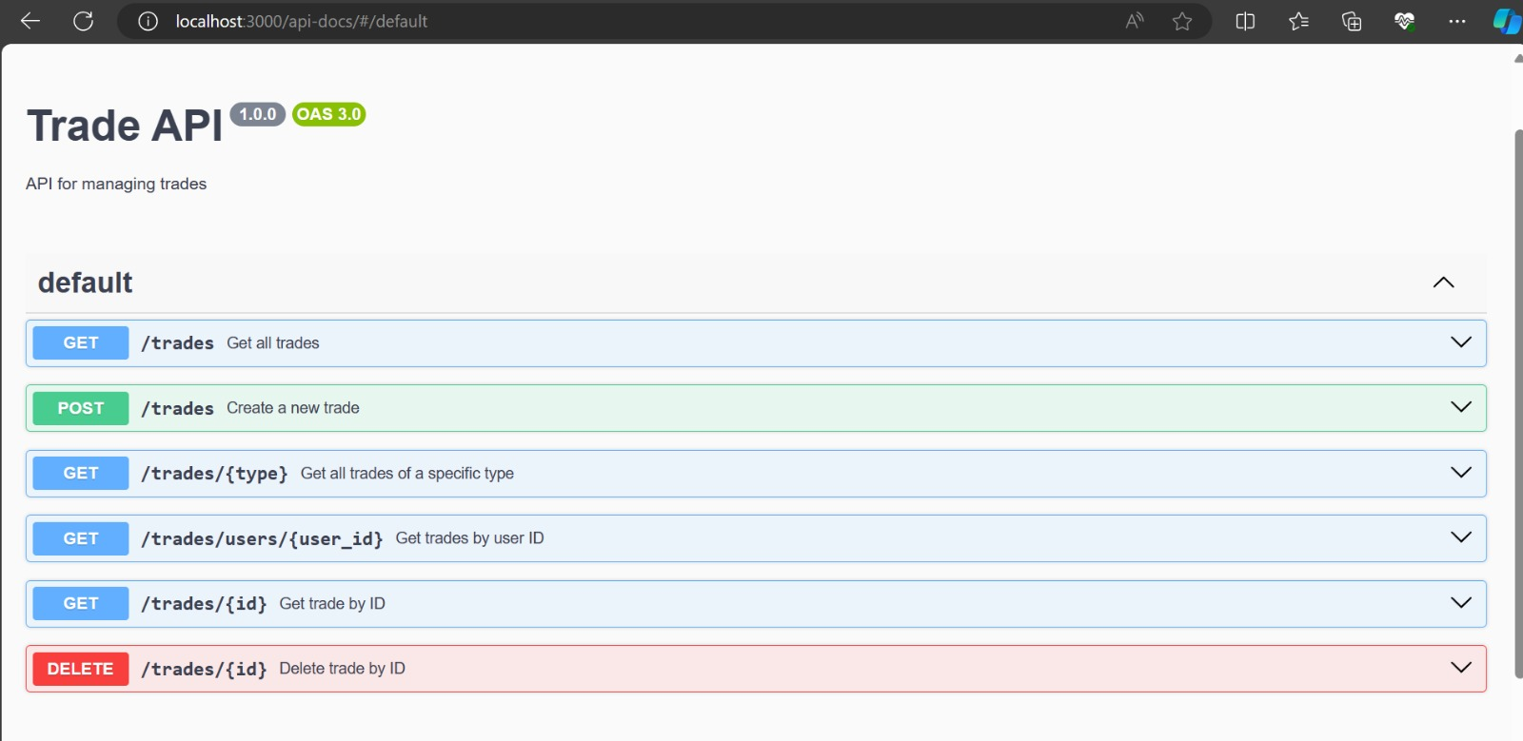

**URL to run these Api: <http://localhost:3000/api-docs/#/default>**

**http://localhost:3000/trades?type=buy**

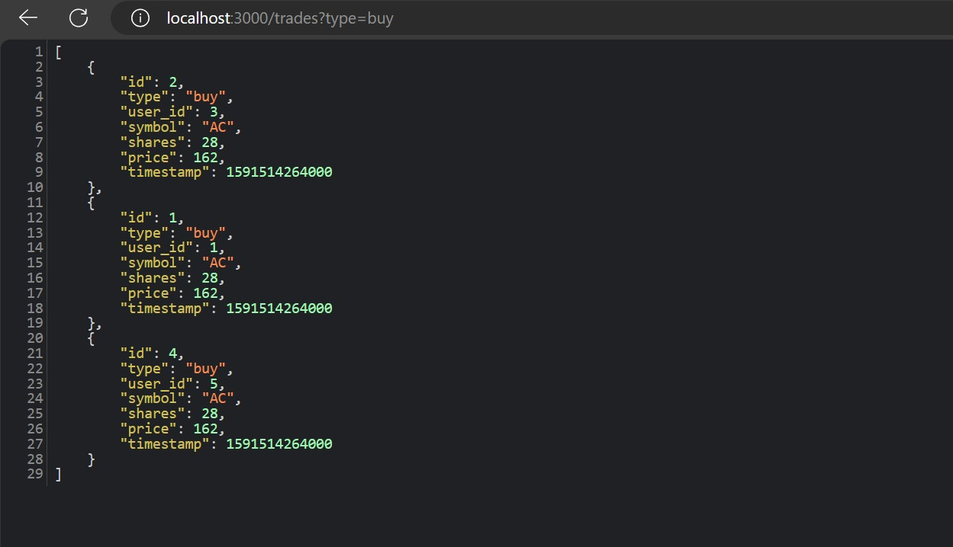

**http://localhost:3000/trades?user_id=1**

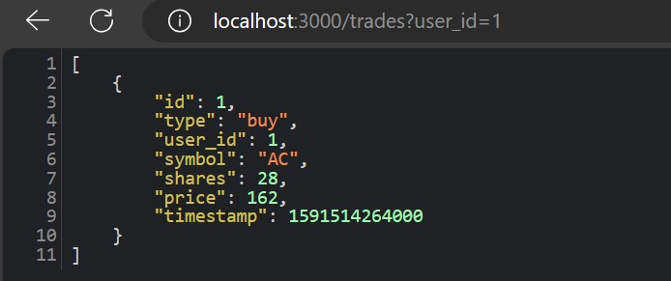

**http://localhost:3000/api-docs/#/default/post_trades**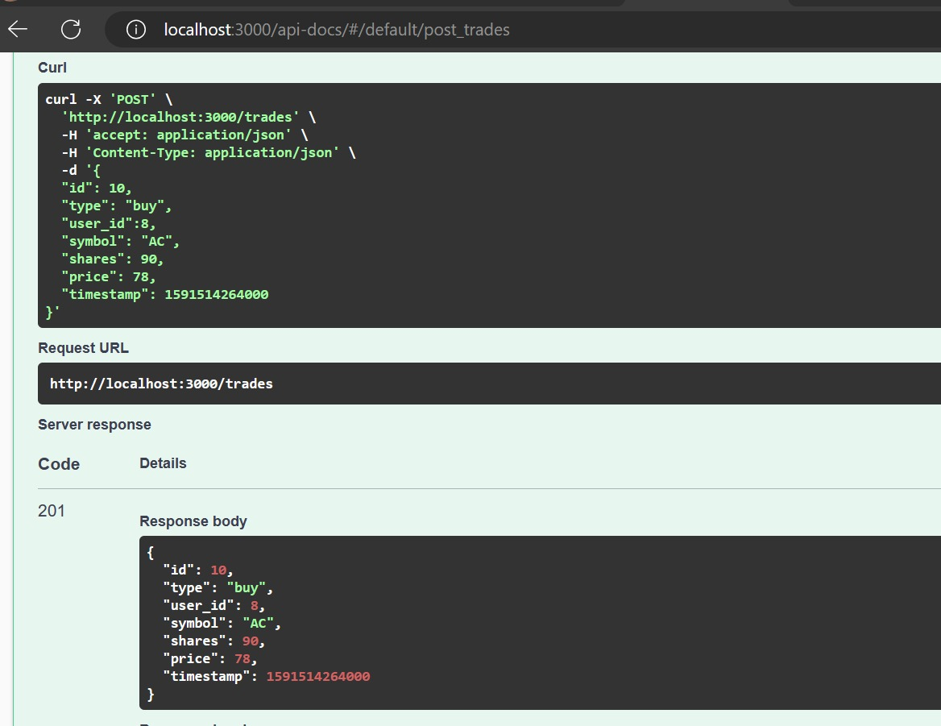

**Logic for PUT**

**The response code is 405 because the API does not allow deleting or modifying trades for any id value**

router.put('/trades/:id', (req, res) => {

return res.status(405).send("API does not allow deleting or modifying trades for any id value");

});

router.delete('/trades/:id', (req, res) => {

return res.status(405).send("API does not allow deleting or modifying trades for any id value");

});

router.patch('/trades/:id', (req, res) => {

return res.status(405).send("API does not allow deleting or modifying trades for any id value");

});

**if there is no trade with the given id in the collection, the response code is 404 with the response body having the text ID not found.**

// PUT /trades/:id

app.put('/trades/:id', (req, res) => {

const { id } = req.params;

const updatedTrade = req.body;

const index = trades.findIndex(trade => trade.id == id);

if (index !== -1) {

trades[index] = updatedTrade;

res.json({ message: 'Trade updated successfully' });

} else {

res.status(404).json({ error: 'Trade not found' });

}

});

**Question 2**

Open the terminal, navigate to the "src" folder, and execute the command "npm start" to run it on the local server.

