**Task Description #1:**

**•** Start a Python class named Student with attributes name, roll_number, and marks. Prompt GitHub Copilot to complete methods for displaying details and checking if marks are above average.

**PROMPT:**

**Write a python program of class student with attributes name,roll number and marks.show different methods for displaying details and check if marks are above average.**

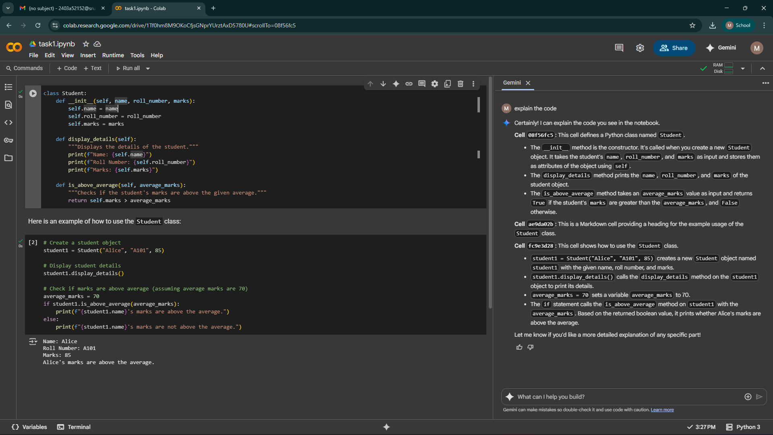

**Task Description #2:**

**•** Write the first two lines of a for loop to iterate through a list of numbers. Use a comment prompt to let Copilot suggest how to calculate and print the square of even numbers only.

**PROMPT:**

Write the first two lines of a for loop to iterate through a list of numbers, how to calculate and print the square of even numbers only.

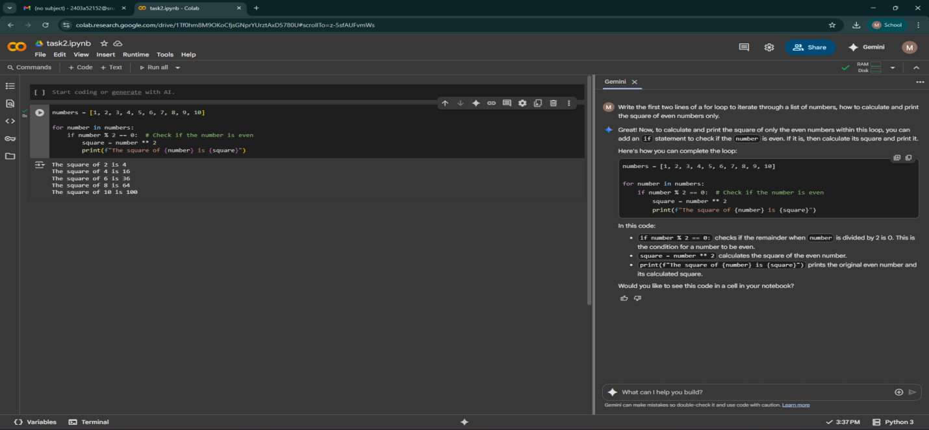**Task Description #3:**

**•** Create a class called BankAccount with attributes account_holder and balance. Use Copilot to complete methods for deposit(), withdraw(), and check for insufficient balance.

**PROMPT:**

**Write a python program** **class called BankAccount with attributes account_holder and balance** **complete methods for deposit(), withdraw(), and check for insufficient balance**

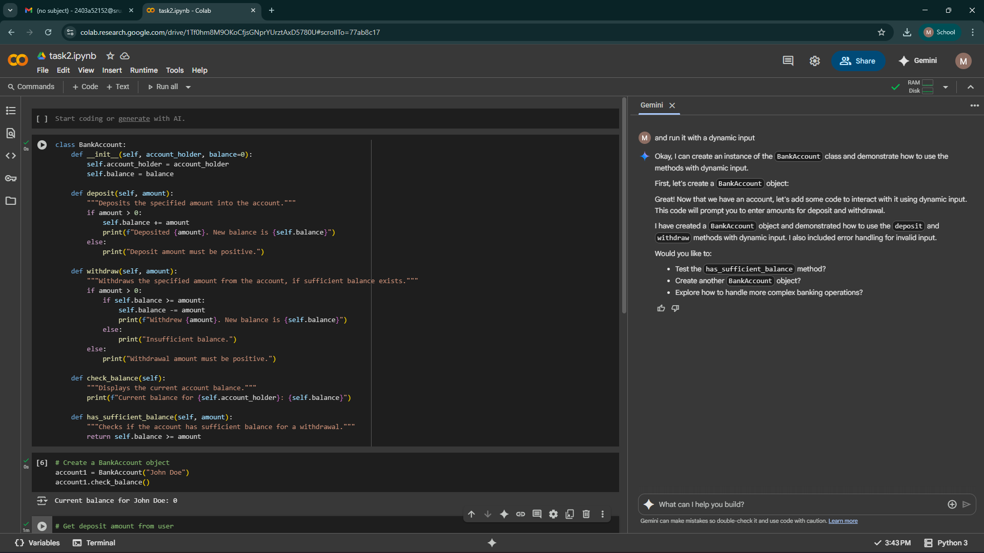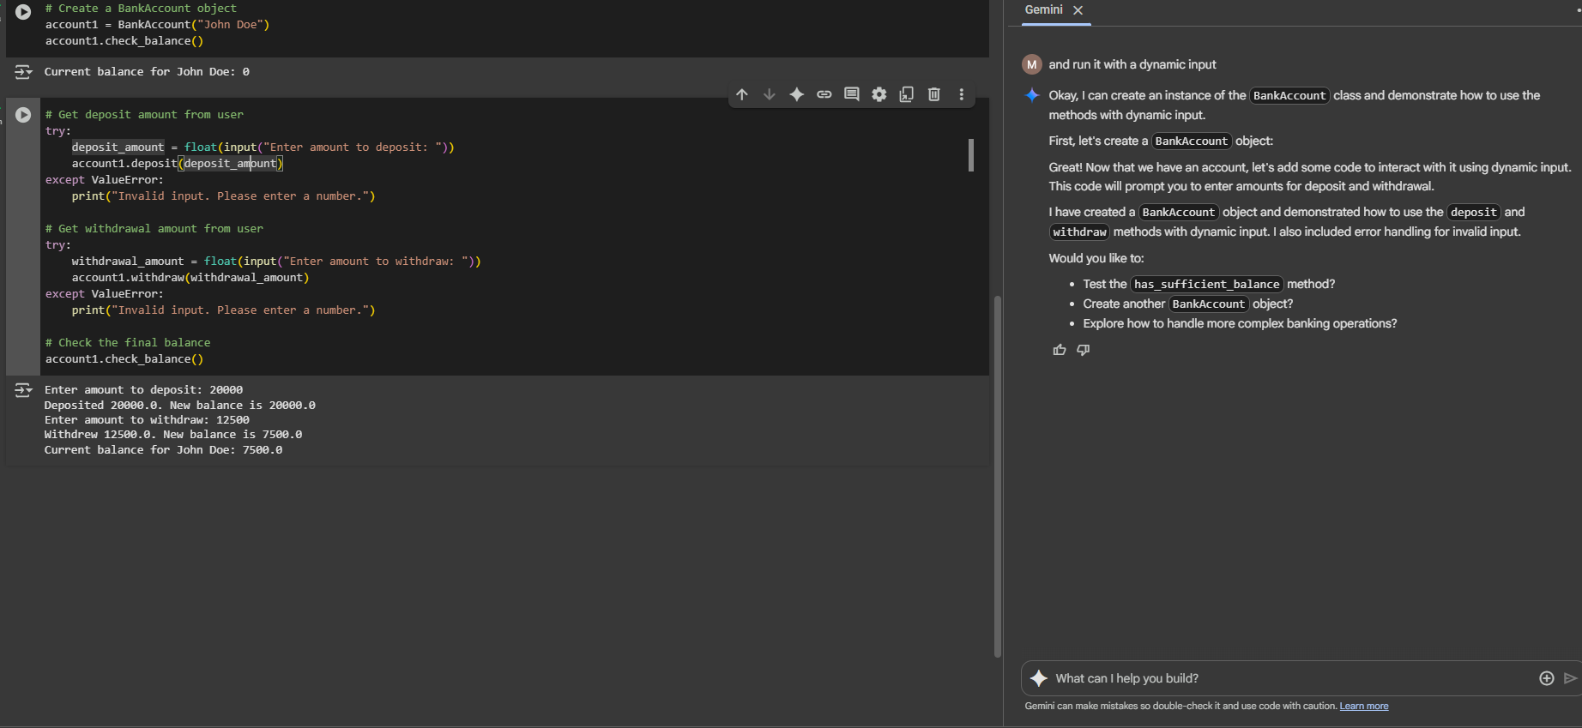

**Task Description #4:**

**•** Define a list of student dictionaries with keys name and score. Ask Copilot to write a while loop to print the names of students who scored more than 75.

**PROMPT:**

**Write a python program** **Defining a list of student dictionaries with keys name and score and write a while loop to print the names of students who scored more than 75.**

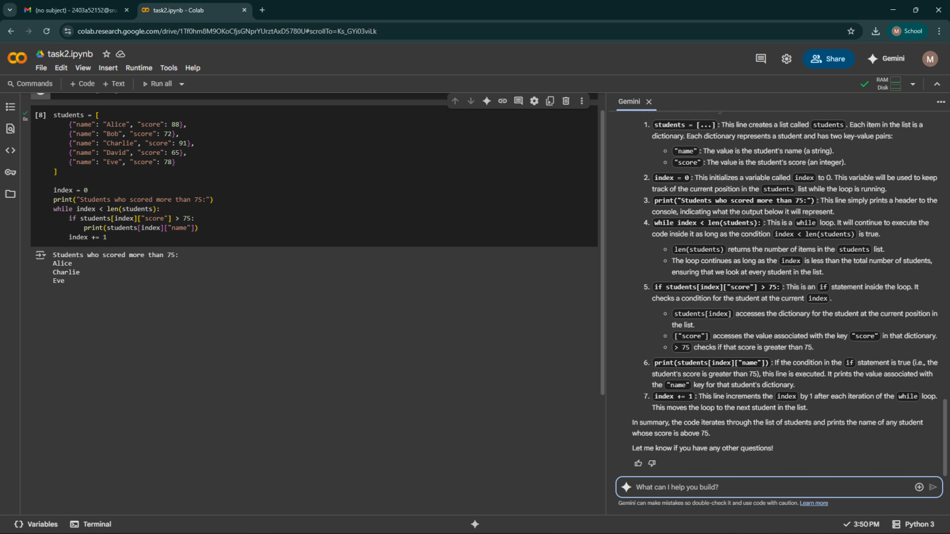

**Task Description #5:**

**•** Begin writing a class ShoppingCart with an empty items list. Prompt Copilot to generate methods to add_item, remove_item, and use a loop to calculate the total bill using conditional discounts.

**PROMPT:**

**Write a python program** **of** **a class ShoppingCart with an empty items list,** **generate methods to add_item, remove_item, and use a loop to calculate the total bill using conditional discounts** 

