Introduction

Modern organizations rely heavily on data to manage operations, resources, and strategic decision-making. As business activities grow in scale and complexity, maintaining accurate and well-structured information becomes increasingly important. Database Management Systems (DBMS) provide an effective solution for storing, organizing, retrieving, and managing large volumes of data while ensuring consistency, integrity, and security.
BuildCorp International is a rapidly expanding engineering and infrastructure company responsible for managing large-scale construction projects across Nepal and international locations. The company handles a wide range of operational information, including project records, equipment inventories, booking schedules, contact details, equipment categories, and financial transactions. Managing such information through manual methods can lead to data duplication, inconsistencies, and difficulties in tracking organizational resources.
This project focuses on the design and implementation of a relational database system for BuildCorp Infrastructure and Equipment Logistics. The database has been developed using normalization techniques to eliminate redundancy and improve data integrity. An Entity Relationship Diagram (ERD) is used to model the relationships between key entities, while Structured Query Language (SQL) is utilized to create tables, establish relationships, insert data, and perform queries.
The final database solution provides a structured framework for managing project operations and equipment logistics efficiently. Furthermore, data visualization techniques are applied to transform stored data into meaningful insights that can support operational planning and decision-making within the organization.

Normalization
Unnormalised Form (UNF)
The original BuildCorp dataset was collected from multiple operational sources and contained non-atomic values, combined attributes, and repeating groups. Examples include multiple category identifiers stored within a single field and employee names combined with job roles. Such a structure increases redundancy and makes data maintenance difficult.
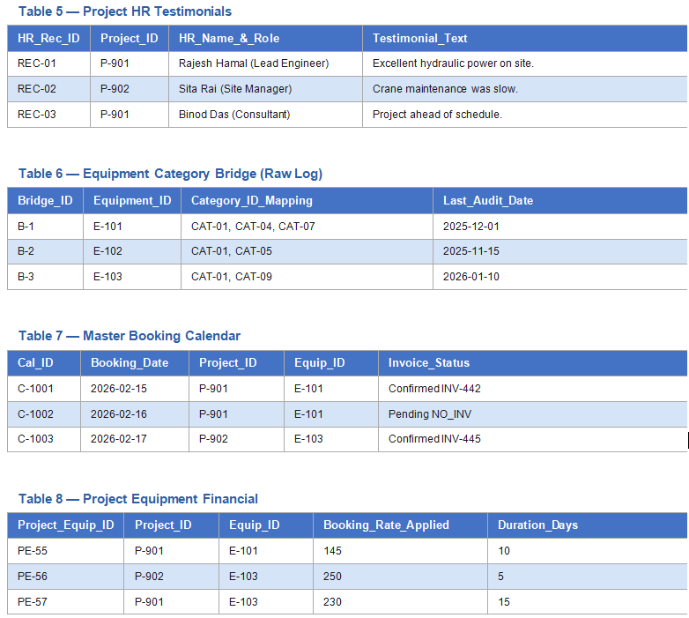

First Normal Form (1NF)
The dataset was transformed into First Normal Form (1NF) by ensuring that each attribute contains only a single, atomic value. Repeating groups and multi-valued attributes were removed by separating combined data into individual fields and records. For example, equipment category mappings were split into separate rows, while combined attributes such as HR Name and Role, and Invoice Status and Invoice Number, were divided into distinct columns. This improved data consistency and reduced redundancy within the database structure.
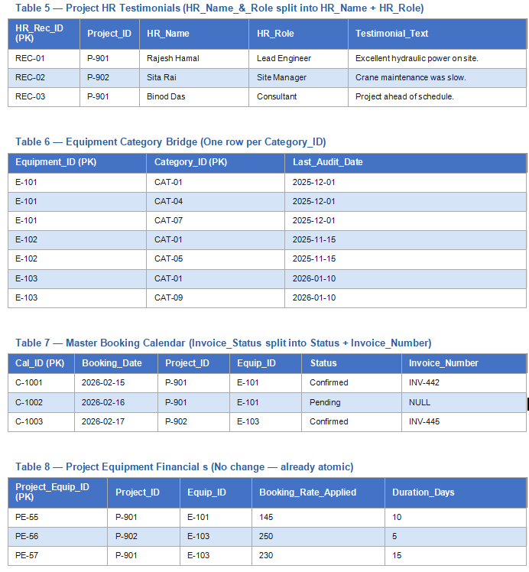

Second Normal Form (2NF)
The database was further refined to achieve Second Normal Form (2NF) by removing partial dependencies and separating related information into dedicated tables. Data relating to contacts, equipment categories, booking statuses, and project records was organized into independent entities linked through primary and foreign keys. This ensured that each non-key attribute depended on the whole primary key, improving data integrity and reducing redundancy.
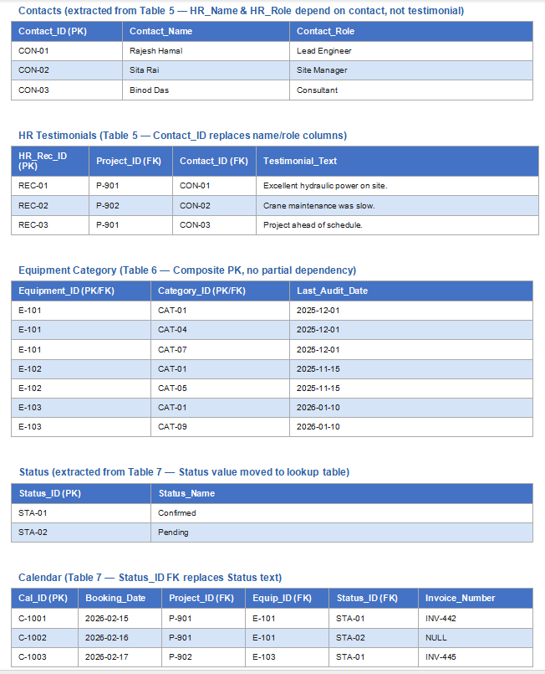
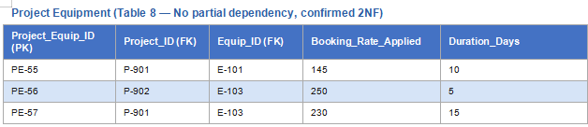
Third Normal Form (3NF)
The database was successfully transformed into Third Normal Form (3NF) by eliminating transitive dependencies and ensuring that all non-key attributes depend solely on the primary key of their respective tables. Separate entities were created for Projects, Equipment, Contacts, Categories, Status, Calendar, and relationship tables. This fully normalized structure minimizes data redundancy, improves consistency, and provides an efficient foundation for data storage, retrieval, and management within the Build Corp Infrastructure and Equipment Logistics system.

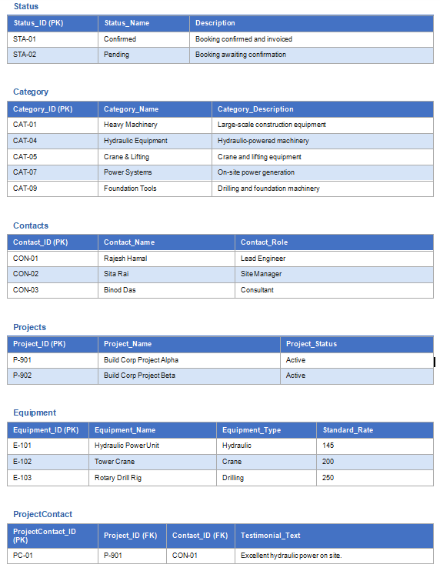
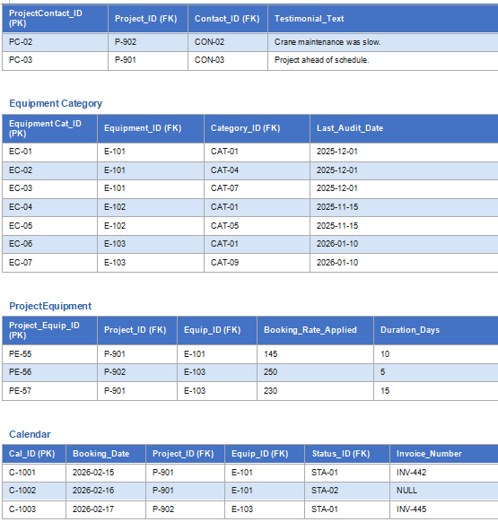

Normalization Summary
The normalization process was carried out from Unnormalised Form (UNF) to Third Normal Form (3NF). During this process, repeating groups, non-atomic attributes, and data redundancies were identified and removed. The final database structure ensures data consistency, minimizes duplication, and improves overall database efficiency. The resulting schema provides a reliable foundation for implementing the BuildCorp Infrastructure and Equipment Logistics database system.

Entity Relationship Diagram (ERD)
An Entity Relationship Diagram (ERD) was developed to visually represent the structure of the BuildCorp Infrastructure and Equipment Logistics database. The ERD illustrates the entities, their attributes, primary keys, foreign keys, and the relationships between tables. It serves as a blueprint for database implementation and ensures that data is organized efficiently according to the normalized schema.
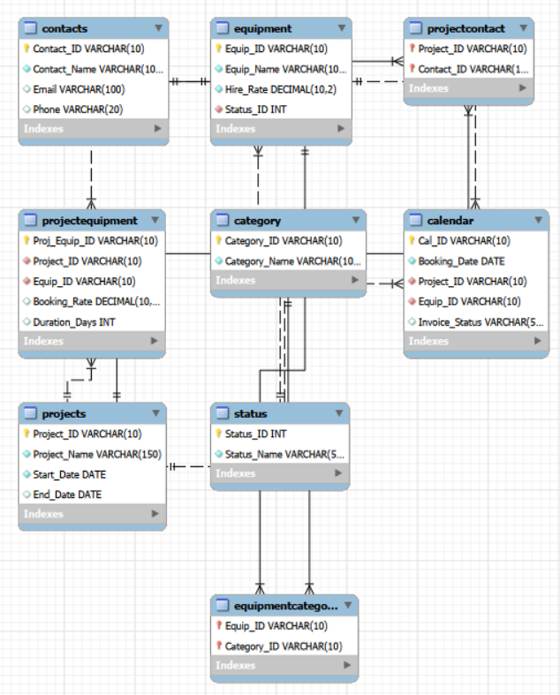

Table Creation
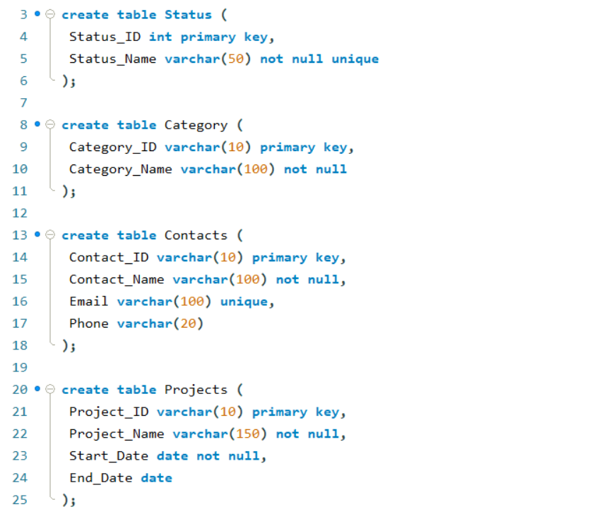
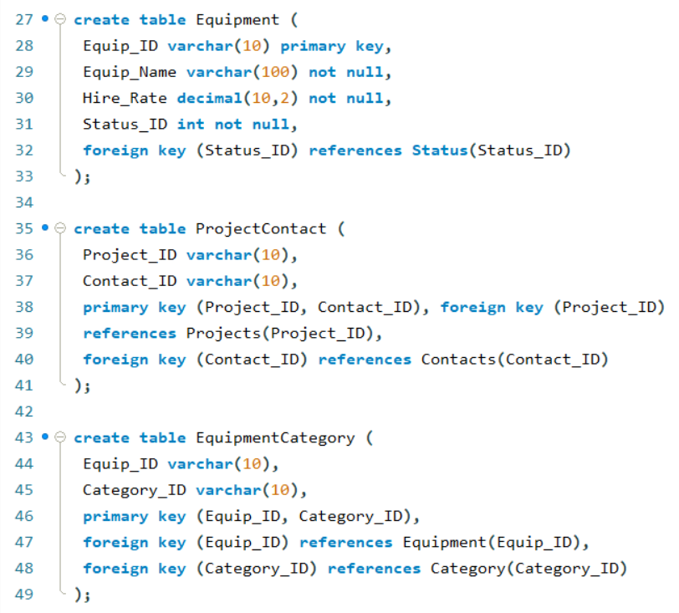
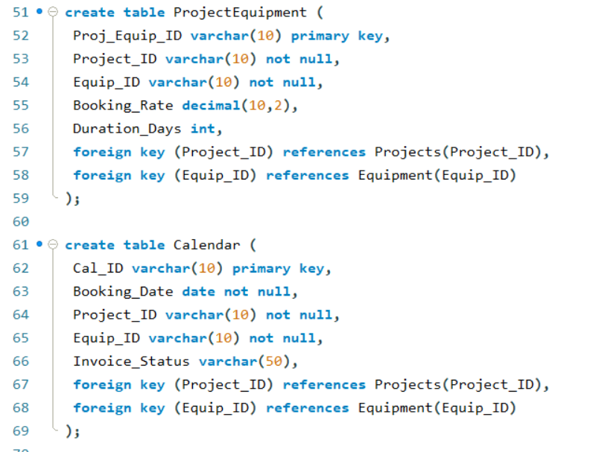

Data Insert
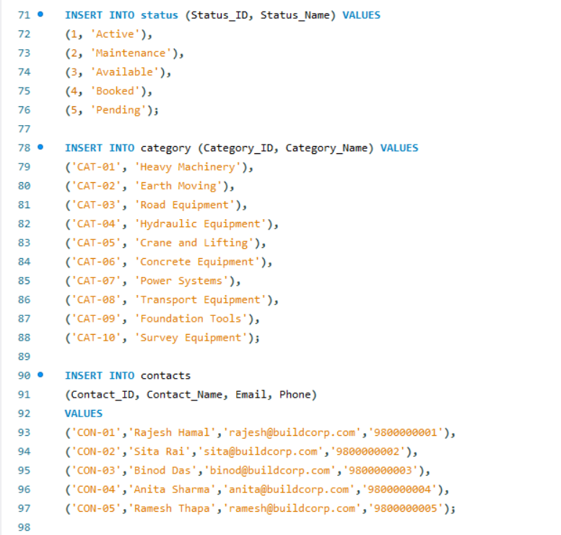

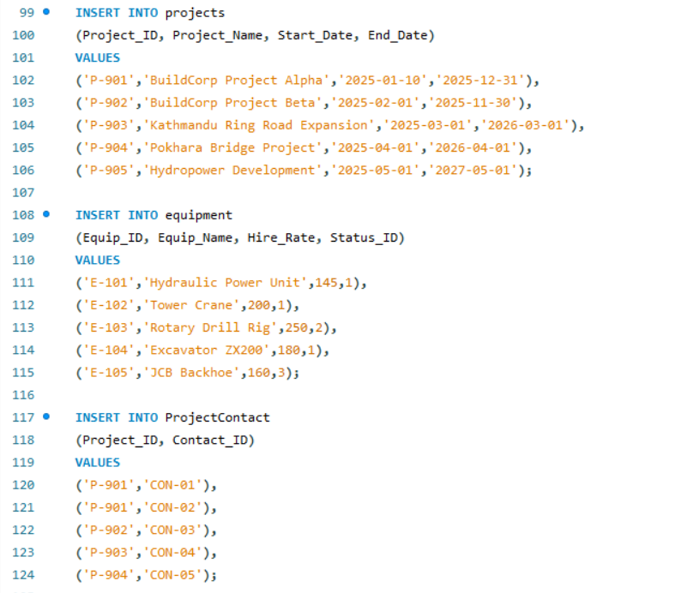

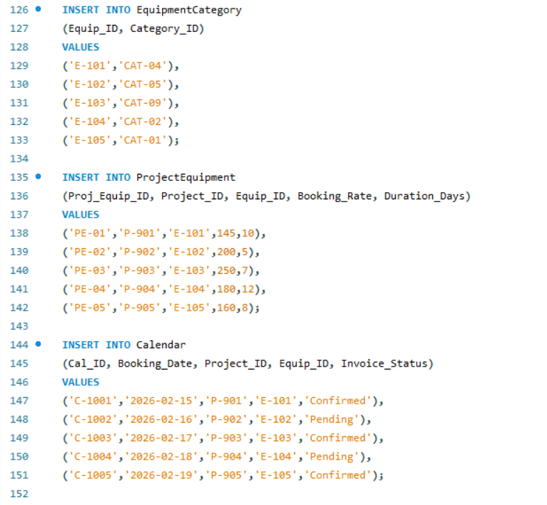

Data Insert Query
Average Hire Rate
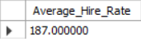

Contact Directory
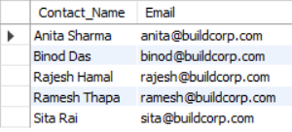

Active Resource Check
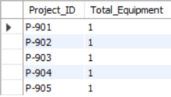

Unique Status Count
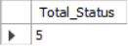

Targeted Search
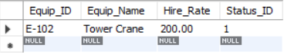

Owner Update
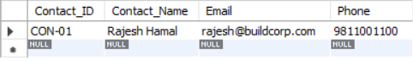

Inventory Expansion
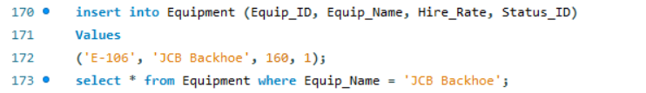
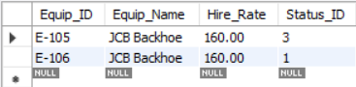

Data Cleanup
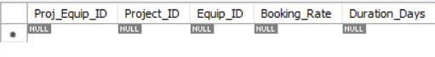

Allocation Summary
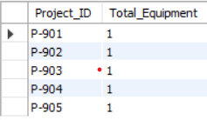

Project Audit
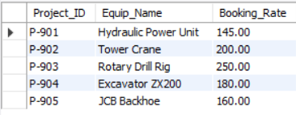

Client Engagement
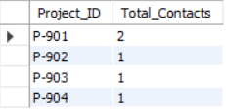
Idle Inventory
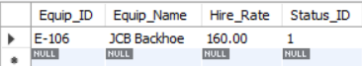

System Upgrade

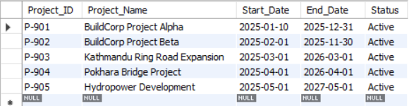

Conclusion

This project successfully developed a database system for Build Corp Infrastructure and Equipment Logistics. The unnormalized data was transformed through UNF, 1NF, 2NF, and 3NF to eliminate redundancy and improve data integrity. An Entity Relationship Diagram (ERD) was created to represent relationships among entities, and SQL was used to create tables, insert records, and execute queries. The final database structure supports efficient management of projects, equipment, contacts, bookings, and operational information. The project demonstrates the practical application of database normalization, relational database design, and SQL-based data management techniques.

References

* Elmasri, R., & Navathe, S. B. Fundamentals of Database Systems.
* Coronel, C., & Morris, S. Database Systems: Design, Implementation and Management.
* MySQL Documentation. Retrieved from: https://dev.mysql.com/doc/

