Graphical Programming Language Application

Part-1

Name: Nischal Shrestha

Level: L6

Semester:1

Subject: BSc It (Hons)

Exam Roll No:77190038

Application Interface

On executing the application, by clicking **run** in Microsoft Visual Studio, following application interface will be displayed to the user.

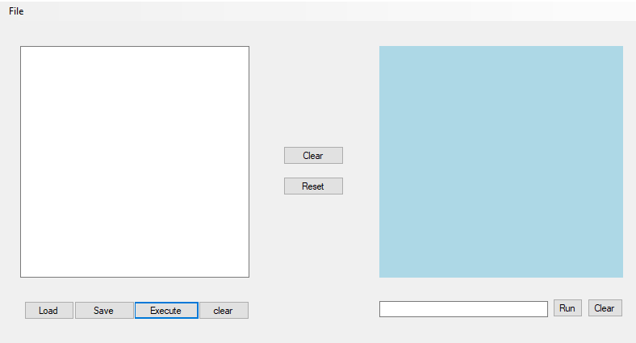

The upper-left corner of the interface consists of **File** menu. File Menu consist of Load, Save and Exit Menu Items.

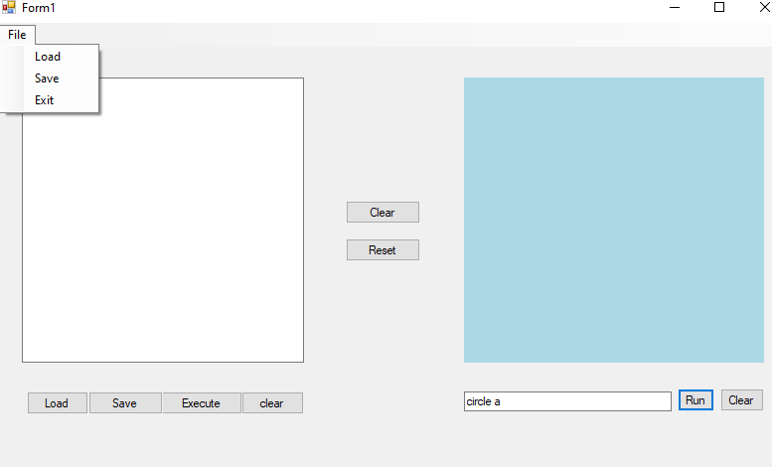

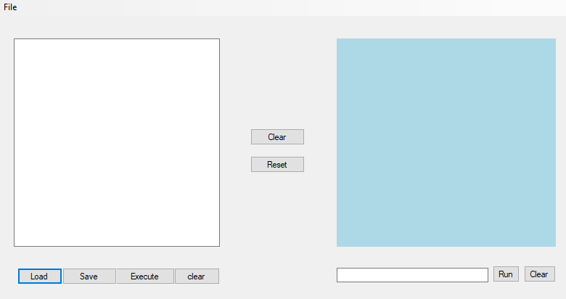

On clicking **load** in Menu Item or **Load button** in interface, a dialogue box with list of files is displayed to the user. Once the user has selected the text file and clicked ok. The following data is displayed on the left side **text area** in the application interface. Each command in text area can be executed by clicking **Execute button** in the interface.

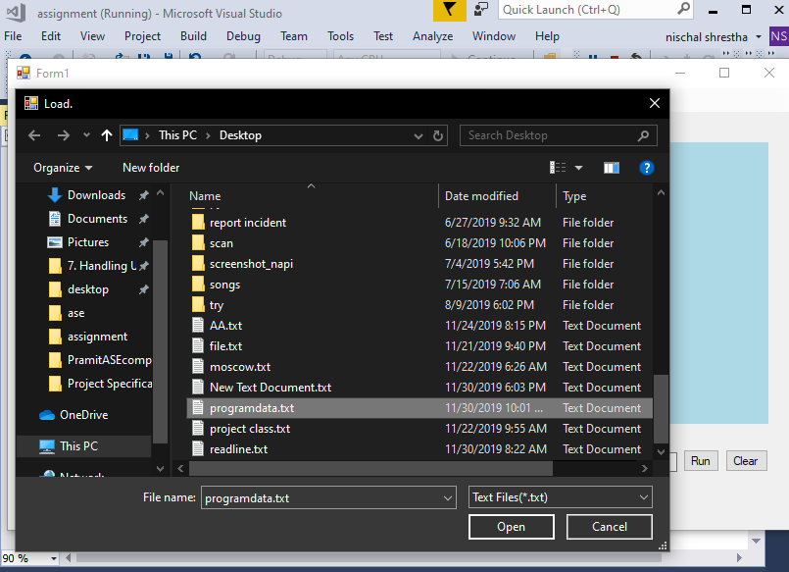

Once the button is clicked, each command in **text area** runs by each line and diagram is displayed in a **panel** to the right side of the interface.

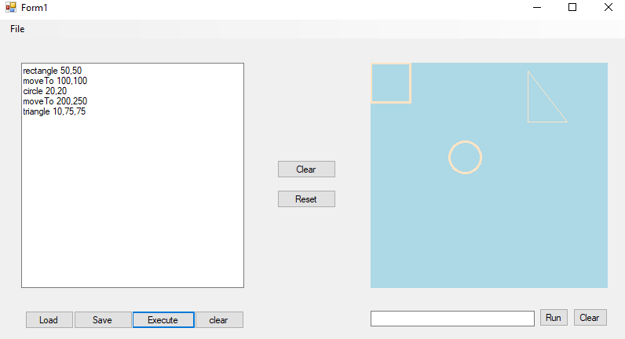

By clicking **clear** button in the center of the interface, user can clear the drawing displayed. Once the drawing has been erased, a prompt message ‘Drawing has been cleared’ is displayed.

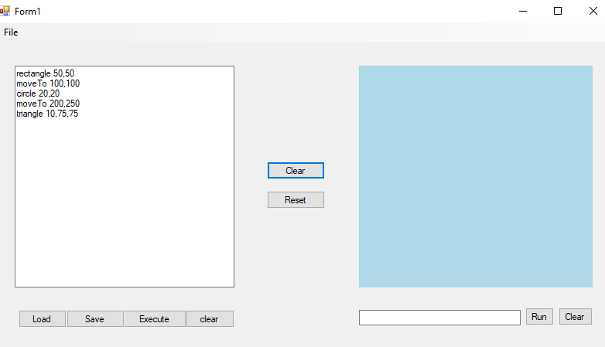

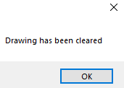

Likewise, user also can save the command in text area by either clicking **save** button or **save** menu item in the interface. Once, button is clicked, a dialogue box is displayed to save the file in desired location.

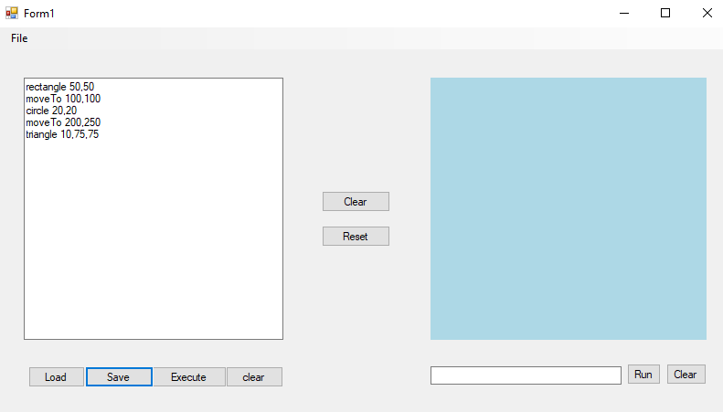

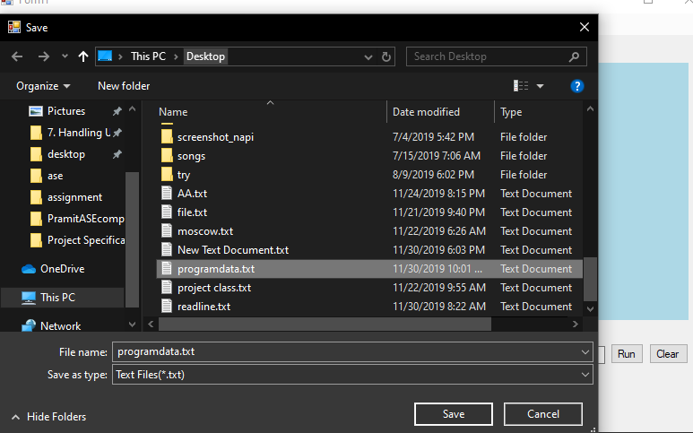

While saving the file, if the file contains same name, user is prompted with a message dialogue box requesting whether to overwrite the file or not as shown in figure below.

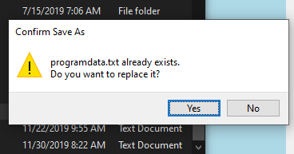

**Exit** menu item in file is used to close the application.



The bottom right side of the interface consist of **text box** which is used to run a single command by simply clicking **run button** in the interface.

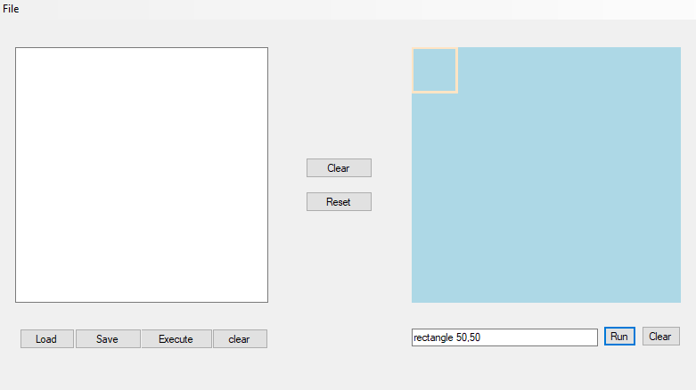

Various command can be run in multiline command area as well as single line command area. Some of the commands are ‘**triangle 50,60,70’, ‘circle 50’, ‘rectangle 70,50’, ‘moveto 50,50’ and ‘drawto 30,40’.**

Commands like ‘**triangle 50,60,70’, ‘circle 50’, ‘rectangle 70,50’ are simply used to draw diagram as shown in figure.**

Circle

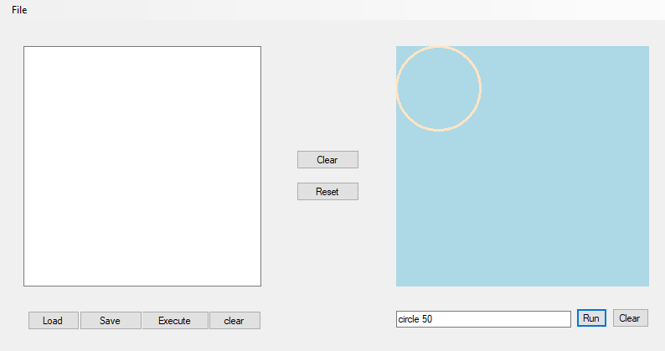

Triangle

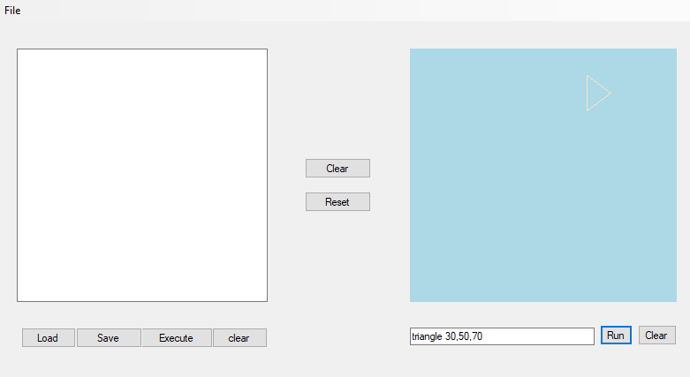

While commands like **‘moveto 50,50’** is used to move the position of the pen to the desired positionand displays a message ‘**points has been moved to X:50 y:50**’in amessage boxwhile **‘drawto 30,40’** is used to drawfrom initial position of pen to desired position specified by the user.

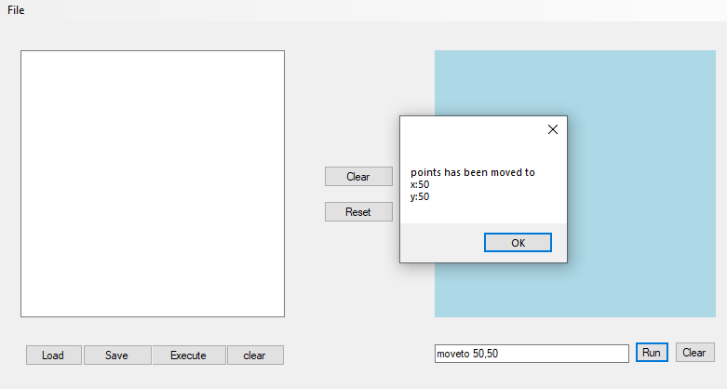

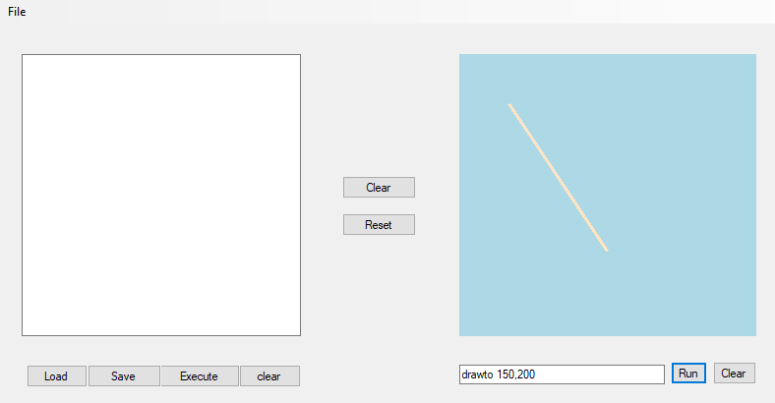

**Clear** button in the bottom left side of the interface is used to clear the command in **text area** whereas **Clear** button on the bottom right side of the interface is used to clear the textbox. Once **textbox** or **text area** is cleared, a message dialogue box with message ‘**text has been cleared** ’is displayed to the user.

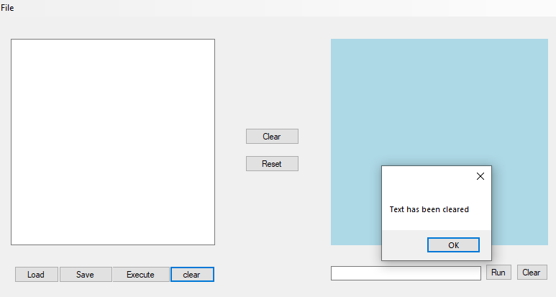

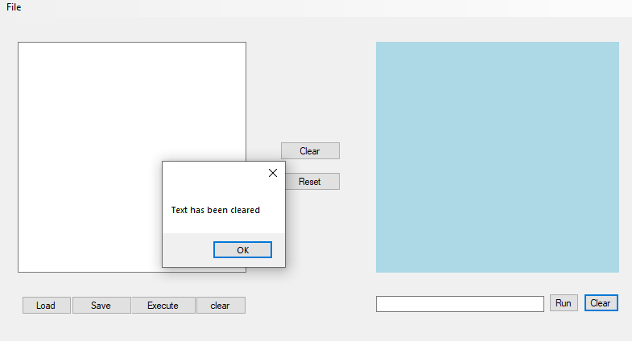

**Reset Button** in the center of the interface is used to reset the position of the cursor. Once reset button is clicked a message box with message” **Points has been resented to X:0 Y:0** “is displayed to user as shown in figure.

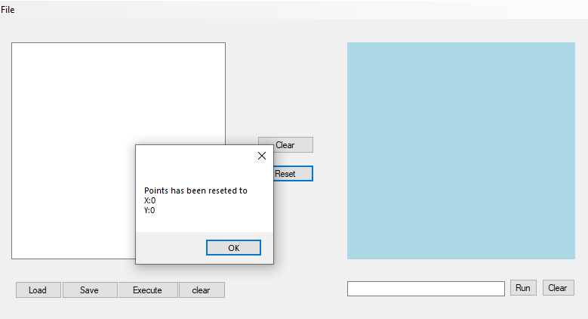

**Invalid commands**

As there are many commands, user might mismatch the command or might type incorrectly. So, for such cases validation is done which are mentioned below.

User might type any command in **text area** or **text box** and simply run the command in such cases an error message box is displayed to the user with message no command to run as shown in figure below.

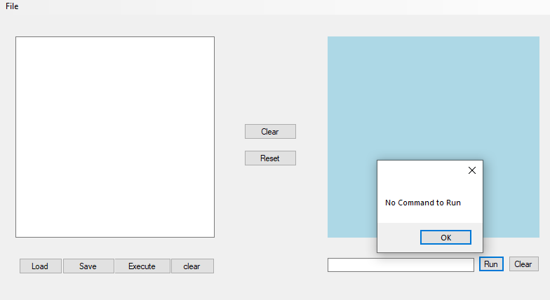

Likewise, user might not complete command in text area or text box and run the command in such case **‘invalid command**’ is displayed to the user in a message box.

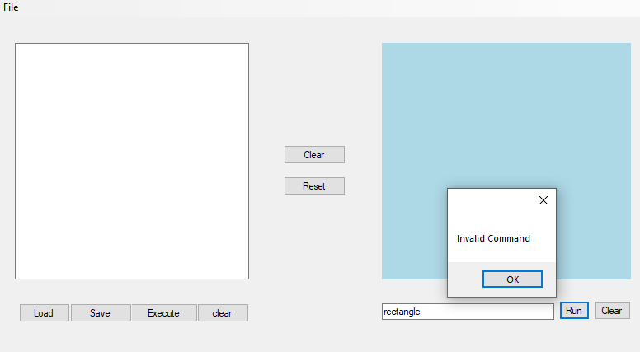

Similarly, user might mistake the command format in text area or text box and run the command in such cases ‘**Input string was not in a correct format’** is displayed to user in a message box.

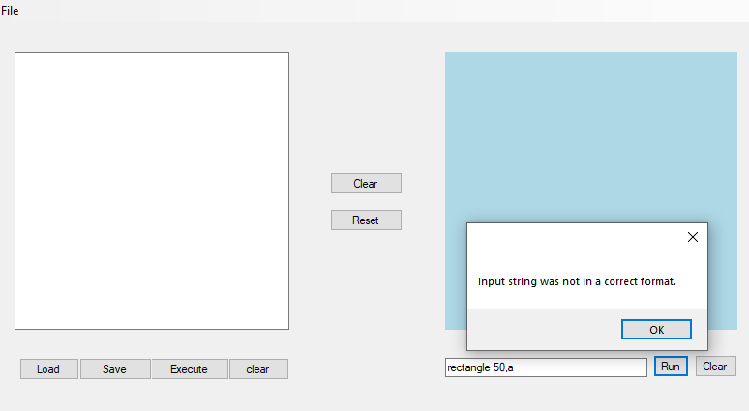

**Testcase**

**Interface Testing**

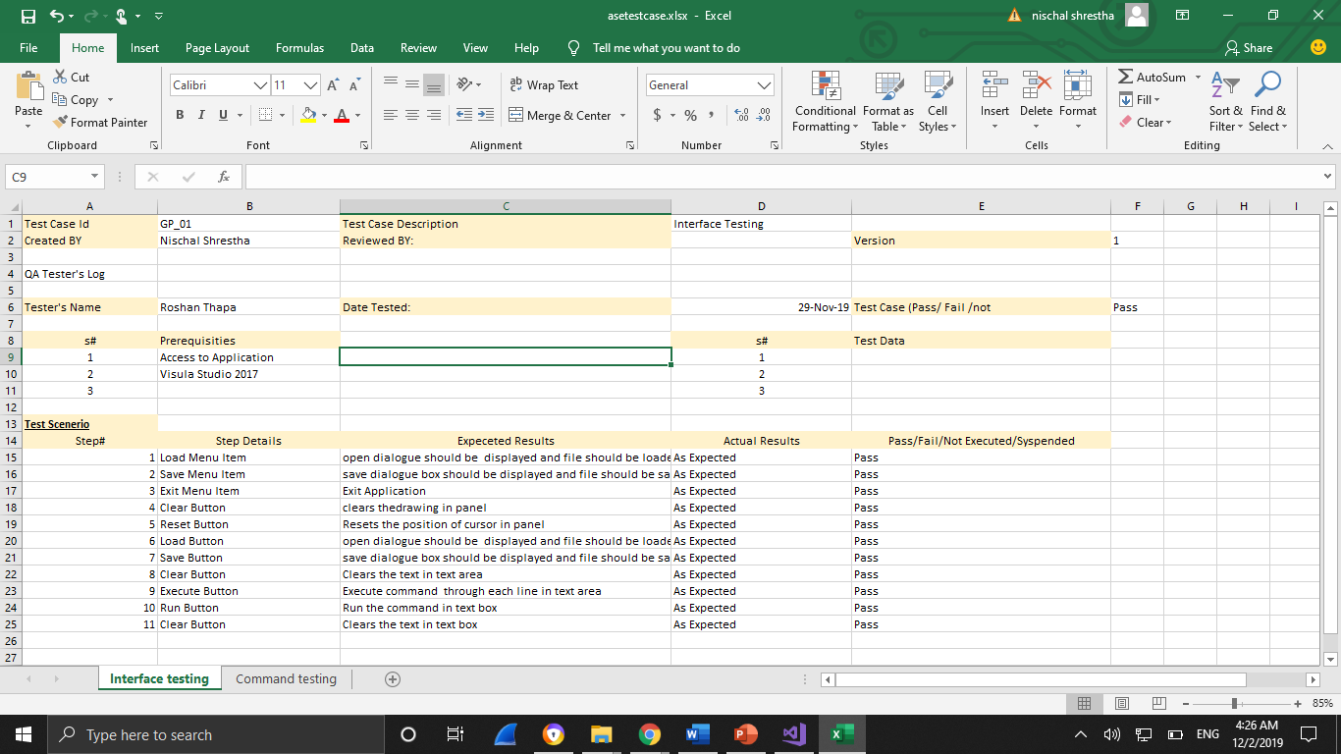

**Command Testing**

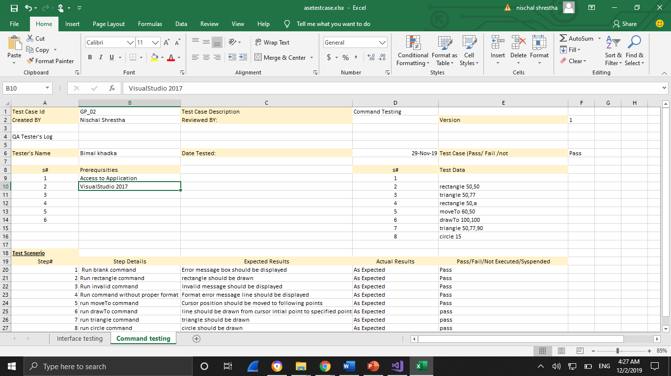

**XML**

