Table of Contents
1.What is jQuery? 3
2.Why jQuery? 3
3. jQuery Syntax 3
4. jQuery Selectors 4
The element Selector 4
Example 5
The #id Selector 5
Example 6
What are Jquery Events? 7
Example 8
Example 9
Example 9
Example 11
jQuery Effects 12
1.Query hide() and show() 12
Example 12
jQuery fadeIn() Method 13
Example 14
3. jQuery slideDown() Method 15
Example 15
4.jQuery Animations - The animate() Method 16
Example 16
5. Dom Manipulation 19
6. Form Validation 21

What is jQuery?
jQuery is a lightweight, "write less, do more", JavaScript library.
The purpose of jQuery is to make it much easier to use JavaScript on your website.
jQuery takes a lot of common tasks that require many lines of JavaScript code to accomplish, and wraps them into methods that you can call with a single line of code.
jQuery also simplifies a lot of the complicated things from JavaScript, like AJAX calls and DOM manipulation.
The jQuery library contains the following features:
- HTML/DOM manipulation
- CSS manipulation
- HTML event methods
- Effects and animations
- AJAX
- Utilities
Tip: In addition, jQuery has plugins for almost any task out there.

Why jQuery?
There are lots of other JavaScript libraries out there, but jQuery is probably the most popular, and also the most extendable.
Many of the biggest companies on the Web use jQuery, such as:
- Google
- Microsoft
- IBM
- Netflix

jQuery Syntax
The jQuery syntax is tailor-made for selecting HTML elements and performing some action on the element(s).
Basic syntax is: $(selector).action()
- A $ sign to define/access jQuery
- A (selector) to "query (or find)" HTML elements
- A jQuery action() to be performed on the element(s)
Examples:
$(this).hide() - hides the current element.
$("p").hide() - hides all <p> elements.
$(".test").hide() - hides all elements with class="test".
$("#test").hide() - hides the element with id="test".

jQuery Selectors
jQuery selectors allow you to select and manipulate HTML element(s).
jQuery selectors are used to "find" (or select) HTML elements based on their name, id, classes, types, attributes, values of attributes and much more. It's based on the existing CSS Selectors, and in addition, it has some own custom selectors.
All selectors in jQuery start with the dollar sign and parentheses: $().

The element Selector
The jQuery element selector selects elements based on the element name.
You can select all <p> elements on a page like this:
Example
When a user clicks on a button, all <p> elements will be hidden:

Example
<!DOCTYPE html>
<html>
<head>
<script src="https://ajax.googleapis.com/ajax/libs/jquery/3.7.1/jquery.min.js"></script>
<script>
$(document).ready(function(){
$("button").click(function(){
$("p").hide();
});
});
</script>
</head>
<body>

<h2>This is a heading</h2>

<p>This is a paragraph.</p>
<p>Program executed by Nischal Khadka.</p>

<button>Click me to hide paragraphs</button>

</body>
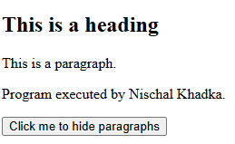
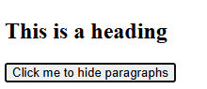

The #id Selector
The jQuery #id selector uses the id attribute of an HTML tag to find the specific element.
An id should be unique within a page, so you should use the #id selector when you want to find a single, unique element.
To find an element with a specific id, write a hash character, followed by the id of the HTML element:
$("#test")
Example
When a user clicks on a button, the element with id="test" will be hidden:

Example
<!DOCTYPE html>
<html>
<head>
<script src="https://ajax.googleapis.com/ajax/libs/jquery/3.7.1/jquery.min.js"></script>
<script>
$(document).ready(function(){
$("button").click(function(){
$("#test").hide();
});
});
</script>
</head>
<body>

<h2>This is a heading</h2>

<p>This is a paragraph.</p>
<p id="test">Program executed by Nischal Khadka.</p>

<button>Click me</button>

</body>

What are Jquery Events?
All the different visitors' actions that a web page can respond to are called events.
An event represents the precise moment when something happens.
Examples:
- moving a mouse over an element
- selecting a radio button
- clickinThe term "fires/fired" is often used with events. Example: "The keypress event is fired, the moment you press a key".
Here are some common DOM events:
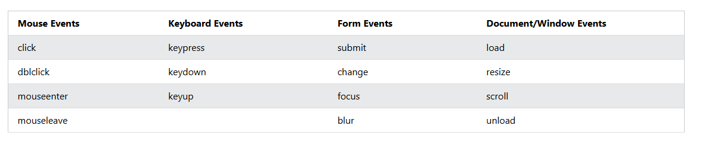

1.$(document).ready()
The $(document).ready() method allows us to execute a function when the document is fully loaded. This event is already explained in the jQuery Syntax chapter.
2.click()
The click() method attaches an event handler function to an HTML element.
The function is executed when the user clicks on the HTML element.
The following example says: When a click event fires on a <p> element; hide the current <p> element:

Example
<!DOCTYPE html>
<html>
<head>
<script src="https://ajax.googleapis.com/ajax/libs/jquery/3.7.1/jquery.min.js"></script>
<script>
$(document).ready(function(){
$("p").click(function(){
$(this).hide();
});
});
</script>
</head>
<body>

<p>If you click on me, I will disappear.</p>
<p>Click me away!</p>
<p>Click me too!</p>
<p> Program executed by Nischal khadka </p>

</body>
</html>
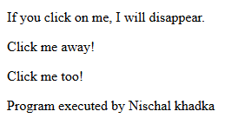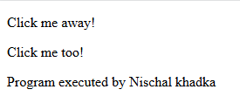
3.dblclick()
The dblclick() method attaches an event handler function to an HTML element.
The function is executed when the user double-clicks on the HTML element:

Example
<!DOCTYPE html>
<html>
<head>
<script src="https://ajax.googleapis.com/ajax/libs/jquery/3.7.1/jquery.min.js"></script>
<script>
$(document).ready(function(){
$("p").dblclick(function(){
$(this).hide();
});
});
</script>
</head>
<body>
<p>If you double-click on me, I will disappear.</p>
<p>Click me away!</p>
<p>Click me too!</p>
<p> Program executed by Nischal khadka </p>
</body>
</html>
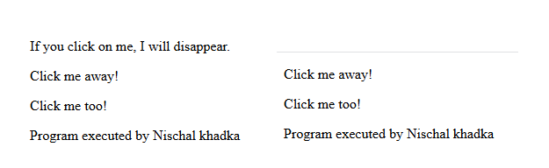
4. mouseenter()
The mouseenter() method attaches an event handler function to an HTML element.
The function is executed when the mouse pointer enters the HTML element:

Example
<!DOCTYPE html>
<html>
<head>
<script src="https://ajax.googleapis.com/ajax/libs/jquery/3.7.1/jquery.min.js"></script>
<script>
$(document).ready(function(){
$("#p1").mouseenter(function(){
alert("You entered p1!");
});
});
</script>
</head>
<body>

<p id="p1">Enter this paragraph.</p>
<p> Program executed by Nischal khadka </p>

</body>
</html><!DOCTYPE html>
<html>
<head>
<script src="https://ajax.googleapis.com/ajax/libs/jquery/3.7.1/jquery.min.js"></script>
<script>
$(document).ready(function(){
$("#p1").mouseup(function(){
alert("Mouse up over p1!");
});
});
</script>
</head>
<body>

<p id="p1">This is a paragraph.</p>
<p> Program executed by Nischal khadka </p>

</body>
</html>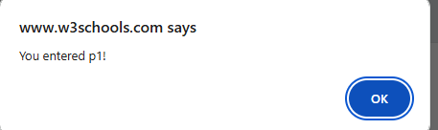

5. mouseleave()
The mouseleave() method attaches an event handler function to an HTML element.
The function is executed when the mouse pointer leaves the HTML element:

Example
<!DOCTYPE html>
<html>
<head>
<script src="https://ajax.googleapis.com/ajax/libs/jquery/3.7.1/jquery.min.js"></script>
<script>
$(document).ready(function(){
$("#p1").mouseup(function(){
alert("Mouse up over p1!");
});
});
</script>
</head>
<body>

<p id="p1">This is a paragraph.</p>
<p> Program executed by Nischal khadka </p>

</body>
</html>

6. hover()
The hover() method takes two functions and is a combination of the mouseenter() and mouseleave() methods.
The first function is executed when the mouse enters the HTML element, and the second function is executed when the mouse leaves the HTML element:
<!DOCTYPE html>
<html>
<head>
<script src="https://ajax.googleapis.com/ajax/libs/jquery/3.7.1/jquery.min.js"></script>
<script>
$(document).ready(function(){
$("#p1").hover(function(){
alert("You entered p1!");
</script>
</head>
<body>

<p id="p1">This is a paragraph.</p>

</body>
</html>

jQuery Effects

jQuery hide() and show()
With jQuery, you can hide and show HTML elements with the hide() and show() methods:

Example
<!DOCTYPE html>
<html>
<head>
<script src="https://ajax.googleapis.com/ajax/libs/jquery/3.7.1/jquery.min.js"></script>
<script>
$(document).ready(function(){
$("#hide").click(function(){
$("p").hide();
});
$("#show").click(function(){
$("p").show();
});
});
</script>
</head>
<body>

<p>If you click on the "Hide" button, I will disappear.</p>
<p> Program executed by Nischal khadka </p>

<button id="hide">Hide</button>
<button id="show">Show</button>

</body>
</html>
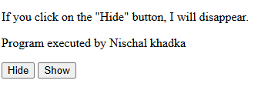

jQuery fadeIn() Method
The jQuery fadeIn() method is used to fade in a hidden element.
Syntax:
$(selector).fadeIn(speed,callback);
The optional speed parameter specifies the duration of the effect. It can take the following values: "slow", "fast", or milliseconds.
The optional callback parameter is a function to be executed after the fading completes.
The following example demonstrates the fadeIn() method with different parameters:

Example
<!DOCTYPE html>
<html>
<head>
<script src="https://ajax.googleapis.com/ajax/libs/jquery/3.7.1/jquery.min.js"></script>
<script>
$(document).ready(function(){
$("button").click(function(){
$("#div1").fadeIn();
$("#div2").fadeIn("slow");
$("#div3").fadeIn(3000);
});
});
</script>
</head>
<body>

<p>Demonstrate fadeIn() with different parameters.</p>
<p> Program executed by Nischal khadka </p>

<button>Click to fade in boxes</button><br><br>

<div id="div1" style="width:80px;height:80px;display:none;background-color:red;"></div><br>
<div id="div2" style="width:80px;height:80px;display:none;background-color:green;"></div><br>
<div id="div3" style="width:80px;height:80px;display:none;background-color:blue;"></div>

</body>
</html>
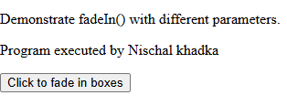

3. jQuery slideDown() Method
The jQuery slideDown() method is used to slide down an element.
Syntax:
$(selector).slideDown(speed,callback);
The optional speed parameter specifies the duration of the effect. It can take the following values: "slow", "fast", or milliseconds.
The optional callback parameter is a function to be executed after the sliding completes.
The following example demonstrates the slideDown() method:

Example
<!DOCTYPE html>
<html>
<head>
<script src="https://ajax.googleapis.com/ajax/libs/jquery/3.7.1/jquery.min.js"></script>
<script>
$(document).ready(function(){
$("#flip").click(function(){
$("#panel").slideDown("slow");
});
});
</script>
<style>
#panel, #flip {
padding: 5px;
text-align: center;
background-color: #e5eecc;
border: solid 1px #c3c3c3;
}

#panel {
padding: 50px;
display: none;
}
</style>
</head>
<body>

<div id="flip">Click to slide down panel</div>
<div id="panel">Hello world!</div>

</body>
</html>
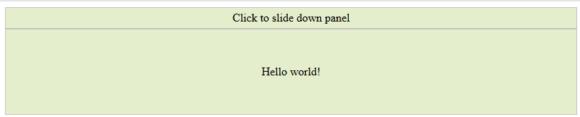

4.jQuery Animations - The animate() Method
The jQuery animate() method is used to create custom animations.
Syntax:
$(selector).animate({params},speed,callback);
The required params parameter defines the CSS properties to be animated.
The optional speed parameter specifies the duration of the effect. It can take the following values: "slow", "fast", or milliseconds.
The optional callback parameter is a function to be executed after the animation completes.
The following example demonstrates a simple use of the animate() method; it moves a <div> element to the right, until it has reached a left property of 250px:

Example
<!DOCTYPE html>
<html>
<head>
<script src="https://ajax.googleapis.com/ajax/libs/jquery/3.7.1/jquery.min.js"></script>
<script>
$(document).ready(function(){
$("button").click(function(){
$("div").animate({left: '250px'});
});
});
</script>
</head>
<body>

<button>Start Animation</button>

<p>By default, all HTML elements have a static position, and cannot be moved. To manipulate the position, remember to first set the CSS position property of the element to relative, fixed, or absolute!</p>

<div style="background:#98bf21;height:100px;width:100px;position:absolute;"></div>

</body>
</html>
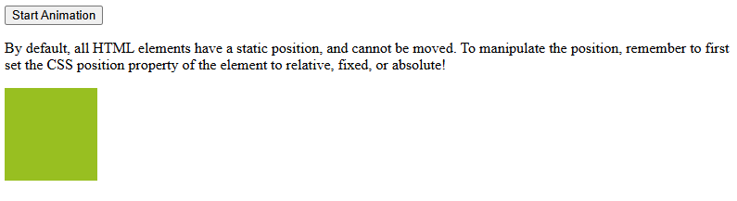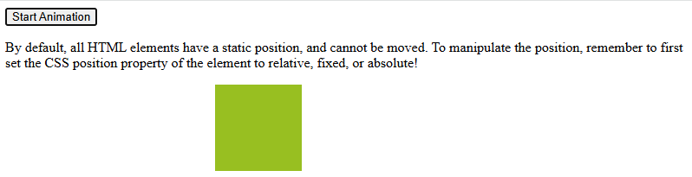

jQuery HTML/CSS Methods
JQuery provides methods to control the DOM inefficient way. JQuery provides methods that act as getter, retrieving information from DOM elements like .attr(), .html(), and .val().
All the selectors included in CSS are supported in jQuery. jQuery CSS Methods are used to apply CSS properties on DOM elements.
Syntax:
$(selector).method(attribute.., function..)
Example: Set text syntax
<!DOCTYPE html>
<html>
​
<body>
<h1>
<center>
Geeks <button onclick="function()">Click me
</button>
</center>
</h1>
​
<script src=
"https://ajax.googleapis.com/ajax/libs/jquery/3.3.1/jquery.min.js">
</script>
<script>
$(document).ready(function() {
$("button").click(function() {
$("p").text("Jquery_text_method");
});
});
</script>
​
<p>GeeksforGeeks</p>
<p>Jquery</p>
​
</body>
​
</html>

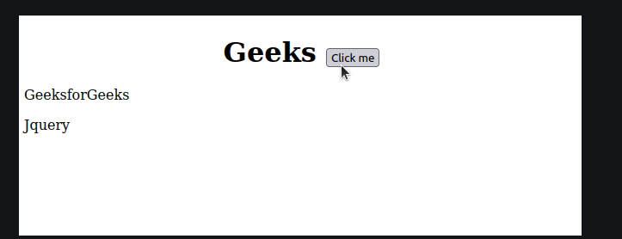

SIMPLE DOM MANIPULATION – DOCUMENT
DOM (Document Object Model) represents the structure of a webpage.
jQuery makes DOM manipulation easier with simple methods for:
- Adding elements
- Deleting elements
- Changing text / HTML
- Changing CSS
- Moving elements
- Getting/setting attributes
<h2 id="title">Original Title</h2>
<div id="box" style="border:1px solid black; width:200px; height:50px;">
This is a box
</div>

<ul id="list">
<li>Item 1</li>
</ul>

<button id="change">Change DOM</button>

<script src="https://ajax.googleapis.com/ajax/libs/jquery/3.6.0/jquery.min.js"></script>

<script>
$(function(){

$("#change").click(function(){

// Change content
$("#title").text("Updated Title");

// Change CSS
$("#box").css("background", "lightblue");

// Add items
$("#list").append("<li>New Item Added</li>");

// Insert before element
$("#title").before("<p>Inserted Before Title</p>");

});

});
</script>
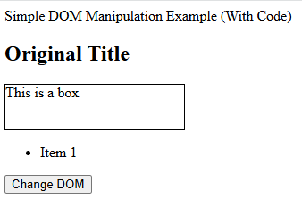
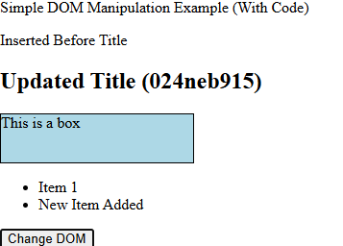

Form Validation
Form validation ensures users enter the correct data before submitting a form.
Common checks include:
- Required fields not empty
- Valid email
- Minimum length criteria
jQuery makes validation easy with simple functions and event handling.

<form id="myForm">
<input type="text" id="name" placeholder="Enter Name"><br><br>
<input type="email" id="email" placeholder="Enter Email"><br><br>
<button type="submit">Submit</button>
</form>

<p id="error" style="color:red;"></p>

<script src="https://ajax.googleapis.com/ajax/libs/jquery/3.6.0/jquery.min.js"></script>

<script>
$(function(){
$("#myForm").submit(function(event){

let name = $("#name").val().trim();
let email = $("#email").val().trim();

// Email regex
const pattern = /^[^ ]+@[^ ]+\.[a-z]{2,3}$/;

if (name === "" || email === ""){
event.preventDefault();
$("#error").text("All fields are required!");
}
else if (!pattern.test(email)){
event.preventDefault();
$("#error").text("Please enter a valid email address");
}
else {
$("#error").text(""); // no errors
alert("Form submitted successfully!");
}

});
});
</script>

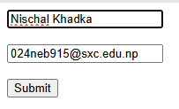

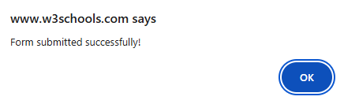

Conclusion
Today’s work provided a clear and practical understanding of key jQuery concepts, including simple DOM manipulation and form validation, through detailed explanations and hands-on examples. We explored how to dynamically change content, styles, and elements within a webpage, and learned how to validate user inputs effectively using jQuery’s concise syntax. Overall, the session strengthened your foundational skills in building interactive, responsive, and user-friendly web pages using jQuery.

