**Chapter 1**

**Introduction**

* 1. **Background**

Quantum computing stands at the cutting edge of technological advancement, redefining how complex problems can be approached and solved. Unlike classical computers that operate strictly on binary bits (0 or 1), quantum computers use quantum bits or qubits, which can exist in a **superposition** of states—representing both 0 and 1 simultaneously. This fundamental property, combined with **entanglement** and **quantum interference**, allows quantum computers to process information in ways that are exponentially more powerful for specific types of problems compared to classical systems.

Despite these advantages, quantum mechanics remains abstract and mathematically intensive. Understanding how a qubit behaves, evolves, or responds to quantum gates often requires advanced mathematical tools like Dirac’s bra–ket notation, probability amplitudes, and Hilbert spaces. For beginners and even intermediate learners, this creates a steep conceptual barrier, making the field difficult to approach without strong mathematical foundations.

**Q-Verse** addresses this challenge by transforming abstract quantum concepts into interactive, immersive 3D visualizations. Built using **Three.js**, a powerful JavaScript library that leverages **WebGL**, Q-Verse renders the **Bloch sphere**—a geometric representation of a qubit’s state—in real time. Through intuitive 3D interaction, users can observe and understand phenomena such as superposition, rotation, and phase change as they happen.

By running entirely within a web browser, Q-Verse ensures **cross-platform compatibility**, **portability**, and **scalability**, eliminating the need for specialized hardware or software. This makes it ideal for use in classrooms, research demonstrations, workshops, and self-learning environments. Q-Verse aims not only to **simplify the learning curve** of quantum computing but also to **enhance conceptual clarity** through visual experience—bridging the gap between theoretical equations and practical understanding.

* 1. **Objectives & Scope**

The primary objective of **Q-Verse** is to design and implement an **interactive 3D visualization environment** that accurately represents the dynamic behavior of qubits and their transformations under various quantum operations. The project aims to bridge the gap between theoretical quantum computing concepts and practical understanding by translating complex mathematical principles into an intuitive and visually engaging experience. By doing so, Q-Verse seeks to make quantum mechanics more approachable to students, educators, and researchers.

Q-Verse specifically focuses on providing a **Bloch sphere-based visualization** of qubit states, enabling real-time observation of the quantum state vector’s position and rotation. The visualization captures the evolution of a qubit defined by its spherical coordinates, θ (theta) and φ (phi), which represent the amplitude and phase components of the quantum state. Users can interact with the model to apply transformations and witness the effects of quantum gates such as the **Hadamard**, **Pauli-X**, **Pauli-Z**, and **Phase** gates, thereby deepening their conceptual understanding of quantum state manipulation.

**Specific objectives of Q-Verse include:**

* To create a 3D Bloch sphere representation of a single qubit using **Three.js** for real-time rendering.
* To visualize the **quantum state vector** and demonstrate its orientation changes under different gate operations.
* To simulate essential **quantum logic gates** and illustrate their effects on the qubit’s superposition and phase.
* To implement an **interactive user interface** allowing users to rotate the sphere, apply transformations, and explore state dynamics.
* To explore the **integration of WebXR** for immersive **AR/VR-based visualization**, enhancing experiential learning.
* To establish a flexible framework that can be extended to multi-qubit systems and entanglement visualization in the future.

The **scope** of this project primarily focuses on the **single-qubit system**, represented geometrically on the Bloch sphere. It provides users with the ability to visualize and interact with fundamental quantum behaviors in a controlled and educational environment. While the current version emphasizes visual learning, future iterations of Q-Verse may incorporate features such as **multi-qubit entanglement simulation**, **quantum circuit design**, and **hardware-level integration** with quantum SDKs like **IBM Qiskit** or **Google Cirq**.

**Chapter 2**

**Problem Statement**

Quantum computing operates on principles that are fundamentally different from classical computation, involving phenomena such as superposition and entanglement. However, these quantum concepts are highly abstract and mathematically intensive, making them difficult to visualize and comprehend. Existing educational tools often rely on textual or numerical simulations, which fail to convey the spatial and dynamic nature of qubit transformations. Therefore, there is a strong need for an intuitive, interactive 3D visualization platform. **Q-Verse** aims to solve this by representing qubits on a Bloch sphere using **Three.js**, enabling real-time observation of quantum state evolution and gate operations.

**Chapter 3**

**System Design**

**3.1 System Architecture**

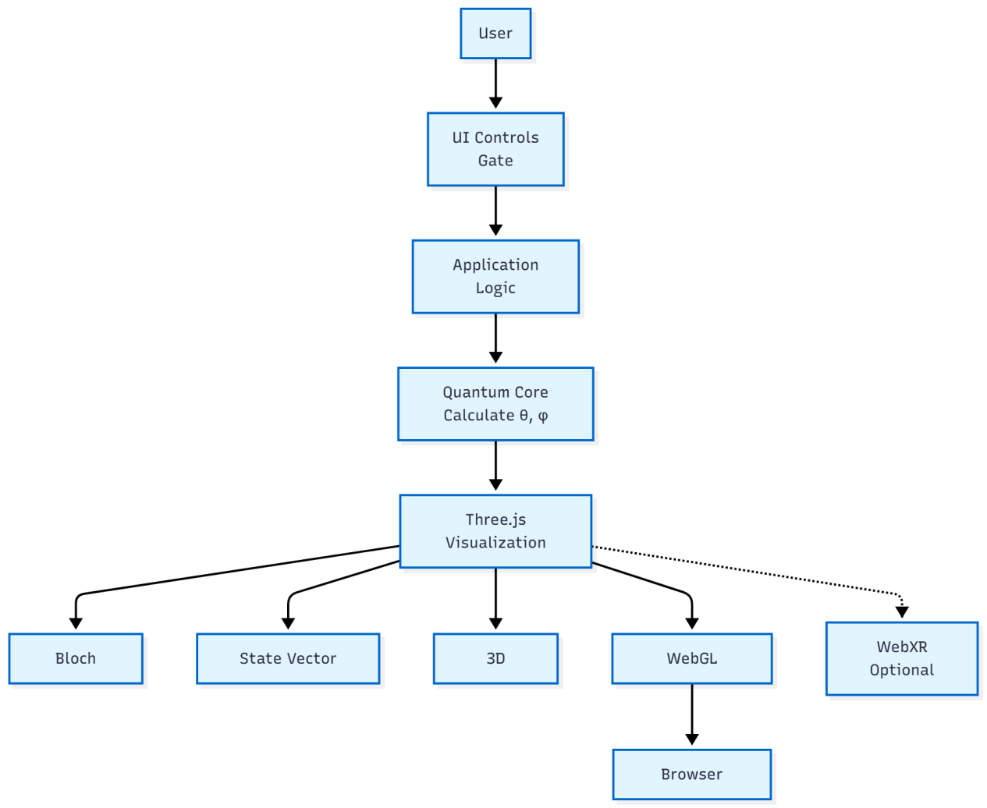

Fig 3.1 System Architecture

**Figure 3.1** describes the system architecture of QVerse, a client-side quantum visualization platform. The diagram illustrates a linear flow starting from user interaction through UI controls (gate buttons), which trigger the application logic layer containing event handlers. These handlers communicate with the Quantum Core, responsible for calculating the qubit's state angles (θ and φ) based on the applied quantum gate operations.

The calculated state parameters are then passed to the Three.js visualization engine, which serves as the rendering backbone of the system. Three.js manages three primary visual components: the Bloch Sphere (representing the quantum state space), the State Vector Arrow (indicating the current qubit position), and 3D Controls for user navigation. The visualization engine utilizes a WebGL Renderer to output the 3D scene to the browser display in real-time. Additionally, the architecture includes optional WebXR integration, enabling immersive AR/VR experiences for users who wish to interact with quantum states in extended reality environments.

**3.2 Data Flow Diagram**

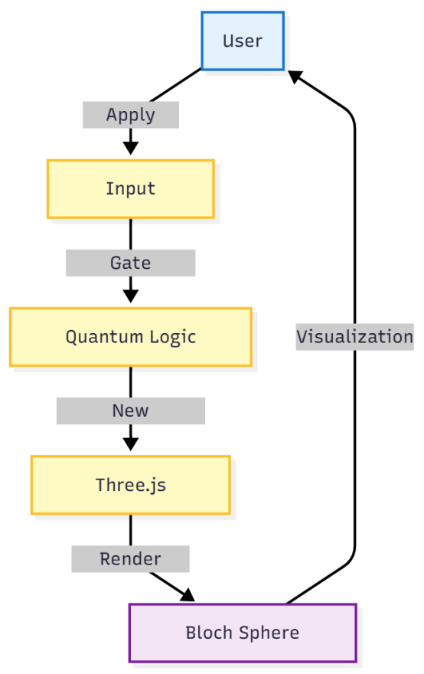

Fig 3.2 Data Flow Diagram

**Figure 3.2** describes the Level 1 Data Flow Diagram (DFD) for the QVerse quantum visualization system, illustrating the sequential flow of data through five key components. The diagram begins with the User, who initiates the process by applying a quantum gate operation. This action is captured by the Input Handler, which processes the user's command and forwards it to the Quantum Logic Module for computation.

The Quantum Logic Module performs the core quantum calculations, determining the new state coordinates (θ and φ angles) based on the applied gate transformation. These calculated coordinates are then passed to the Three.js Renderer, which updates the 3D scene accordingly. Finally, the Bloch Sphere Display renders the visual output, showing the qubit's rotation and phase change on the screen. The user views this visualization, completing the feedback loop. This cyclic process enables real-time, interactive exploration of quantum states, with each gate application triggering an immediate visual update of the qubit's position on the Bloch sphere.

**Chapter 4**

**Implementation**

The implementation of **Q-Verse** leverages modern web technologies to create an interactive, 3D visualization of qubits on a Bloch sphere. The project is designed to be accessible via any modern web browser, requiring no additional software installations.

**Technologies Used:**

**HTML/CSS**: Provides the basic structure of the web interface and styling of buttons, sliders, and information panels.

**JavaScript (ES6)**: Handles the logic for quantum state calculations, animations, and interactivity.

**Three.js**: A WebGL-based library used for rendering 3D objects, such as the Bloch sphere and qubit vectors.

**OrbitControls**: Enables users to rotate, pan, and zoom the Bloch sphere for an intuitive view of qubit states.

**Core Components:**

**Initialization**: A scene is created along with a perspective camera, lighting sources, and a WebGL renderer. The renderer attaches to the HTML canvas to display the 3D graphics.