**LensKart**

**Overview:**

LensKart is an E-commerce website where we can find all types of eyeglasses which fits us.

**Pages:**

**Home Page**

**Sign In Page**

**Sign Up page**

**Details Page**

**Payment page**

**Home Page:**

Home page consists of a navbar, Carousel showing some advertisements, Items section and a footer **.**

**Navbar:**



**Carousel:**



**Items section:**

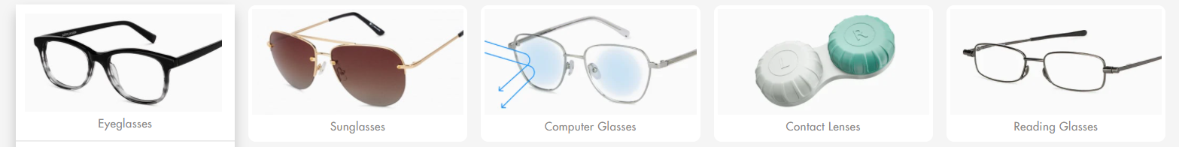

**Footer:**

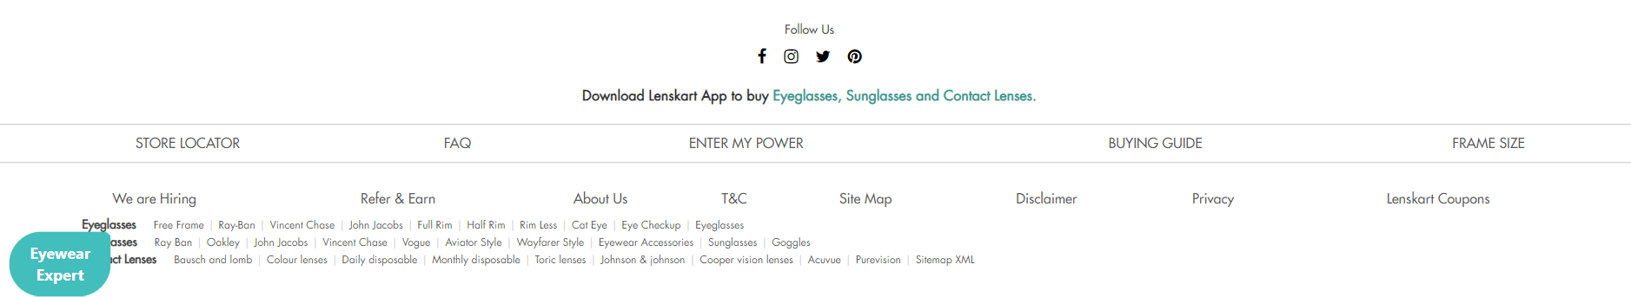

**Sign In page:**

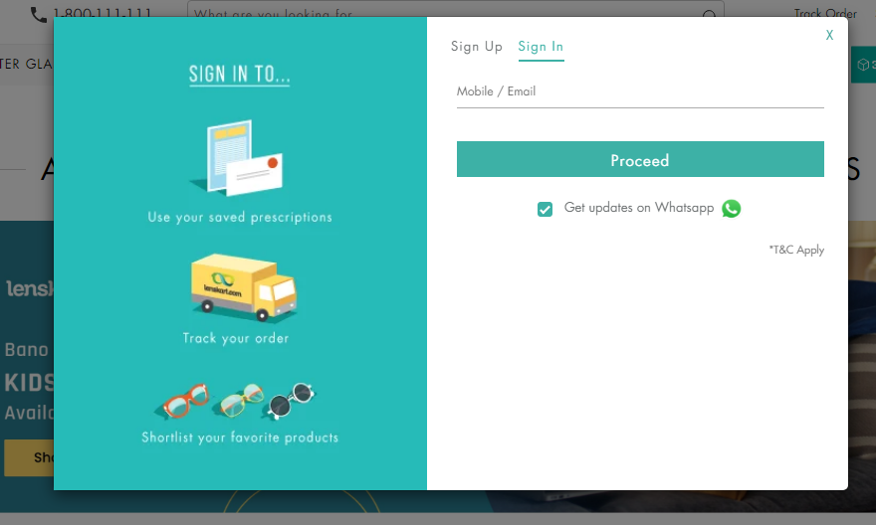

**Sign Up page:**

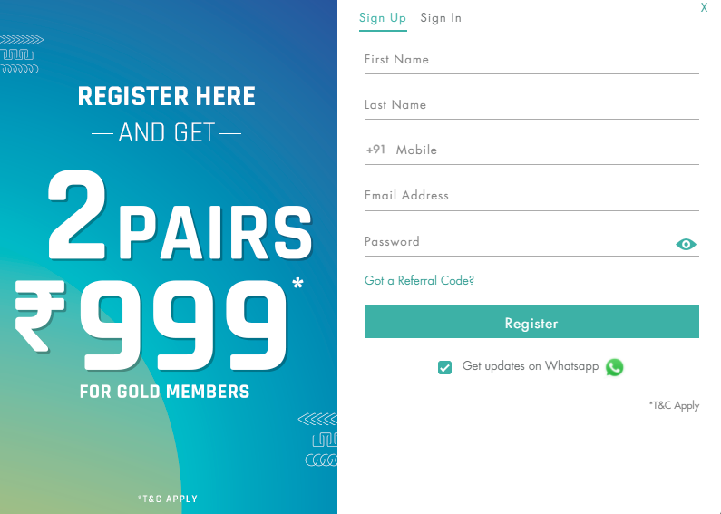

**Details Page:**

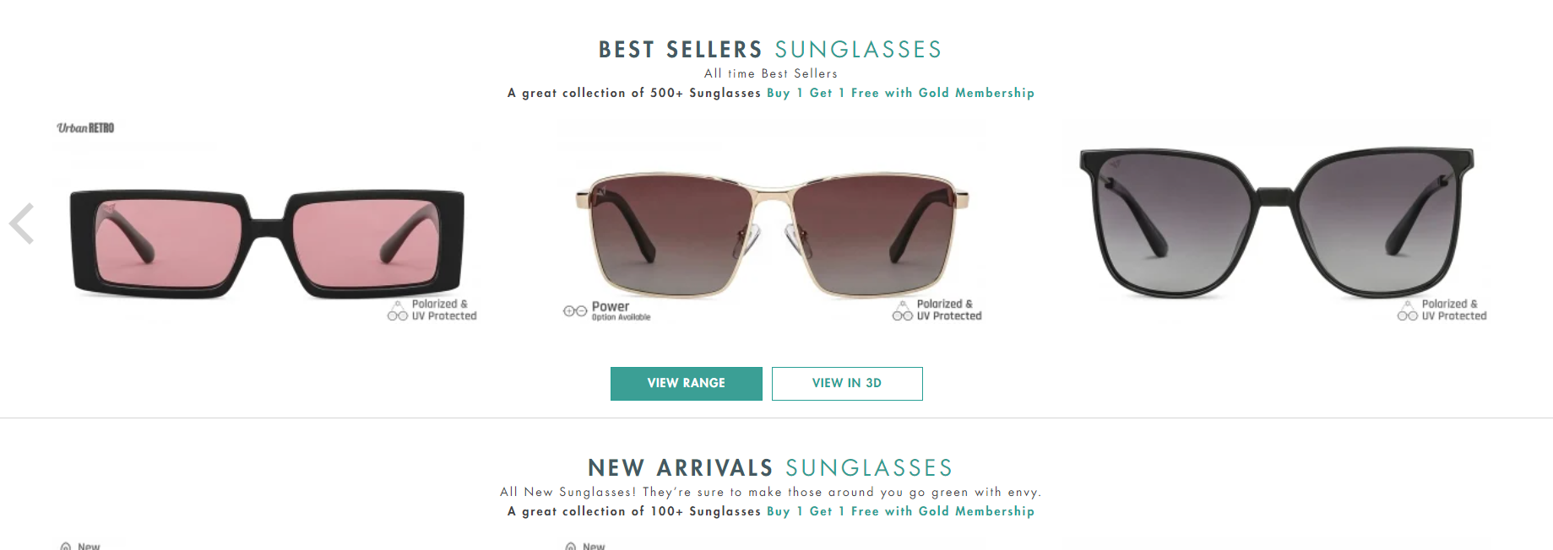

**Payment Page:**

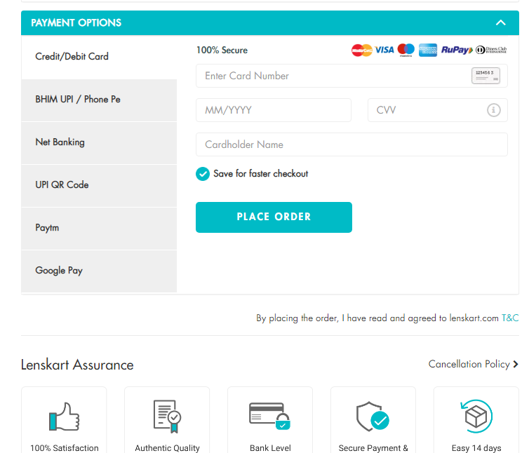

**Reference site:**

**https://www.lenskart.com**

**By**

**Golla Nischala |Edureka Intern**