**Bootstrap Interview Questions**

### What is a breadcrumb in Bootstrap?

Breadcrumbs are a wonderful way to display a site's hierarchy-based information. Breadcrumbs can show the dates of publication, categories, and tags in the case of blogs. They show where the current page is in the navigational hierarchy.

In Bootstrap, a breadcrumb is essentially an unordered list with the class .breadcrumb. CSS adds the separator for you automatically.

### How can you use Bootstrap to make thumbnails?

To make thumbnails with Bootstrap, go through the steps below:

Wrap an image in an <a> tag with the class .thumbnail. It will add a grey border and four pixels of padding. An animated light will now outline the image when it has hovered over.

### In Bootstrap, what are the two codes for displaying code?

In Bootstrap, there are two straightforward ways to display code:

* The <code> element is used to showcase a piece of inline code.
* You can use the <pre> tag to display a code that has multiple lines or even a block element

### What is a lead?

Lead adds some emphasis to a paragraph. The .lead class is used to achieve this and it makes the font larger, taller, and lighter in weight.

<p class= "lead" > Paragraph </p>

### In Bootstrap 4, what is flexbox?

Flexbox is a layout module for flexible boxes. Without using float or positioning, you can quickly create a flexible layout design with flexbox.

### What contextual classes can be used to style the panels?

To make a panel more meaningful to a specific context, use contextual state classes like panel-primary, panel-success, panel-info, panel-warning, and panel-danger

### What are the two types of spinners that you can create using Bootstrap?

Use the .spinner-border class to make a spinner/loader.

<div class= "spinner-border" ></div>

If you want the spinner/loader to grow instead of "spin", use the .spinner-grow class.

<div class= "spinner-grow" ></div>

### Write the HTML code to create a basic toast.

When something happens, the toast component acts as an alert box that only appears for a few seconds (i.e. when the user clicks on a button, submits a form, etc.).

<div class= "toast" >

<div class= "toast-header" >

Toast Header

</div>

<div class="toast-body">

Toast Body Text

</div>

</div>

### What is the media object in Bootstrap and what are their types?

Bootstrap's media objects allow you to position media objects such as images, videos, and audio to the left or right of content blocks. Media elements can be constructed using the class .media and the source is specified by using the class .media-object. There are two types of media objects:

* .media
* .media-list

### What do you mean by the Bootstrap well?

The Bootstrap well is simply a container that makes the content appear sunken. It can also produce an inset effect on the webpage. With the aid of <div> and class, a developer may create a well and also wrap the content in the well. The content will be displayed according to your preferences

### What are glyphicons?

Glyphicons are icon fonts that you can use on your website. Their developer has made them freely available for Bootstrap projects.

To utilize the icons, simply copy and paste the following code anywhere in your code. To ensure adequate padding, leave a space between the icon and the text.

<span class = "glyphicon glyphicon-search" ></span>

### What is bootstrap pagination and how are they classified?

If your website has lots of pages, you might require adding some sort of pagination to each page.

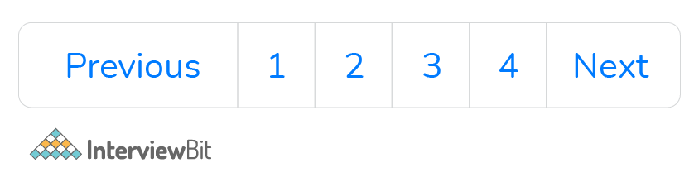

<ul class="pagination">

<li class="page-item"><a class="page-link" href="#">Previous</a></li>

<li class="page-item"><a class="page-link" href="#">1</a></li>

<li class="page-item"><a class="page-link" href="#">2</a></li>

<li class="page-item"><a class="page-link" href="#">3</a></li>

<li class="page-item"><a class="page-link" href="#">4</a></li>

<li class="page-item"><a class="page-link" href="#">Next</a></li>

</ul>

Pagination is how Bootstrap handles an unordered list. The following classes are provided by bootstrap to manage pagination:

**.pagination**: This class is required to enable pagination on your page.

**.disabled, .active**: Use .disabled for unclickable links and .active to indicate the current page when customising links.

**.pagination-Ig and .pagination-sm**: use these to get different size items