CSS Interview Questions

1. What is the best way to include CSS Styling in HTML?

There are three methods for incorporating [CSS into HTML](https://www.simplilearn.com/tutorials/html-tutorial/link-css-files-to-html):

* You use inline [CSS](https://www.simplilearn.com/11-css-secrets-rar400-article) when only a single element needs to be styled or when a little quantity of styling is required.
* External Style Sheet: When a style is applied to many elements or HTML pages, it employs an external style sheet.
* Internal Style Sheet: An internal style sheet is employed when a single HTML document has a distinct style and numerous elements.

# Top 50 Frontend Developer Interview Questions and Answers

Lesson 9 of 15[By Simplilearn](https://www.simplilearn.com/authors/simplilearn)

Last updated on Nov 2, 2021134571

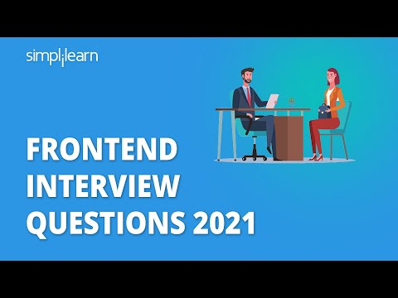

[Previous](https://www.simplilearn.com/tutorials/programming-tutorial/best-front-end-programming-languages)[Next](https://www.simplilearn.com/tutorials/programming-tutorial/typescript-generics)

## Table of Contents

[Git Interview Questions](https://www.simplilearn.com/tutorials/programming-tutorial/front-end-developer-interview-questions#git_interview_questions)

[HTML Interview Questions](https://www.simplilearn.com/tutorials/programming-tutorial/front-end-developer-interview-questions#html_interview_questions)

[CSS Interview Questions](https://www.simplilearn.com/tutorials/programming-tutorial/front-end-developer-interview-questions#css_interview_questions)

[JavaScript Interview Questions](https://www.simplilearn.com/tutorials/programming-tutorial/front-end-developer-interview-questions#javascript_interview_questions)

[ReactJS Interview Questions](https://www.simplilearn.com/tutorials/programming-tutorial/front-end-developer-interview-questions#reactjs_interview_questions)

View More

[Frontend Developers](https://www.simplilearn.com/how-to-become-a-front-end-developer-article) are in demand today. A lot of companies are readily hiring them with attractive salary packages. If you believe you possess the skills to become a frontend developer and wish to make a career in it, then you’re in the right place. This tutorial on Frontend Developer Interview Questions will help you crack your next interview. This Frontend Developer Interview Questions tutorial has put together questions on various languages and frameworks used for frontend development.

## Git Interview Questions

### 1. What is ‘Version Control System’?

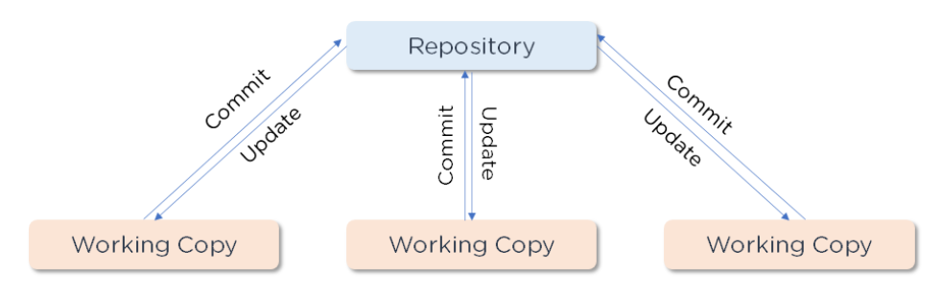

A [version control system](https://www.simplilearn.com/tutorials/devops-tutorial/version-control) (VCS) is a program that records any changes to a file or set of data so that it is possible to restore it to a previous version if necessary. This guarantees that everyone on the team is working on the most up-to-date version of the file.

#### Full Stack Java Developer Course

In Partnership with HIRIST and HackerEarth[EXPLORE COURSE](https://www.simplilearn.com/java-full-stack-developer-certification-training-course?source=GhPreviewCTABanner)

Full Stack Java Developer Course

### 2. Differentiate Between Centralized and Distributed Version Control System

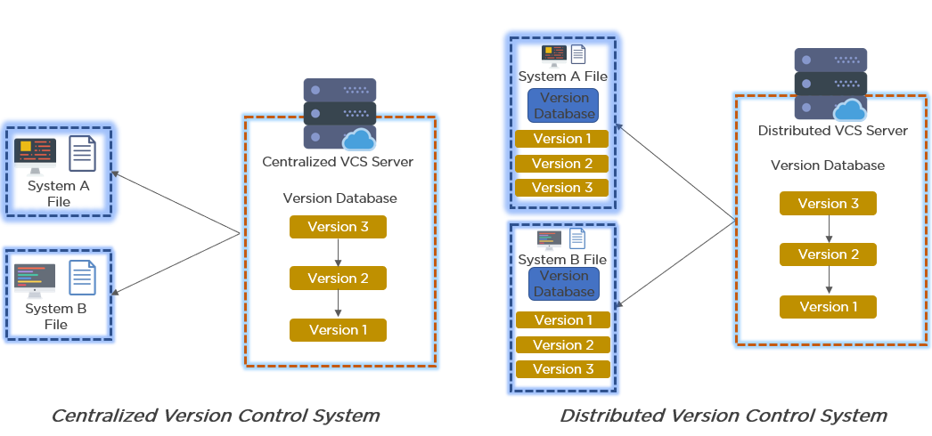

In a Centralized Version Control System:

* It stores all file versions on a central server.
* No developer has a complete copy of the local system's files.
* If the project's central server fails, you will lose all the project's data.

In a Distributed Version Control System:

* Every developer has a copy of all the code versions on their computer.
* Improves the ability to work offline and eliminates the need for a single backup location.
* Even if the server crashes, there is no danger.

### 3. Explain Git Push and Git Pull

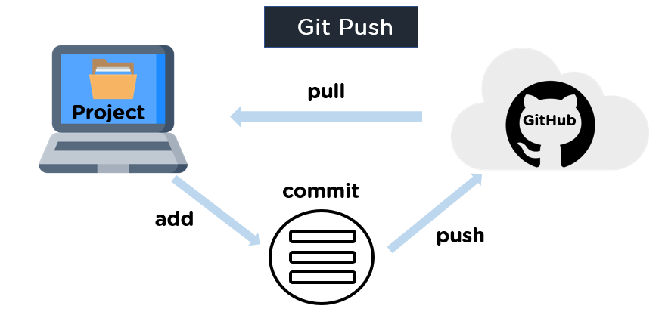

[Git push](https://www.simplilearn.com/tutorials/git-tutorial/git-push-command) is a command that pushes the contents of a local repository to a remote repository. It runs a push after it has changed a local repository to share the changes with remote team members.

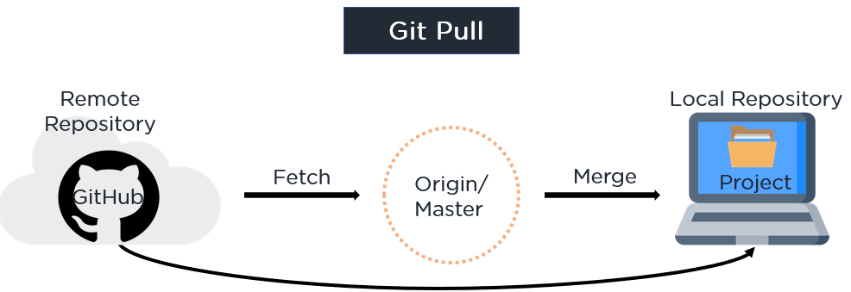

[Git pull](https://www.simplilearn.com/tutorials/git-tutorial/git-pull-request) is a command that pulls changes from a remote repository and merges them into the local repository. It's made up of two commands: git fetch followed by git merge.

### 4. Name a few Git Commands and function

* Git Config - Configure the username and email address
* Git init - Initialize a local Git repository
* Git Add - Add one or more files to the staging area
* Git Diff - View the changes made to the file
* Git Commit - Commit changes to the head but not to the remote repository
* Git reset - Undo local changes to the state of a Git repo
* Git Status - Displays the state of the working directory and staging area
* Git Merge - Merge a branch into an active branch
* Git Push - Upload content from the local repository to a remote repository
* Git Pull - Fetch and download content from a remote repository

### 5. Explain the Difference Between Git Pull and Git Fetch

#### Git Fetch

* It downloads only new data from a remote repository using Git fetch
* It does not include any of this new information in your working files
* To update the remote-tracking branches, run Git fetch at any time
* Command - git fetch origin

              git fetch –-all

#### Git Pull

* Git pulls new data and integrates it with the current working files, updating the current HEAD branch with the latest modifications from the remote server
* It attempts to combine remote modifications with those made locally
* Command - git pull origin master

#### FREE GIT Training

Learn the basics of GIT[ENROLL NOW](https://www.simplilearn.com/learn-git-basics-skillup?utm_source=frs&utm_medium=skillup-course-banner&utm_campaign=frs-tutorial-skillup-course-promotion)

FREE GIT Training

### 6. What is a Merge Conflict in Git and how can it be resolved?

When you have merging branches with opposing commits, a [merge conflict](https://www.simplilearn.com/tutorials/git-tutorial/merge-conflicts-in-git) occurs, and Git needs your help to select which changes to include in the final merge.

#### Resolve using GitHub conflict editor

When competing for line changes, i.e. when users make different modifications to the same line of the same file on different branches in your Git repository, this is done to avoid merging conflicts.

Step 1: Under your repository name, click Pull requests.

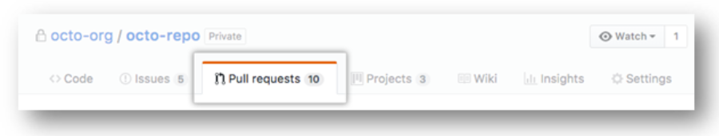

Step 2: Click the pull request with the merge conflict you'd like to resolve in the "Pull Requests" list. Click Resolve conflicts near the bottom of your pull request.

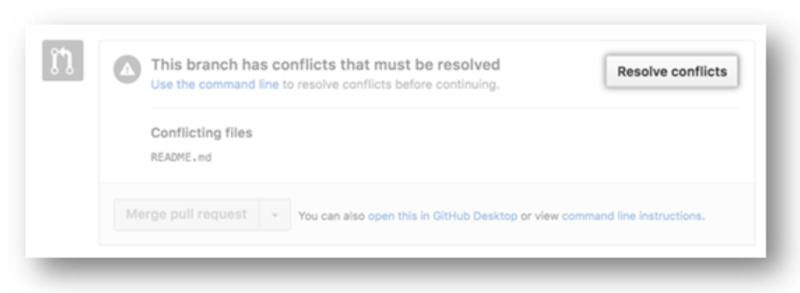

Step 3: Decide whether you want to maintain just your branch's changes, only the other branch's changes, or make a completely new modification that includes both branches' changes.

Step 4: Delete the conflict markers and make the changes you want in the final merge.

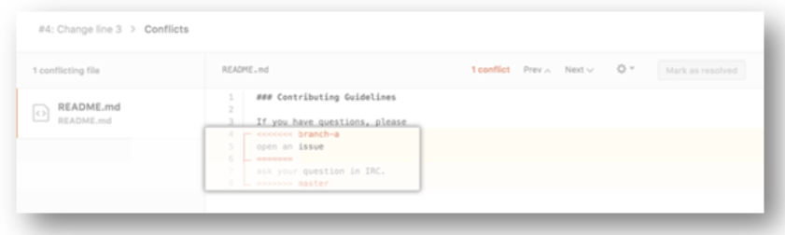

Step 5: If your file has over one merge conflict, scroll down to the next set of conflict markers and repeat steps four and five to resolve the issue. Mark the file as resolved once you've resolved all the conflicts.

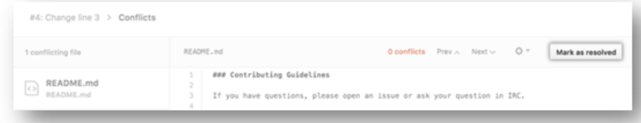

Step 6: If you have more than one file with a conflict, go to the left side of the screen and select the next file you wish to edit under "conflicting files". Then repeat the above steps until you've resolved all the merge conflicts in your pull request.

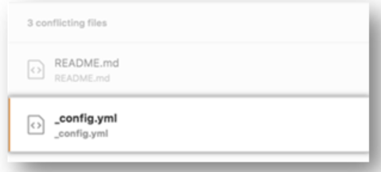

Step 7: Click Commit merge once you've resolved all of your merge conflicts. It merges the entire base branch into your head branch as a result of this. Click Merge pull request to combine your pull requests.

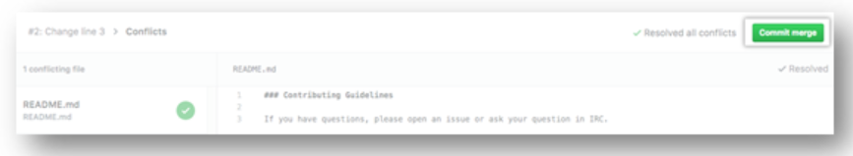

Resolve the issue with a local clone of the repository and commit the update to your GitHub branch.

It resolves all other forms of merge conflicts using this method. To push the update, you can use the command line or a program like GitHub desktop.

Step1: Open Git Bash. Go to the local Git repository where the merge conflict exists.

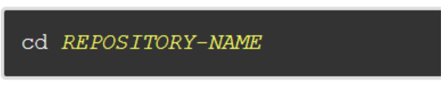

Step2: Make a list of the files that have been affected by the merge dispute. In this case, there is a merge conflict in the file styleguide.md.

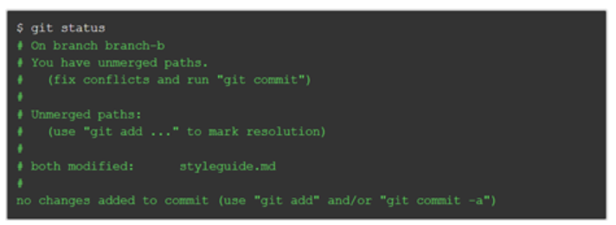

Step 3: Navigate to the file with merge conflicts in any text editor, such as Sublime Text or Atom. Look for the conflict marker "<<<<<<" if you want to see where the merging conflict started in your file.

After the line "<<<<<<HEAD", you'll see the changes from the base branch.

Step 4: Next you’ll see =======, which divides your changes from the changes in the other branch, followed by >>>>>>> BRANCH-NAME

Step 5: Decide whether you want to simplt maintain your branch's changes, only the other branch's changes, or make a completely new modification that includes both branches' changes.

Step 6: Delete the conflict markers, <<<<<, =====, >>>>> and make changes you want in the final merge.

Step 7: Add or stage your changes. Commit your changes with a comment.

You may now combine the branches using the command line, or you can upload your changes to your [GitHub](https://www.simplilearn.com/tutorials/git-tutorial/what-is-github) remote repository and merge them in a pull request.

### 7. What is Git Stash?

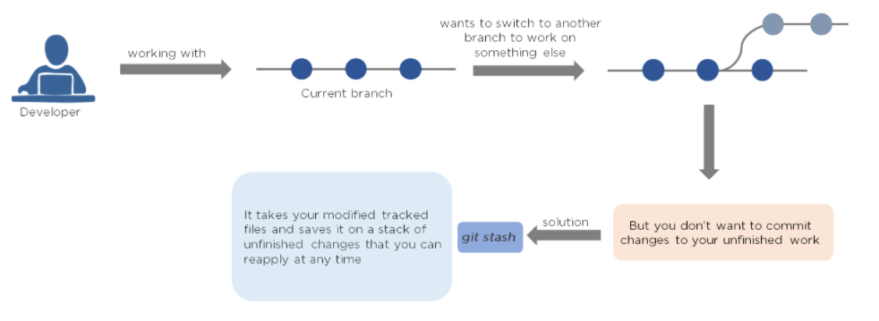

#### FREE Java Certification Training

Learn A-Z of Java like never before[ENROLL NOW](https://www.simplilearn.com/learn-java-basics-skillup?utm_source=frs&utm_medium=skillup-course-banner&utm_campaign=frs-tutorial-skillup-course-promotion)

FREE Java Certification Training

### 8. Differentiate Between Git Merge and Git Rebase

Assume you're working on a new feature in a dedicated branch, and another team member pushes new commits to the master branch.

#### Merge

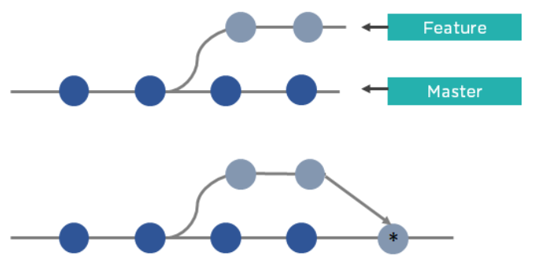

Merge is used to incorporate new commits into your feature branch. Every time you need to include modifications, this requires an extra merging commit. It taints the history of your feature branch.

#### Rebase

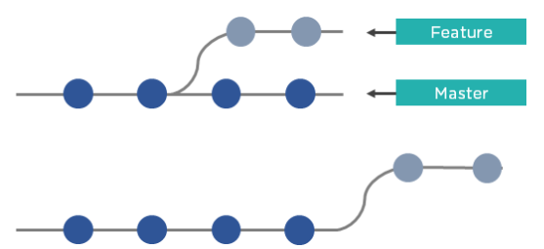

You can rebase the feature branch into master instead of merging it. This incorporates all the new commits in the master branch. It also re-writes the project history by creating brand new commits for each commit in the original branch.

This brings us to the end of Git Questions. These are some of the most important Front End Interview Questions related to Version Control.

## HTML Interview Questions

[HTML](https://www.simplilearn.com/tutorials/html-tutorial/what-is-html) is an integral part of Frontend Development. The following set of Frontend Developer Interview Questions are based on HTML.

### 1. What Is an Attribute in HTML?

<h1>Hello</h1>

<p>Welcome</p>

<br>

<h2>Click on the button to subscribe</h2>

<button>Subscribe</button>

* Attributes are the properties that can be added to an [HTML tag](https://www.simplilearn.com/tutorials/html-tutorial/html-tags) that change the way the tag behaves or is displayed.
* It adds attributes right after the name of the HTML tag, inside the brackets.

### 2. What is Marquee in HTML?

* The marquee is used to scroll the text on the webpage.
* It automatically scrolls the image or text up, down, left, or right.
* You must use <marquee> tags to apply for a marquee.

### 3. What is Semantic HTML? and how does it work?

* Semantic HTML is a type of coding.
* It is the use of HTML markup to emphasize the content's semantics or meaning.
* Consider the following scenario: The <b></b> tag is not used for bold statements in semantic HTML, while the <i></i> element is used for italic.
* Instead, you use the <em></em> and <strong></strong> tags.

### 4. How do you Display a Table on an HTML Webpage?

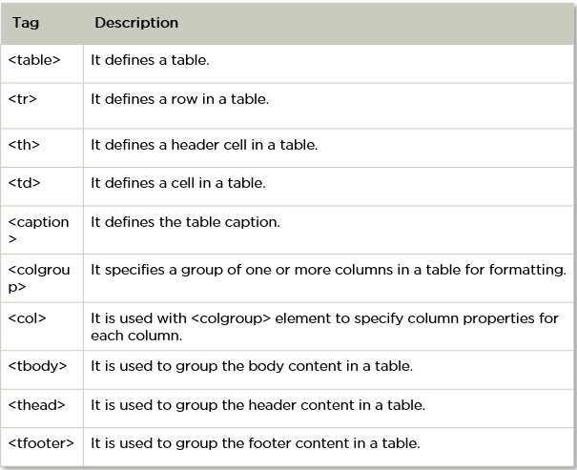

* To display data in a tabular format, use the HTML table> tag.
* It's also utilized to control the page's layout, such as the header section, navigation bar, body content, and footer section.

#### Free Course: Java Hibernate Fundamentals

Learn Java Hibernate Basic Skills for Free[ENROLL NOW](https://www.simplilearn.com/learn-java-hibernate-basics-skillup?utm_source=frs&utm_medium=skillup-course-banner&utm_campaign=frs-tutorial-skillup-course-promotion)

Free Course: Java Hibernate Fundamentals

### 5. What is SVG in HTML?

<svg width="100" height="100">

      <circle cx="50" cy="50" r="40" stroke="yellow" stroke-width="4" fill="red" />

    </svg>

* HTML SVG is a markup language that describes vector and raster graphics. XML text files define SVG pictures and associated behaviors.
* It's typically used for X, Y coordinate system diagrams like pie charts and 2-Dimensional graphs.

### 6. In HTML, how do you separate a section of text?

In HTML, you use the following tags to divide a chunk of text:

<br> tag–It's a character that's used to break up a line of text. It transfers the text flow to a new line by breaking the existing line.

<p> tag–This tag is used to create a text paragraph.

<blockquote> This tag is used to indicate big quoted passages.

### 7. How do you Create Nested Web Pages in HTML?

<!DOCTYPE html>

    <html>

      <body>

        <h2>HTML Iframes example</h2>

        <p>

          specify the size of the iframe using the height and width attributes:

        </p>

        <iframe src="https://simplilearn.com/" height="600" width="800"></iframe>

      </body>

    </html>

* You refer a webpage within a webpage to as a nested web page.
* Using HTML's built-in iframe tag, you can create nested web pages.

### 8. Differentiate Between Ordered List and Unordered List

<!DOCTYPE html>

    <html>

      <body>

        <h2>HTML List Example</h2>

        <ul>

          <li>Coffee</li>

          <li>Tea</li>

          <li>Milk</li>

        </ul>

        <ol>

          <li>Coffee</li>

          <li>Tea</li>

          <li>Milk</li>

        </ol>

      </body>

    </html>

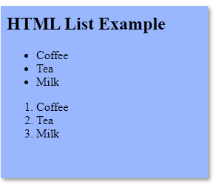

* An unordered list uses <ul> </ul> tags and each element of the list is written between <li> </li> tags.
* An ordered list uses <ol> </ol> tags and each element of the list is written between <li> </li> tags.

Now that we are familiar with HTML questions, let’s look at the next set of Frontend Developer Interview Questions, CSS

## CSS Interview Questions

### 1. What is the best way to include CSS Styling in HTML?

There are three methods for incorporating [CSS into HTML](https://www.simplilearn.com/tutorials/html-tutorial/link-css-files-to-html):

* You use inline [CSS](https://www.simplilearn.com/11-css-secrets-rar400-article) when only a single element needs to be styled or when a little quantity of styling is required.
* External Style Sheet: When a style is applied to many elements or HTML pages, it employs an external style sheet.
* Internal Style Sheet: An internal style sheet is employed when a single HTML document has a distinct style and numerous elements.

#### Post Graduate Program: Full Stack Web Development

in Collaboration with Caltech CTME[ENROLL NOW](https://www.simplilearn.com/pgp-full-stack-web-development-certification-training-course?source=GhPreviewCTABanner)

Post Graduate Program: Full Stack Web Development

### 2. Mention the different types of CSS Selectors

//Universal Selector

* {

        color: "green";

        font-size: 20px;

        line-height: 25px;

      }

//Element type Selector

ul {

    line-style: none;

    border: solid 1px #ccc;

  }

// ID Selector

#container {

    width: 960px;

    margin: 0 auto;

  }

  <div id="container"></div>

//Class Selector

 .box {

    padding: 10px;

    margin: 10px;

    width: 240px;

  }

  <div class="box"></div>

//Descendent Combinator

 #container .box {

    float: left;

    padding-bottom: 15px;

}

<div id="container">

    <div class="box"></div>

    <div class="box-2"></div>

</div>

<div class=”box”></div>

//Child Combinator

 #container> .box {

    float: left;

    padding-bottom: 15px;

}

<div id="container">

    <div class="box"></div>

    <div>

        <div class="box"></div>

    </div>

</div>

// General Sibling Combinator

h2 ~ p {

    margin-bottom: 20px;

}

<h2>Title</h2>

<p>Paragraph example.</p>

<div class=”box”>

    <p>Paragraph example.</p>

</div>

//Attribute Selector

input [type=”text”] {

    background-color: #444;

    width: 200px;

}

<input type="text">

### 3. What are Sass, Less, and Stylus?

Sass - Sass is the acronym for “Syntactically Awesome Style Sheets”. A ‘$’ sign commonly precedes it.

$font-color: #fff

        $bg-color: #00f         
#box

          color: $font-color

          background: $bg-color

Less - LESS is an acronym for “Leaner Stylesheets”. Less uses ‘@’ to define the variables.

@font-color: #fff;

          @bg-color: #00f

          #box{

            color: @font-color;

            background: @bg-color;

          }

Stylus - Stylus offers a great deal of flexibility in writing syntax. It doesn’t use @ or $ for defining variables.

font-color= #fff;

        bg-color = #00f;      
#box {

          color: font-color;

          background: bg-color; }

### 4. Explain Box Sizing Property

Box Sizing property defines how the height and width of a box are calculated.

Content Box - The default width and height apply only to the element’s content. Padding and border are added outside the box.

Padding Box - You add the dimensions to both element’s content and padding. It adds the border outside the box.

Border Box - The dimensions are added to the content, padding, and border.

### 5. What are the different ways to hide an Element using CSS?

display: none

Hides the content and doesn’t store it in the DOM

visibility: hidden

It adds the element to the DOM and takes up space. However, it is not visible to the user

position: absolute

You can make the element appear outside the screen

6. What does ‘Important’ in CSS mean?

The ‘important’ keyword indicates the highest precedence, and it overrides the cascaded property.

p {

                color:blue !important;

            }

            #thing {

                color: green;

            }

<p id="thing">Will be BLUE.</p>

7. What are CSS Sprites?

* Since each image sends out an HTTP request separately, a web page with a high number of photos takes longer to load.
* CSS sprites are used to minimize the loading time of a web page by combining multiple small pictures into a single image.
* It decreases the number of HTTP requests and, as a result, the time it takes for pages to load.

8. Which Property is used to Underline, Strikethrough, and Overline Text?



text-style

Text-type

text-decoration

Text-transform