**Introduction to Telecommunication**

Today vast amounts of information are communicated using radio communications systems. In order that a steady radio signal or "radio carrier" can carry information it must be changed or modulated in one way so that the information can be conveyed from one place to another.

There are very many ways in which a radio carrier can be modulated to carry a signal, each having its own advantages and disadvantages. The choice of modulation has a great impact on the radio communications system. Some forms are better suited to one kind of traffic whereas other forms of modulation will be more applicable in other instances. Choosing the correct form of modulation is a key decision in any radio communications system design.

**Basic types of Analog modulation:**

**Amplitude modulation (AM):**

This form of modulation involves modulating the amplitude or intensity of the signal. Amplitude modulation was the first form of modulation to be used to broadcast sound, and although other forms of modulation are being increasingly used, amplitude modulation is still in widespread use.

| **Advantages** | **Disadvantage** |
| --- | --- |
| * It is simple to implement * It can be demodulated using a circuit consisting of very few components * AM receivers are very cheap as no specialized components are needed. | * An amplitude modulation signal is not efficient in terms of its power usage * It is not efficient in terms of its use of bandwidth, requiring a bandwidth equal to twice that of the highest audio frequency * An amplitude modulation signal is prone to high levels of noise because most noise is amplitude based and obviously AM detectors are sensitive to it. |

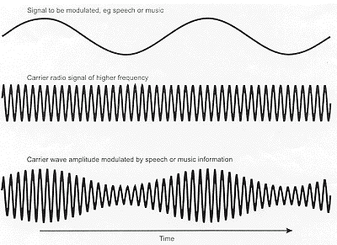

**Frequency modulation (FM)**:

This form of modulation varies the frequency in line with the modulating signal. Frequency modulation has the advantage that, as amplitude variations do not carry any information on the signal, it can be limited within the receiver to remove signal strength variations and noise. As a result is form of modulation has been used for many applications including high quality analogue sound broadcasting.

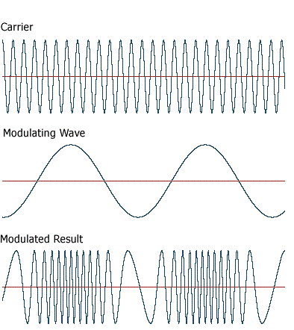

**Phase modulation (PM):**

As the name indicates, phase modulation varies the phase of the carrier in line with the modulating signal. Phase modulation and frequency modulation have many similarities and are linked - one is the differential of the other. However phase modulation lends itself to data transmissions and as a result its use has grown rapidly over recent years.

In addition to the three main basic forms of modulation or modulation techniques, there are many variants of each type. Again these modulation techniques are used in a variety of applications, some for analogue applications, and others for digital applications.

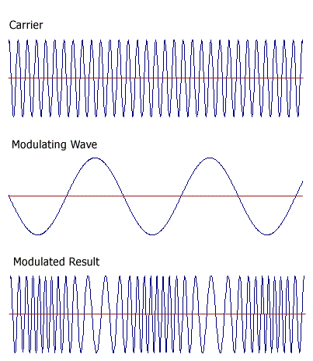

Fig: Phase Modulation

**Digital modulation**

|  |
| --- |
| In digital modulation, an analog carrier signal is modulated by a digital bit stream.  There are three major classes of digital modulation techniques used for transmission of digitally represented data:   * Phase-shift keying (PSK) * Frequency-shift keying (FSK) * Amplitude-shift keying (ASK)   **Phase-shift keying (PSK)** is a digital modulation scheme that conveys data by changing, or modulating, the phase of a reference signal (the carrier wave). PSK uses a finite number of phases; each assigned a unique pattern of binary bits. Usually, each phase encodes an equal number of bits. Each pattern of bits forms the symbol that is represented by the particular phase.  **Frequency-shift keying (FSK)** is a frequency modulation scheme in which digital information is transmitted through discrete frequency changes of a carrier wave. The simplest FSK is binary FSK (BFSK). BFSK literally implies using a couple of discrete frequencies to transmit binary (0s and 1s) information. With this scheme, the "1" is called the mark frequency and the "0" is called the space frequency. The time domain of an FSK modulated carrier is illustrated in the figures to the right.  **Amplitude-shift keying (ASK)** is a form of modulation that represents digital data as variations in the amplitude of a carrier wave. The amplitude of an analog carrier signal varies in accordance with the bit stream (modulating signal), keeping frequency and phase constant. The level of amplitude can be used to represent binary logic 0s and 1s. We can think of a carrier signal as an ON or OFF switch. In the modulated signal, logic 0 is represented by the absence of a carrier, thus giving OFF/ON keying operation and hence the name given.  **MODEM**   Short for modulator-demodulator. A modem is a device or program that enables a computer to transmit data over, for example, telephone or cable lines. Computer information is stored digitally, whereas information transmitted over telephone lines is transmitted in the form of analog waves. A modem converts between these two forms.  **Bps**: Modems are measured in terms of baud rates. The slowest rate is 300 baud (about 25 cps). At higher speeds, modems are measured in terms of bits per second (bps). The fastest modems run at 57,600 bps, although they can achieve even higher data transfer rates by compressing the data. Obviously, the faster the transmission rate, the faster you can send and receive data.  **Voice/data**: Many modems support a switch to change between voice and data modes. In data mode, the modem acts like a regular modem. In voice mode, the modem acts like a regular telephone. Modems that support a voice/data switch have a built-in loudspeaker and microphone for voice communication.  **Auto-answer:** An auto-answer modem enables your computer to receive calls in your absence. This is only necessary if you are offering some type of computer service that people can call in to use.  **Data compression**: Some modems perform data compression, which enables them to send data at faster rates. However, the modem at the receiving end must be able to decompress the data using the same compression technique. |