Tribhuvan University
Faculty of Humanities and Social Sciences

A Project Report On
NEPAL360 – A CROWDFUNDING PLATFORM FOR NEPAL

Submitted to
Department of Computer Application Itahari Namuna College
In partial fulfillment of the requirements for the degree of Bachelors in Computer Application

Submitted By
Nischal Bhattarai (6-2-1152-49-2022)

Under the Supervision of
Chandra Acharya

Tribhuvan University
Faculty of Humanities and Social Sciences
Itahari Namuna College

SUPERVISOR’S RECOMMENDATION

I hereby recommend that this project prepared under my supervision by Nischal Bhattarai entitled “NEPAL360 – A CROWDFUNDING PLATFORM FOR NEPAL” in partial fulfillment of the requirements for the degree of Bachelor of Computer Application is thoroughly researched and well executed, demonstrating the student’s technical proficiency and understanding of the subject matter. I highly recommend it for the final evaluation.

Chandra Acharya
Project Supervisor
Itahari Namuna College
Itahari-8, Sunsari

Tribhuvan University
Faculty of Humanities and Social Sciences
Itahari Namuna College

LETTER OF APPROVAL

This is to certify that this project prepared by Nischal Bhattarai entitled “NEPAL360 – A CROWDFUNDING PLATFORM FOR NEPAL” in partial fulfillment of the requirements for the degree of Bachelor in Computer Application has been evaluated. In our opinion it is satisfactory in the scope and quality as a project for the required degree.

-------------------- --------------------
Chandra Acharya Nabin Shrestha
Supervisor HOD/Coordinator
Itahari Namuna College Itahari Namuna College

-------------------- --------------------
Internal Examiner External Examiner
Itahari Namuna College Tribhuwan University

ACKNOWLEDGEMENT

The success and final outcomes of this project requires a lot of guidance and assistance from many people and I am very fortunate to have this all through the completion of this project. I would like to express my gratitude and appreciation to all those who gave me the possibility to complete this project. I am very glad to express my deepest sense of gratitude and sincere thanks to my supervisor Mr. Chandra Acharya whose contribution in simulating suggestions and encouragement helped me in completing my project.
I am also thankful to Mr. Nabin Shrestha, HOD, Itahari Namuna College and Mr. Dharma Neupane, Principal, Itahari Namuna College for encouraging and guiding me throughout the completion of this project. All useful suggestions for this whole work and co-operative behavior are sincerely acknowledged.
Last but not the least, many thanks go to my teachers, friends, guardians who directly or indirectly helped me in achieving the goal. I would like to appreciate all the guidance and support which helped in the completion of this project. Special thanks to their comment and advice.

ABSTRACT

Nepal360 is a full-stack crowdfunding platform specifically designed for Nepal that enables users to create verified fundraising campaigns, donate money via Khalti payment gateway, pledge items, track impact, and compete on leaderboards. The platform enforces trust through mandatory KYC (Know Your Customer) verification and admin oversight, ensuring that only verified beneficiaries can create campaigns. The system supports both monetary and in-kind donations, recurring donation subscriptions, milestone-based fund releases, and generates PDF donation certificates for contributors.
Traditionally, crowdfunding in Nepal involves fragmented efforts through social media posts, personal requests, and unverified fundraising pages, which leads to a lack of transparency, trust issues, and difficulty in tracking donations. Many Nepali citizens and communities in need of financial support have no centralized, trustworthy platform to raise funds for education, health, disaster relief, and community projects. The absence of a structured system leads to difficulties in verifying campaign authenticity, managing donor contributions, and ensuring accountability.
Nepal360 offers a comprehensive solution by providing a centralized, verified, and gamified crowdfunding platform. It features campaign management with admin verification workflows, Khalti payment integration for secure transactions, AI-powered campaign success predictions, interactive maps showing campaigns across Nepal’s districts, donor leaderboards with badge rewards, multi-language support (English and Nepali), dark mode, social sharing capabilities, and a comprehensive admin dashboard with analytics. The system enhances transparency, minimizes fraud, and makes charitable giving more accessible and efficient in Nepal.
Keywords: Crowdfunding, Donation Management, KYC Verification, Khalti Payment, Campaign Management, Nepal

TABLE OF CONTENTS

SUPERVISOR’S RECOMMENDATION ii
LETTER OF APPROVAL iii
ACKNOWLEDGEMENT iv
ABSTRACT v
LIST OF FIGURES viii
LIST OF TABLES ix
LIST OF ABBREVIATIONS x
CHAPTER 1: INTRODUCTION 1
Introduction 1
Background and Significance 1
Problem Statement 2
Objectives 2
Scope and Limitation 3
Development Methodology 3
CHAPTER 2: LITERATURE REVIEW 5
Background Study 5
Literature Review 5
CHAPTER 3: SYSTEM ANALYSIS AND DESIGN 10
System Analysis 10
Requirement Analysis 10
Feasibility Analysis 12
Conceptual ER Diagram 13
Process Modelling (DFD) 14
System Design 16
Database Schema Diagram 16
Architectural Design 17
CHAPTER 4: IMPLEMENTATION AND TESTING 18
Implementation 18
Tools Used 18
Implementation Details of Modules 19
Testing 20
Test Cases for Unit Testing 20
CHAPTER 5: CONCLUSION AND FURTHER WORK 24
Conclusion 24
Lesson Learnt/Outcome 24
Future Plans 25
REFERENCES 26
APPENDICES

LIST OF FIGURES
Figure 1.1 Agile Model 4
Figure 2.1 GoFundMe 7
Figure 2.2 Ketto 8
Figure 2.3 GlobalGiving 8
Figure 2.4 Sahayogi Haat 9
Figure 3.1 Gantt Chart 12
Figure 3.2 Conceptual ER Diagram of Nepal360 13
Figure 3.3 Context Diagram of Nepal360 14
Figure 3.4 Level 1 DFD of Nepal360 15
Figure 3.5 Database Schema Diagram of Nepal360 16
Figure 3.6 Architectural Design of Nepal360 17

LIST OF TABLES
Table 4.1 Test Cases For Unit Testing 20
Table 4.2 Test Cases for System Testing 22

LIST OF ABBREVIATIONS

API | Application Programming Interface
AI | Artificial Intelligence
CORS | Cross-Origin Resource Sharing
CRUD | Create, Read, Update, Delete
CSS | Cascading Style Sheets
DBMS | Database Management System
DFD | Data Flow Diagram
ERD | Entity Relationship Diagram
HTML | HyperText Markup Language
HTTPS | HyperText Transfer Protocol Secure
i18n | Internationalization
JSON | JavaScript Object Notation
JS | JavaScript
JWT | JSON Web Token
KYC | Know Your Customer
ORM | Object-Relational Mapping
OTP | One-Time Password
PDF | Portable Document Format
RDBMS | Relational Database Management System
REST | Representational State Transfer
SQL | Structured Query Language
TCID | Test Case Identity
UI/UX | User Interface / User Experience
XSS | Cross-Site Scripting

CHAPTER 1: INTRODUCTION

Introduction
Nepal360 is a full-stack web-based crowdfunding platform developed specifically for Nepal that digitizes and simplifies the process of fundraising and charitable giving. The system provides a user-friendly interface that allows verified beneficiaries to create fundraising campaigns, donors to contribute through monetary donations via Khalti payment gateway or in-kind item pledges, and administrators to oversee campaign verification and platform integrity. The platform supports secure digital payments using the Khalti e-wallet, ensuring fast and cashless transactions. User authentication is implemented using JWT tokens with email OTP verification and Google OAuth social login. Role-based access control ensures data security and prevents unauthorized access. Features such as KYC verification, milestone-based fund releases, donor leaderboards, badge rewards, AI-powered campaign predictions, interactive campaign maps, multi-language support (English and Nepali), dark mode, and PDF donation certificates make the platform comprehensive and trustworthy. Overall, Nepal360 offers an efficient, secure, and reliable solution for crowdfunding operations in Nepal’s growing digital environment.

Background and Significance
In today’s digitally driven environment, the need for transparent and accessible crowdfunding platforms has become increasingly important, especially in developing countries like Nepal. With frequent natural disasters, limited access to healthcare and education in rural areas, and a growing entrepreneurial spirit among the youth, there is a significant demand for a centralized platform that connects those in need with willing donors. Currently, most fundraising efforts in Nepal are conducted through fragmented social media posts, personal networks, and unverified fundraising pages, which lack transparency and accountability.
Nepal360 addresses this critical need by providing a centralized, verified, and gamified crowdfunding platform tailored for the Nepali context. The system not only simplifies the donation process but also builds trust through mandatory KYC verification for campaign creators and admin oversight for campaign approval. The integration of Khalti, Nepal’s leading digital payment gateway, ensures secure and convenient cashless transactions. Features like donor leaderboards, badges, and impact tracking gamify the giving experience, encouraging more participation. As a result, Nepal360 serves as an efficient and practical solution for modern crowdfunding in Nepal, bridging the gap between those who need help and those who want to help.

Problem Statement
Nepal lacks a centralized, trustworthy digital platform for crowdfunding that ensures campaign authenticity, transparent fund management, and secure donation processing.
Most fundraising efforts in Nepal still rely on social media posts and personal requests, which makes it difficult to verify campaign legitimacy, track donations, and ensure that funds reach the intended beneficiaries.
The absence of a structured verification system leads to trust issues among potential donors, reducing the overall effectiveness of fundraising campaigns. Additionally, the lack of integrated digital payment solutions, donor recognition systems, and impact tracking mechanisms further hinders the growth of charitable giving in Nepal.
Manual or informal fundraising processes heavily depend on personal networks, increasing the risk of fraud, misuse of funds, and limited reach to potential donors beyond immediate social circles.

Objectives
To develop a centralized and verified crowdfunding platform for Nepal that enables transparent campaign creation, secure donation processing through Khalti, and comprehensive donor engagement through gamification features.
To implement a robust KYC verification system and admin oversight workflow that ensures campaign authenticity and builds donor trust, while providing secure digital payments and role-based access control.

Scope and Limitation

Scope
This system covers the complete crowdfunding lifecycle, including campaign creation with verification workflows, monetary donations via Khalti payment gateway, in-kind item donations with delivery tracking, and recurring donation subscriptions.
It supports a comprehensive KYC verification system where beneficiaries must submit identity documents, profile photos, and bank account details before creating campaigns. Admin verification ensures only legitimate campaigns go live on the platform.
The system includes gamification features such as donor leaderboards (monthly, yearly, campaign-specific), badge rewards, donor statistics tracking, and impact dashboards. Additional features include AI-powered campaign success predictions, interactive maps showing campaigns across Nepal’s districts, multi-language support (English and Nepali), dark mode, social sharing, comment sections, bookmarks, activity feeds, and PDF donation certificates.
The platform is designed as a web-based application with a responsive interface that improves fundraising efficiency by providing transparency, accountability, and convenience to all stakeholders.

Limitation
The system requires an internet connection to perform digital payments and access real-time donation updates and campaign information.
It currently supports only Khalti as a payment gateway, which may limit users who prefer other payment methods such as eSewa or bank transfers.
The AI prediction feature uses basic statistical analysis rather than advanced machine learning models, which may limit prediction accuracy for complex campaign scenarios.
Users need basic digital literacy to operate the platform efficiently, which may exclude some potential beneficiaries in remote areas of Nepal.

Development Methodology
The Agile methodology was adopted as the development approach for this project. Agile follows an iterative and incremental approach, where the project is divided into small manageable sprints, each delivering a working increment of the software. This methodology was chosen because the project requirements evolved over time as new features were identified, and the iterative nature of Agile allowed for continuous improvement and adaptation.

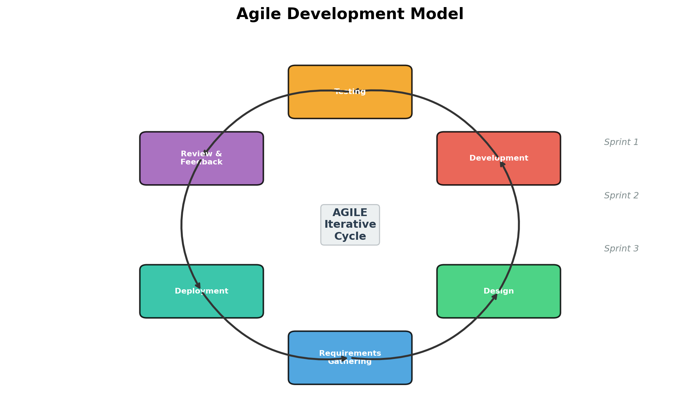
Figure 1.1 Agile Model
The development process started with requirement gathering and initial planning, where core features like campaign management, donations, and user authentication were identified. Development proceeded in iterative sprints: the first sprint focused on authentication and campaign CRUD operations; the second sprint added donation processing with Khalti integration; subsequent sprints introduced KYC verification, admin dashboard, leaderboards, AI predictions, maps, internationalization, dark mode, and other advanced features. Each sprint included testing and refinement based on feedback, ensuring continuous quality improvement throughout the development process.

CHAPTER 2: LITERATURE REVIEW

Background Study
In Nepal, charitable giving and fundraising have traditionally been conducted through personal networks, religious institutions, and community organizations. These methods, while effective at a local level, are often limited in reach and lack transparency in fund management. With the rapid growth of internet penetration and digital payment adoption in Nepal, there is a significant opportunity to modernize the fundraising landscape through technology.
While international crowdfunding platforms like GoFundMe and Kickstarter have revolutionized fundraising globally, they often do not cater to the specific needs of the Nepali market, such as local payment gateway integration, Nepali language support, and understanding of local regulatory requirements. A few Nepali platforms have emerged, but they often lack comprehensive features like KYC verification, gamification, and AI-powered recommendations.
Nepal360 aims to address these gaps by providing a comprehensive, Nepal-specific crowdfunding platform that combines trust-building mechanisms like KYC verification and admin oversight with modern features like AI predictions, gamification, and multi-language support. By integrating Khalti, Nepal’s leading digital payment gateway, the platform ensures accessible and secure donation processing for the Nepali population.

Literature Review
The global crowdfunding industry has experienced exponential growth over the past decade, transforming how individuals and organizations raise funds for various causes. Research by Mollick (2014) demonstrated that crowdfunding platforms have democratized access to capital, enabling anyone with a compelling cause to reach potential donors worldwide. The success of platforms like GoFundMe, which has facilitated billions of dollars in donations, underscores the viability and demand for online fundraising solutions [1].
Trust and transparency have been identified as the most critical factors influencing donor behavior on crowdfunding platforms. Studies by Gerber and Hui (2013) found that donors are significantly more likely to contribute when campaigns provide verifiable information about the beneficiary and transparent fund utilization [2]. Nepal360 addresses this through mandatory KYC verification, admin campaign approval workflows, milestone-based fund releases, and audit logging of all administrative actions.
The integration of gamification elements in charitable platforms has shown promising results in increasing donor engagement and retention. Research by Hamari et al. (2014) demonstrated that gamification features such as leaderboards, badges, and progress tracking can significantly enhance user motivation and participation [3]. Nepal360 capitalizes on this by implementing donor leaderboards (monthly, yearly, and campaign-specific), badge reward systems, donor statistics tracking, and impact dashboards that visualize a donor’s contribution history.
Mobile and digital payment adoption in Nepal has accelerated rapidly, with platforms like Khalti and eSewa becoming widely used for everyday transactions. According to Nepal Rastra Bank reports, digital payment transactions have grown significantly year over year [4]. Nepal360 leverages this trend by integrating Khalti as its primary payment gateway, enabling secure and convenient cashless donations.
However, crowdfunding platforms in developing countries face unique challenges. A study by Agrawal et al. (2015) highlighted issues such as low digital literacy, limited internet access in rural areas, and the need for localized solutions [5]. Nepal360 addresses some of these challenges through multi-language support (English and Nepali), an intuitive user interface, and district-based campaign mapping that helps donors find and support causes in their local communities.
In summary, while crowdfunding presents a significant opportunity for charitable giving in Nepal, platforms must address trust, transparency, localization, and user engagement challenges. Nepal360 incorporates evidence-based features including KYC verification, gamification, AI predictions, and local payment integration to create a comprehensive and trustworthy crowdfunding ecosystem for Nepal.

Existing System Overview

GoFundMe
GoFundMe is the world’s largest social fundraising platform, allowing individuals to create campaigns for personal causes, medical expenses, education, and emergencies. The platform has facilitated over $15 billion in donations since its inception. However, GoFundMe does not support Nepali payment gateways, lacks Nepali language support, and does not enforce KYC verification for campaign creators, which can lead to fraudulent campaigns. Additionally, the platform charges platform fees on donations, reducing the total amount received by beneficiaries [6].
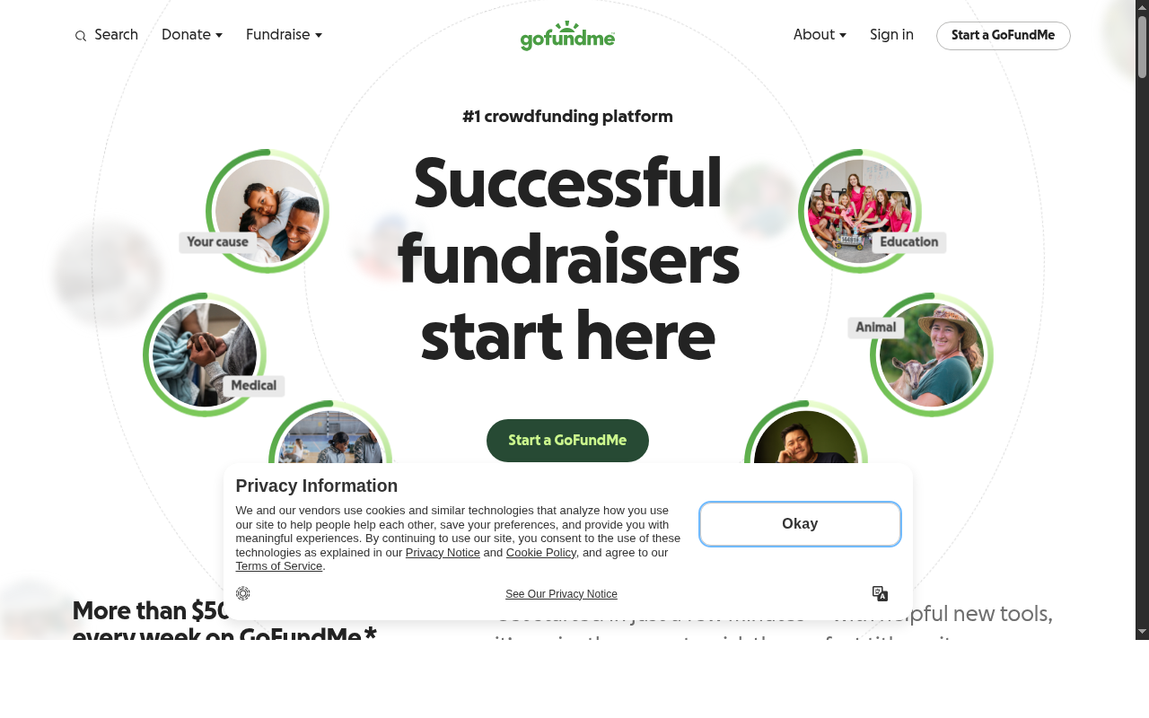
Figure 2.1 GoFundMe

Ketto
Ketto is one of Asia’s largest crowdfunding platforms, based in India. It supports fundraising for medical emergencies, education, disaster relief, and social causes. Ketto provides campaign verification and has partnered with hospitals for direct medical fund disbursement. However, Ketto primarily serves the Indian market with Indian payment gateways (UPI, Paytm), does not support Khalti or Nepali payment methods, and lacks features specific to Nepal’s geographical and cultural context. The platform also does not offer gamification features or AI-powered recommendations [7].
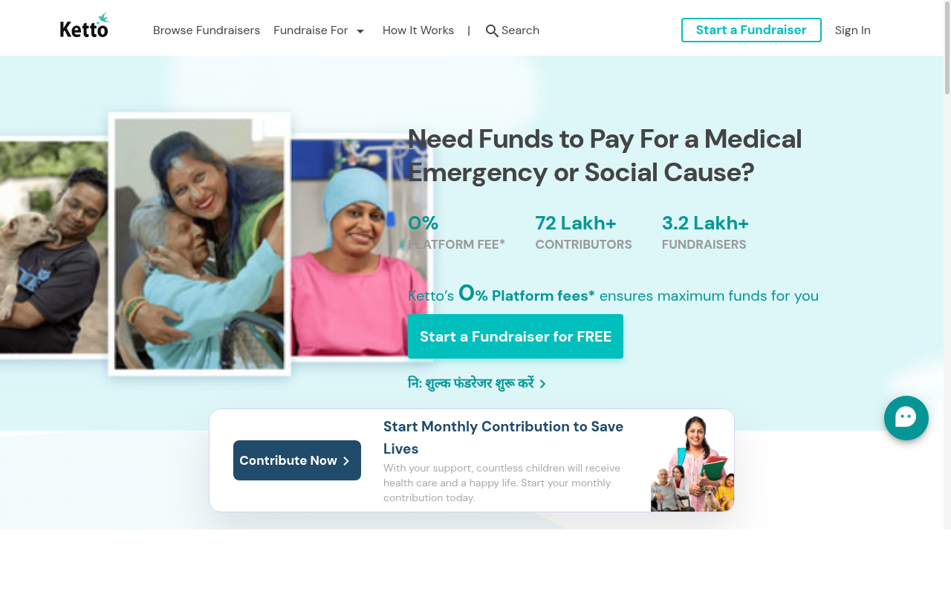
Figure 2.2 Ketto

GlobalGiving
GlobalGiving is an international nonprofit that connects donors with grassroots projects worldwide. It features a rigorous vetting process for organizations and provides impact reports to donors. While GlobalGiving has some presence in Nepal through partnered NGOs, it primarily serves organizations rather than individual beneficiaries. The platform’s complex application process and organizational requirements make it inaccessible for individual Nepali citizens seeking fundraising support [8].
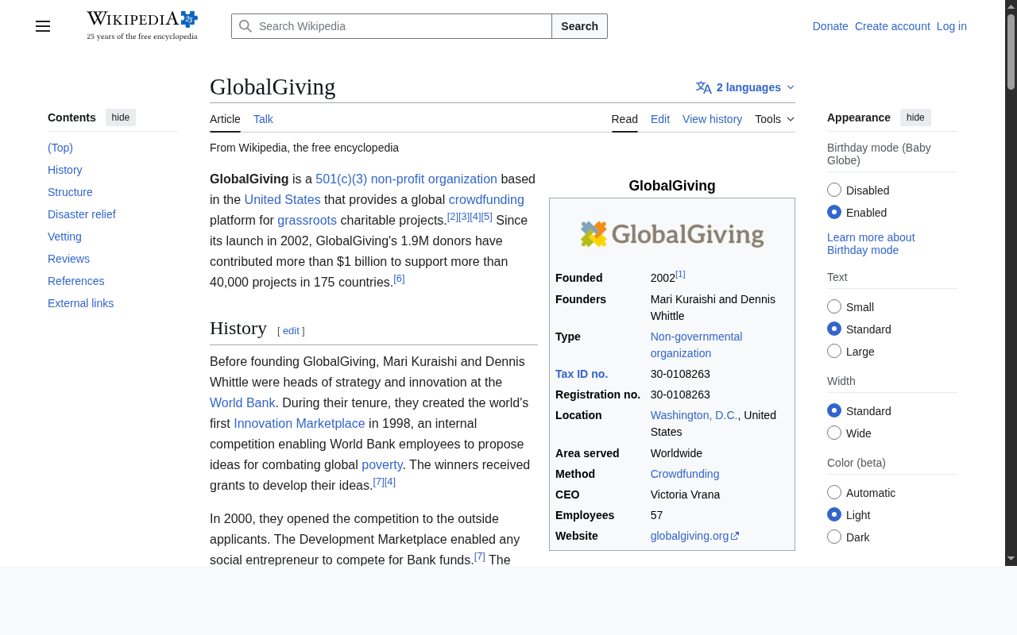
Figure 2.3 GlobalGiving

Sahayogi Haat
Sahayogi Haat is a Nepal-based crowdfunding initiative that aims to support local causes and community projects. While it addresses the local market need, the platform has limited features compared to international alternatives, lacking comprehensive KYC verification, gamification features, AI-powered recommendations, and a robust admin dashboard. The platform also has limited scalability and user engagement features, making it less competitive in retaining donors long-term [9].
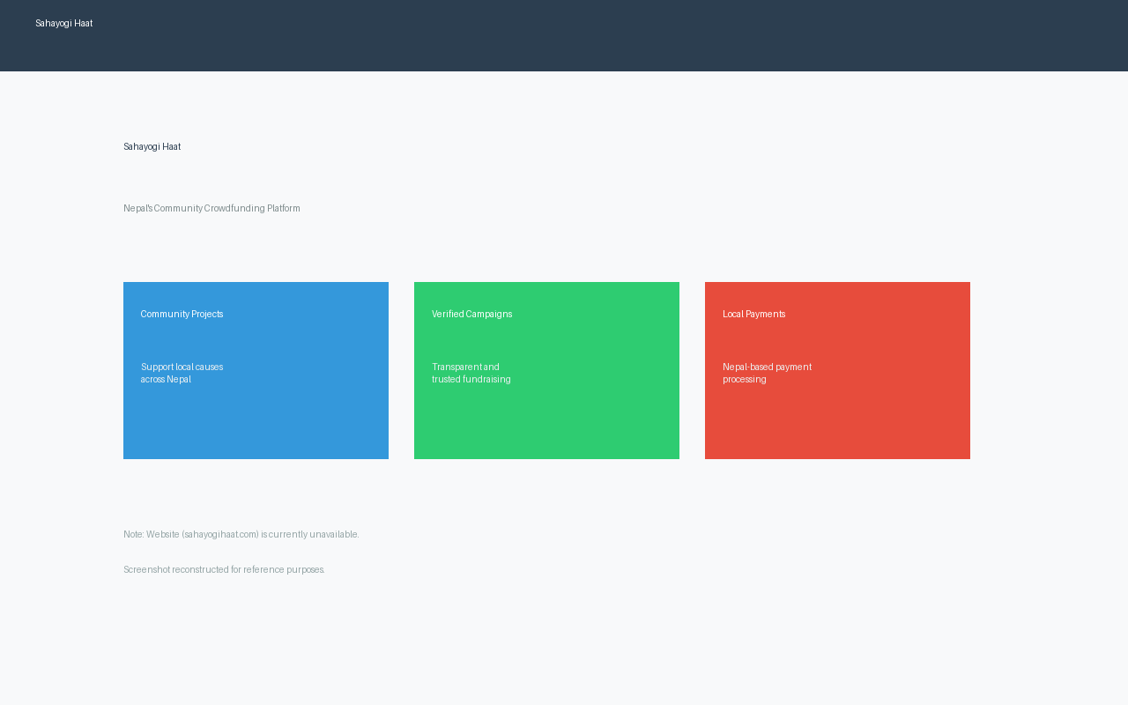
Figure 2.4 Sahayogi Haat

CHAPTER 3: SYSTEM ANALYSIS AND DESIGN

System Analysis
The Nepal360 crowdfunding platform is developed with a strong focus on user needs, trust, and seamless functionality. The platform is built using modern technologies including React 19, TypeScript, Tailwind CSS, Vite, Express.js 5, Prisma 7, and MySQL. The system is designed to offer a user-friendly interface with key features including campaign management with verification workflows, KYC verification, monetary and item donations, recurring subscriptions, leaderboards, badges, AI predictions, interactive maps, multi-language support, dark mode, and a comprehensive admin dashboard with analytics. Nepal360 provides transparency and accountability while ensuring security and efficiency throughout the crowdfunding process.

Requirement Analysis
For any system, there are functional and non-functional requirements to be considered. While determining the requirements of the system, functional requirements are product features or functions that developers must implement to enable users to accomplish their tasks. Non-functional Requirements (NFRs) define system attributes such as security, reliability, performance, maintainability, scalability, and usability.

Functional Requirements
Only authenticated users, including admins, beneficiaries, and donors should have access to their respective dashboards, but anybody can view live campaigns and their details.
Admin:
Admin must be authenticated before accessing the system. They can access the admin dashboard.
Admins can verify, reject, or suspend campaigns after reviewing campaign details and proof documents.
Admins can approve or reject KYC applications submitted by beneficiaries.
Admins can confirm or reject item donation deliveries.
Admins can manage badges, award badges to users, and view audit logs of all administrative actions.
Admins can view comprehensive analytics including campaign distribution, donation trends, user growth, and top campaigns/donors.
Beneficiary (Campaign Creator):
Beneficiaries must complete KYC verification (document upload, profile photo, bank details) before creating campaigns.
Beneficiaries can create campaigns with title, description, category, district, cover image, target amount, and proof links.
Beneficiaries can add milestones to campaigns and claim fund releases upon milestone completion.
Beneficiaries can post campaign updates with images to keep donors informed about impact.
Beneficiaries can view campaign analytics including visit counts, share counts, and donation statistics.
Donor (Regular User):
Donors can browse live campaigns with search and filter capabilities (by category, keyword, amount range).
Donors can make monetary donations via Khalti with public or anonymous visibility options.
Donors can pledge item donations with quantity and delivery notes.
Donors can set up recurring donation subscriptions (monthly/weekly) and manage them.
Donors can leave comments, best wishes cards, and ratings on campaigns.
Donors can view their impact dashboard, badges, leaderboard rankings, and download PDF donation certificates.
Donors can bookmark campaigns, view the interactive campaign map, and switch between English and Nepali languages.

Non-Functional Requirements
Performance: The system should respond quickly to user requests, ensuring minimal latency during campaign browsing, donation processing, and payment verification.
Scalability: The platform must handle an increasing number of users, campaigns, and transactions without performance degradation.
Security: Ensure secure user authentication via JWT, password hashing with bcrypt, XSS sanitization using DOMPurify, CORS protection, rate limiting, and safe payment transactions through Khalti.
Availability: The system should have high uptime, ensuring access at all times with minimal disruptions.
Usability: The user interface should be intuitive and easy to navigate for all user roles, with support for dark mode and Nepali language.

Feasibility Analysis
A detailed feasibility analysis was conducted to determine the likelihood of the project succeeding. It helped in determining the viability of the idea, ensuring the project is legally and technically feasible as well as economically justifiable.
Four major analyses were done to predict the system’s success:
1. Technical Feasibility
2. Operational Feasibility
3. Economic Feasibility
4. Schedule Feasibility
Technical Feasibility:
This study was carried out to check the technical requirements of the system. The project is technically feasible as it uses well-established open-source technologies (React, Express.js, MySQL, Prisma) with extensive community support. Khalti provides a well-documented API for payment integration. All development tools (VS Code, Git, pnpm) are freely available. The development team has adequate knowledge of the required technology stack.
Operational Feasibility:
The system is easy to operate with basic knowledge of web browsing and internet usage. The multi-language support (English and Nepali) ensures accessibility for a wider Nepali audience. The intuitive UI with dark mode support provides a comfortable user experience across different preferences.
Economic Feasibility:
Development of this system is highly economically feasible. All technologies used are open-source and free. Khalti provides developer-friendly pricing. The system can be hosted on affordable cloud infrastructure.
Schedule Feasibility:
The schedule feasibility shows the estimated time to complete the project using Agile sprints. The iterative development approach allowed features to be delivered incrementally, ensuring timely completion of core functionality while allowing for feature additions in subsequent sprints.
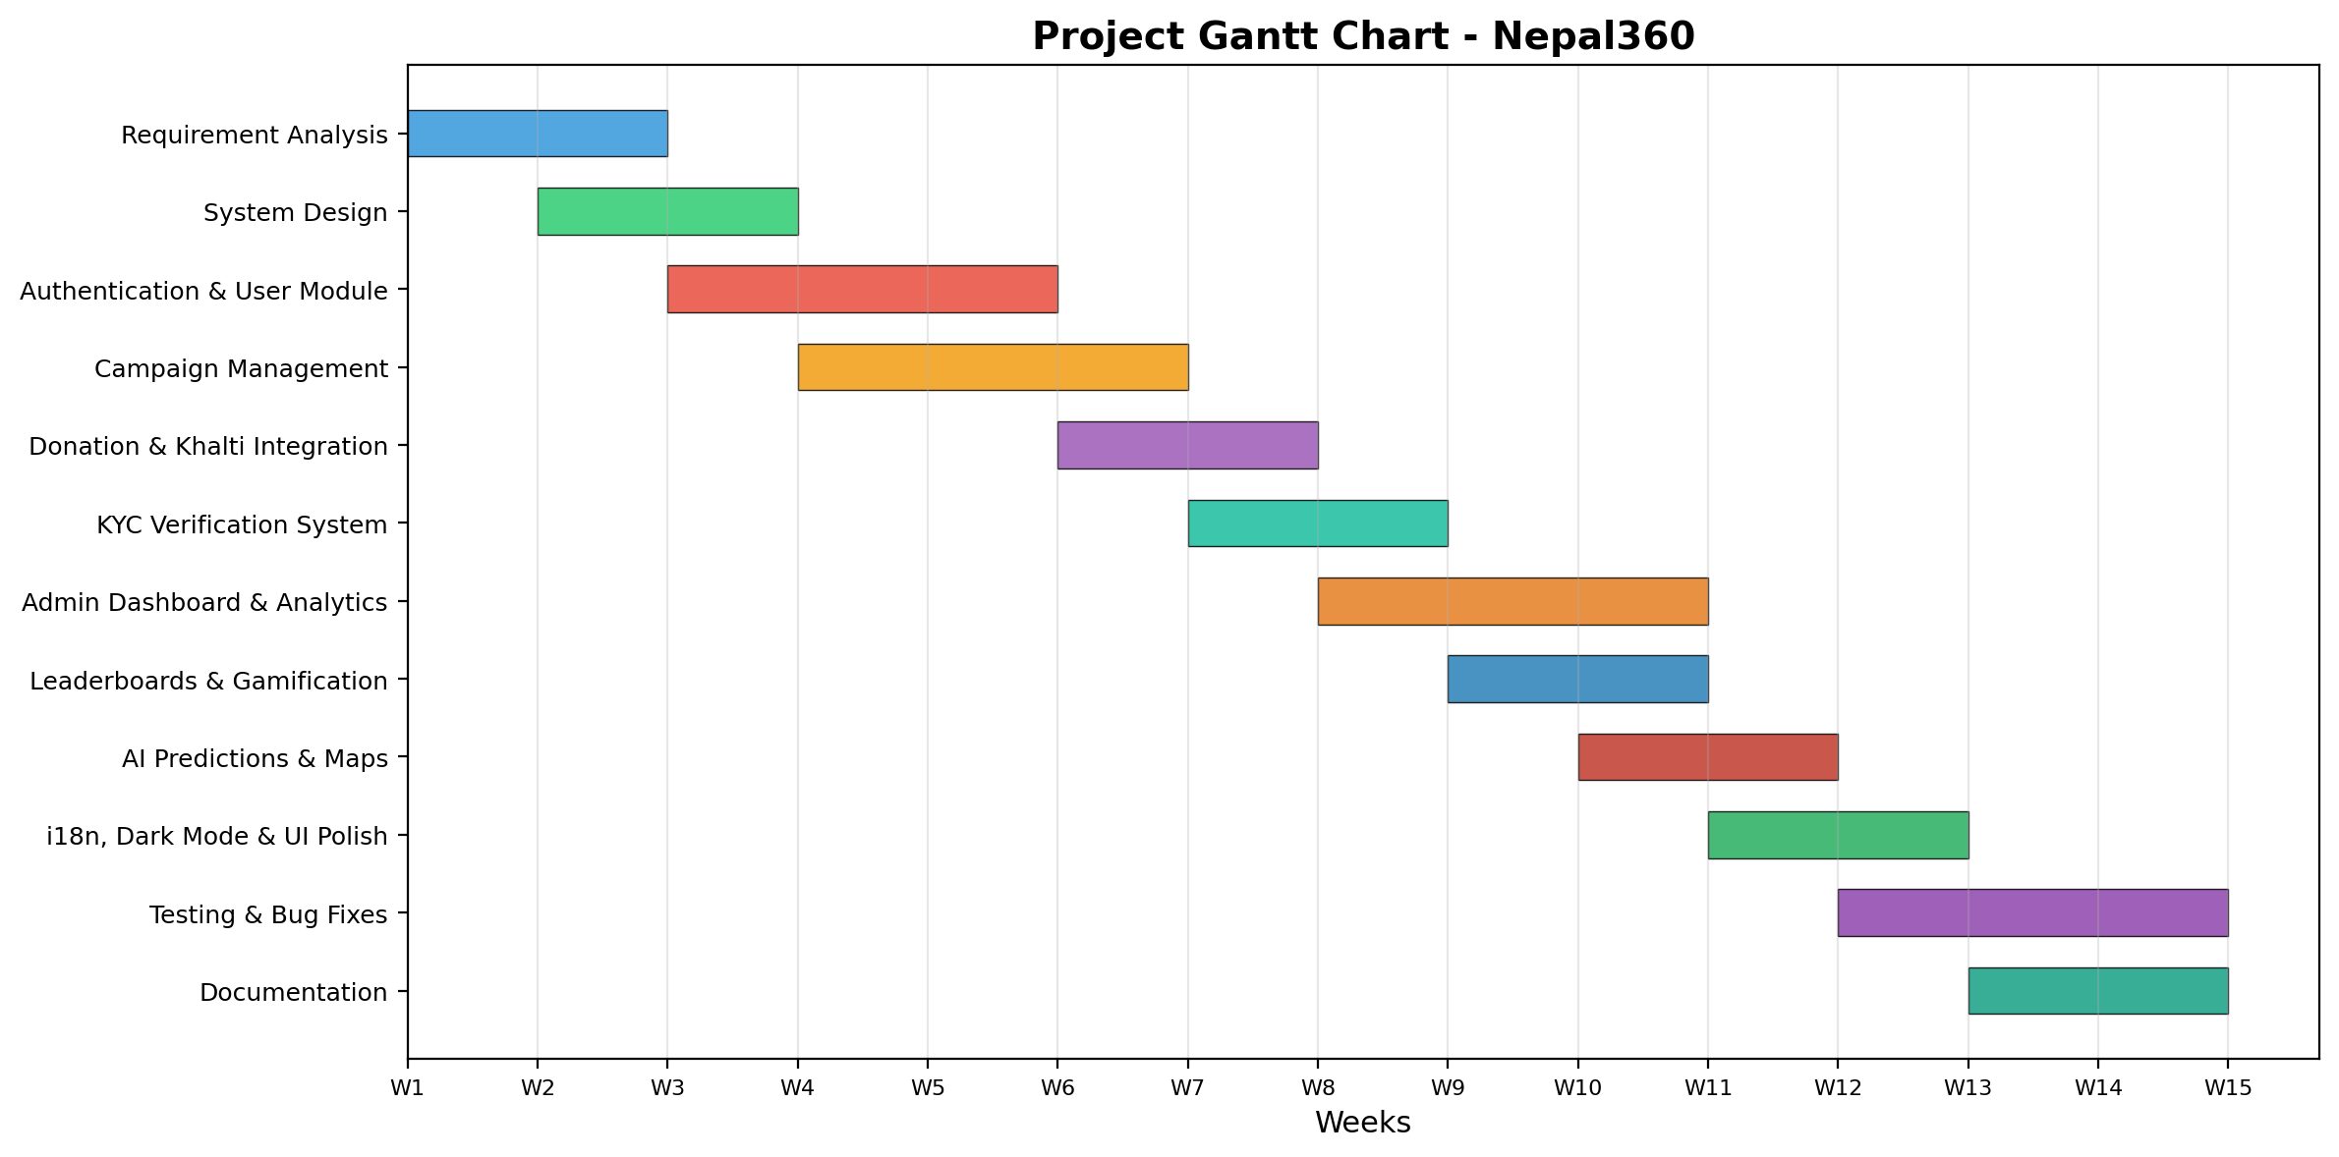
Figure 3.1 Gantt Chart

Conceptual ER Diagram
A conceptual ER diagram (Entity Relationship Diagram) is a high-level representation of a system’s data, focusing on the key business entities and their relationships without going into detailed attribute specifications, providing a broad overview of the data structure from a business perspective.
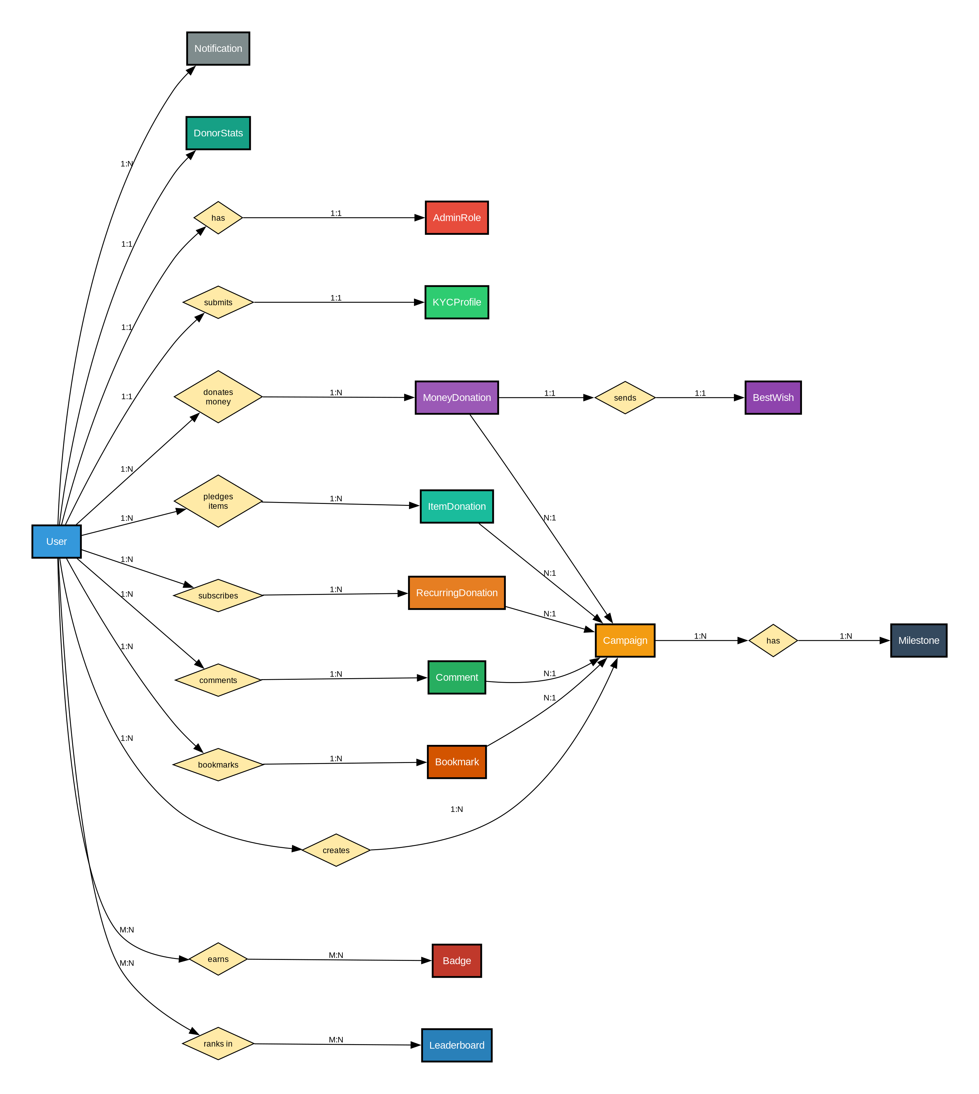
Figure 3.2 Conceptual ER Diagram of Nepal360

Process Modelling (DFD)
Process Modelling involves graphically representing the processes, or actions, that capture, manipulate, store, and distribute data between a system and its environment and among components within a system. A common form of a process model is a data flow diagram (DFD).

Context Diagram
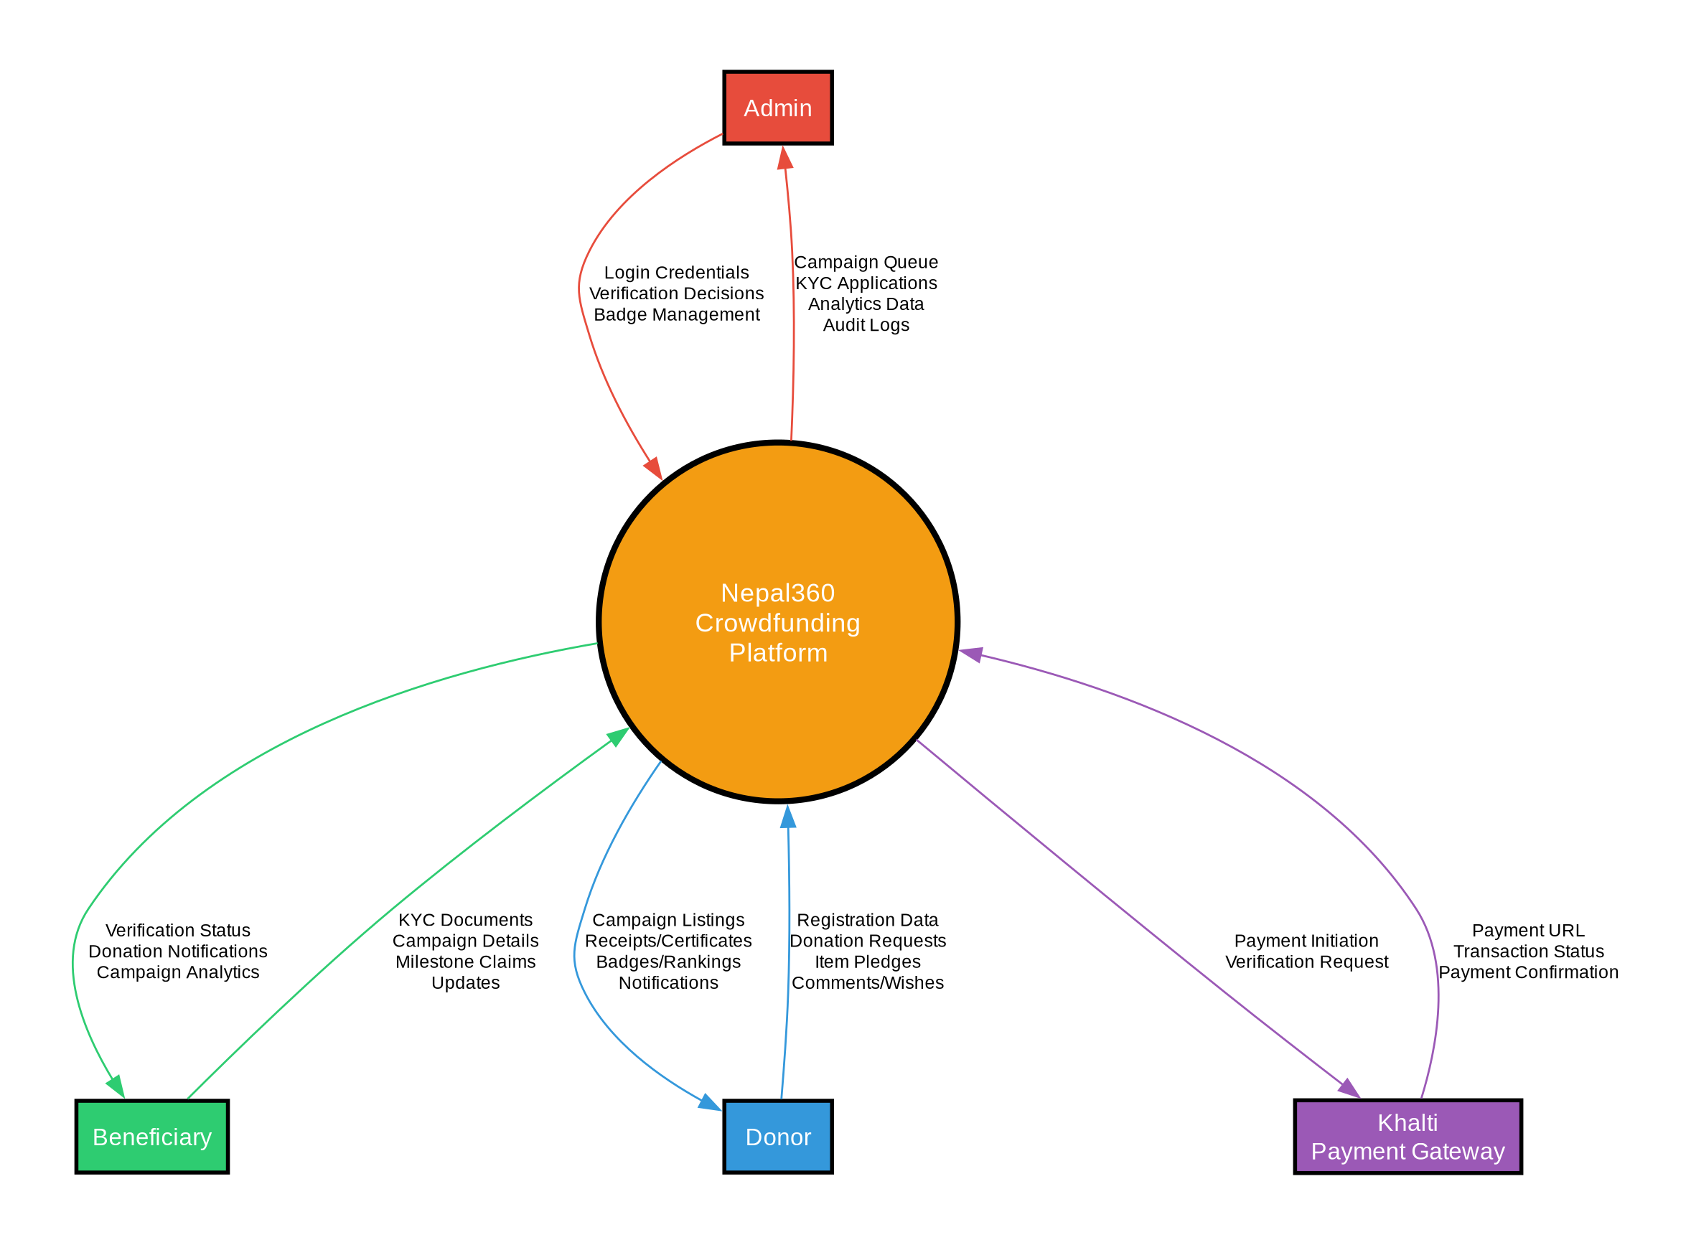
Figure 3.3 Context Diagram of Nepal360
This diagram provides a high-level overview of the Nepal360 system by representing it as a single process. It shows how external entities—namely, the Admin, Beneficiary, Donor, and Khalti Payment Gateway—interact with the system through major data flows (e.g., KYC data, campaign details, donation requests, payment confirmations, and verification decisions). This high-level view establishes the system boundaries and external interactions without showing internal process details.

Level-0 Diagram
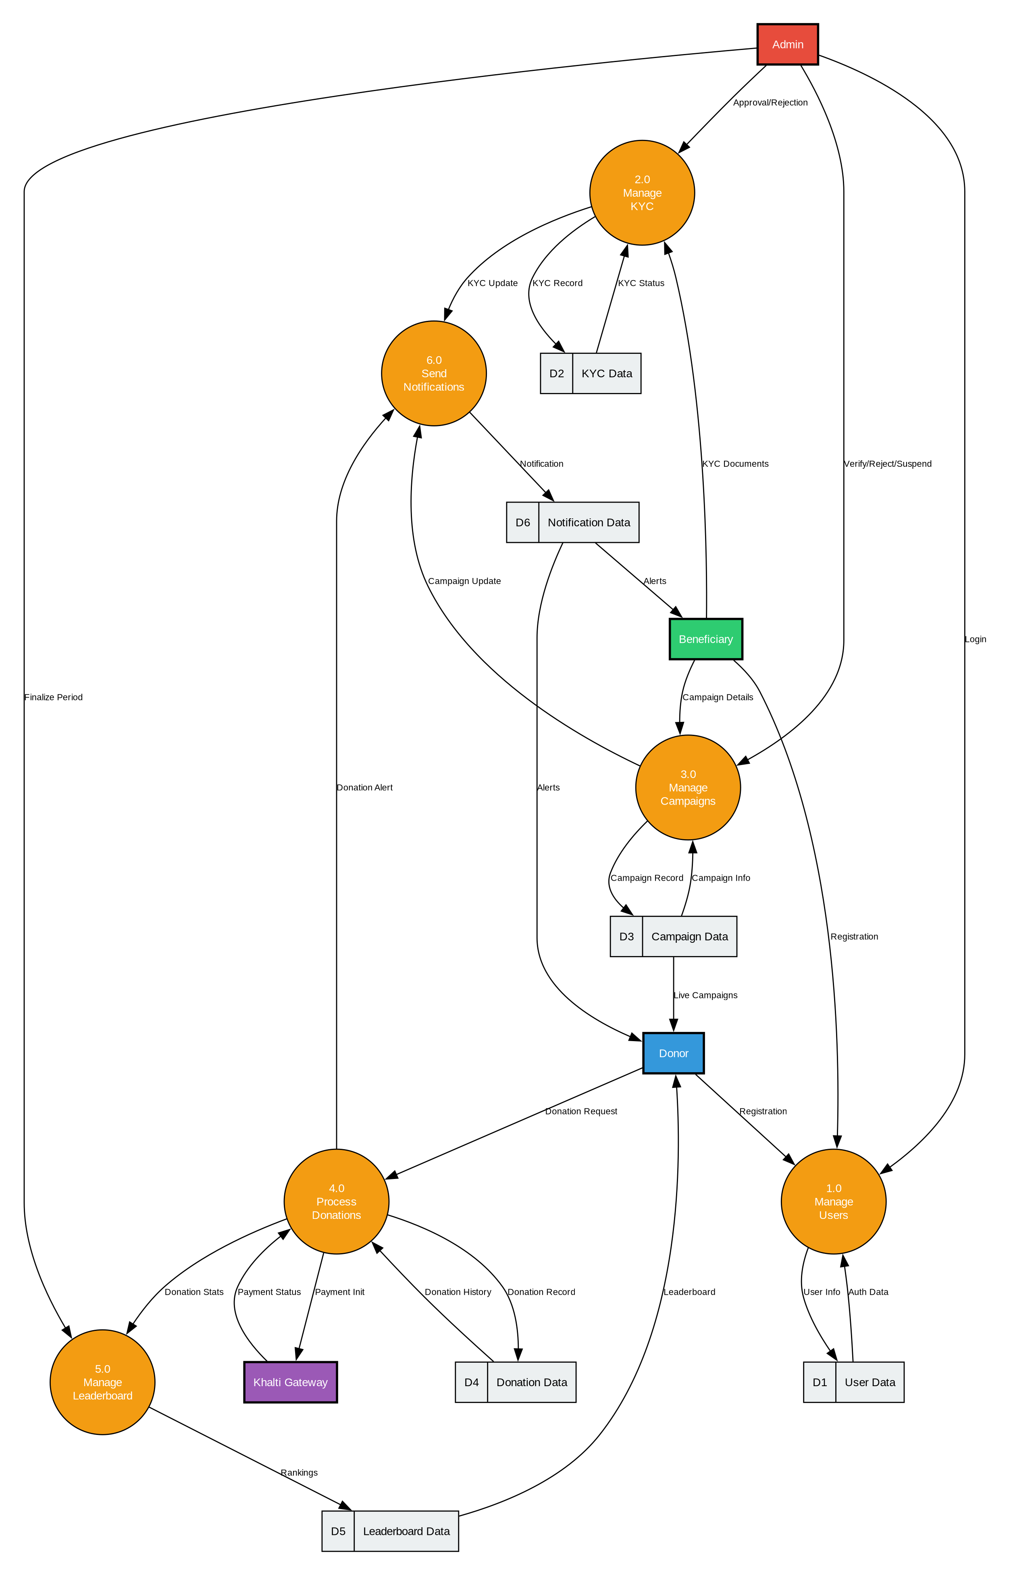
Figure 3.4 Level 1 DFD of Nepal360
The Level-0 Diagram decomposes the Nepal360 system into its major internal processes, such as managing users, KYC verification, campaigns, donations, leaderboards, and notifications. It also depicts the primary data stores (User Data, KYC Data, Campaign Data, Donation Data, Leaderboard Data, and Notification Data) that support these processes. This diagram offers a more detailed view of the system’s internal workings while maintaining clear boundaries with external entities.

System Design
System Design is the process of defining the elements of a system such as architectures, modules and components, the different interfaces of the component and the data that goes through the system.

Database Schema Diagram
The design of the database is called schema. The Nepal360 database schema includes 20+ models covering users, admin roles, KYC profiles, campaigns, milestones, campaign updates, money donations, item donations, recurring donations, best wishes, badges, user badges, donor stats, leaderboards, leaderboard entries, bookmarks, comments, notifications, and audit logs. The schema uses MySQL with Prisma ORM for type-safe database interactions.
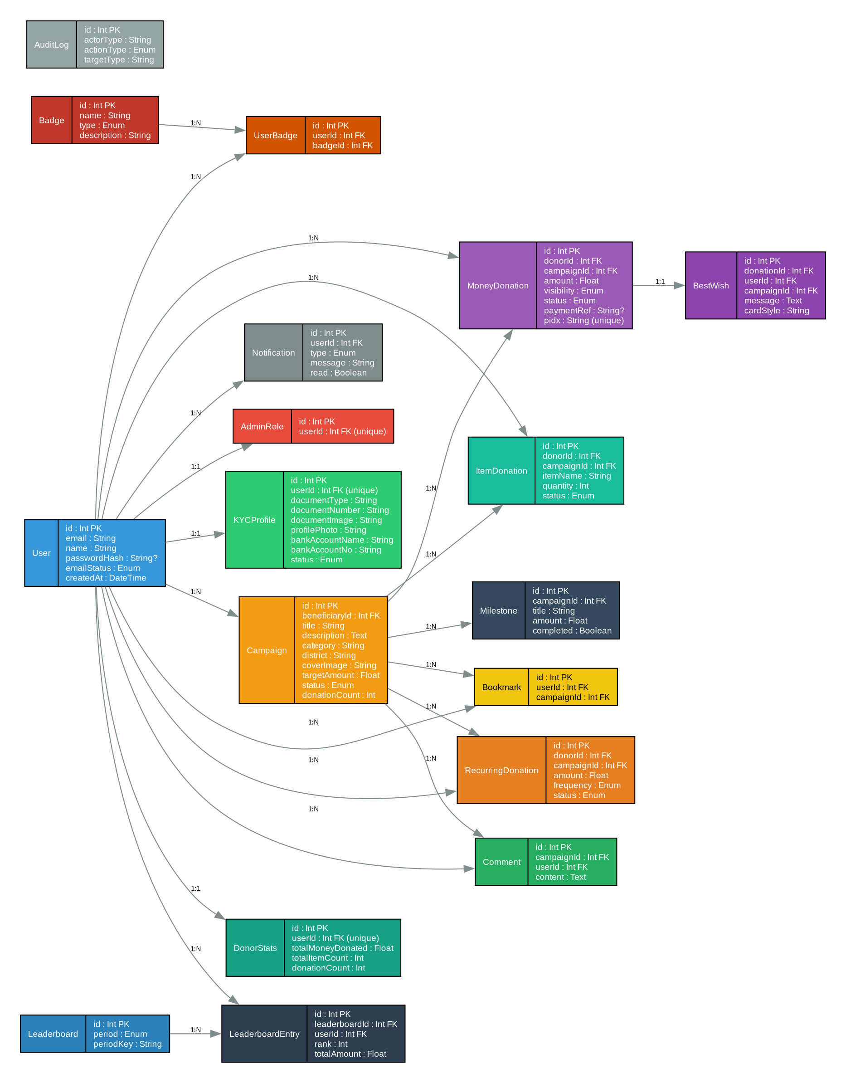
Figure 3.5 Database Schema Diagram of Nepal360

Architectural Design
The architectural design of Nepal360 follows a three-tier architecture, ensuring scalability, maintainability, and efficiency. The system consists of the frontend (presentation layer built with React, Tailwind CSS, and Vite), backend (application layer built with Express.js and TypeScript), and database (data layer using MySQL with Prisma ORM). The frontend communicates with the backend through RESTful API endpoints, while the backend handles business logic, authentication, payment processing, and database operations.
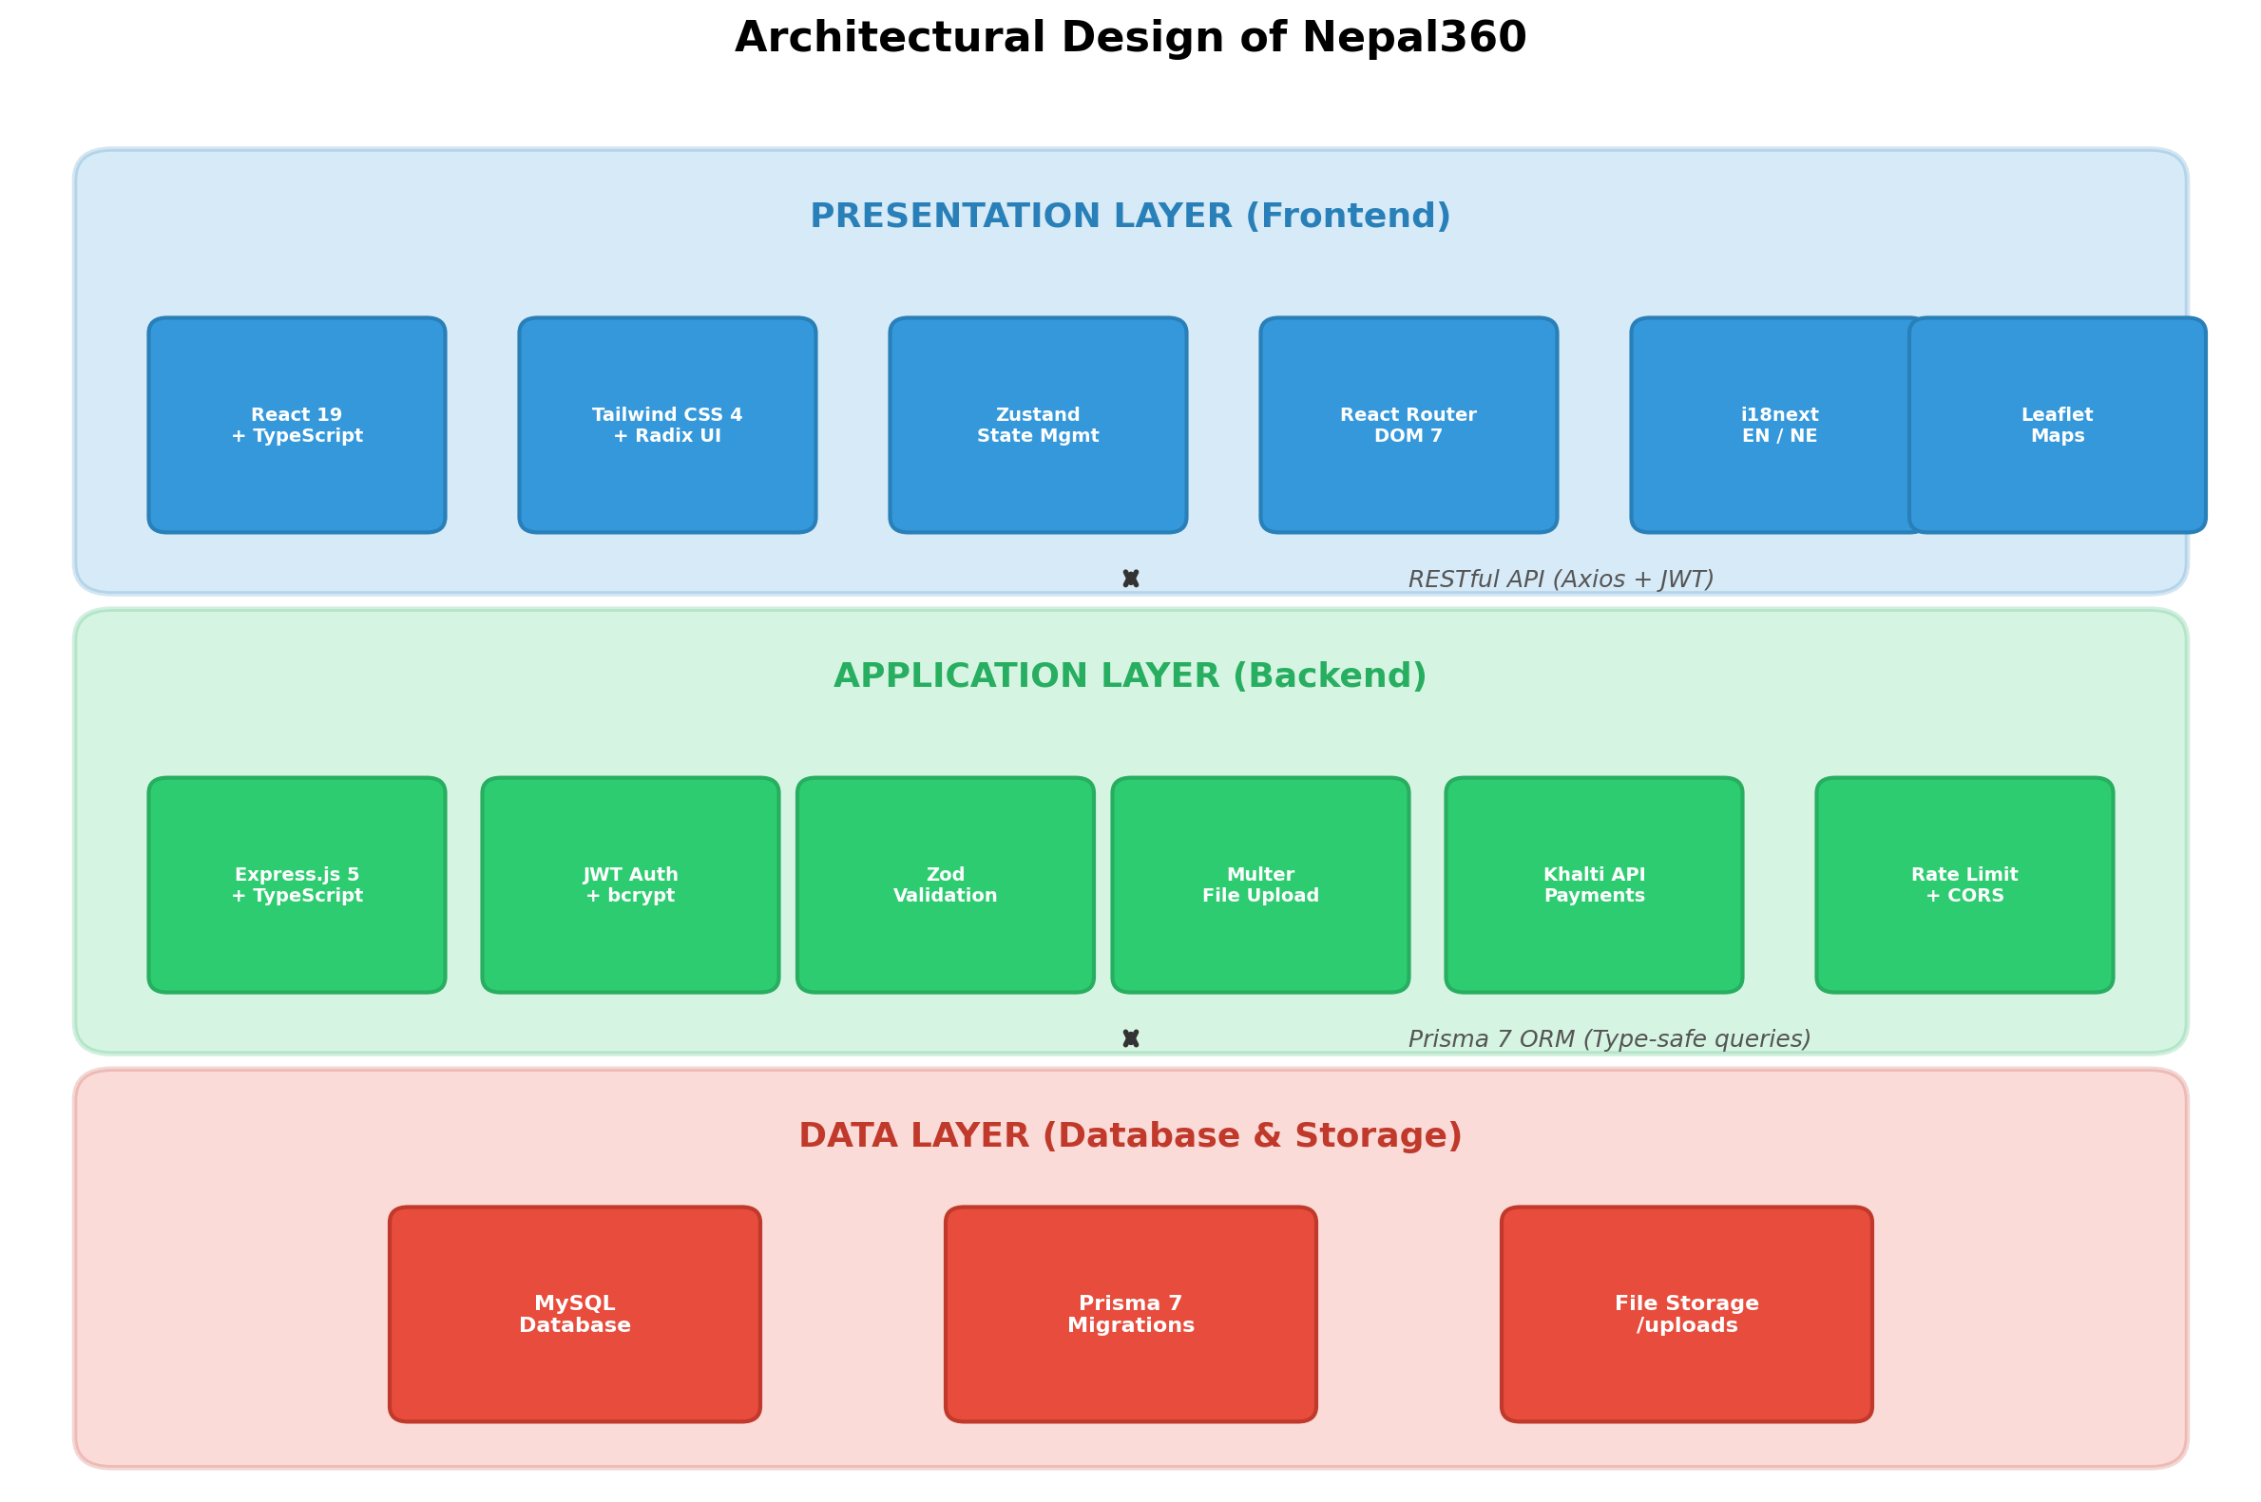
Figure 3.6 Architectural Design of Nepal360
Interface Design
Note: Screenshots are available at Appendix 1.

CHAPTER 4: IMPLEMENTATION AND TESTING

Implementation

Tools Used
In the development of Nepal360, a combination of modern frontend and backend technologies has been utilized to ensure a robust and efficient application.
Frontend
The frontend of the system is implemented using React 19, TypeScript, Tailwind CSS 4, and Vite 7 to ensure a seamless and interactive user experience.
React: React [10] is a JavaScript library for building user interfaces, primarily used for developing single-page applications. It allows developers to create reusable UI components, ensuring fast rendering and an efficient development process. Nepal360 uses React 19 with TypeScript for type-safe component development.
Tailwind CSS: Tailwind CSS [11] is a utility-first CSS framework that provides pre-defined classes to design responsive and modern interfaces. Nepal360 uses Tailwind CSS 4 along with Radix UI for accessible, headless UI components.
TypeScript: TypeScript [12] is a strongly-typed superset of JavaScript that adds static type checking, improving code reliability and developer productivity. It is used across both frontend and backend of Nepal360.
Vite: Vite [13] is a next-generation frontend build tool that provides lightning-fast hot module replacement (HMR) and optimized production builds, significantly improving the development experience.
Backend and Database
The backend is developed using Express.js 5 with TypeScript, and the database is managed using MySQL with Prisma 7 ORM.
Express.js: Express.js [14] is a minimal and flexible Node.js web application framework that simplifies backend development. Nepal360 uses Express.js 5, the latest major version, with features for handling routes, middleware, and API requests.
Prisma: Prisma [15] is a modern database toolkit that acts as an ORM (Object-Relational Mapper) for MySQL and other databases. Nepal360 uses Prisma 7 for type-safe queries, schema-based data modeling, and automated migration management.
MySQL: MySQL [16] is an open-source relational database management system (RDBMS) widely used for handling structured data. Nepal360’s database includes 20+ tables managing users, campaigns, donations, KYC profiles, leaderboards, badges, and more.
Various software tools have been utilized throughout the development process, including:
Visual Studio Code: As an integrated development environment (IDE) for coding.
Git & GitHub: For version control and collaborative development.
Postman: For API testing and documentation.
Microsoft Word: For project documentation.
App Diagram: For creating diagrams and visual representations of system architecture and workflow.

Implementation Details of Modules
The implementation involved the creation of specific modules to achieve different aspects of the Nepal360 crowdfunding platform:
User Registration and Authentication: This module ensures a seamless and secure registration and login process. React is used to build an intuitive UI with form validation using React Hook Form and Zod. Authentication is implemented using JWT tokens with email OTP verification and Google OAuth social login. Password hashing uses bcryptjs for security.
KYC Verification: Beneficiaries submit identity documents (document type, number, and photo), profile photos, and bank account details through a multi-step form. Admins review and approve/reject KYC applications. Only KYC-approved users can create campaigns.
Campaign Management: Beneficiaries create campaigns with detailed information including title, description, category, district, cover image, target amount, and proof links. Campaigns go through an admin verification workflow (DRAFT → PENDING_VERIFICATION → LIVE → COMPLETED). Beneficiaries can add milestones and post updates with images.
Donation Processing: The system supports three types of donations: monetary donations via Khalti payment gateway with automatic verification, in-kind item donations with delivery tracking and admin confirmation, and recurring donation subscriptions (monthly/weekly). Donors can choose public or anonymous visibility and attach best wishes cards to their donations.
Gamification and Engagement: The platform includes donor leaderboards (monthly, yearly, campaign-specific), badge rewards (First Donation, Lifetime Amount, Campaign Supporter, Item Donor, Leaderboard Winner), donor statistics tracking, impact dashboards, bookmarks, comments, activity feeds, and social sharing features.
Admin Dashboard: A comprehensive admin panel with campaign verification queue, KYC approval workflow, item donation management, badge management, audit log viewing, and analytics dashboard with charts showing campaign distribution, donation trends, user growth, and top campaigns/donors.

Testing
Software testing is an essential aspect of ensuring the functionality, correctness, and quality of Nepal360. It involves a systematic technical investigation aimed at identifying and rectifying errors and anomalies within the software. Testing encompasses various methodologies and techniques to validate the system’s behavior and performance within its operational context, ultimately ensuring a seamless and robust user experience.

Test Cases for Unit Testing
The smallest testable parts of the application, called units, are individually and independently scrutinized for proper operation. The main objective of unit testing is to isolate written code to test and determine if it works as intended.
Table 4.1 Test Cases For Unit Testing
TC ID | Test Case | Test Data | Description | Expected Result | Actual Result | Remarks
1 | Testing Admin Login | Email: admin@nepal360.com  Password: AdminPass3# | While entering correct credentials | Successfully logged in and redirect to admin dashboard. | As expected result | Pass
2 | Testing Admin Login | Email: admin08@nepal360.com  Password: Admin12345# | While entering wrong credentials | Show error and please try again. | As expected result | Pass
3 | Click logout button | Click Logout button | Clicking logout button | Redirect to login page | As expected result | Pass
4 | Testing User Login | Email: user@nepal360.com  Password: UserPass1! | While entering correct credentials | Successfully logged in and redirect to home page. | As expected result | Pass
5 | Testing User Login | Email: test77@nepal360.com  Password: Hello12345# | While entering wrong credentials | Show error and please try again. | As expected result | Pass
6 | Click logout button | Click Logout button | Clicking logout button | Redirect to login page | As expected result | Pass
7 | Testing Google OAuth Login | Valid Google account | While logging in with Google OAuth | Successfully logged in via Google and redirect to home page. | As expected result | Pass
8 | Testing Email OTP Verification | Valid OTP: 123456 | While entering correct OTP | Email verified successfully. | As expected result | Pass
9 | Testing Email OTP Verification | Invalid OTP: 000000 | While entering wrong OTP | Show invalid OTP error. | As expected result | Pass

Test Cases for System Testing
System testing evaluates the complete and integrated Nepal360 platform to ensure all modules function correctly together. It involves testing the overall workflow, including authentication, KYC verification, campaign management, donation processing, leaderboards, and admin operations.
Table 4.2 Test Cases for System Testing
Test Scenario | Test Steps | Expected Result | Actual Result | Status
User Registration & Email Verification | User registers with valid details, receives OTP, and verifies email. | User is successfully registered and email verified. | User is able to register and verify email successfully. | Pass
KYC Submission & Approval | User submits KYC with documents, admin approves. | KYC is approved and user can create campaigns. | KYC approved and campaign creation enabled. | Pass
Campaign Creation & Verification | Verified user creates campaign, admin verifies it. | Campaign goes live and visible to donors. | Campaign appears in live listings. | Pass
Khalti Donation Process | Donor selects campaign, enters amount, completes Khalti payment. | Donation is confirmed and reflected in campaign progress. | Donation processed and stats updated. | Pass
Item Donation Pledge | Donor pledges item donation with details. | Item pledge recorded and visible to admin. | Pledge appears in admin panel. | Pass
Recurring Donation Setup | Donor sets up monthly recurring donation. | Recurring subscription created and trackable. | Subscription created successfully. | Pass
Leaderboard & Badge System | Donor makes donation, checks leaderboard and badges. | Donor appears on leaderboard and receives badge. | Leaderboard and badge updated correctly. | Pass
Admin Dashboard Analytics | Admin checks dashboard for reports and statistics. | Reports display real-time data on donations & campaigns. | Data is displayed accurately. | Pass
Multi-language Support | User switches language from English to Nepali. | UI text changes to Nepali language. | Language switches correctly. | Pass
Security - Unauthorized Access | A non-logged-in user tries to access admin panel. | System restricts access and redirects to login page. | Access is denied and user redirected. | Pass

CHAPTER 5: CONCLUSION AND FURTHER WORK

Conclusion
With the increasing need for transparent and accessible charitable giving solutions in Nepal, online crowdfunding platforms have gained significant importance. Nepal360 provides donors with an easy-to-use platform to discover, support, and track fundraising campaigns from the comfort of their homes. It ensures a seamless and trustworthy donation process through KYC verification, admin oversight, and Khalti payment integration, while allowing beneficiaries to manage their campaigns efficiently with milestone tracking and impact updates.
In addition to enhancing donor convenience, the system streamlines campaign verification, improves donation tracking, and optimizes the overall crowdfunding operation through comprehensive admin tools and analytics. The gamification features including leaderboards, badges, and impact dashboards encourage greater donor participation and engagement. For beneficiaries, it means access to a wider audience of potential donors across Nepal, eliminating the limitations of traditional fundraising methods. With smart features like AI-powered campaign predictions, interactive maps, multi-language support, and donation certificates, Nepal360 enhances the user experience while ensuring transparency and reliability in crowdfunding.

Lesson Learnt/Outcome
Throughout the development of this project, I have gained valuable insights and hands-on experience in building a full-stack web application. I realized the importance of proper planning, iterative development, and effective problem-solving in building a functional and user-friendly system. This project enhanced my ability to understand real-world requirements, translate them into technical solutions, and implement them efficiently using modern technologies.
Nepal360 focuses on modernizing charitable giving in Nepal by bringing crowdfunding to a digital platform. It provides transparency to donors through KYC verification and admin oversight while streamlining operations for beneficiaries. By integrating Khalti payment gateway, implementing real-time donation tracking, gamification features, AI predictions, and a comprehensive admin dashboard, the system enhances the overall crowdfunding experience. Throughout this project, I learned the significance of full-stack development with TypeScript, database design with Prisma ORM, JWT authentication, payment gateway integration, internationalization, and responsive UI design with React and Tailwind CSS. Additionally, I gained hands-on experience with XSS prevention, rate limiting, role-based access control, and RESTful API design, which are essential for building scalable and secure applications. This experience has not only strengthened my technical skills but also improved my problem-solving and project management abilities, preparing me for real-world software development challenges.

Future Plans
The following enhancements are planned for future development of Nepal360:
Integrate additional payment gateways such as eSewa and bank transfers for wider payment coverage.
Develop a dedicated mobile application using React Native for better accessibility and convenience.
Implement advanced machine learning models for more accurate campaign success predictions and personalized recommendations.
Enhance system security with multi-factor authentication and end-to-end encryption for sensitive data.
Introduce reward points, discounts, and membership benefits for frequent donors to increase engagement.
Add real-time chat support between donors and beneficiaries for better communication.
Implement webhook-based notification system with email and SMS alerts for important events.

REFERENCES

[1] E. Mollick, "The dynamics of crowdfunding: An exploratory study," Journal of Business Venturing, vol. 29, no. 1, pp. 1-16, 2014.
[2] E. Gerber and J. Hui, "Crowdfunding: Motivations and deterrents for participation," ACM Transactions on Computer-Human Interaction, vol. 20, no. 6, pp. 1-32, 2013.
[3] J. Hamari, J. Koivisto, and H. Sarsa, "Does gamification work? A literature review of empirical studies on gamification," 47th Hawaii International Conference on System Sciences, pp. 3025-3034, 2014.
[4] Nepal Rastra Bank, "Payment Systems Overview," Nepal Rastra Bank, [Online]. Available: https://www.nrb.org.np.
[5] A. Agrawal, C. Catalini, and A. Goldfarb, "Crowdfunding: Geography, social networks, and the timing of investment decisions," Journal of Economics & Management Strategy, vol. 24, no. 2, pp. 253-274, 2015.
[6] GoFundMe, "GoFundMe: The Most Trusted Online Fundraising Platform," GoFundMe Website, [Online]. Available: https://www.gofundme.com.
[7] Ketto, "Ketto: India’s Most Trusted Crowdfunding Platform," Ketto Website, [Online]. Available: https://www.ketto.org.
[8] GlobalGiving, "GlobalGiving: Donate to Charity Projects Around the World," GlobalGiving Website, [Online]. Available: https://www.globalgiving.org.
[9] Sahayogi Haat, "Sahayogi Haat: Nepal Crowdfunding," Sahayogi Haat Website, [Online]. Available: https://sahayogihaat.com.
[10] J. Clark, "React: A JavaScript library for building user interfaces," Journal of Web Development, vol. 14, no. 2, pp. 101-118, 2023.
[11] A. White and B. Green, "Utility-first design with Tailwind CSS," International Journal of Frontend Development, vol. 9, no. 3, pp. 212-227, 2022.
[12] Microsoft, "TypeScript: JavaScript With Syntax For Types," TypeScript Documentation, [Online]. Available: https://www.typescriptlang.org.
[13] Vite, "Vite: Next Generation Frontend Tooling," Vite Documentation, [Online]. Available: https://vitejs.dev.
[14] K. Patel, "Building scalable web applications with Express.js," Journal of Backend Technologies, vol. 8, no. 4, pp. 145-163, 2023.
[15] R. Adams and M. Zhao, "The evolution of Object-Relational Mapping: A study on Prisma," International Journal of Database Management, vol. 12, no. 1, pp. 98-112, 2022.
[16] S. Thompson, "Relational database systems: MySQL in modern applications," Computing Advances Journal, vol. 15, no. 2, pp. 189-204, 2021.

APPENDICES

Appendix 1: Screenshots

(Screenshots of the application to be inserted here)

Appendix 2: Database Tables

User Table

AdminRole Table

KYCProfile Table

Campaign Table

Milestone Table

CampaignUpdate Table

MoneyDonation Table

ItemDonation Table

RecurringDonation Table

BestWish Table

Badge Table

UserBadge Table

DonorStats Table

Leaderboard Table

LeaderboardEntry Table

Bookmark Table

Comment Table

Notification Table

AuditLog Table

