



Table of Content

**1. Introduction 1**

1.1 Purpose 1

1.2 Application Overview 1

1.3 Feature Overview 1

1.4 Audience 1

**2. Test Strategy 2**

2.1 Test Objective: 2

2.2 Types of Testing 2

2.3 Test Assumptions 2

2.4 Scope 3

2.4.1 Inclusion 3

2.4.2 Exclusion 4

**3. Test Scenarios 4**

3.1 Authentication 4

3.2 Hiring 5

3.3 Employee Information Management 7

**4. Time Estimation 8**

**5. Test Approach By 9**

**6. Test Environment and Tools 9**

**7. Test Case 10**

7.1 Test Case Hyperlink 10

**8. Installation and Upgrade Test 10**

**9. Exit Criteria 10**

# Introduction

## Purpose

This document explains about the activities which will be carried out to perform **TEST** on **BambooHR** mobile application. The document will serve as a guidance to stakeholders, developers, QA teams and clients to know about the Scope, Features, Bug findings and Reporting and for future reference.

## Application Overview

**BambooHR** is the complete HR platform that brings all your employee, payroll, time, and benefit information together in one place, giving you the data accuracy, security, and coordination

For more information visit: <https://www.bamboohr.com/homepage-customer>

## Feature Overview

This document will provide detailed overview of following features:

* Authentication
* Hiring
* Employee Information Management

## Audience

* The HR can view new applicants and job listings
* The HR will be able to contact employees via mobile and email
* The HR can view personal information of new applicants
* The employee can view their job title, salary, compensation and performance
* The employee can make request to the HR
* The HR will be able to view employee working hours and leave hours

# Test Strategy

## Test Objective:

The Objective of test is to ensure an application meets its major requirements and following are the major key objectives:

* Requirement Fulfilment
* Quality Software
* Identifying bugs and errors
* Better Performance
* Scalability
* Trust and Confidence

## Types of Testing

* Functional Testing
* Smoke Testing
* Performance Testing

## Test Assumptions

* The **Tester** must be aware of the business requirements
* The **Requirement Documents** will be readily available
* The application must be developed to perform at least smoke testing
* The Test environment must be made ready
* The **Tester** will be provided necessary authorization
* The sufficient time and resources will be provided to perform tests
* Must have technical and human resources backup if any failure occurs

## Scope

### Inclusion

1. Authentication
   * Login with registered work email id and password
   * Forgot Password
2. Hiring
   * Job listing(Opening) and Candidates
   * Applicants Information Management
   * Candidates Rating
   * Filter and Sort
   * Search
   * Backward Navigation
3. Employee Information Management
   * Employee Directory
   * Employee Information
   * Search
   * Filter
   * Back Navigation

### Exclusion

1. Third party application Integration
2. API Testing
3. Mobile Testing on outdated version of Operating System
4. Web Browser

# Test Scenarios

## Authentication

| **S.N** | **Positive Test Scenarios** |
| --- | --- |
|  | Verify that a user can log in with a valid email id and password. |
|  | Verify that a user can enter a registered “**work email id**” in the email field before proceeding to the password. |
|  | Verify that the system throws an error message if a user tries to enter with an unregistered email id and wrong password. |
|  | Verify that a user can **“Continue”** to the password field once the correct email is entered. |
|  | Verify that a user can enter a password up to certain digits with characters, numbers and symbols. |
|  | Verify that if a user can **Reset** password using **“Forgot Password”** functionality |
|  | Verify that the system automatically logs out users once the **“Session Time”** ends. |
|  | Verify that a user can select between **“Show Password”** and **“Hide Password”** while entering password. |
|  | Verify that the color of the **“Continue”** button changes from dark to green if the correct email format is entered. |

| **S.N** | **Negative Test Scenarios** |
| --- | --- |
|  | Verify that a user can login with **“Invalid”** email id and password. |
|  | Verify that a user can login with **“Scripts”**. |
|  | Verify that a user can login without providing any credentials. |
|  | Verify that a user can login with **“Unregistered work email id”**. |

## Hiring

| **S.N** | **Positive Test Scenarios** |
| --- | --- |
|  | Verify that HR can view the number of new job listings and candidates. |
|  | Verify that HR is notified when there are new applicants and job listings. |
|  | Verify that if HR can view applicants detailed information like job applied date, resume, phone number, email, home address, desired pay, websites and application source |
|  | Verify that if HR can notify applicants and hiring team members about “Hiring Status” |
|  | Verify that if HR can make calls and emails to the applicants |
|  | Verify that if HR can “Sort” list of applicants based on job title |
|  | Verify that if HR can view new job openings and applicants on Top based on **“DATE”** |
|  | Verify that if HR can filter names of applicants and job titles |
|  | Verify that if HR can make ratings to candidates to prioritize talent |
|  | Verify that if HR can **search** applicants names and job titles |
|  | Verify that hiring members can make notes about the applicants |
|  | Verify that if user can **“Back Navigate”** |

| **S.N** | **Negative Test Scenarios** |
| --- | --- |
|  | Verify that if “**Search Box**” accepts Invalid **characters** and **Scripts** |
|  | Verify that if system accepts fake job applicants made by bots |

## Employee Information Management

| **S.N** | **Positive Test Scenarios** |
| --- | --- |
|  | Verify that HR can view the Personal information of an individual employees |
|  | Verify that the names of employees are sorted alphabetically |
|  | Verify that if HR can view leave date |
|  | Verify that HR can search names and job titles |
|  | Verify that HR can filter employees list |
|  | Verify that if HR can view detailed job information of an employee |
|  | Verify that if HR can view documents of an individual employee |
|  | Verify that if HR can make a note about an employee |
|  | Verify that if HR can view the Emergency information of an employee |

# Time Estimation

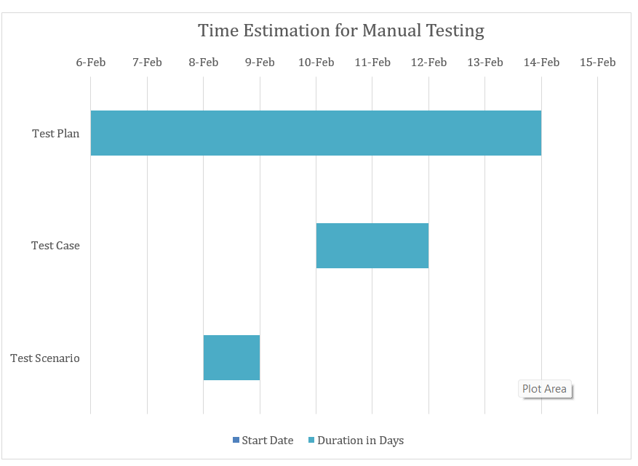

Fig: Gantt chart for Manual Testing

# Test Approach By

| QA Team | Nischal Rawal |
| --- | --- |
| QA Lead | Nischal Rawal |

# Test Environment and Tools

| Versions | **iOS** **(OS Version 14+)**, **Android (OS Version 11+)** | | |
| --- | --- | --- | --- |
| Tested Builds | **1.0.0.001, 1.1.0.001, 2.0.0.001** | | |
| Environments | **Hardware** | | **Software** |
| Device Models | iPhone 11+ | IOS and Android |
| Samsung Galaxy  S24 Ultra |
| Redmi  Note 13 Pro |
| Google Pixel 9 Pro |
| Network | Mobile Data **(At least 3G)** |
| Browser Compatibility | **N/A** | | |

# Test Case

## [Test Case Hyperlink](https://docs.google.com/spreadsheets/d/1OcFTk8qJyhi9gJYhEXM_wjQKrnzoWoCCDpWOrQ0hr7g/edit?gid=1617898909#gid=1617898909)

# Installation and Upgrade Test

| **Upgrade Path** | **Installation Time** | **Test Build** | **Status** |
| --- | --- | --- | --- |
| Fresh Build V-1.0.0 | 2 Minute | V-1.0.0-Build-001 | Pass |
| V-1.0.0 >> V1.1.0 | 1.5 Minutes | V-1.0.0-Build-001 | Pass |
| Fresh Build 2.0.0 | 2 Minutes | V-2.0.0- Build-001 | Fail |
| V-2.0.0 >> 2.1.0 | TBD | V-2.0.0-Build-001 | TBD |

# Exit Criteria

* The initial developed application must meet **Software Requirement Specification (SRS)** document
* All the Test cases must have cover the functional requirements
* Critical Test cases must pass
* Min 95% Test cases must pass
* Must prepare a detail documents for changes and bugs
* Stakeholders must have reviewed the pass test results