**Nischal Shrestha**

Bidur-03, Nuwakot | Dhungedhara, Banasthali, Kathmandu| +977 9843481901 | [nischalstha9@gmail.com](mailto:nischalstha9@gmail.com)

Profile: I am a Diploma graduated student in Information Technology form Nepal Banepa Polytechnic Institute. I have developed Diploma level skills on Information Technology through my education. I am one of the determined and dedicated student. I am now looking to further develop and use my skills in an official organization.

Hobbies: Video editing and animation, Photoshop, Drawing, Conception and imagination

|  |  |
| --- | --- |
| **Objective** |  |
| A basic to intermediate level computer based works. |  |
| **Education** |  |
| Diploma in Information Technology, DIT-00025-015  Nepal Banepa Polytechnic Institute, Banepa-Kavre  Successfully passed Diploma in Information Technology with 67.68% in aggregate. | 2072-2075 |
| * Major: Science * Minor: Computer Engineering * Related course work: Computer fundamental, Microsoft Office, C Basic, C++ basic, VB, PHP, Data mining, System analysis and design, E-commerce, EDC, Microprocessor, Engineering Drawing |  |
| School Leaving Certificate,  Orchid Academy Nuwakot, Battar-Nuwakot  Passed the exam with 69% | 2071 |

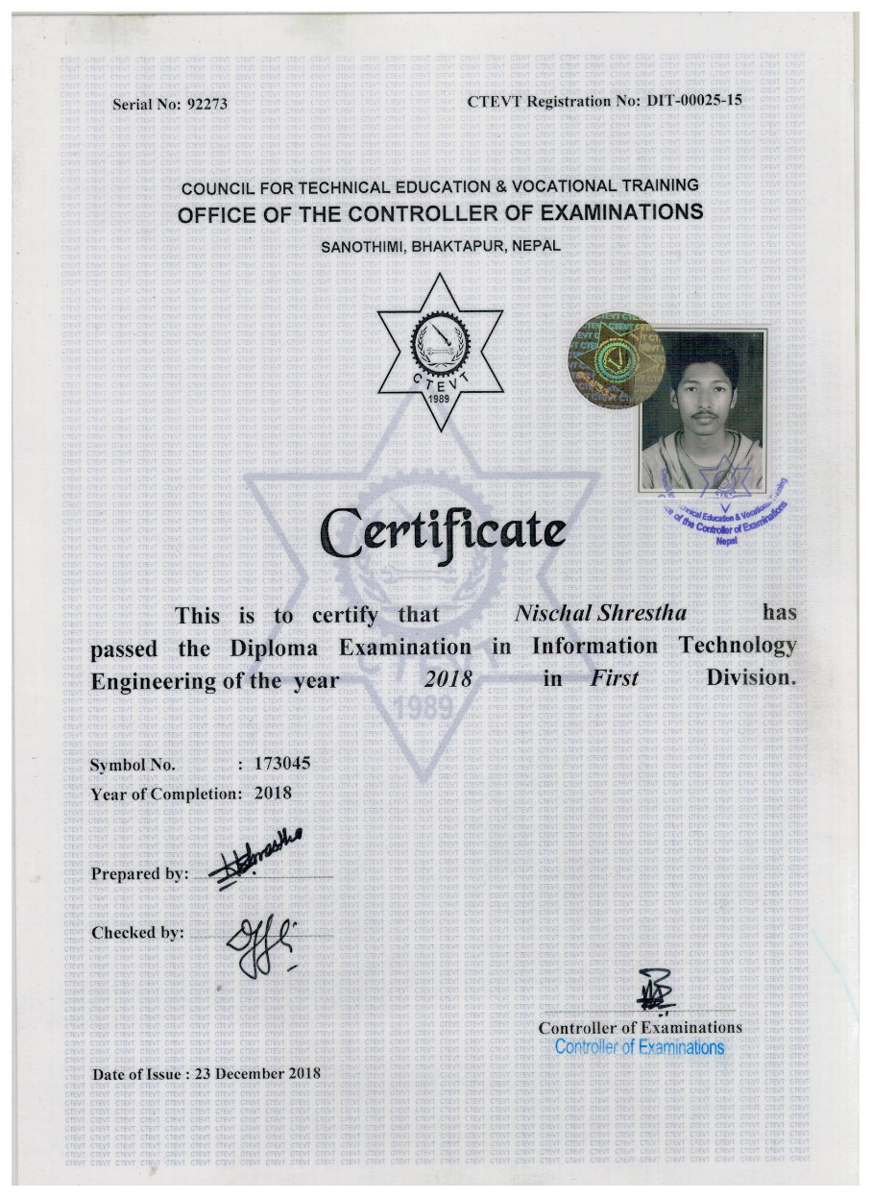

|  |  |
| --- | --- |
| **Skills & Abilities** |  |
| Basic Web System Development |  |
| * Developed two projects in college level  1. Bus Ticket Reservation System as College Major Project 2. Font face Helvetica as College Minor Project |  |
| Microsoft office |  |
| * Can Work with every important office based works on office programs as MS-Word, MS-Excel. |  |
| Networking |  |
| * Have basic knowledge of Computer Networking * Interested in networking further seeking for advanced networking knowledge and tasks |  |
| Basic Photo and Video editing skills |  |
| * Can perform basic actions in Adobe Premiere Pro * Can perform basic to medium level of photo editing in Photoshop in Lightroom. |  |
| **Experience** |  |
| Currently I am only graduated from a Diploma level college and seeking for a suitable job. |  |
| **Organizations** |  |
| Currently I haven’t been employed to any of the organizations. |  |
| **Languages** |  |
| Nepali *****  English ***  Hindi *** |  |
| **Interests** |  |
| Photos, videos, animation, networking, web system, management, Leadership, client dealing skills, computer maintenance |  |
| **lEADERSHIP AND vOLUNTEERING** |  |
| * Successfully guided every team member for their specific task they were good at. * Managed every administrative task in the project. |  |
| **Personal projects** |  |
| 1. **Simple Bus Ticket Reservation System (01/2075 to 02/2075)**   Objectives   * To provide complete information about bus routes and tickets. * To provide bus tickets in easy way. * To provide anytime anywhere service to the customer. * To minimize no. of staff and ticketing loads. * Dynamic ticket pricing system that provides increase or decrease of the ticket pricing for any day   Some Screenshots of the project:    Figure 1: Homepage    Figure 2: Booking Section    Figure 3: Page of available routes for the destination    Figure 4: Seat Selection Menu    Figure 5: Checkout Section    Figure 6: Admin Panel of the system   1. **Font face Helvetica (06/2074 to 012/2074)**     Figure 7: Helvetica simple webpage |  |