Understanding Algorithm Efficiency and Scalability

Nischal Tiwari
University of the Cumberlands
Algorithms and Data Structures (MSCS-532-B01)
Prof. Michael Solomon
03/22/2026
Github Link: https://github.com/nischalt1996/MSCS_532_Assignment_3

Introduction
In modern computer science, understanding how algorithms perform under different conditions is very important, especially when dealing with large datasets and real-world systems. In my opinion, it is not enough to just implement an algorithm; we also need to analyze how efficient and scalable it is in practice (Cormen et al., 2022). This helps in making better decisions when choosing the right algorithm for a specific problem, especially when performance can vary depending on the type of input.
For this assignment, I focused on analyzing algorithm efficiency and scalability using two important concepts: Randomized Quicksort and Hashing with Chaining. In Part 1, the goal is to implement Randomized Quicksort and compare its performance with Deterministic Quicksort. I personally feel like this is a very interesting comparison because it clearly shows how randomness can actually improve performance in many situations, especially when dealing with worst-case inputs (Cormen et al., 2022).
Overall, this assignment helps in connecting theoretical concepts from the course book Introduction to Algorithms with practical implementation and real-world behavior. At the same time, it also shows how algorithm design choices can directly impact performance and scalability (Goodrich et al., 2014).

Part 1: Randomized Quicksort Analysis
Implementation
In this part, I implemented the Randomized Quicksort algorithm where the pivot element is selected uniformly at random from the subarray. The main idea behind this approach is to avoid the worst-case behavior that can occur in deterministic quicksort when the pivot is poorly chosen, such as always selecting the first element (Cormen et al., 2022).
To make the implementation more practical and easier to work with, I created a main function that takes an input array and internally calls a recursive helper function. This helper function divides the array into smaller subarrays and sorts them using the divide-and-conquer approach, which is a core concept discussed in the course material (Cormen et al., 2022). I also implemented a partition function that rearranges elements around the pivot so that elements smaller than or equal to the pivot are placed on the left side, while larger elements are placed on the right side.
One important design decision I made was to return a sorted copy of the array instead of modifying the original array directly. I personally think this makes testing much easier, especially in a Jupyter Notebook environment where I can clearly compare the original and sorted outputs without losing the initial data.
I also made sure that the implementation handles important edge cases such as empty arrays, single-element arrays, already sorted arrays, reverse-sorted arrays, and arrays with repeated elements. These cases are important because, in real-world scenarios, input data is not always ideal, and algorithms need to handle all possible situations properly (Goodrich et al., 2014).
Additionally, I added detailed comments throughout the code to explain each step of the logic, including how the pivot is selected, how partitioning works, and how recursion is applied. In my view, this is important because it improves readability and makes the implementation easier to understand for anyone reviewing the code.
Additionally, I added extensive comments throughout the code to explain each step of the logic, including how the pivot is selected, how partitioning works, and how recursion is applied. This improves readability and makes the implementation easier to understand.
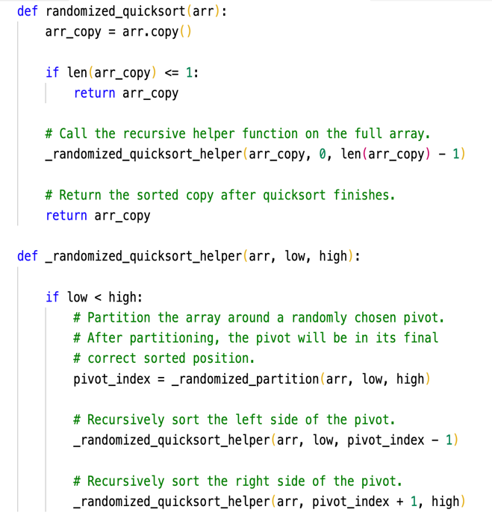
Fig 1: Quick-Sort implementation
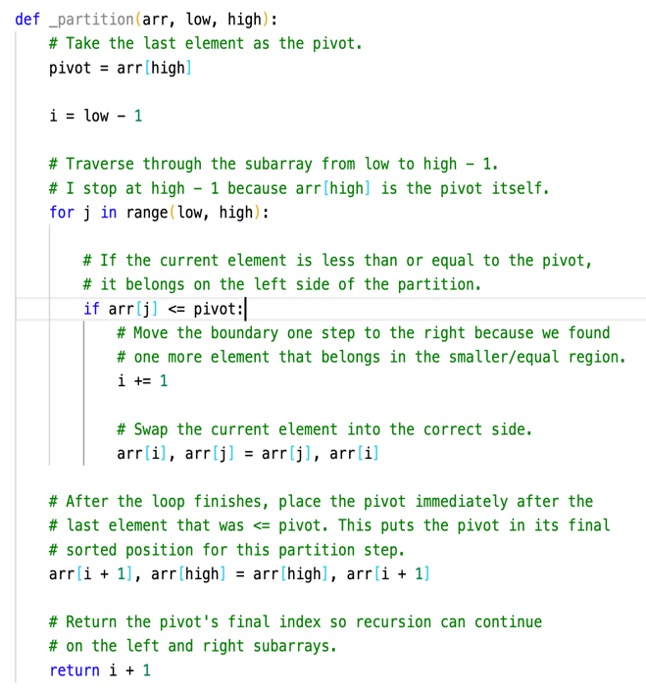
Fig 2: Partitioning Logic

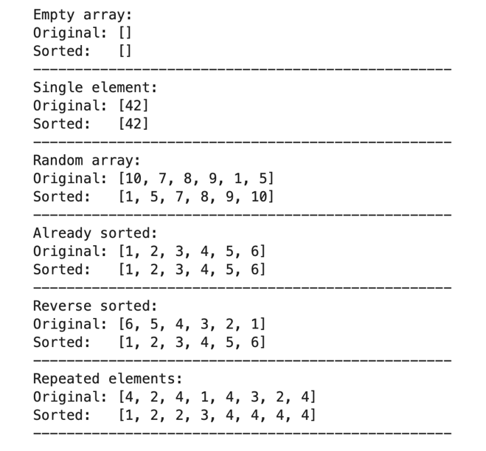
Fig 3: Sorted Results

Analysis
The time complexity of Randomized Quicksort depends on how the pivot divides the array at each step. In the best and average cases, the pivot divides the array into two roughly equal halves, leading to the recurrence relation:
T(n) = 2T(n/2) + O(n)
Solving this recurrence results in a time complexity of O(n log n), which is considered efficient for sorting algorithms (Cormen et al., 2022).
In Randomized Quicksort, the pivot is chosen uniformly at random, meaning that every element has an equal probability of being selected. Because of this, the chances of consistently choosing poor pivots that lead to worst-case performance are very low. As a result, the expected time complexity remains O(n log n) in most practical situations (Cormen et al., 2022).
Another way to analyze this is by using indicator random variables, where we evaluate the probability that any two elements are compared during execution. It can be shown that the expected number of comparisons grows proportionally to n log n, which further supports the average-case performance (Goodrich et al., 2014).
In my opinion, the biggest advantage of Randomized Quicksort is that it avoids predictable worst-case inputs. Unlike deterministic quicksort, where certain inputs like already sorted arrays can significantly degrade performance, the randomized version maintains more balanced partitions on average.

Comparison
To evaluate the performance of Randomized Quicksort, I compared it with Deterministic Quicksort, where the pivot is always chosen as the first element. I tested both algorithms on different types of input arrays, including random arrays, already sorted arrays, reverse-sorted arrays, and arrays with repeated elements.
From the experimental results, it can be observed that Deterministic Quicksort performs slightly faster than Randomized Quicksort on random input. For example, for an array size of 1000, the deterministic version had a slightly lower execution time compared to the randomized version. I personally think this happens because deterministic quicksort does not include the overhead of random pivot selection.
However, a major difference appears when testing sorted and reverse-sorted arrays. In these cases, Deterministic Quicksort performs significantly worse. For instance, with an input size of 1000, the execution time increased drastically to around 0.04–0.048 seconds, while Randomized Quicksort remained stable at around 0.002 seconds. This clearly reflects the worst-case time complexity of O(n²) for deterministic quicksort (Cormen et al., 2022).
For arrays with repeated elements, both algorithms showed an increase in execution time, but deterministic quicksort was still slightly faster. This behavior is likely related to how partitioning handles duplicate values.
Overall, based on both theoretical analysis and empirical results, Randomized Quicksort provides more consistent and reliable performance across different input types. In my opinion, this makes it a better choice for real-world applications where the nature of input data cannot be predicted in advance (Goodrich et al., 2014).
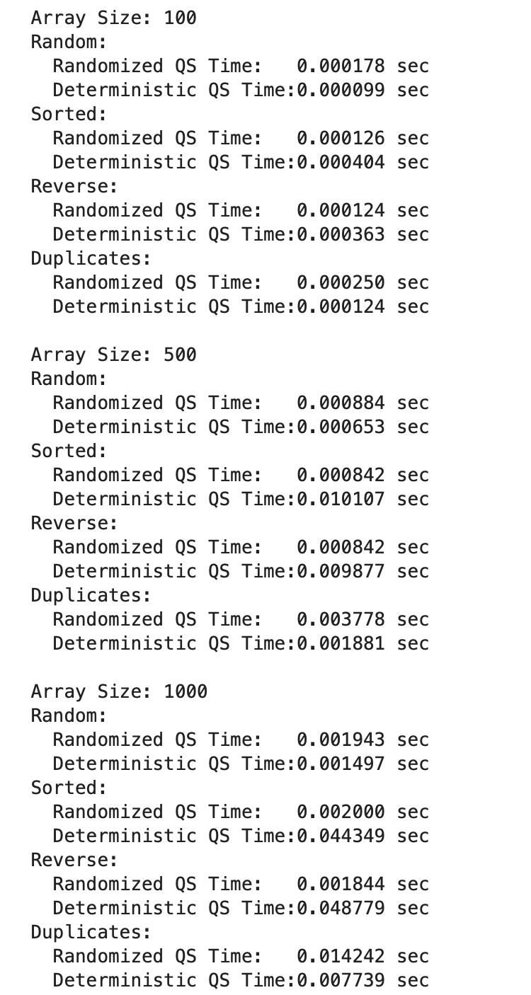
Fig 4: Comparison results

Part 2: Hashing with Chaining
Implementation
In this part, I implemented a hash table using chaining as the collision resolution technique. In this approach, each index of the hash table stores a list of key-value pairs, which allows multiple elements to exist at the same index without overwriting each other (Cormen et al., 2022).
To map keys to indices, I used Python’s built-in hash function combined with the modulo operation. This ensures that the computed index always falls within the bounds of the table size. I personally think this is a simple yet effective method for distributing keys across the table.
The implementation supports three main operations: insert, search, and delete. During insertion, the algorithm checks whether the key already exists and updates the value if necessary. Otherwise, it adds a new key-value pair to the chain. The search and delete operations similarly traverse the chain to locate the target key.
One important feature I included in this implementation is dynamic resizing. When the load factor exceeds 0.7, the table size is doubled, and all existing elements are rehashed. This helps reduce collisions and maintain efficient performance as the table grows (Goodrich et al., 2014).
I also tested the implementation with different operations such as inserting values, updating keys, searching for both existing and missing elements, deleting elements, and triggering resizing. These tests confirmed that the hash table behaves correctly under different scenarios.
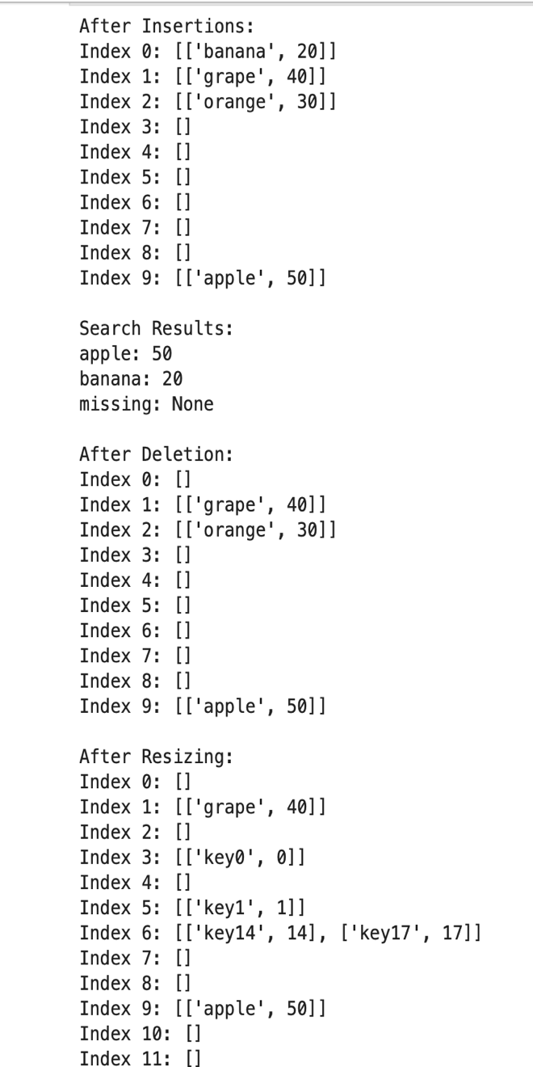

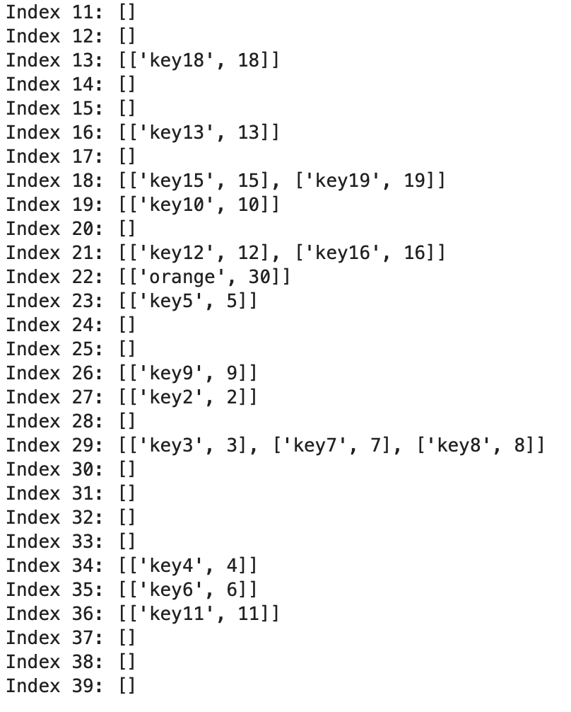
Fig 5: Hashing results

Analysis
The performance of a hash table with chaining depends largely on the load factor, which is defined as the ratio of the number of stored elements to the number of slots in the table.
Under the assumption of simple uniform hashing, the average-case time complexity for insert, search, and delete operations is O(1 + α), where α represents the load factor (Cormen et al., 2022). When α is small, these operations are very close to constant time.
However, as the load factor increases, more elements are stored in each chain, which increases the time required for operations. In the worst case, when all elements hash to the same index, the time complexity can degrade to O(n).
To maintain good performance, it is important to control the load factor. In this implementation, I used dynamic resizing to address this issue. When the load factor exceeds 0.7, the table size is increased, which reduces collisions and improves efficiency (Goodrich et al., 2014).
In my opinion, chaining is a simple and flexible collision-handling method. Although it requires extra memory for storing lists, it provides stable performance and is easier to implement compared to other techniques such as open addressing.

References:
Cormen, T. H., Leiserson, C. E., Rivest, R. L., & Stein, C. (2022). Introduction to algorithms (4th ed.). MIT Press.
Goodrich, M. T., Tamassia, R., & Goldwasser, M. H. (2014). Data structures and algorithms in Python. Wiley.

