1) CODE
import re
text = input("Enter a sentence: ")
phone = re.findall(r"\d{10}", text)
email = re.findall(r"\S+@\S+", text)
print("Phone Number:", phone)
print("Email:", email)
word = input("Enter the word to search: ")
if re.search(word, text):
print("Word Found")
else:
print("Word Not Found")
Output:
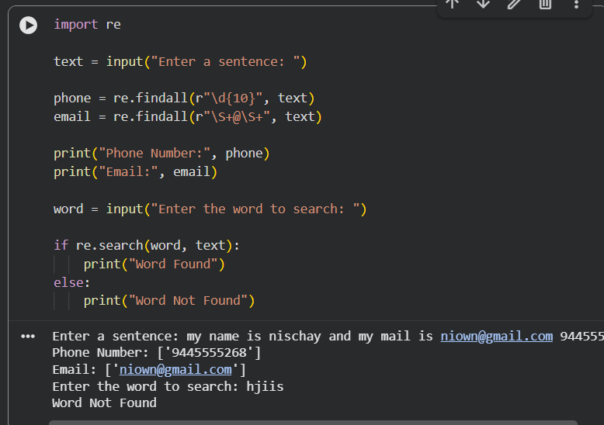

2) CODE:
def finite_state_automaton(string):
return string.endswith("ab")
s = input("Enter a string: ")
if finite_state_automaton(s):
print("Accepted")
else:
print("Rejected")
OUTPUT:
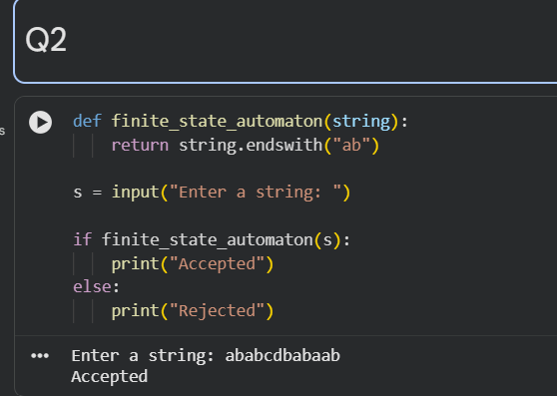

3) CODE:
import nltk
from nltk.tokenize import word_tokenize
from nltk.stem import WordNetLemmatizer
nltk.download('punkt')
nltk.download('wordnet')
nltk.download('omw-1.4')
text = input("Enter a sentence: ")
words = word_tokenize(text)
lemmatizer = WordNetLemmatizer()
print("Word\tLemma")
for word in words:
print(word, "\t", lemmatizer.lemmatize(word))
OUTPUT:
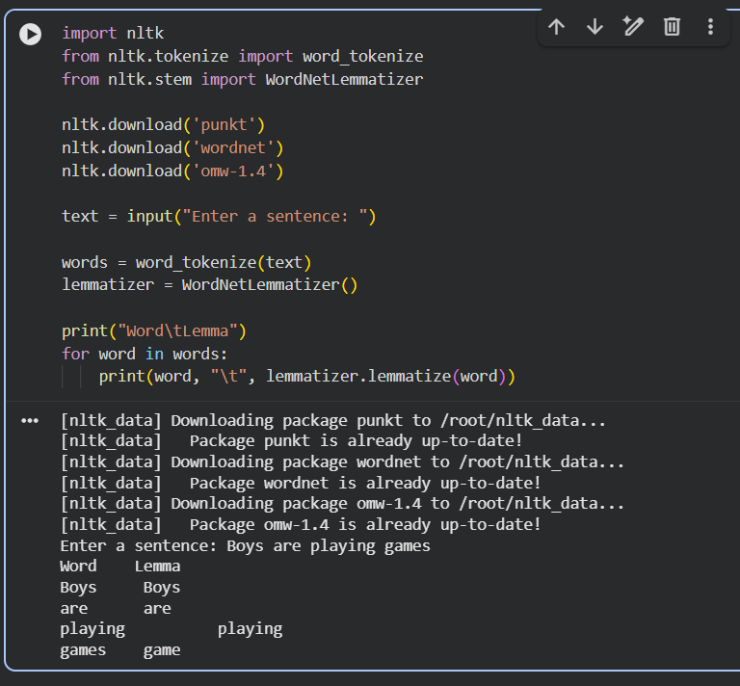

4) CODE:
def generate_plural(noun):
if noun.endswith(("s", "x", "z", "ch", "sh")):
plural = noun + "es"
elif noun.endswith("y") and len(noun) > 1 and noun[-2].lower() not in "aeiou":
plural = noun[:-1] + "ies"
else:
plural = noun + "s"
return plural
words = ["cat", "dog", "bus", "box", "church",
"dish", "baby", "city", "toy", "book"]
print("Singular\tPlural")
print("------------------------")
for word in words:
print(f"{word:10}\t{generate_plural(word)}")
OUTPUT:
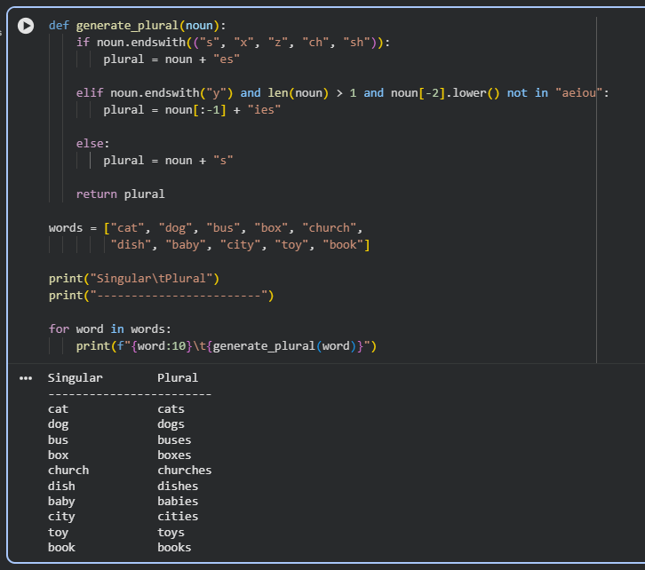
5) CODE
import nltk
from nltk.stem import PorterStemmer

stemmer = PorterStemmer()

word = input("Enter a word: ")

stem = stemmer.stem(word)
# Display result
print("\nOriginal Word :", word)
print("Stemmed Word :", stem)
OUTPUT:
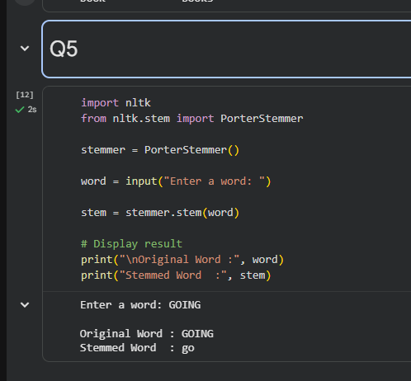

6) CODE:
import nltk
from nltk import bigrams
from collections import defaultdict
import random
nltk.download('punkt')
nltk.download('punkt_tab')
text = input("Enter a sentence: ")
words = nltk.word_tokenize(text.lower())
model = defaultdict(list)
for w1, w2 in bigrams(words):
model[w1].append(w2)
start = input("Enter the starting word: ").lower()
if start not in model:
print("Starting word not found in the sentence.")
else:
generated = [start]
current = start
for i in range(10):
if current not in model:
break
current = random.choice(model[current])
generated.append(current)
print("\nGenerated Text:")
print(" ".join(generated))

OUTPUT:

