**TripHorsePower**

Project Description

Taking a break from the busy urban life style is an important part in the modern era of fast paced society. Taking break for some people means to discover what a new place has to offer. This can include a refreshing natural water-fall a few miles away from the city or a scenic hill station. But wait how to reach there? The immediate response would be “of course the google maps”. Unfortunately google maps does not have sufficient information about these places from which one can decide to visit. Since we are not referring to well-known city or a famous tourist spot, our website offers information about less explored places, and it’s from people who have actually visited those places. You will find reviews about places, useful tips which can actually make your trip more convenient and help you enjoy your time in a better way. Once you have been there, you can comment on the existing or create a new review based on your experience and help other fellow travelers to make their trip a better experience. You can also share these experiences on your favorite social networking websites such as Facebook and Twitter. You can also follow other travelers and know about their recent trips. We also offer you information and reviews regarding the kind of vehicle you may want to buy or hire which matches your traveler lifestyle.

## Actors

1. **Guest User**

Any person who wants just view the information regarding any trip. This user can only view a review but cannot comment, rate and post reviews.

1. **User**

Any person who has a profile and has provided basic information to our system. This user can comment, rate and post a new review. He can also follow other people in the website and know about their recent trips.

1. **Admin**

He is the person who maintains the website, He manages the content of the website and removes any inappropriate content posted by user. And also post new articles or reviews about new automobiles launched.

## Architecture

### Below diagram shows the architecture of proposed website. The user interacts with the UI which is build using HTML, Bootstrap CSS and AngularJS. All the request by the user and the data provided by the user is sent to the NodeJS (server) through JSON using REST protocol.

### The server responds to the request by embedding the data in JSON format.

### The server writes/reads data to or from database in JSON format

### The server makes calls to external APIs for data using AJAX but in JSON (JSONP) data format

### The external domain responds through JSON (JSON)

## C:\Users\Nischay M\Downloads\Architecture - New Page (1).jpeg

## Use Case Analysis

## Use cases

## Guest User Use cases

1. Guests enters the homepage url
2. Guests can click on the available trip pictures to open the respective trip review
3. Guest user can click on the top rated trips
4. Guest user can search about a trip to a place using the name of the place
5. Guest user when clicks on a particular trip, can view the related full details

## Admin Use Cases

1. Admin logs in
2. Admin updates the homepage content if any
3. Admin updates the trip review details if any
4. Admin removes any unused profiles after a certain period of time
5. Admin check for any content or comment which is flagged as in-appropriate
6. Admin can remove any content
7. Admin logs out

## User Use cases

1. User registers
2. User logs in
3. User views his profile
4. User updates his profile
5. User logs out
6. User can view profile of other users

## Trip review use cases

1. Review is created by user
2. Review is posted by a user
3. Review can be edited by its owner
4. Review can be commented on by any user
5. Review can be rated by any user

## Comment Use Cases

1. Comment for a review can be added by its owner
2. Comment can be added by a user
3. Comment can be edited by only its creator
4. Comment can be like by any user
5. Comment can be deleted by its owner
6. Comment can be flagged as inappropriate

## Profile Use cases

1. Profile is created by a user
2. Profile fields are edited by user
3. Profile has two views, personal and public
4. Profile of other users can only be viewed
5. Profile is accessible only for the users

**UML Diagram**

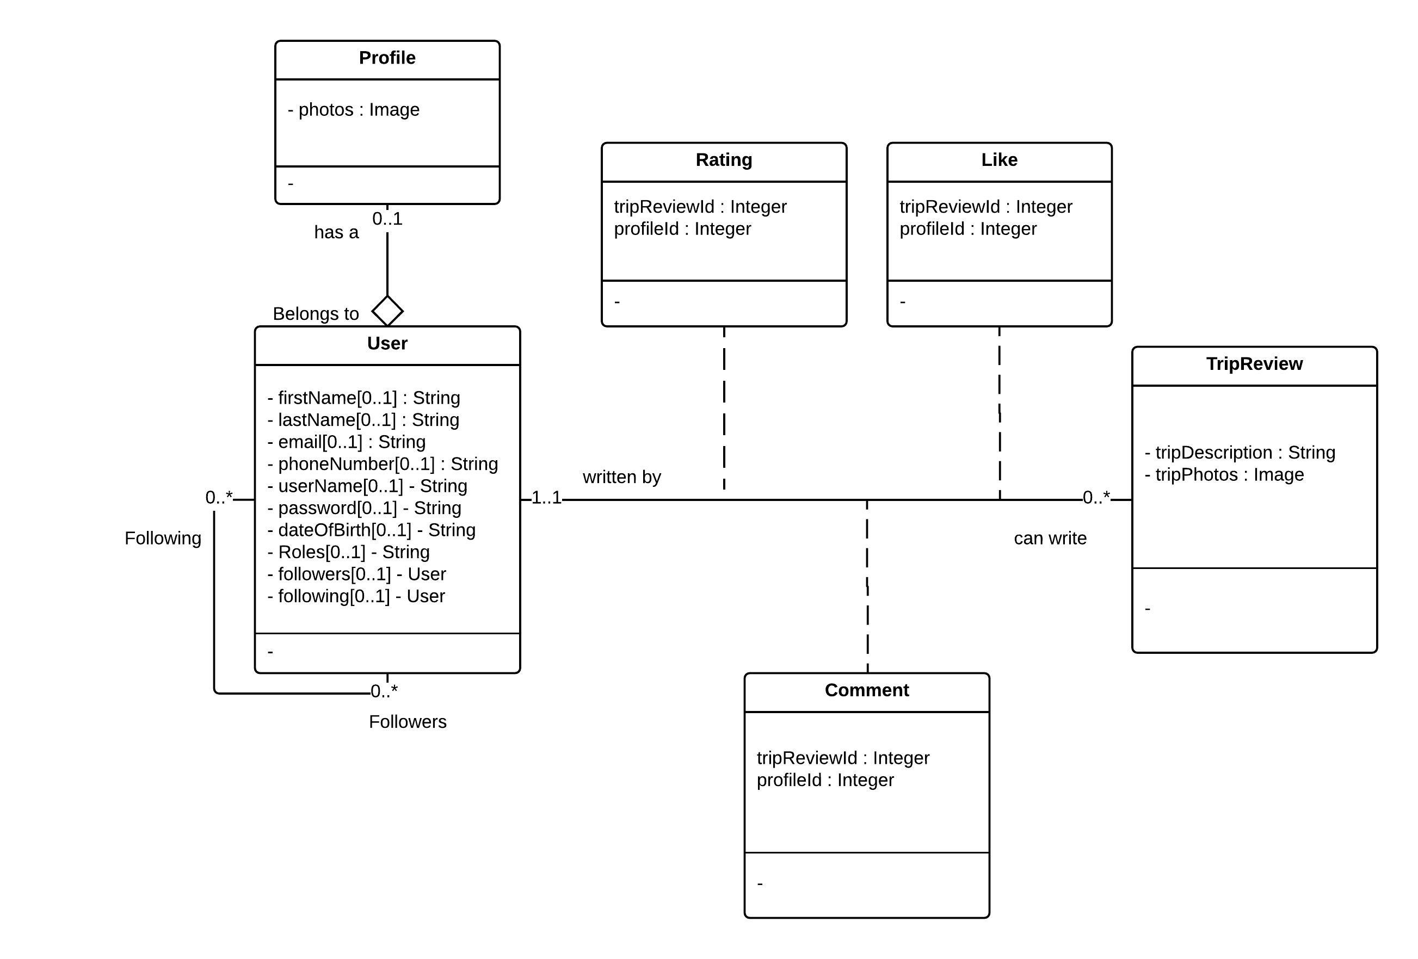

**Wireframe**

Moqup link

<https://moqups.com/nischaym@gmail.com/kE2OpfQp/p:a0a0df9d4>

Google Doc link

<https://docs.google.com/document/d/1kZjsJHUYeOBcrOqCHf2fvGiQpaigPx-XlbkAQXTJvik/edit?usp=sharing>