**DMT C# Snippet Overview  
Unity C# “ready to use” code examples**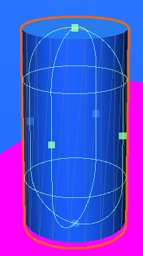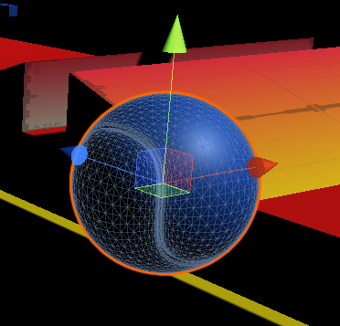

|  |  |  |
| --- | --- | --- |
|  | **Snippet Name (class Name)** | **Short description** |
| **A** | Move/Reset GameObjects |  |
| **1** | DMTGoBack.cs | Back when “ball” falls down |
| **2** | DMTGoBackZero.cs | Back and set all velocities to zero |
| **3** | DMTRotateMe.cs | Rotate the GO X/Y/Z |
| **4** | DMT**Key**GoXYZ.cs | On Key go to a position set be another GO |
| **5** | DMT**Key**GoPosGO.cs | On Key go to a GO Position & Rotation (eg. Cam) |
|  |  |  |
| **B** | Interaction: e.g. Click on GO |  |
| **1** | DMTCamRotMouse.cs | Rotate Cam with mouse movement (on Cam!) |
| **2** | DMTCamRotMouseButton.cs | Rotate Cam only when button is clicked |
| **3** | DMTClickHide.cs | Hide GO when GO is clicked (away for ever) |
| **4** | DMTClickHideOther.cs | Hide GO when another GO is clicked |
| **5** | DMTClickHideToggle.cs | Toggle view state of GO when other GO is clicked |
| **6** | DMT**Key**ToggleActive | With a **Key** set GO Active or inactive |
|  |  |  |
| **C** | Menü & Scenen |  |
| **1** | DMT**Key**Quit.cs | Quit App when ESC is pressed (Input.GetKey) |
| **2** | DMT**Button**Quit.cs | Quit App when GUI Button is pressed |
| **3** | DMT**Click**Quit.cs | Quit App when (3D) GO is clicked (OnMouseDown) |
| **4** | DMT**Click**Scene.cs | Click on (3D) GO to change scene by name |
| **5** | DMT**Button**Scene.cs | Scripts for UI-Button Interaction (go Scene or Quit) |
| **6** | DMT**Key**GoScene.cs | On Key go to another Scene |
| **7** | DMTDontDestroy.cs | Do not destroy GO in new Scene |
|  |  |  |
| **D** | Multimedia on**Click** on GO |  |
| **1** | DMTPlayAudio.cs | Play Audio (Toggle) |
| **2** | DMTPlayAudioGO.cs | Play Audio with another GO click |
| **3** | DMTPlayVideo.cs | Play Video (Toggle) |
| **4** | DMTPlayVideoGO.cs | Play Video with another GO click |
|  |  |  |
| **E** | **Trigger** Events |  |
| **1** | DMTTriggerScene.cs | Change Scene when trigger is fired |
| **2** | DMTTriggerAudio.cs | Play Audio when trigger is fired |
| **3** | DMTTriggerVideo.cs | Play Video when trigger is fired or pause when exit |
| **4** | DMTTriggerHide.cs | Hide when trigger (with collider) is fired |
| **5** | DMTTriggerShowToggle.cs | Show & Hide when trigger (with collider) is fired |
| **6** | DMTTriggerTime.cs | Shows round time and clock time for racing games |
| **7** | DMTTriggerCollectText.cs | Hide and Count and show Text (TMPro) when trigger for ballgame (with freecam und rollerball prefab) |
|  |  |  |
| **F** | Info/Debug/Helper |  |
| **1** | DMTConsoleLog.cs | Write Text into the console |
| **2** | DMTCursorOnOff.cs | Show or hide mouse cursor and lock/unlock it. |
|  |  |  |

Version 1.7b, last update 25.02.2020 Nischelwitzer