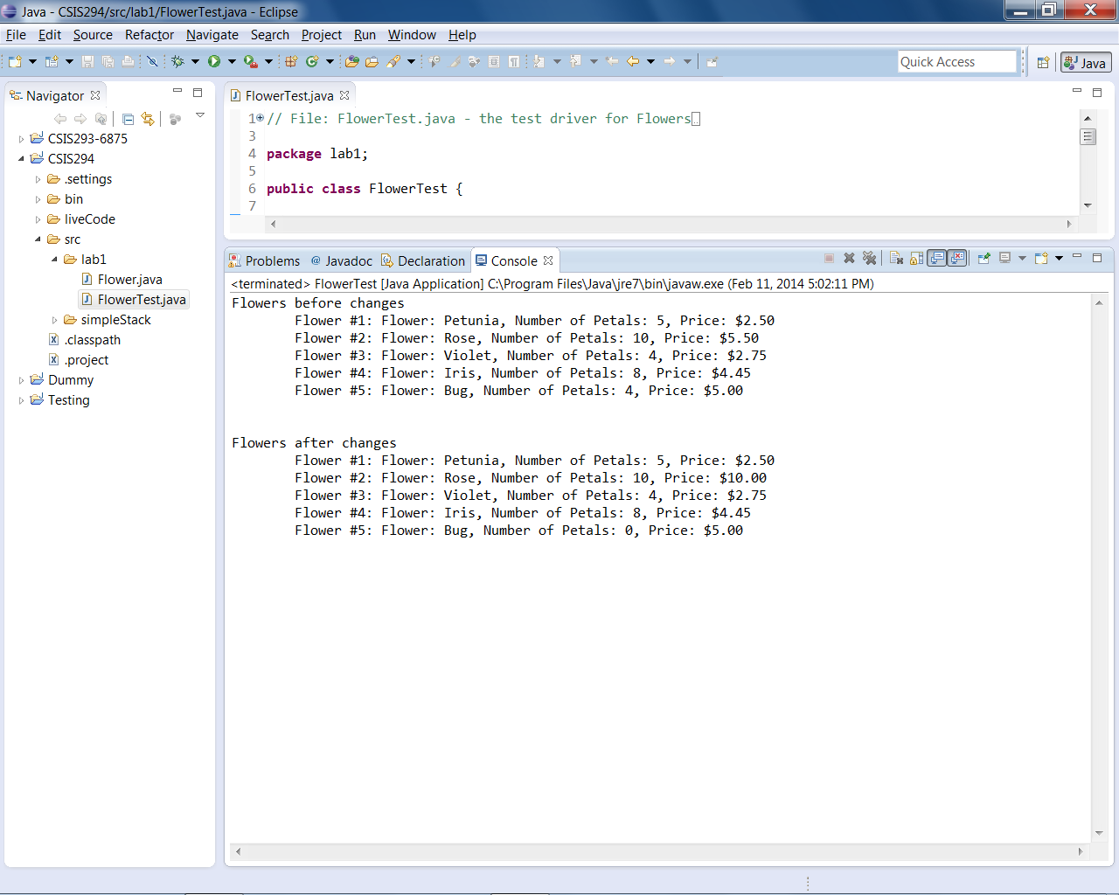

Mike Qualls

CSIS-294, Lab #1 Output