Medium Articles Analysis

### Read the dataset

library(tidyverse)

## Warning: package 'tidyverse' was built under R version 3.5.1

## -- Attaching packages --------------------------------------- tidyverse 1.2.1 --

## v ggplot2 3.0.0 v purrr 0.2.5  
## v tibble 1.4.2 v dplyr 0.7.6  
## v tidyr 0.8.2 v stringr 1.3.1  
## v readr 1.3.0 v forcats 0.3.0

## Warning: package 'ggplot2' was built under R version 3.5.1

## Warning: package 'tibble' was built under R version 3.5.1

## Warning: package 'tidyr' was built under R version 3.5.1

## Warning: package 'readr' was built under R version 3.5.1

## Warning: package 'purrr' was built under R version 3.5.1

## Warning: package 'dplyr' was built under R version 3.5.1

## Warning: package 'stringr' was built under R version 3.5.1

## Warning: package 'forcats' was built under R version 3.5.1

## -- Conflicts ------------------------------------------ tidyverse_conflicts() --  
## x dplyr::filter() masks stats::filter()  
## x dplyr::lag() masks stats::lag()

medium_dataset_csv <- read_csv("https://raw.githubusercontent.com/rfordatascience/tidytuesday/master/data/2018/2018-12-04/medium_datasci.csv")

## Parsed with column specification:  
## cols(  
## .default = col_double(),  
## title = col_character(),  
## subtitle = col_character(),  
## author = col_character(),  
## publication = col_character(),  
## url = col_character(),  
## author_url = col_character()  
## )

## See spec(...) for full column specifications.

medium_dataset_processed <- (medium_dataset_csv) %>% select(-x1)

### display the count of top 10 publication

medium_dataset_processed %>% count(publication, sort = TRUE) %>% head(10)

## Warning: package 'bindrcpp' was built under R version 3.5.1

## # A tibble: 10 x 2  
## publication n  
## <chr> <int>  
## 1 <NA> 44072  
## 2 Towards Data Science 3135  
## 3 Hacker Noon 1178  
## 4 Becoming Human: Artificial Intelligence Magazine 671  
## 5 Chatbots Life 450  
## 6 Data Driven Investor 351  
## 7 Chatbots Magazine 350  
## 8 SyncedReview 320  
## 9 Planeta Chatbot todo sobre los Chatbots y la Inteligencia Artific~ 294  
## 10 DEEPAERODRONES 273

### Top 10 most popular author

medium_dataset_processed %>% count(author, sort = TRUE) %>% head(10)

## # A tibble: 10 x 2  
## author n  
## <chr> <int>  
## 1 Yves Mulkers 487  
## 2 Synced 328  
## 3 <NA> 286  
## 4 DEEP AERO DRONES 279  
## 5 AI Hawk 245  
## 6 Peter Marshall 209  
## 7 Ilexa Yardley 162  
## 8 Alibaba Cloud 160  
## 9 Corsair's Publishing 156  
## 10 Jae Duk Seo 150

### aggregate the tags & find the most common tags

medium_dataset_processed %>% summarize_at(vars(starts_with("tag_")),sum)

## # A tibble: 1 x 8  
## tag_ai tag_artificial_~ tag_big_data tag_data tag_data_science  
## <dbl> <dbl> <dbl> <dbl> <dbl>  
## 1 13763 29580 8686 9420 15424  
## # ... with 3 more variables: tag_data_visualization <dbl>,  
## # tag_deep_learning <dbl>, tag_machine_learning <dbl>

### reshaping the above data

medium_gathered <-medium_dataset_processed %>%   
 gather(tag,value,starts_with("tag_")) %>%  
 mutate(tag = str_remove(tag,"tag_"))%>%   
 filter(value == 1)  
  
medium_gathered %>% View  
medium_gathered %>% count(tag,sort = TRUE)

## # A tibble: 8 x 2  
## tag n  
## <chr> <int>  
## 1 artificial_intelligence 29580  
## 2 machine_learning 25175  
## 3 data_science 15424  
## 4 ai 13763  
## 5 data 9420  
## 6 big_data 8686  
## 7 deep_learning 6612  
## 8 data_visualization 4334

### find the most popular tag based on the number of claps

medium_gathered %>%   
 group_by(tag) %>%  
 summarize(median_claps = median(claps)) %>%  
 arrange(desc(median_claps))

## # A tibble: 8 x 2  
## tag median_claps  
## <chr> <dbl>  
## 1 deep_learning 25  
## 2 machine_learning 12  
## 3 data_science 11  
## 4 artificial_intelligence 5  
## 5 data_visualization 5  
## 6 ai 4  
## 7 data 3  
## 8 big_data 1

### find the average number of claps for an article in towards data science

medium_gathered %>%   
 group_by(publication) %>%  
 filter(publication== "Towards Data Science") %>%  
 summarize(median_claps = median(claps)) %>%  
 arrange(desc(median_claps))

## # A tibble: 1 x 2  
## publication median_claps  
## <chr> <dbl>  
## 1 Towards Data Science 215

### find the most popular tag based on the number of claps

medium_gathered %>%  
 group_by(tag) %>%  
 summarize(median_claps = median(claps)) %>%  
 arrange(desc(median_claps))

## # A tibble: 8 x 2  
## tag median_claps  
## <chr> <dbl>  
## 1 deep_learning 25  
## 2 machine_learning 12  
## 3 data_science 11  
## 4 artificial_intelligence 5  
## 5 data_visualization 5  
## 6 ai 4  
## 7 data 3  
## 8 big_data 1

### distribution of claps

medium_dataset_processed %>%  
 ggplot(aes(claps)) +  
 geom_histogram(binwidth = 0.08) +  
 scale_x_log10(labels = scales::comma_format())

## Warning: Transformation introduced infinite values in continuous x-axis

## Warning: Removed 25729 rows containing non-finite values (stat_bin).

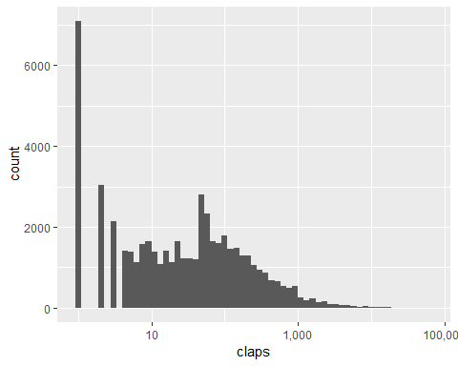

### distribution of reading time

medium_dataset_processed %>%  
 mutate(reading_time = pmin(14,reading_time)) %>%  
 ggplot(aes(reading_time)) +  
 geom_histogram(binwidth = 0.02) +  
 scale_x_log10(breaks =seq(2,14,2),  
 labels = c(seq(2,12,2),"14+")) +  
 labs(x = "Median Reading Time")

## Warning: Transformation introduced infinite values in continuous x-axis

## Warning: Removed 814 rows containing non-finite values (stat_bin).

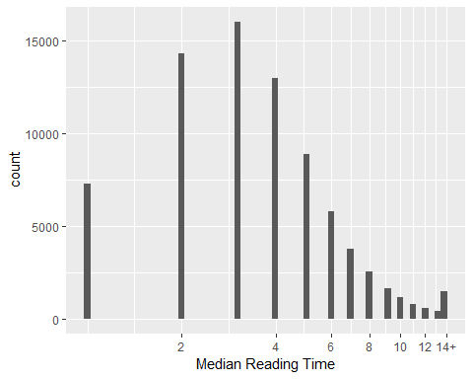

Q1 <- c(10,3,7,9)  
Q2 <- c(9,4,6,4)  
  
pmax(Q1,Q2) #parallel maxima

## [1] 10 4 7 9

### reading time associated with various tags

medium_gathered %>%  
 group_by(tag) %>%  
 summarize(reading_time = mean(reading_time)) %>%  
 arrange(desc(reading_time))

## # A tibble: 8 x 2  
## tag reading_time  
## <chr> <dbl>  
## 1 deep_learning 5.08  
## 2 machine_learning 4.76  
## 3 data_science 4.69  
## 4 artificial_intelligence 4.36  
## 5 data_visualization 4.26  
## 6 ai 4.14  
## 7 data 4.05  
## 8 big_data 3.97

## Text Mining

library(tidytext)

## Warning: package 'tidytext' was built under R version 3.5.2

words <- medium_dataset_processed %>%   
   
 filter(!is.na(title)) %>% #removing missing data  
 unnest_tokens(word,title) %>% # tokenizing  
 anti_join(stop_words, by= "word") %>% # removing stop words  
 transmute(post_id = row_number(),subtitle,year,reading_time,claps,word) %>%  
 filter(word!= 'de',str_detect(word,'[a-z]'))   
   
 class(words)

## [1] "tbl_df" "tbl" "data.frame"

### Most Common words in medium post titles

words %>%  
 count(word,sort = TRUE) %>%  
 head(20) %>%  
 mutate(word = fct_reorder(word,n)) %>%  
 ggplot(aes(word,n)) +  
 geom_col() +  
 coord_flip()+  
 xlab("Most Common words in medium post titles")

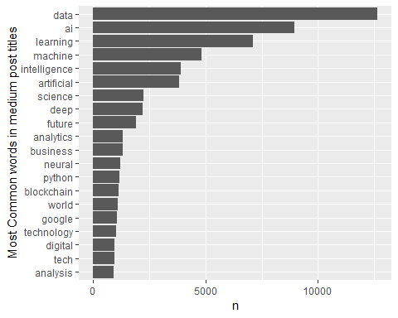

words %>%  
 add_count(word)%>% #adds a column with count of the word  
 filter(n>500) %>%  
 group_by(word) %>%  
 summarize(median_claps = median(claps),  
 geometric_mean_claps = exp(mean(log(claps +1))),  
 occurences = n()) %>%  
 arrange(desc(median_claps))

## # A tibble: 49 x 4  
## word median_claps geometric_mean_claps occurences  
## <chr> <dbl> <dbl> <int>  
## 1 tensorflow 53 36.6 704  
## 2 building 36 27.0 669  
## 3 deep 35 27.7 2194  
## 4 guide 35 27.6 569  
## 5 networks 24 25.1 764  
## 6 blockchain 23 19.2 1123  
## 7 model 23 19.2 623  
## 8 neural 22 23.3 1199  
## 9 network 21 20.8 759  
## 10 build 20 20.1 536  
## # ... with 39 more rows

The words that got the most claps were ‘tensorflow,building,guide,deep learning, neural networks’ and the words that got the least no of claps were ‘marketing, trends’ and so on

rm(medium_dataset_processed)  
rm(medium_gathered)  
rm(medium_dataset_csv)  
rm(Q1)   
rm(Q2)  
gc()

## used (Mb) gc trigger (Mb) max used (Mb)  
## Ncells 2269588 121.3 4172378 222.9 4172378 222.9  
## Vcells 10337771 78.9 32229094 245.9 35841690 273.5